1. Write a java Program to display only digits in an alpha numeric String (Input: 75#41\* Output:7541)

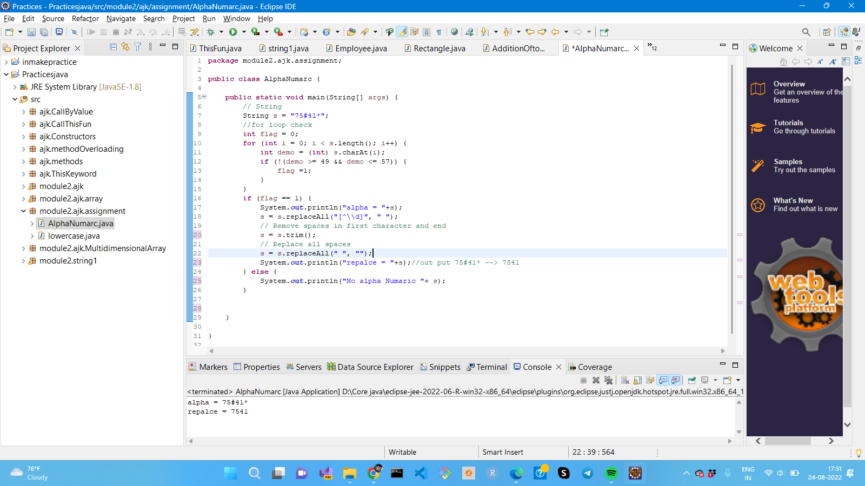

1. Write a program to convert Given String onto uppercase and lowercase without using String Method

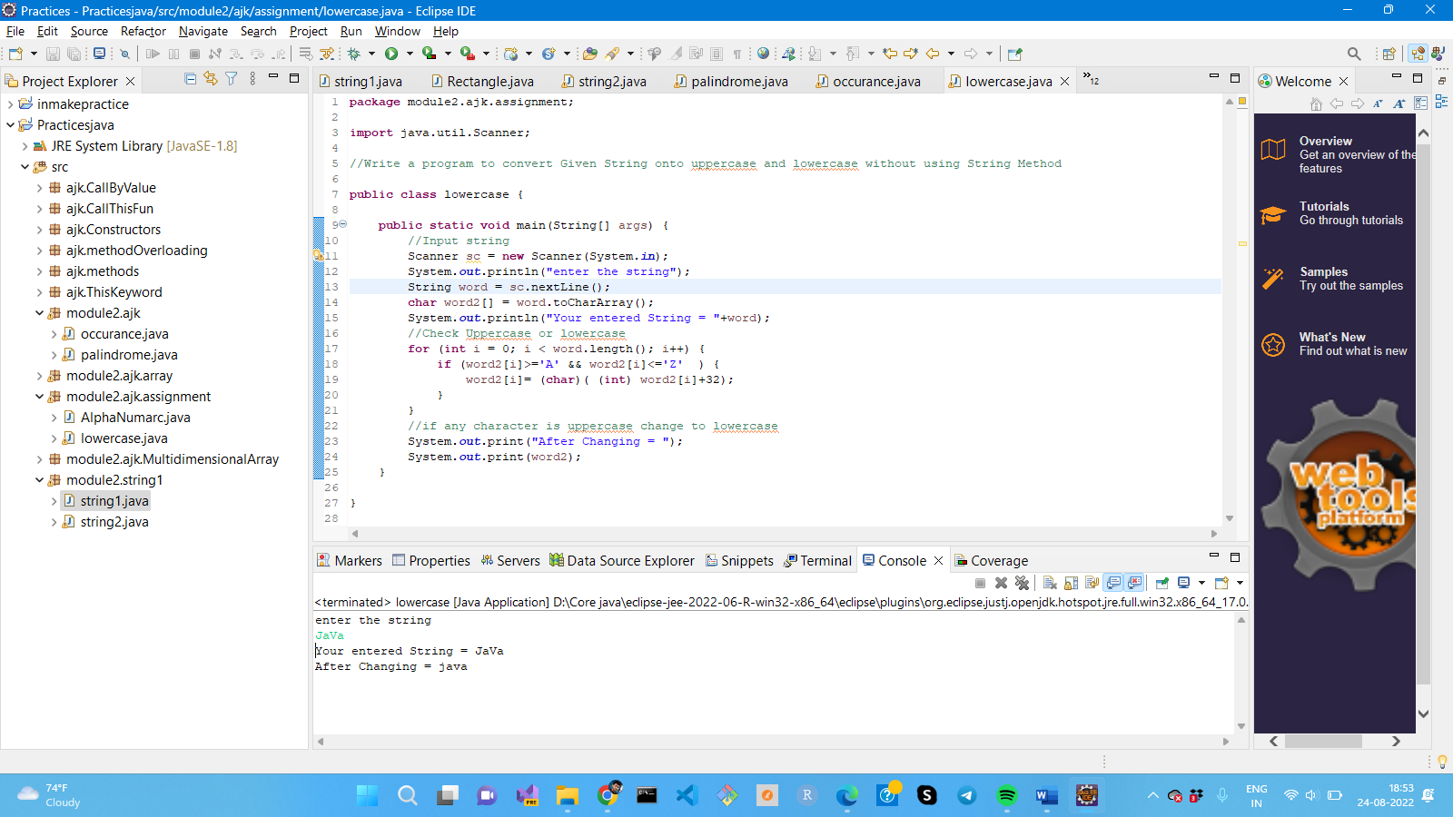

1. Write a program to print reverse a of a string word by word (Input: I am a developer Output: developer a am I) Graphical user interface, text, application

   Description automatically generated
2. Write a program to print repeated characters from a given String

OR

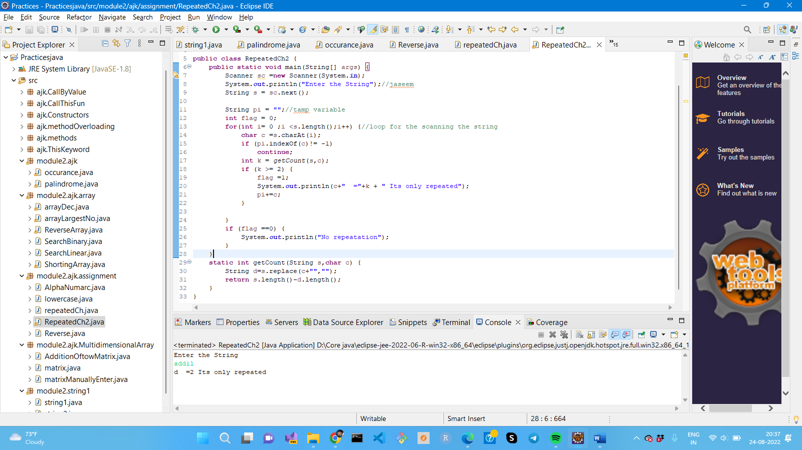

1. Write a program to count number of vowels in a given String

