Evaluating Retrieval Augmentation for Electoral Text to SQL
Deep Learning with Python | Technical project summary
Author: Zapfack Jasen Steve
Instructor: Benoit Mialet
Report date: 30 September 2026 | Study: development-split generation comparison

1 Project overview
I built a French-language assistant for the supplied Côte d'Ivoire 2025 election results. It translates questions into SQL, computes answers in a database and displays results in Streamlit. This study compares text-to-SQL with a fixed context against three retrieval-augmented variants, first by the context they supply and then by the SQL results a real language model generates with that context.

Problem and motivation
Natural-language access makes complex electoral tables easier to explore. Reliable answers require the correct place, aggregation and denominator, and recognition of missing data.
- Aggregation: constituency totals repeat across candidate rows. Summing at the wrong level produces 29.45% turnout instead of 35.04%.
- Language: French questions contain paraphrases, accents and aliases that differ from database labels.
- Reliability: SQL can execute successfully and still answer the wrong question. Missing demographic or historical data must not be invented.

Research questions
1. Does text-to-SQL benefit from retrieval augmentation over a fixed-context baseline?
2. Which search method supplies the required context most reliably: BM25, multilingual E5 or hybrid retrieval?
3. How can result correctness, execution and appropriate abstention be evaluated separately?
A denotes text-to-SQL without retrieval. B is the RAG family: B1 BM25, B2 E5 and B3 hybrid. They share the generator, prompt, six SQL examples, database and execution rules.

Main findings and scope
- With Claude Haiku 4.5 generating SQL, strict SQL-result accuracy on the 14 answerable development questions is A 11/14 (78.6%), B1 14/14 (100%), B2 13/14 (92.9%) and B3 13/14 (92.9%).
- Paired against A, B1 wins 3 questions and loses 0, B2 wins 2 and loses 0, and B3 wins 3 and loses 1. Exact McNemar p-values are 0.25, 0.50 and 0.625: no difference is statistically established at this sample size.
- A's three errors all involve place names absent from its fixed context: an accented spelling, a hyphenated spelling and an under-specified name match. This is the information that RAG entity cards supply.
- E5 supplies complete annotated context for 15/16 eligible questions, versus 10/16 for BM25 and 14/16 for hybrid retrieval.
- Fine-tuning E5 on synthetic queries raises held-out Recall@1 from 74.4% to 89.9%, but lowers complete context on the benchmark from 15/16 to 11/16: the gain does not transfer.
The SQL generator is a hosted pretrained model; only the E5 retriever is trained. It covers 18 predeclared development questions with draft reference labels and one run per condition; the 60 held-out questions remain unevaluated.

2 Dataset preprocessing and essential EDA

Dataset and observation units
The supplied 35-page PDF describes Côte d'Ivoire's election of deputies on 27 December 2025. The CSV contains 1,125 candidate/list entries, 205 constituencies, 33 extracted region/district labels and 43 party/grouping labels, with 16 business columns and three provenance columns for PDF page, table and row.
A record may represent a list. Winning rows count constituency wins, not seats. Gender labels, list-member rosters and historical series are absent. The publisher has not been independently authenticated.

Preprocessing and validation
- Reconstruct merged constituency cells and vertical region labels; carry context across pages and recover omitted rows.
- Preserve three-character constituency IDs, accents and source labels; parse counts, percentages and election markers into explicit types.
- Separate candidature, constituency and elected-row database views to avoid multiplying constituency totals by candidate counts.
- Retain unusual source values with their provenance rather than replacing extremes with invented values.
All 21 structural checks pass. Fresh extraction reproduces the CSV/Parquet, and seven printed national totals reconcile. These checks establish extraction reproducibility, not certainty about geographic interpretation.

EDA findings that affect the task
Finding | Observation | Consequence
Unequal sizes | 7,903 to 555,901 registrations; median 28,375 | Specify aggregation weights
Different turnout measures | National 35.04%; constituency mean 42.22% | Define the unit and denominator
Unequal competition | 1 to 17 entries; 11 single-entry constituencies | Margins need a runner-up
Source extremes | Adzopé invalid rate 28.11%; Odienné turnout 99.98% | Document unusual values

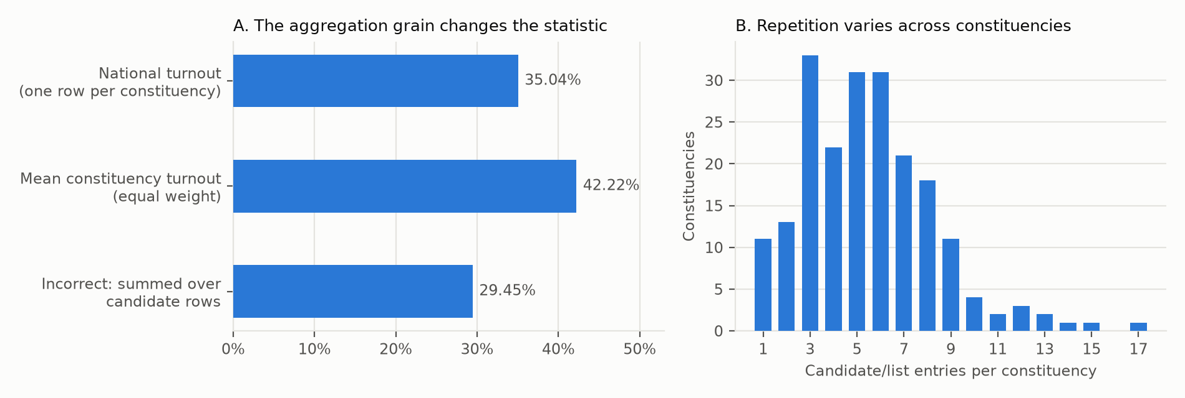
Figure 1. National turnout uses one row per constituency: 3,012,094 voters divided by 8,597,092 registered voters. Repeated candidate rows distort the ratio.
A pre-run audit found ambiguous region carry-forward on PDF page 14, affecting IDs 073–077. A hypothetical reassignment changes references for dev-006 and dev-007; both were excluded before any model outcome existed. The source issue remains unresolved: matching national totals does not settle regional membership.

3 Method models and comparison conditions

Shared text-to-SQL pipeline
1. Construct context according to A, B1, B2 or B3.
2. Supply the French question, context, shared instructions and six SQL examples to the generator.
3. Receive structured JSON containing SQL, a clarification request or an unsupported-data response.
4. Validate read-only SQL against approved DuckDB views; execute it and return the result table.
5. Score the returned values or the prescribed non-answer against the reference.
Retrieval-Augmented Generation (RAG) selects external information before generation. Here, retrieval supplies definitions and labels; SQL calculates.

A versus the three RAG variants
Condition | Context supplied | Cards selected | SQL-result accuracy
A — no retrieval | All schema/domain cards; no entity search | 19 fixed | 11 / 14
B1 — BM25 | Lexical retrieval | 2–11 in this run | 14 / 14
B2 — E5 | Neural semantic retrieval | 11 | 13 / 14
B3 — hybrid | Fusion of lexical/neural rankings | 11 | 13 / 14

B1/B2/B3 share a maximum of 3 schema + 3 domain + 5 entity cards. BM25 drops zero-score matches. A retains database knowledge with fixed context. An A-to-B comparison changes context size, entity information and selection; B1/B2/B3 share quotas.

Corpus and models
- Corpus: 300 short reference cards: 7 schema, 12 domain and 281 entity cards. Entity cards cover 205 constituencies, 33 regions/districts and 43 parties/groupings.
- BM25 [1]: term-based ranking with French accent normalization.
- Multilingual E5 small [2]: a pretrained local encoder creates embeddings, numerical text representations used for similarity ranking. E5 does not generate SQL.
- Hybrid RRF [3]: reciprocal rank fusion combines the BM25 and E5 rank positions.
- Fine-tuned E5 (B2-FT): the same encoder after contrastive fine-tuning on this corpus (Section 4); evaluated for retrieval only.
- Generator [4]: Claude Haiku 4.5 through the Anthropic API (requested as claude-haiku-4-5; provider-reported version claude-haiku-4-5-20251001), temperature 0, with JSON-schema structured output.
Protocol deviation. The predeclared protocol named gemini-3.8-flash. All four Gemini attempts failed with network errors and returned no response, so the generator was changed to Claude Haiku 4.5 before any model outcome was observed. Questions, exclusions, prompts, examples, context settings and metrics are unchanged; the benchmark hash matches the pre-run audit.
The application uses local NumPy embedding caches and an exact-question response cache. Evaluation bypasses the response cache. Adaptive-search variants are outside this four-condition study.

4 Evaluation setup and hyperparameters

Training development and test split
The SQL generator is not trained. The E5 retriever is fine-tuned on synthetic query–card pairs generated from the corpus by French templates (for example "résultats {place}", "région {name}"), including case, hyphen and accent variants. No benchmark question is used; 5 generated queries too similar to a benchmark question (token Jaccard ≥ 0.5) were removed.
- Training pairs: 969 pairs for 244 cards.
- Held-out pairs: 227 pairs for 56 cards never seen in training (card-level split).
- Loss: in-batch contrastive cross-entropy on cosine similarities (temperature 0.05); batches never repeat a card.
- 20 development questions: inspected during development; dev-006/007 are excluded because their references depend on the source ambiguity.
- 18 retained questions: 14 answerable, 2 ambiguous and 2 unsupported. Four conditions yield 72 generation trials, all completed.
- 60 held-out questions: reserved for later evaluation. Paraphrase families do not cross the development/test split.
All 80 records remain draft. The 16 answerable development reference queries agree with independent CSV calculations. The two exclusions are database-consistent but sensitive to regional assignment. Human source review remains necessary.

Fixed comparison protocol
Questions, exclusions, metrics and context settings were declared before outcome inspection. Interleaved conditions share the generator, prompt, examples, validator and repair policy. No item is excluded because of its outcome.
Setting | Value | Purpose
RAG quotas | 3 schema + 3 domain + 5 entity | Shared context budget
BM25 | k1 = 1.5; b = 0.75 | Term and length weighting
E5 | 384 dimensions; normalized vectors; batch 32; CPU | Semantic ranking
E5 input | query: / passage: prefixes; maximum 512 tokens | Encoder format
Hybrid | RRF constant = 60 | Rank fusion
Generator | Haiku 4.5; temperature 0; JSON schema; 60 s timeout | Shared generation setting
Recovery and SQL | 3 repairs; 2 transient retries; 5 s SQL timeout; maximum 500 rows | Bound recovery/execution
E5 fine-tuning | AdamW, lr 2e-5, weight decay 0.01, 10% warmup + linear decay | Optimizer and schedule
E5 fine-tuning | 3 epochs, batch 32 (93 steps), gradient clip 1.0, seed 42, Apple MPS | Training budget

Hyperparameter exploration
The local retrieval run checks entity quotas 3, 5 and 8, holding schema/domain quotas at 3 each. All three settings give identical annotated coverage for each method on this sample. The report uses quota 5; no optimal value or tuning improvement is established. BM25 parameters and the RRF constant are unchanged; fine-tuning hyperparameters were set once and not tuned.
Manifests preserve source/configuration fingerprints and the E5 revision. Traces record context, SQL, values and outcomes; a provider ledger records every attempted call, including failures.

5 Retrieval results and interpretation

What the metrics mean
An evidence slot is a requirement, such as the correct table, rule or place label. Alternative cards may satisfy it. Finding two of three slots gives 66.7% recall but incomplete context.
- Mean slot recall: average fraction of required slots covered per question.
- Complete-context rate: fraction of questions for which every slot is covered.
- Recall@5: slot recall within the first five results of the global ranking.
- Slot-based nDCG@5: normalized discounted cumulative gain; rewards new evidence appearing early in the ranking.
16 of 18 questions have evidence slots, including two unsupported requests. The two ambiguous questions have none and are excluded from retrieval averages. This differs from the 14-question SQL denominator.

Context selected under the shared quotas
Method | Complete contexts | Complete-context rate | Mean slot recall
B1 — BM25 | 10 / 16 | 62.5% | 79.7%
B2 — E5 | 15 / 16 | 93.8% | 97.9%
B2-FT — fine-tuned E5 | 11 / 16 | 68.8% | 84.9%
B3 — hybrid | 14 / 16 | 87.5% | 93.8%

Table 1. Coverage after per-type selection with quotas 3/3/5. The generation run used the same selection settings; card counts match on every trial. Reference annotations remain draft.

Global ranking gives a different diagnostic
Method | Recall@5 | nDCG@5 | Complete within top 5
B1 — BM25 | 60.4% | 0.623 | 6 / 16
B2 — E5 | 60.9% | 0.617 | 5 / 16
B2-FT — fine-tuned E5 | 60.9% | 0.564 | 6 / 16
B3 — hybrid | 54.7% | 0.564 | 4 / 16

BM25 leads nDCG@5; E5 leads coverage after per-type selection. These assess different outputs: global ranking versus balanced context. A deliberately omits entity cards, so its slot coverage cannot serve as a retrieval score.

Fine-tuning result
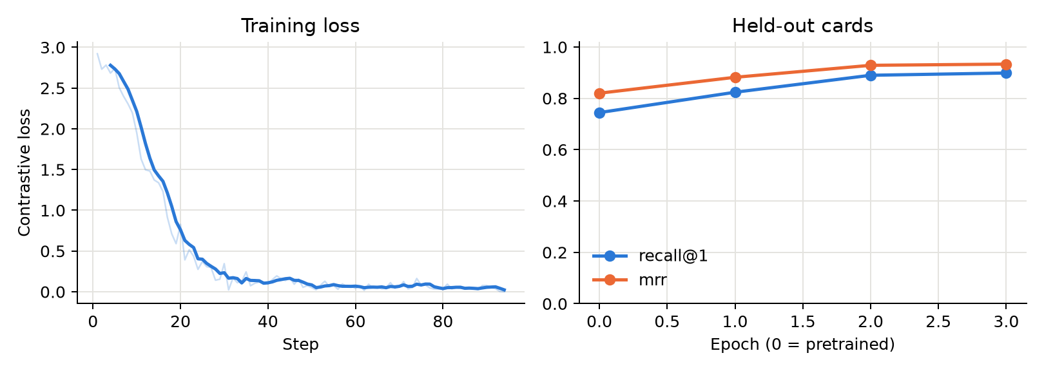
Figure 2. Contrastive loss falls from 2.9 to about 0.06 over 93 steps (about 3 minutes). On the 56 held-out cards, Recall@1 rises from 74.4% to 89.9%, Recall@5 from 90.3% to 96.9% and MRR from 0.820 to 0.933.
The benchmark tells a different story. All five slots that fine-tuned E5 misses are schema or domain cards, never entities; pretrained E5 finds four of them. 96% of the training pairs are short place or party queries, so the model learned to favour entity cards over the table and rule cards that complete questions also need. The synthetic held-out set measures entity lookup, not this balance. A class-balanced pair mix, tuned on development questions, is the next experiment; B2-FT was not used for SQL generation.
Coverage did not predict accuracy. BM25 had the least complete context yet the highest SQL-result accuracy. Its six incomplete contexts lacked a view card (four questions), the INDEPENDANT party card or the data-scope rule, and the model answered all six correctly, probably helped by the shared instructions and examples. A's errors instead involved place names absent from its context.

6 Generation results

SQL accuracy and task success
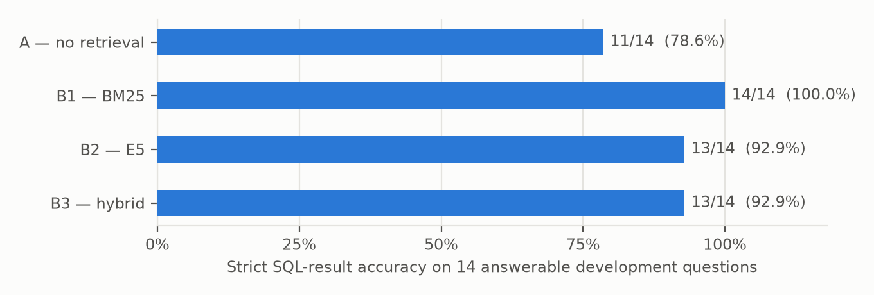
Figure 3. Strict SQL-result accuracy: a correct executed result on an answerable question, checked by value, tolerance and ordering rather than SQL wording. Claude Haiku 4.5, one run per condition.
Condition | SQL-result accuracy | Task success (of 18) [95% CI] | Non-answers correct
A — no retrieval | 11 / 14 (78.6%) | 15 (83.3%) [60.8, 94.2] | 4 / 4
B1 — BM25 | 14 / 14 (100%) | 18 (100%) [82.4, 100] | 4 / 4
B2 — E5 | 13 / 14 (92.9%) | 17 (94.4%) [74.2, 99.0] | 4 / 4
B3 — hybrid | 13 / 14 (92.9%) | 17 (94.4%) [74.2, 99.0] | 4 / 4

Table 2. Task success accepts a correct result or the prescribed clarification/abstention. Intervals are Wilson 95% intervals. Every generated query executed; no condition answered an unsupported question.
Comparison with A | Wins | Losses | Exact McNemar p
B1 — BM25 | 3 | 0 | 0.25
B2 — E5 | 2 | 0 | 0.50
B3 — hybrid | 3 | 1 | 0.625

Table 3. Paired strict SQL-result accuracy on the same 14 questions. A win means only the RAG condition was correct. p-values are two-sided and unadjusted for three comparisons.

Every error inspected
- Bouaké winner, dev-001, A: filtered on 'BOUAKÉ'; the source writes BOUAKE, so the query returned no rows. All RAG conditions were correct.
- San-Pédro results, dev-011, A: filtered on 'SAN-PEDRO'; the source writes SAN PEDRO, so no rows. B1 and B3 were correct.
- San-Pédro results, dev-011, B2: the name filter also matched a second constituency (173), returning 16 rows instead of 9, although the context was complete.
- Yamoussoukro source page, dev-019, A: a loose name match with LIMIT 1 selected constituency 052 and page 9 instead of 053 and page 10.
- RHDP vote share, dev-010, B3: a malformed aggregation returned the INDEPENDANT row with 0%, despite complete context.
All three A errors occurred with incomplete context; both RAG errors occurred with complete context and are generation errors.

Operational measures
- Calls: 73 provider calls for 72 trials. One request timed out and succeeded on retry; no SQL repair was needed.
- Tokens: mean input 4,516 for A versus 2,644–3,044 for RAG; mean output 84–87 tokens. Totals: 237,673 input and 6,129 output tokens.
- Cost: about USD 0.27, estimated from Anthropic list prices of USD 1 / 5 per million input/output tokens, not from an invoice.
- Latency: median 1.7–1.9 s per trial, including retrieval and SQL execution.
Before the live run, a scripted generator returning reference answers passed all 72 trials, confirming the evaluator and database integration.

7 Discussion and short conclusion

Meaning of the findings
RAG was numerically more accurate than A in all three variants, but the evidence is not conclusive. With 14 answerable questions, one question changes accuracy by about 7 points, and every confidence interval and paired test is compatible with no difference.
The error analysis is more informative than the totals. A failed where exact place spellings mattered, precisely what entity cards supply. RAG also sent 32.6–41.5% fewer input tokens than A. Complete context was not sufficient, however: both RAG errors were semantic mistakes made with every required card present.

What worked and what did not
- Worked: all 72 trials completed and scored; every generated query executed; all ambiguous and unsupported questions received the prescribed non-answer.
- Retrieval: E5 gives the most complete context, but BM25's exact place labels were enough for the highest accuracy on this sample.
- Unexpected: coverage ranking (E5 > hybrid > BM25) did not match accuracy ranking (BM25 > E5 = hybrid).
- Did not transfer: fine-tuning improved synthetic held-out retrieval but reduced benchmark coverage, because the training pairs over-represent entity lookups.
- Data lesson: matching totals and reproducible extraction can coexist with ambiguous regional assignments. Source interpretation must precede scoring.

Limitations
- Development data: these 18 questions were inspected during development; they are not held-out findings.
- Draft benchmark: automated checks cannot replace independent review. Labels and acceptable evidence may be incomplete.
- Small sample and one run: 14 answerable questions, one repetition; temperature 0 does not guarantee identical repeated outputs.
- One generator: results describe Claude Haiku 4.5, not the originally configured Gemini model or other models.
- Context design: A supplies 19 fixed cards; RAG uses up to 11 selected cards with entities. The difference combines selection, content and context size.
- Training data: synthetic template queries, dominated by entity lookups; one fine-tuning configuration and seed.
- Scope: one election snapshot, unresolved regional ambiguity and one encoder family. Adaptive search is not evaluated.

Improvements with more time
1. Resolve the source ambiguity and independently review reference SQL, answerability and evidence labels; then freeze the test set.
2. Run the 60 held-out questions with repeated inference and paired uncertainty estimates.
3. Replicate with a second generator, such as the configured Gemini model, to test whether the pattern holds.
4. Rebalance fine-tuning pairs across schema, domain and entity cards, select the mix on development questions, then test B2-FT in generation.
5. Isolate card count, domain rules and entity information through controlled ablations; then consider reranking or adaptive search.

Conclusion
The project delivers an electoral assistant and a reproducible comparison framework, now with real generated SQL. On the development questions, all three RAG variants answered more questions correctly than text-to-SQL without retrieval, and A's failures were place-name errors that retrieval addresses. The sample is too small to establish a significant benefit; the held-out evaluation must confirm it.

Appendix Terms references and reproducibility

Short glossary
Term | Meaning in this project
Text to SQL | Convert a natural-language question into a database query
LLM and inference | Large language model; inference uses existing weights to generate output
RAG | Retrieve external context before asking the model to generate
Corpus and card | Complete reference collection; one short reference document
Schema domain and entity | Database structure; calculation rules; places or party labels
Embedding and encoder | Numerical text representation; model that computes it
Baseline and ablation | Reference approach; controlled change/removal of a component
Gold result | Expected reference answer used for scoring; still needs validation
Abstention and clarification | State that data cannot answer; ask the user to resolve ambiguity
McNemar test | Paired test that uses only questions where exactly one condition is correct

References
[1] Robertson, S. and Zaragoza, H. (2009). The Probabilistic Relevance Framework: BM25 and Beyond. Foundations and Trends in Information Retrieval, 3(4), 333-389. https://doi.org/10.1561/1500000019
[2] Wang, L. et al. (2024). Multilingual E5 Text Embeddings: A Technical Report. https://arxiv.org/abs/2402.05672
[3] Cormack, G. V., Clarke, C. L. A. and Büttcher, S. (2009). Reciprocal Rank Fusion Outperforms Condorcet and Individual Rank Learning Methods. SIGIR. https://cormack.uwaterloo.ca/cormack/cormacksigir09-rrf.pdf
[4] Anthropic. Claude models overview and pricing. https://docs.anthropic.com/en/docs/about-claude/models

Reproducibility and supplementary material
Stage | Command | Outputs
1 EDA | python -m src.pipeline.eda | outputs/eda
2 Preprocessing | python -m src.pipeline.preprocess | dataset/, outputs/preprocessing
3 Training | python -m src.pipeline.train | models/, outputs/training
4 Evaluation | python -m src.pipeline.evaluate | experiments/, outputs/evaluation

- Settings: configs/core.json, configs/text_to_sql_comparison.json (protocol) and configs/training.json; pinned requirements.txt and requirements.lock.
- Evidence: pre-run audit in experiments/preflight; generation run experiments/runs/text-to-sql-comparison-haiku-20260930 (live with --provider claude, ANTHROPIC_MODEL=claude-haiku-4-5, --max-calls 300).
- Environment: Python 3.14.4, macOS arm64; E5 intfloat/multilingual-e5-small revision 614241f622f53c4eeff9890bdc4f31cfecc418b3; manifests record library versions and hashes.
The app and evaluator share the context builder and SQL pipeline. AI assistants supported implementation and writing; findings are tied to saved traces and explicit scoring rules.

