Title: Proximity to Pesticide-Intensive Floriculture Spray Sites and Neurobehavioral Performance: A Longitudinal Analysis from Childhood to Adolescence in Ecuador

Authors: Kayser, G.L.ª, Zhang, J.ª, Calderón-Villarreal A.ª, Wei, J.ª, Chronister, B.N.C.ª, Checkoway, H.ª, Suarez-Torres, J. ^{b}, De La Cruz, F. ^{b}, Suarez-Lopez, J.R. ª

Author Affiliations:
ª Herbert Wertheim School of Public Health and Human Longevity, University of California, San Diego, United States
^{b} Fundación Cimas del Ecuador, Quito, Ecuador

Prepared for: BMC Environmental Health (fast turnaround) or Environmental Research

Abstract
Background: Children of agricultural workers have increased risk of pesticide exposure. Off-target pesticide drift plays an important role in pesticide exposures for families living near pesticide-spray sites. Exposure to pesticides during early childhood can affect neurodevelopment. In Pedro Moncayo County, Ecuador, regular use of insecticides, fungicides, and herbicides, has been documented, making children of agricultural families and those living in proximity to floriculture highly susceptible to pesticide exposure. This study aims to tests associations of residential proximity to pesticide-intensive floricultural crops with neurobehavior assessed longitudinally from childhood through adolescence.

Methods: We examined participants from the ESPINA study living in agricultural settings in Ecuador at three time periods - Visit 1: July-August 2008 (4-9-year-olds), Visit 2: April 2016 (11-17-year-olds), and Visit 3: July-October 2016 (11-17-year-olds). Neurobehavioral performance was evaluated using the NEPSY-II across all time periods. Distance between participants’ households and the nearest floricultural crop, and total surface area of floricultural crops near homes were calculated. Associations were tested using generalized estimating equation models.

Results: We included XXX observations of 629 children examined across the 3 time periods. Average distance from nearest plantation was 441.8m (±348.3m), 508.8m (±630.8m) and 566.9m (±803.6m) in time 1, 2, and 3 respectively. Most participants lived within 500m of a crop: Visit 1 (62.6%), Visit 2 (61.8%), and Visit 3 (63.6%). Across the three visits, NEPSY-II scores mean (SD) ranged from 5.9 (3.0) to 10.7 (4.9). Increasing floriculture distance between participant’s homes and floricultural crop was associated with higher performance on the domains of Attention/Inhibitory Control, Language, and Memory/Learning. Concurring with these findings, all crop areas within 100-500m buffers around homes were associated with lower Attention/Inhibitory Control domain scores. For instance, doubling crop areas within 300m was associated with lower scores by -0.026 (CI: -0.045, -0.007; p = 0.0064).

Conclusions: Residential proximity to floricultural crops was associated with lower neurobehavioral performance in some domains in longitudinal analysis. These findings suggest that off target pesticide drift from crops may affect neurobehavioral performance of children living nearby, in tasks related to impulsivity and cognitive flexibility, understanding complex verbal instructions, and challenges with verbal-visual associative learning among children and adolescents.

Key words (1-7): neurodevelopment, children, Attention, Inhibition, Memory, Learning

Highlights (3 to 5 bullet points, each a maximum of 85 characters, including spaces):

- Introduction

Children of agricultural workers have increased risk of pesticide exposure not only through direct contact but also through off-target drift from agricultural crops to residential homes (Coronado et al., 2011; Hyland & Laribi, 2017; Lu et al., 2000; Simcox et al., 1995; Suárez-López et al., 2020; Ward et al., 2006). Studies indicate that off-target pesticide drift plays an important role in pesticide exposures for families living near pesticide-spray sites (Coronado et al., 2011; Ward et al., 2006). For example, children living within 60-275 m of agricultural sites had lower acetylcholinesterase (AChE) activity, an enzyme inhibited by organophosphate (OP) insecticides, and higher urinary pesticide biomarkers and pesticide levels within their house dust (Bradman et al., 2011; Lu et al., 2000). (Suarez-Lopez et al., 2020)

Exposure to certain insecticides including organophosphates (OPs), carbamates, organochlorines (OCs), neonicotinoids (NEOs), and pyrethroids, as well as fungicides and herbicides during early childhood, may have adverse effects on neurodevelopment (Dórea, 2021; Sapbamrer & Hongsibsong, 2019). Children are more susceptible to the neurotoxic effects of pesticide exposure than adults due to their higher intake of air, food, and water relative to body weight, their proximity to the ground, and exploratory behaviors (Gary et al., 2004) (Eskenazi et al., 2007). Associations between pesticide exposure with neurobehavioral performance has primarily been observed for attention, motor function and inhibition domains (Burns et al., 2013; Eskenazi et al., 2007; Ismail et al., 2017; Marks et al., 2010; Muñoz-Quezada et al., 2013; Rosas & Eskenazi, 2008; Sánchez Lizardi et al., 2008; Shelton et al., 2014; Suarez-Lopez et al., 2013; Wagner-Schuman et al., 2015). A review of studies examining the association between pyrethroid exposure and neurobehavioral, neuromotor, and neurocognitive functions in agricultural workers and their children found that eight out of twelve studies reported adverse effects, particularly in the domains of attention, processing speed (related to hand-eye coordination), and motor coordination (Lucero & Muñoz-Quezada, 2021).
OPs are used extensively in agriculture. Studies of animals and adult humans suggest OPs are neurodevelopmental toxicants (González-Alzaga et al., 2014). A cohort study of Latino farmworker families in the Salinas Valley of California, found emotional and behavioral problems in childhood after prenatal exposure to OPs (Hyland et al., 2021). Dialkylphosphate (DAP) metabolites, a proxy measure for cumulative exposure to OP pesticides, was found to be negatively associated with mental development indices (Eskenazi et al.,2007). Pre- and postnatal DAPs were associated with risk of pervasive developmental disorder at 24 months of age (Eskenazi et al., 2007). Geospatial analyses in the same population found that children’s IQ scores decreased with increasing use of OP within 1 km of maternal residence during pregnancy (Gunier, Bradman, Harley, Kogut, et al., 2017). Results from a study on organophosphate (OP) pesticide exposure in Latino children living in orchard communities in the Pacific Northwest of the United States suggest that greater OP exposure in children who grow up with an agricultural worker was associated with less improvement over time in neurobehavioral performance on motor function compared to non-agricultural children with lower OP exposure, measured in household dust samples (Butler-Dawson et al., 2016). Lastly, children who had been hospitalized due to a single acute OP pesticide poisoning during infancy showed deficits in inhibitory control compared to children with no OP poisoning events (Kofman et al., 2006). Inhibitory control is the ability to purposely inhibit a prepotent response that will not have valuable results and release another response on cue (e.g. think before acting) (Kang et al., 2022).

Pedro Moncayo County, Ecuador is an agricultural region characterized by intensive floriculture and high densities of rose plantations. Regular use of insecticides (organophosphates, neonicotinoids, and pyrethroids) and fungicides (quinone outside inhibitors, azoles, and dithiocarbamates) has been documented, making children from agricultural families and those residing near floricultural operations highly susceptible to pesticide exposure (Grandjean et al., 2006; Handal et al., 2016; Harari, 2004; Suarez-Lopez et al., 2017, 2018). In the study of Secondary Exposures to Pesticides among Children and Adolescents (ESPINA: Estudio de la Exposición Secundaria a Plaguicidas en Niños y Adolescentes) conducted in Pedro Moncayo, children living within 275m from floricultural crops had lower AChE activity compared to those living farther away (Suarez-Lopez et al., 2018). This finding suggested that off-target drift of organophosphate and carbamate insecticides from floricultural fields to nearby homes was sufficient to suppress AChE activity. Reduced AChE activity is indicative of greater exposure to cholinesterase-inhibiting pesticides, such as organophosphates and carbamates. Prior studies have also found an association between AChE activity and mental health processes, where lower AChE activity was associated with neurodevelopmental deficits in attention, inhibition and memory in boys (Suarez-Lopez et al., 2013), and greater depression symptoms in girls (Suarez-Lopez et al., 2019; Suarez-Lopez et al., 2021).
In a recent cross-sectional analysis of 307 Ecuadorian children from the ESPINA study (Friedman et al., 2020), we found that residential proximity to floricultural crops within 50 or 100 meters was associated with poorer neurobehavioral performance in the domains of Attention/Inhibitory Control, Language, and Memory/Learning, compared to children living more than 500 meters away (Friedman et al., 2020). For every 100m closer to residential proximity to floriculture, the odds of a lower overall neurobehavioral score increased by 10%, odds of a lower Language score increased by 9% and odds of lower Memory/Learning score increased by 24%. However, it remains unclear whether these associations are sustained over time, particularly as children transition from childhood into adolescence
Based on our prior work, we hypothesized that inverse associations between residential proximity to floricultural farmland is associated with lower neurobehavioral performance in both childhood and adolescence. Longitudinal studies assessing residential proximity to flower plantation and crops on children’s neurobehavioral performance is needed to understand chronic effects of pesticide exposure and to inform policy on how far away agricultural pesticide spray sites should be stationed from residential homes and schools.

- Methods

2.1 Study design
We examined participants longitudinally from the ESPINA study on three different time periods: Visit 1: July-August 2008 (N = 313, 4-9-year-olds); Visit 2: April 2016 (N = 330, 12-17-year-olds); and Visit 3: July-October 2016 (N = 535, 12-17-year-olds). Neurobehavioral performance assessments were administered to participants across all three time periods.
Participants were recruited for the ESPINA study in 2008 from 922 children who participated in the 2004 Survey of Access and Demand of Health Services in Pedro Moncayo County, and other parents and children living in Pedro Moncayo recruited by community announcements and word of mouth. Pedro Moncayo is a floriculture region of Ecuador where roses are grown for export and where approximately 21% of the adult population works in the flower industry (Suarez-Lopez et al., 2019). At baseline in 2008, the cohort was recruited to achieve an approximately equal distribution of children who did (exposed group) and did not (unexposed group) live with an agricultural or floricultural worker. Of the 313 participants, 179 (57.2%) cohabitated with such a worker, while 134 (42.8%) did not. Children were selected after their parents completed a pre-survey to confirm eligibility based on inclusion criteria. In the exposed group, children were required to have cohabitated with a floricultural worker for at least one year. In contrast, children in the unexposed group must have never cohabitated with a floricultural worker, had no direct contact with pesticides, and not lived in a household where pesticides were stored. Informed consent was obtained from participating adults, parental permission was secured for selected children, and assent was obtained from minors aged 7 years and older. Further recruitment details can be found in Suarez-Lopez et al. (2012).

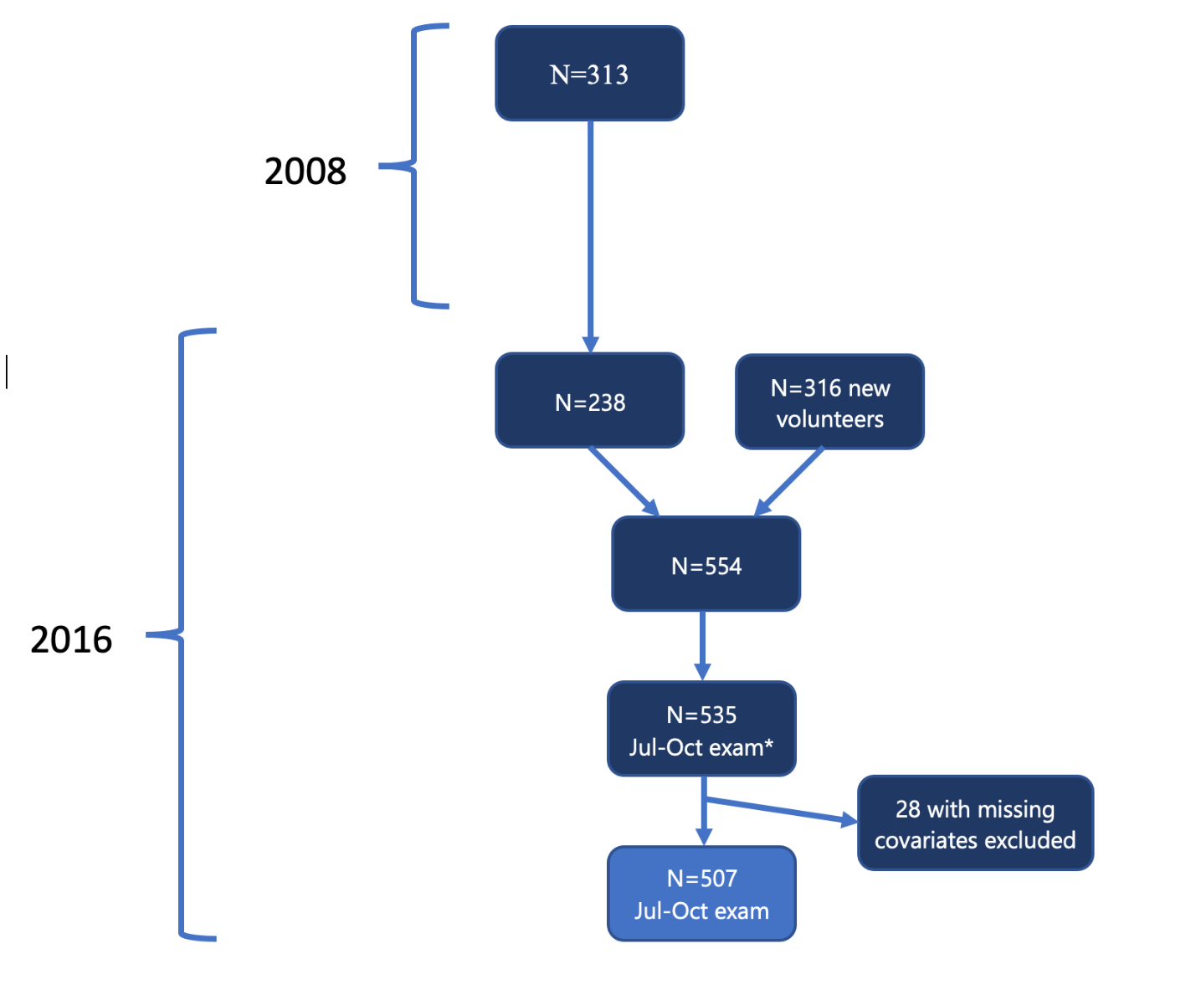
Figure 1. Participant flow chart

2.3 Survey Collection
Survey data were collected with parents to document demographic, occupational, and SES data. Examiners were blinded to participants' pesticide exposure status.

Height was also measured to the nearest 1 mm, using a height board, and following recommended procedures (World Health Organization (WHO). 2008), and weight was measured using a digital scale (Tanita model 0108 MC; Corporation of America, Arlington Heights, IL, USA). We calculated hHeight-for-age z score (z-height-for-age) and body-mass-index-for-age z score (z-BMI-for-age) was calculated using the WHO growth standards (WHO, 2006).

2.4. Neurobehavioral Performance
Neurobehavioral performance was assessed using tests from NEPSY-II (NCS Pearson, San Antonio, TX), a standardized and validated neurodevelopment test for children three to 16 years old (Korkman et al., 2013; Korkman et al., 2007). NEPSY-II provides the ability to assess underlying impaired performance both within and across functional domains. Children were tested accordingly to 12 age-appropriate subtests in five content domains: 1) Attention/Inhibitory Control (subtests: auditory attention and response set, and inhibition), 2) Language (subtests: comprehension of instructions and speed naming), 3) Memory/Learning (subtests: memory for faces immediate and memory for faces delayed), 4) Visuospatial Processing (subtest: design copying and geometric puzzles) and 5) Social Perception (subtest: affect recognition) (Table 1).

Table 1. Selected Tests from NEPSY-II Taken at Three Time Periods: Summer 2008, Spring and Summer 2016
Content Domains | Subtest | Subsets Tested | A:  Jul–Aug 2008 | B:  Apr 2016 | C:  Jul–Oct 2016
Attention/  Inhibitory Control | Auditory Attention and Response Set | 1) Auditory attention combined (AAC) | X | X | X
Attention/  Inhibitory Control | Auditory Attention and Response Set | 2) Response set combined (RSC) | X | X | X
Attention/  Inhibitory Control | Inhibition | 3) Inhibition-inhibition combined (IIC) | X | X | X
Attention/  Inhibitory Control | Inhibition | 4) Inhibition-naming combined (INC) | X | X | X
Attention/  Inhibitory Control | Inhibition | 5) Inhibition-switching combined (ISC) | X | X | X
Language | Comprehension of Instructions | 6) Comprehension of instructions total score (CITS) | X |  | X
Language | Speeded Naming | 7) Speeded naming combined (SNC) | X |  | X
Memory/Learning | Memory for Faces Immediate | 8) Memory for faces total score (MFFS) | X |  | X
Memory/Learning | Memory for Faces Delayed | 9) Memory for faces delayed total score (MFFDTS) | X |  | X
Memory/Learning | Narrative Memory | N/A
Visuospatial Processing | Design Copying | 10) Design copying process total score (DCGTS) | X |  | X
Visuospatial Processing | Geometric Puzzles | 11) Geometric puzzles total score (GPTS) | X |  | X
Sensorimotor | Visuospatial Processing | N/A
Sensorimotor | Visuomotor Precision | N/A
Social Perception | Affect Recognition | 12) Affect recognition total score (ARTS) |  |  | X

For your reference, this is how we calculate the domain scores (sas code but the logic is understandable);

a_nepsy_aac_rsc= mean(a_nepsy_aac, a_nepsy_rsc);
a_nepsy_iic_isc= mean(a_nepsy_iic, a_nepsy_isc);
a_nepsy_d_attnexec= mean(a_nepsy_aac_rsc, a_nepsy_iic_isc, a_st_ss);
a_nepsy_d_language= mean(a_nepsy_cits, a_nepsy_snc);
a_nepsy_d_memlearn= mean(a_nepsy_mffts, a_nepsy_mffdts, a_nepsy_nmfcr);
a_nepsy_d_visuospat= mean(a_nepsy_dcgts, a_nepsy_gpts);
a_nepsy_d_sensorimotor=mean (a_nepsy_vp_ss);
a_nepsy_totalneuro=mean(a_nepsy_d_attnexec, a_nepsy_d_language, a_nepsy_d_memlearn, a_nepsy_d_visuospat, a_nepsy_d_sensorimotor);

b_nepsy_aac_rsc= mean(b_nepsy_aac, b_nepsy_rsc);
b_nepsy_iic_isc= mean(b_nepsy_iic, b_nepsy_isc);
b_nepsy_d_attnexec= mean(b_nepsy_aac_rsc, b_nepsy_iic_isc);

c_nepsy_aac_rsc= mean(c_nepsy_aac, c_nepsy_rsc);
c_nepsy_iic_isc= mean(c_nepsy_iic, c_nepsy_isc);
c_nepsy_d_attnexec= mean(c_nepsy_aac_rsc, c_nepsy_iic_isc);
c_nepsy_d_language= mean(c_nepsy_cits, c_nepsy_snc);
c_nepsy_d_memlearn= mean(c_nepsy_mffts, c_nepsy_mffdts);
c_nepsy_d_visuospat= mean(c_nepsy_dcgts, c_nepsy_gpts);
c_nepsy_d_socialper= c_nepsy_arts;
c_nepsy_totalneuro=mean(c_nepsy_d_attnexec, c_nepsy_d_language, c_nepsy_d_memlearn, c_nepsy_d_visuospat, c_nepsy_d_socialper);

Attention/Inhibitory Control included the subset of ‘auditory attention combined’ (AAC) and ‘response set combined’ (RSC), and ‘inhibition’. AAC assesses selective auditory attention and the ability to sustain it and RSC assesses the ability to shift attention while selectively responding to auditory target words. Participants listened to a series of words and point to appropriate circles when they hear a target word. “Combined” indicates that two or more measures within the subtest were combined to create a total score. Inhibition test assesses the ability to inhibit automatic responses in favor of novel responses and the ability to switch between response types. Inhibition is split into three parts: ‘inhibition-inhibition combined’ (IIC), ‘inhibition-naming combined (INC) and ‘inhibition-switching combined (ISC). The test has two items: Shapes or Arrows. If participants are given pictures of shapes (circle or square), INC refers to the ability to name the shapes accurately; IIC is naming the circle as a square and the square as circle; ISC is naming black shapes the accurate shape type and naming white shapes the other shape type (ex: black square should be named “square”, white circle should be named “square”). Inhibition subsets were also reported as the average of IIC, INC and ISC subsets (Korkman et al., 2013; Korkman et al., 2007).
Language included the subsets of ‘comprehension of instructions total score’ (CITS) and ‘speeded naming combined’ (SNC). CITS assesses the ability to perceive, process and execute oral instructions with increasing syntactic complexity. The participant pointed to appropriate stimuli in response to oral instructions. SNC is a timed subtest that assesses the participants rapid semantic access to and production of names of colors, shapes, sizes or numbers. Participants are given an array of colors and shapes, and they name them in order as fast as possible.
Memory/Learning included the subsets of ‘memory for faces immediate total score’ (MFFS) and ‘memory for faces delayed total score’ (MFFDTS). MFFS assesses encoding of facial features and face discrimination and recognition. Participants look at a series of faces and then given three photographs at a time, from which they pick pictures of faces they have previously seen. MFFDTS assesses long-term memory for faces using delayed tasks.
Visuospatial Processing included the ‘design copying total score’ (DCGTS) and ‘geometric puzzle total score (GPTS) subsets. DCGTS assesses motor and visual-perceptual skills through the ability to copy drawings of two-dimensional geometric figures. GPTS assesses mental rotation, visuospatial analysis, and attention to ana lysanalysis. Participants are presented with a grid containing different shapes and must match shapes from outside the grid to shapes within the grid.
Social Perception included the subset of ‘affect recognition total score’ (ARTS), which assesses the ability to recognize affect (happy, sad, anger, fear, disgust or neutral) from photos of faces (Korkman et al., 2013; Korkman et al., 2007; Miller, 2015).
Tests were translated into Spanish when needed. It should be noted that translation of NEPSY-II is relatively unaffected by language (Gunier, Bradman, Harley, Kogut, et al., 2017). Evaluations were conducted by trained examiners in a controlled and quiet setting and most assessments lasted less than 2 hours. A parent of the child was allowed to attend in the evaluation room upon request, but were asked to remain silent and not in-sight of participant. Specific descriptions of the NEPSY-II test, and assessment processes have been previously described in Korkman et al., 2007, 2013, Suarez-Lopez et al., 2013 and Suarez-Lopez et al., 2017 (Korkman et al., 2013; Korkman et al., 2007; Suarez-Lopez et al., 2013, 2017). Subtest scaled scores were calculated using the NEPSY-II scoring assistant software (NCS Pearson Inc., San Antonio, TX). The scaled scores range from 1 to 19 (mean=10, SD=3). A higher score on the NEPSY-II indicates better neurobehavioral performance, where scores 13 to 19 is “above expected”, 8 to 12 is “at expected”, 6 to 7 is “borderline” and less than 6 is “below expected” (Korkman † et al., 2013; Korkman et al., 2007). Averages of subtest scores were used for subtests that comprise of more than one primary scaled score (such as inhibition), while scores were combined for subtests with either correct and error components (such as auditory attention and response) or time and error components (such as speed naming). The total neurobehavioral score was calculated as the average of primary scores for all 12 subtests. To reduce the number of tested associations and type 1 errors, the domain score and total neurobehavioral score were used as primary measures of neurobehavioral performance.

2.4 Geographical variables
To assess the proximity of children’s homes to the nearest floricultural crops, geographic coordinates of residences in Pedro Moncayo County were collected using portable GPS receivers as part of the Fundación Cimas del Ecuador's System of Local and Community Information (Sistema de Información Local y Comunitario [SILC]). Floriculture plantation boundaries were delineated as polygons using satellite imagery (Suarez-Lopez et al., 2018). The distance between each participant’s home and the nearest plantation edge was calculated using ArcGIS 9.3 (Esri, Redlands, CA). To calculate greenhouse areas near homes, we determined the total surface area (in m²) of floricultural greenhouses within buffers of (100 m, 150 m, 200 m, 300 m, and 500 m) around children’s homes using ArcGIS.

2.5 Other Covariables
Demographic variables included age, ethnicity (Indigenous, Mestizo, White, and other), parental education in years and cohabitating with an agricultural or floricultural worker. Days after Mother’s Day harvest was also collected, as the period prior to the Mother’s Day harvest is a peak pesticide spray period. Socioeconomic status, demographic characteristics, health, and pesticide exposures of household members were obtained from household surveys conducted with the children’s parents or adult residents of their household.

2.6 Statistical Analysis
Descriptive statistics for covariates and NEPSY-II scores for each visit are presented with the mean and standard deviation (SD) for continuous variables or counts and percentages for categorical variables (Table 2). We then reported the same descriptive statistics after stratifying by quartiles of home distance to the nearest floricultural field (Table 3). Furthermore, we conducted an analysis of variance (ANOVA) test or chi-squared goodness-of-fit test for continuous and categorical covariates respectively to investigate the associations between home distance quartile with the NEPSY-II scores. We also produced an identical table for the NEPSY-II scores (Supplementary Table 1). We modeled the association between NEPSY-II scores and various measures of pesticide exposure with a generalized estimating equation generalized linear model (GEEGLM) with an exchangeable covariance structure. Measurements of pesticide exposure included distance from household to nearest plantation and area of plantation within a given radius ranging from 50 m to 1000 m, all of which were log-normalized. Log refers to natural log throughout this paper. Each model also included the following covariates: age, race, gender, time period of NEPSY-II assessment, days after Mother’s Day harvest, age-for-height z-score (zha), parental salary, parental education, and cohabitation with an agricultural worker. For each GEEGLM model, observations with any missing values were dropped. Distance and area variables were log-transformed, so to interpret their effects, the GEEGLM β coefficients were multiplied by log(2). The model estimates the additive effects of neurobehavioral outcomes due to doubling the respective distance or area variable. For each time point, we performed ANOVA tests to identify preliminary associations between distance from residency to nearest plantation quantiles with each NEPSY-II score.

We performed additional analyses to gain further insights into NEPSY-II score trend nuances. One such analysis is GEEGLMs with binarized NEPSY-II score outcomes. The binary thresholds that determine high versus low NEPSY-II scores were pre-selected for each score. In this model, the GEEGLM had a logit link function and exchangeable covariance structure. Similar to the aforementioned GEEGLM model, β coefficients are multiplied by log(2), which are then interpreted as the additive effects of the odds ratio of a high NEPSY-II score due to doubling the respective pesticide exposure variable. We also estimated least-square means differences by adjusting subjects by their measurements of pesticide exposure. These values were then plotted using locally weighted polynomial regression (LOESS) curves to graph associations between pesticide exposure variables and the NEPSY-II domain scores. Throughout our analysis, we define a statistically significant association with a p-value < 0.05. All analysis were preformed using R 4.1.1 statistical programming software.

2.7 Ethical Approval
The ESPINA study was approved by the Institutional Review Boards of the University of Minnesota, The University of California San Diego, Universidad San Francisco de Quito, and approved by the Ministry of Public Health of Ecuador and the Commonwealth of Rural Parishes of Pedro Moncayo County, Ecuador.

- Results

3.1 Summary Statistics

Of the 629 children included in this study, 50% (N=313) were examined in Summer 2008 (visit #1), 52% (N=330) in Spring 2016 (visit #2), and 85% (n=535) in Summer 2016 (visit #3) (Table 2). The mean age of participants was 6.6 years old (±1.6) for visit #1, 14.3 years old (±1.8) for visit #2 and 14.5 years old (±1.8) for visit #3. Most participants identified as mestizo in all time points and approximately half of participants were female. The mean z-score-height-for-age was -1.3 (1.0) for visit #1, -1.6 (1.0) for visit #2, and -1.5 (0.9) for visit #3. Participants cohabitating with an agricultural worker was reported by 57% in visit #1, 68% in visit #2, and 68% in visit #3.

The average residential distance to the nearest floricultural greenhouse was 442m (±348m), 509m (±631m) and 567m (±804m) in Summer 2008, and Spring and Summer 2016 respectively. Approximately 63% of the cohort at the three time points had floricultural greenhouses within 500 m of their homes. Scores of Attention/Inhibitory Control, Language, Visuospatial Processing and Social Perception are described by visit in Table 2. In Summer 2008 and 2016, below expected NEPSY scores were reported in Language and Inhibition, while expected scores (8-12) were reported in many of the other categories (Table 2). NEPSY-II subscale scores by residential proximity and visit time are described in Supplementary Table 1.

In our data analysis, we found that distance from residency to nearest plantation was associated with a few covariates such as days after Mother’s Day harvest in all time periods, Indigenous children in Spring and Summer 2016, scaled salary in Summer 2008, parental average education in Summer 2008 and cohabitating with an agricultural worker in Spring 2016 (Table 3).

3.2 Associations

.

In our longitudinal analyses, statistically significant associations were found between our pesticide exposure constructs with Inhibition-Inhibition Combined, Inhibition-Switching Combined, Inhibition subdomain, and the Attention/Inhibitory Control domain (Figure 2 and Supplementary Table 1). The 95% confidence intervals for the association between distance or crop areas and these neurobehavioral scores are shown in Figure 1.

Table 2: Participant characteristics by visit
Variable | Visit 1 (Summer 2008)  (n=313) | Visit 2 (Spring 2016)  (n=330) | Visit 3 (Summer 2016)  (n=535)
Age in years, mean (SD) | 6.6 (1.6) | 14.3 (1.8) | 14.5 (1.8)
Race, N (%)
Indigenous | 66 (21.1) | 78 (23.6) | 115 (21.5)
Mestizo | 247 (78.9) | 225 (76.4) | 420 (78.5)
Sex, N (%)
Female | 154 (49.2) | 162 (49.1) | 272 (50.8)
Male | 159 (50.8) | 168 (50.9) | 263 (49.2)
Days after Mother's Day harvest, mean (SD) | 84.5 (10.9) | -12.7 (5.5) | 102.3 (18.6)
Z-score-height-for-age, mean (SD) | -1.3 (1.0) | -1.6 (1.0) | -1.5 (0.9)
Parental average education (years), mean (SD) | 7.6 (3.7) | 8.2 (3.6) | 8.1 (3.4)
Cohabitation with an agricultural worker, n (%) | 179 (57.2) | 223 (68.2) | 360 (67.5)
Distance from household to the nearest plantation (meters), mean (SD) | 441.8 (348.3) | 508.8 (630.8) | 566.9 (803.6)
Non-zero crop area within a certain radius (m²), N (%)
50m | 18 (5.8) | 29 (8.8) | 55 (10.3)
100m | 43 (13.9) | 72 (21.8) | 117 (21.9)
150m | 60 (19.4) | 106 (32.1) | 181 (33.8)
200m | 84 (27.1) | 133 (40.3) | 216 (40.4)
300m | 135 (43.5) | 163 (49.4) | 263 (49.2)
500m | 194 (62.6) | 204 (61.8) | 340 (63.6)
1000m | 279 (90.0) | 289 (87.6) | 461 (86.2)
NEPSY-II Overall score, mean (SD) | 7.9 (1.9) | 7.7 (2.0) | 8.0 (1.5)
Attention/Inhibitory Control, mean (SD) | 7.8 (2.2) | 8.0 (2.1) | 8.4 (2.2)
Auditory attention combined (AAC) | 8.2 (3.4) | 8.5 (3.8) | 9.6 (3.4)
Response set combined (RSC) | 8.8 (3.2) | 9.4 (3.0) | 9.7 (2.8)
Inhibition-inhibition combined (IIC) | 7.1 (3.1) | 6.6 (3.2) | 6.8 (3.2)
Inhibition-naming combined (INC) | 7.1 (3.7) | 6.3 (2.8) | 6.5 (3.0)
Inhibition-switching combined (ISC) | 7.0 (2.6) | 7.5 (2.7) | 7.5 (3.2)
Language | 6.6 (2.4) | NA | 7.0 (2.0)
Comprehension of instruction total score (CITS) | 7.3 (2.9) | NA | 6.3 (2.6)
Speed naming combined (SNC) | 5.9 (3.0) | NA | 7.7 (2.9)
Memory/Learning | 8.1 (2.3) | NA | 8.3 (2.3)
Memory for faces total score (MFFTS) | 7.4 (2.8) | NA | 8.2 (2.7)
Memory for faces delayed total score (MFFDTS) | 8.7 (3.0) | NA | 8.4 (2.8)
Visuospatial Processing | 9.6 (3.1) | NA | 8.7 (2.3)
Design copying process total score (DCGTS) | 10.7 (4.9) | NA | 9.5 (3.6)
Geometric puzzles total score (GPTS) | 8.6 (3.2) | NA | 7.8 (2.4)
Social Perception | NA | NA | 8.2 (2.3)
Affect recognition total score (ARTS) | NA | NA | 8.2 (2.3)
For NEPSY-II, scores have the following classification label. 13-19 is above expected, 8-12 is at expected, 6-7 is slightly below expected, 4-5 is below expected, and 1-3 is well below expected for each domain.

Table 3: Summary of covariates stratified by distance from residency to nearest plantation. Continuous variables have their mean (SD) reported, and categorical variables have their % (N) reported. One-way ANOVA tests and chi-squared goodness-of-fit tests and are used to calculate P-values for continuous and categorical variables respectively.

 |  |  | Residential distance to the nearest crop
Variable | Visit Time | N | 1st quartile | 2nd quartile | 3rd quartile | 4th quartile | P-value
Age, years, mean (SD) | Summer 2008 | 310 | 6.59 (1.64) | 6.41 (1.49) | 6.93 (1.64) | 6.43 (1.6) | 0.157
Age, years, mean (SD) | Spring 2016 | 330 | 14.3 (1.8) | 14.33 (1.88) | 14.27 (1.91) | 14.15 (1.81) | 0.932
Age, years, mean (SD) | Summer 2016 | 535 | 14.23 (1.86) | 14.51 (1.75) | 14.57 (1.81) | 14.55 (1.69) | 0.359
Race, Indigenous, % (n) | Summer 2008 | 310 | 0.25 (19) | 0.27 (21) | 0.17 (13) | 0.16 (13) | 0.279
Race, Indigenous, % (n) | Spring 2016 | 330 | 0.15 (12) | 0.3 (24) | 0.19 (16) | 0.31 (26) | 0.029*
Race, Indigenous, % (n) | Summer 2016 | 535 | 0.1 (14) | 0.24 (32) | 0.19 (26) | 0.32 (43) | <0.001*
Sex, female, % (n) | Summer 2008 | 310 | 0.46 (35) | 0.48 (38) | 0.51 (39) | 0.53 (42) | 0.815
Sex, female, % (n) | Spring 2016 | 330 | 0.51 (42) | 0.49 (40) | 0.52 (44) | 0.43 (36) | 0.659
Sex, female, % (n) | Summer 2016 | 535 | 0.57 (77) | 0.52 (68) | 0.51 (70) | 0.43 (57) | 0.106
Days after Mother’s Day harvest, mean (SD) | Summer 2008 | 310 | 84.82 (8.09) | 83.41 (7.88) | 88.22 (8.21) | 81.76 (15.89) | 0.002*
Days after Mother’s Day harvest, mean (SD) | Spring 2016 | 330 | -12.22 (5.83) | -12.26 (4.83) | -10.77 (6.04) | -15.49 (3.85) | <0.001*
Days after Mother’s Day harvest, mean (SD) | Summer 2016 | 535 | 102.35 (18.71) | 97.56 (15.22) | 103.44 (21.81) | 105.6 (17.4) | 0.004*
Z-score-height-for-age, mean (SD) | Summer 2008 | 309 | -1.41 (0.98) | -1.22 (0.99) | -1.29 (0.92) | -1.1 (1.03) | 0.26
Z-score-height-for-age, mean (SD) | Spring 2016 | 326 | -1.49 (1) | -1.66 (0.9) | -1.61 (0.86) | -1.58 (1.03) | 0.716
Z-score-height-for-age, mean (SD) | Summer 2016 | 531 | -1.38 (0.93) | -1.51 (0.94) | -1.52 (0.83) | -1.53 (1.02) | 0.547
Scaled salary, mean (SD) | Summer 2008 | 310 | 3.18 (0.73) | 3.29 (0.94) | 3.19 (0.85) | 2.81 (0.64) | 0.001*
Scaled salary, mean (SD) | Spring 2016 | 330 | 4.34 (0.89) | 4.27 (0.91) | 4.37 (0.94) | 4.16 (0.83) | 0.426
Scaled salary, mean (SD) | Summer 2016 | 535 | 4.28 (0.91) | 4.37 (0.84) | 4.43 (0.89) | 4.16 (0.85) | 0.072
Parental average education, years, mean (SD) | Summer 2008 | 293 | 6.82 (2.96) | 9.06 (3.98) | 7.71 (3.65) | 6.76 (3.54) | <0.001*
Parental average education, years, mean (SD) | Spring 2016 | 330 | 8.19 (3.46) | 8.36 (4.12) | 8.69 (3.69) | 7.43 (3) | 0.138
Parental average education, years, mean (SD) | Summer 2016 | 535 | 8.1 (3.46) | 8 (3.52) | 8.57 (3.74) | 7.72 (3.01) | 0.236
Cohabitating with an agricultural worker, % (n) | Summer 2008 | 310 | 0.64 (49) | 0.54 (43) | 0.51 (39) | 0.59 (47) | 0.372
Cohabitating with an agricultural worker, % (n) | Spring 2016 | 327 | 0.54 (44) | 0.76 (61) | 0.71 (60) | 0.72 (58) | 0.011*
Cohabitating with an agricultural worker, % (n) | Summer 2016 | 533 | 0.59 (79) | 0.7 (92) | 0.71 (97) | 0.7 (92) | 0.107
* Significant value (p<0.05)

The NEPSY-II Attention/Inhibitory Control domain score was significantly associated with distance from residency to nearest plantation and all crop area variables between 100 and 500m (Figure 2). Doubling the area of plantation is associated with the largest decrease in Attention/Inhibition scores within 100m of the home, as indicated by the lowest point estimate (Figure 2). Doubling distance from the child’s home to the nearest crop is estimated to increase the Attention/Inhibitory Control domain score by 0.086 (95% CI; 0.020, 0.152) points. Similarly, doubling area of greenhouses within 300m had the highest significance (p-value = 6.40e-3) and decreased Attention/Inhibitory Control domain scores by 0.026 (95% CI; 0.007, 0.045) points (Supplemental Table 1).

The Inhibition-Inhibition Combined (IIC) score was found to be significantly associated with distance from residency to nearest plantation and all crop area variables except at 1000 m. Doubling distance from the floriculture greenhouses increased IIC by 0.169 (95% CI; 0.077, 0.262) points. Doubling greenhouse area under 150m had the highest significance (p-value = 5.81e-05) and decreased IIC by 0.068 (95% CI; 0.035, 0.101) points (Figure 2 and Supplemental Figure 1). The ISC score was significantly associated with crop areas within 150m, 300m, and 500m. Doubling greenhouse area under 500m had the highest significance (p-value = 0.010) and decreased ISC by 0.032 (95% CI; 0.008, 0.057) points (Figure 2).

The Inhibition subdomain score—which is the average of the IIC, INC and ISC subsets—was significantly associated with distance from residency to nearest planation and all crop area variables except at 1000m. Doubling distance between the household and the greenhouse (decreasing exposure) increased the inhibition subdomain score by 0.135 (95% CI; 0.060, 0.210) points. Doubling area of greenhouses (increasing exposure) within 150m had the highest significance (p-value = 3.59e-05) and decreased the inhibition subdomain score by 0.056 (95% CI; 0.030, 0.083) points.
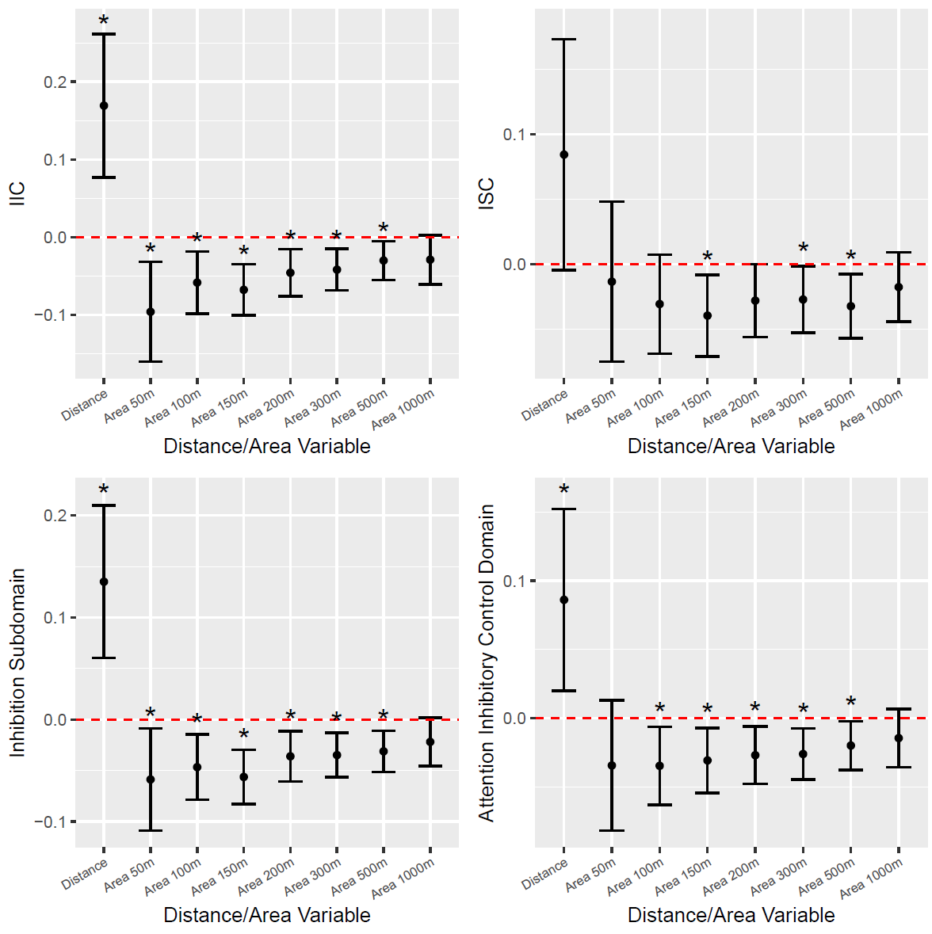
Figure 2: Estimates of the effect size of distance or area variable with respect to select NEPSY-II scores and subdomain scores. The estimate is indicated by a point with a 95% confidence interval.

  - Odds Ratio Model

In the odds ratio model, we decided on binarizing nearly all NEPSY-II scores with a threshold of greater than five vs less than or equal to five, as this is ‘below expected’ on the NEPSY scale. For ISC, we chose a cutoff of greater than six versus less than or equal to six get similar percentiles with those of IIC and INC. We found statistically significant results for IIC, INC, ISC, CITS and MFFTS scores (Figure 2).

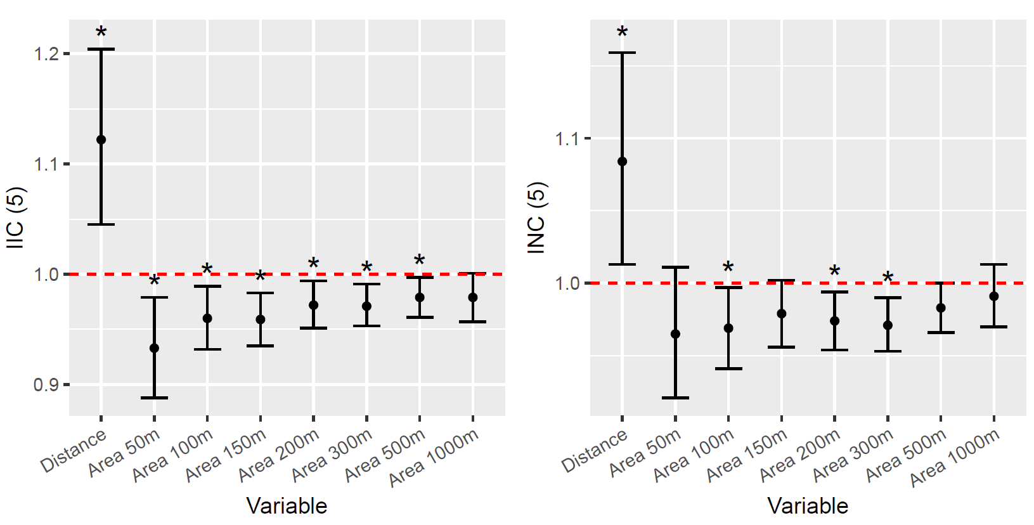

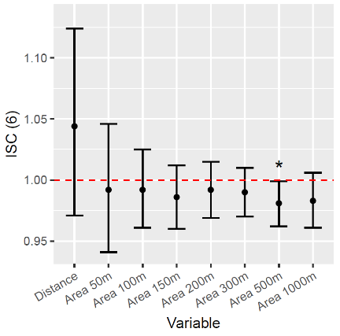
​​ 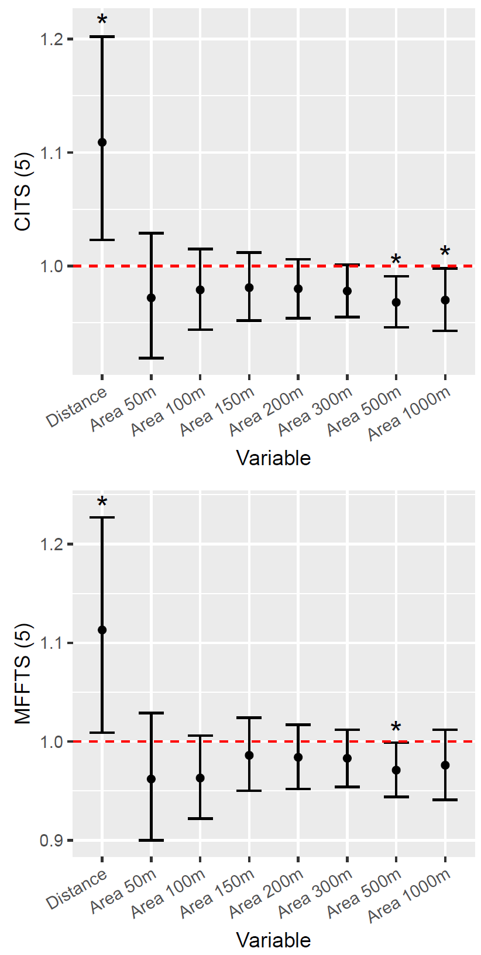
Figure 2: Odds ratio of having a high NEPSY-II score (reference: low score) after doubling distance or area variable for select NEPSY-II scores and subdomains. The odds ratio is indicated by a point with a 95% confidence interval. To binarize NEPSY-II scores, a high score is a score that is greater than the value indicated in the title/axis label of each graph (e.g. 5 or 6).

The IIC score was found to be significantly associated with distance from residency to nearest plantation and all crop area variables between 50m and 500m, to understand levels of proximity and differences in exposure. Doubling distance increased the odds of having a high IIC score by a factor of 1.122 (95% CI: 1.045, 1.204), while doubling greenhouse area under 150 m had the highest statistical significance (p-value = 9.25e-4) and changed the odds ratio of a high IIC score by a factor of 0.959 (95% CI: 0.935, 0.983). The INC score was found to be significantly associated with distance from residency to nearest plantation as well as areas under 100m, 200m, and 300m radii values. Doubling distance changed the odds ratio of a high INC score by a factor of 1.084 (95% CI: 1.013, 1.159), while doubling greenhouse area under 300m had the highest significance (p-value = 2.22e-3) and changed the odds ratio of a high INC score by a factor of 0.971 (95% CI: 0.953, 0.990). The ISC score was only found to be significant in crop areas under 500m. Doubling crop areas under 500m led to a change in the odds ratio of a high ISC score by 0.981 (95% CI: 0.962, 0.999).

In the Language domain, the CITS score was found to be significantly associated with distance from residency to nearest plantation, and crop areas under 500m and 1000m. Doubling distance changed the odds ratio of a high CITS score by a factor of 1.109 (95% CI: 1.023, 1.202), while doubling area under 500m had the highest significance (p-value = 6.36e-3) and changed the odds ratio of a high CITS score by a factor of 0.968 (95% CI: 0.946, 0.991).

In the Memory and Learning domain, the MFFTS score was found to be significantly associated with distance from residency to nearest plantation and crop areas under 500m. Doubling distance and doubling area under 500m changed the odds ratio of a high MFFTS score by a factor of 1.113 (95% CI: 1.009, 1.227) and 0.971 (95% CI: 0.944, 0.999) respectively.

- Discussion

This study analyzed the neurobehavioral performance associations with crop area around the household and home distance to nearest plantation. Neurobehavioral performance was measured with specific NEPSY-II domains among children and adolescents in Pedro Moncayo, Ecuador. Crop areas around home and distance to nearest plantation were associated with subdomains related to Attention/Inhibitory Control, Language, and Memory/Learning performance. Our results suggest geographical proximity to floriculture crops where pesticides are sprayed may create exposures that increase risk of worse neurobehavioral performance, specifically related to impulsivity and cognitive flexibility, difficulties understanding complex verbal instructions that involve language and syntax, and challenges with verbal-visual associative learning among study participants (Miller, 2012).

We saw significant associations for many neurobehavioral variables with crop areas within 500m of the home, especially in the inhibition subdomain (Figure 1). But when the radius was very small (50m) or very large (1000m), the associations were often diminished. The lack of association with a small radius in some subdomains could be due to the fact that a vast amount of crop areas are not captured in the 50m area nor are there many people living in this small radii of the greenhouses. Thereby, 50m area cannot effectively explain the full effects of crop area on neurobehavioral outcomes. On the other hand, a very large radius such as 1000m may capture too much additional crop area that does not contribute to changes in neurobehavioral outcomes and may be too far from the household for pesticide drift to reach the home.

Exposure to insecticides, particularly organophosphates have been associated with neurodevelopment effects in animal and human studies, and children in diverse contexts, including prenatal, postnatal, and dietary exposures (Marks et al., 2010; Ramírez et al., 2022; Thistle et al., 2020; Eskenazi et al., 2007). Organophosphates can inhibit acetylcholinesterase (AChE) and impair neurobehavioral function, including attention, inhibitory control, and verbal function (Eskenazi et al., 2007; Gunier et al., 2017; Butler-Dawson et al., 2016; Suarez-Lopez et al., 2013; Kofman et al., 2006; Wang et al., 2016)). Among children and adolescents, a systematic review reported evidence suggesting the association between pesticides exposure and autism spectrum disorder and attention deficit/hyperactivity disorder (ADHD) among children (Tessari et al., 2022). Available literature studying the association between insecticide exposure on child neurodevelopment suggests that prenatal exposure is linked with neurodevelopmental disorders, including, reduced IQ, increased rates of attention deficit hyperactivity disorder, autism, and youth reported hyperactivity and inattention (Hyland et al., 2022; Sagiv et al., 2018; Richardson et al., 2015; Eskenazi et al., 2007; Sapbamrer & Hongsibsong, 2019). While evidence in postnatal exposure is limited, insecticide exposure documented by presence of urinary insecticide metabolites in children has been found to be associated with ADHD, memory, and attention and inhibitory control (Lee et al., 2020; Sapbamrer et al., 2019; Reed et al., 2023). Our research suggests that proximity to pesticide spray sites where intense pesticide application regularly occurs, is associated with reduced memory, attention and inhibition control, and increased impulsivity, difficulties understanding complex verbal instructions, and challenges with verbal-visual learning among adolescents.

Existing literature using NEPSY-II is limited to two cohort studies, ESPINA—the parent research of this study in Ecuador, and CHAMACOS—among Mexican Americans in California. Among 519 adolescents (age 11-17 years) in the same study population (ESPINA), urinary concentration of 2,4-D and glyphosate were associated with low NEPSY-II scores (average domain score between 7.0 and 8.7 points) in the same subdomains (Attention/Inhibitory Control, Language, and Memory/Learning) and the Visuospatial Processing subdomain as well (Chronister et al., 2023). Aligned with our results, a cross-sectional analysis among 307 children (mean age 6.6 years) in the same population (ESPINA), Friedman et al reported a better performance in NEPSY-II Language and Memory/Learning domains (domain average scores ranged from 6.6 to 9.9 points) when increasing distance between children’s households and plantations (Friedman et al., 2020). Further, our study expanded the analysis scope to three points in time and utilized two geospatial analyses. Apart from distance to the nearest plantation, used in previous analyses, this study intended to better represent the exposure by including the area of agriculture around participant’s households. In a recent ESPINA study of insecticides urinary metabolites and neurobehavior, it was found that organophosphates were associated with lower performance on Language, Social Perception, and Attention/Inhibitory Control; however, neonicotinoids were associated with better performance on Memory/Learning and Social Perception scores (Yen et al., unpublished).

In contrast, in the CHAMACOS study, 320 3.5-year-old children were assessed using NEPSY-II visual attention subdomain (average score 8.8 ± 2.3), which was not correlated with urinary organophosphate metabolites (Marks et al., 2010). However, in CHAMACOS study, prenatal exposure to organophosphates was associated with attention problems and ADHD among 3.5-year-old and 5-year-old children using the Child Behavior Checklist (Marks et al., 2010). Differences in NEPSY-II results between CHAMACOS and ESPINA studies, could be based in the narrow use of one NEPSY-II subdomain (visual attention) in the CHAMACOS study vs a larger inclusion of subdomains in ESPINA (Attention/Inhibitory Control, Language, Memory/Learning, Visuospatial Processing and Social Perception). Furthermore, this analysis did not assess biomarkers, but geographical proximity to crops suggesting a broader range of mechanisms that could impact child neurodevelopment. Organochlorine and other types of insecticides are the most common pesticides explored in the literature on pesticide exposure and neurobehavioral performance; yet, more than 150 active ingredients or metabolites have been studied (Reed et al., 2023) that can be explored to better understand their implications in child neurodevelopment.

This study has many strengths and some limitations. This is the first longitudinal study to assess the association between proximity to pesticide spray sites and children’s neurobehavioral performance in South America, contributing to the scarcity of research on this topic in Latin America, and one of only a few studies to study the area of pesticide spray sites around children’s homes (Reed et al., 2023). While the NEPSY II was used in the CHAMACOS study and here, no other known studies have used NEPSY in assessment of neurobehavior in children and exposure to pesticides. There are, however, some limitations. This analysis included greenhouse floriculture; however, the study area also has other vegetable and fruit plantations outside greenhouses not explored and these crops use pesticides as well. The sample size is small and may be underpowered to detect some associations. Further, exposures were defined based on household characteristics—such as occupation of household members and distance to plantation—but children enroll in school spend about one third of their day at school. This geospatial construct could be incorporated into future studies. Further, two previous studies reported no differences in NEPSY-II scores based on language administration (English vs Spanish) (Gunier, Bradman, Harley, Kogut, et al., 2017; Korpinen et al., 2023). However, when assessing expressive language in young children considering the child's language background is important (Korpinen et al., 2023). For instance, language–and particularly comprehension of instruction—could limit the ability to respond correctly if participants’ mother language is different than Spanish (e.g., Quechua).

- Conclusion
In this longitudinal ESPINA study of children who grow up near floriculture, where pesticides are heavily used, residential proximity to floriculture plantations and crop areas around children’s households were associated with lower performance in Attention/Inhibitory Control, Language, and Memory/Learning among children and adolescents assessed in three different time periods in Pedro Moncayo, Ecuador. The distance from residence to nearest plantation and all crop area variables between 50 and 500m were associated with lower performance in the domain of Attention/Inhibitory Control. This research contributes to the body of research that suggests that exposure to pesticides is negatively associated with neurobehavior. This research has implications for health-based standards and adds to the body of literature that suggests that pesticide sprays sites should not be within 500m of residential areas, schools or daycare facilities (Gunier, Bradman, Harley, & Eskenazi, 2017). Further research is still needed to disentangle the varying pesticide exposure mechanisms among children and adolescents who grow up near pesticide spray sites and neurobehavioral outcomes and identify the classes of pesticides that may be triggering these outcomes.

Acknowledgements

Research funding was provided by National Institute of Environmental Health Sciences (NIEHS) of the National Institutes of Health grant K01ES031697 to Dr. Georgia Kayser to help make this research possible. Other NIEHS research awards were also helpful in bringing this research to fruition (R01ES030378, R01ES025792; PI: Suraez, J.R.). We also greatly appreciate the contributions of ESPINA study staff, Fundación Cimas del Ecuador, the Parish Governments of Pedro Moncayo County, community members of Pedro Moncayo, and the Education District of Pichincha-Cayambe-Pedro Moncayo counties for their contributions and support on this project.

Bibliography:

Bradman, A., Castorina, R., Boyd Barr, D., Chevrier, J., Harnly, M. E., Eisen, E. A., McKone, T. E., Harley, K., Holland, N., & Eskenazi, B. (2011). Determinants of Organophosphorus Pesticide Urinary Metabolite Levels in Young Children Living in an Agricultural Community. International Journal of Environmental Research and Public Health, 8(4), Article 4. https://doi.org/10.3390/ijerph8041061
Burns, C. J., McIntosh, L. J., Mink, P. J., Jurek, A. M., & Li, A. A. (2013). Pesticide Exposure and Neurodevelopmental Outcomes: Review of the Epidemiologic and Animal Studies. Journal of Toxicology and Environmental Health, Part B, 16(3–4), 127–283. https://doi.org/10.1080/10937404.2013.783383
Butler-Dawson, J., Galvin, K., Thorne, P. S., & Rohlman, D. S. (2016). Organophosphorus pesticide exposure and neurobehavioral performance in Latino children living in an orchard community. NeuroToxicology, 53, 165–172. https://doi.org/10.1016/j.neuro.2016.01.009
Chronister, B. N. C., Yang, K., Yang, A. R., Lin, T., Tu, X. M., Lopez-Paredes, D., Checkoway, H., Suarez-Torres, J., Gahagan, S., Martinez, D., Barr, D., Moore, R. C., & Suarez-Lopez, J. R. (2023). Urinary Glyphosate, 2,4-D and DEET Biomarkers in Relation to Neurobehavioral Performance in Ecuadorian Adolescents in the ESPINA Cohort. Environmental Health Perspectives, 131(10), 107007. https://doi.org/10.1289/EHP11383
Coronado, G. D., Holte, S., Vigoren, E., Griffith, W. C., Barr, D. B., Faustman, E., & Thompson, B. (2011). Organophosphate Pesticide Exposure and Residential Proximity to Nearby Fields: Evidence for the Drift Pathway. Journal of Occupational and Environmental Medicine, 53(8), 884. https://doi.org/10.1097/JOM.0b013e318222f03a
Dórea, J. G. (2021). Neurodevelopment in mining environments entails different types of exposure and non-essential element interactions: Broadening the significance of the Nyanza et al study in Tanzania. Environment International, 149, 106407. https://doi.org/10.1016/j.envint.2021.106407
Eskenazi, B., Marks, A. R., Bradman, A., Harley, K., Barr, D. B., Johnson, C., Morga, N., & Jewell, N. P. (2007). Organophosphate Pesticide Exposure and Neurodevelopment in Young Mexican-American Children. Environmental Health Perspectives, 115(5), 792–798. https://doi.org/10.1289/ehp.9828
Friedman, E., Hazlehurst, M. F., Loftus, C., Karr, C., McDonald, K. N., & Suarez-Lopez, J. R. (2020). Residential proximity to greenhouse agriculture and neurobehavioral performance in Ecuadorian children. International Journal of Hygiene and Environmental Health, 223(1), 220–227. https://doi.org/10.1016/j.ijheh.2019.08.009
Garry, V. F. (2004). Pesticides and children. Toxicology and Applied Pharmacology, 198(2), 152–163. https://doi.org/10.1016/j.taap.2003.11.027
González-Alzaga, B., Lacasaña, M., Aguilar-Garduño, C., Rodríguez-Barranco, M., Ballester, F., Rebagliato, M., & Hernández, A. F. (2014). A systematic review of neurodevelopmental effects of prenatal and postnatal organophosphate pesticide exposure. Toxicology Letters, 230(2), 104–121. https://doi.org/10.1016/j.toxlet.2013.11.019
Grandjean, P., Harari, R., Barr, D. B., & Debes, F. (2006). Pesticide Exposure and Stunting as Independent Predictors of Neurobehavioral Deficits in Ecuadorian School Children | Pediatrics | American Academy of Pediatrics. Pediatrics, 117(3), e546–e556. https://doi.org/10.1542/peds.2005-1781
Gunier, R. B., Bradman, A., Harley, K. G., & Eskenazi, B. (2017). Will buffer zones around schools in agricultural areas be adequate to protect children from the potential adverse effects of pesticide exposure? PLOS Biology, 15(12), e2004741. https://doi.org/10.1371/journal.pbio.2004741
Gunier, R. B., Bradman, A., Harley, K. G., Kogut, K., & Eskenazi, B. (2017). Prenatal Residential Proximity to Agricultural Pesticide Use and IQ in 7-Year-Old Children. Environmental Health Perspectives, 125(5), 057002. https://doi.org/10.1289/EHP504
Handal, A. J., Hund, L., Páez, M., Bear, S., Greenberg, C., Fenske, R. A., & Barr, D. B. (2016). Characterization of Pesticide Exposure in a Sample of Pregnant Women in Ecuador. Archives of Environmental Contamination and Toxicology, 70(4), 627–639. https://doi.org/10.1007/s00244-015-0217-9
Harari Compilador, R. (2004). Seguridad, salud y ambiente en la floricultura. IFA, PROMSA. https://www.ifa.org.ec/docs/floricultura.pdf
Hyland, C., Bradshaw, P. T., Gunier, R. B., Mora, A. M., Kogut, K., Deardorff, J., Sagiv, S. K., Bradman, A., & Eskenazi, B. (2021). Associations between pesticide mixtures applied near home during pregnancy and early childhood with adolescent behavioral and emotional problems in the CHAMACOS study. Environmental Epidemiology, 5(3), e150. https://doi.org/10.1097/EE9.0000000000000150
Hyland, C., & Laribi, O. (2017). Review of take-home pesticide exposure pathway in children living in agricultural areas. Environmental Research, 156, 559–570. https://doi.org/10.1016/j.envres.2017.04.017
Ismail, A. A., Wang, K., Olson, J. R., Bonner, M. R., Hendy, O., Abdel Rasoul, G., & Rohlman, D. S. (2017). The impact of repeated organophosphorus pesticide exposure on biomarkers and neurobehavioral outcomes among adolescent pesticide applicators. Journal of Toxicology and Environmental Health, Part A, 80(10–12), 542–555. https://doi.org/10.1080/15287394.2017.1362612
Kang W, Hernández SP, Rahman MS, Voigt K, Malvaso A. Inhibitory Control Development: A Network Neuroscience Perspective. Front Psychol. 2022 Oct 10;13:651547. doi: 10.3389/fpsyg.2022.651547. PMID: 36300046; PMCID: PMC9588931.
Kofman, O., Berger, A., Massarwa, A., Friedman, A., & Jaffar, A. A. (2006). Motor Inhibition and Learning Impairments in School-Aged Children Following Exposure to Organophosphate Pesticides in Infancy. Pediatric Research, 60(1), 88–92. https://doi.org/10.1203/01.pdr.0000219467.47013.35
Korkman †, M., Lahti-Nuuttila, P., Laasonen, M., Kemp, S. L., & Holdnack, J. (2013). Neurocognitive development in 5- to 16-year-old North American children: A cross-sectional study. Child Neuropsychology, 19(5), 516–539. https://doi.org/10.1080/09297049.2012.705822
Korkman, M., Kirk, U., & Kemp, S. (2007). NEPSY II: Clinical and Interpretive Manual (Second Edition). The Psychological Corporation.
Korpinen, E., Slama, S., Rosenqvist, J., & Haavisto, A. (2023). WPPSI-IV and NEPSY-II performance in mono- and bilingual 5–6-year-old children: Findings from The FinSwed Study. Scandinavian Journal of Psychology, 64(4), 409–420. https://doi.org/10.1111/sjop.12895
Lu, C., Fenske, R., Simcox, N., & Kalman, D. (2000). Pesticide Exposure of Children in an Agricultural Community: Evidence of Household Proximity to Farmland and Take Home Exposure Pathways. Environmental Research, 84, 290–302. https://doi.org/10.1006/enrs.2000.4076
Lucero, B., & Muñoz-Quezada, M. T. (2021). Neurobehavioral, Neuromotor, and Neurocognitive Effects in Agricultural Workers and Their Children Exposed to Pyrethroid Pesticides: A Review. Frontiers in Human Neuroscience, 15. https://doi.org/10.3389/fnhum.2021.648171
Marks, A. R., Harley, K., Bradman, A., Kogut, K., Barr, D. B., Johnson, C., Calderon, N., & Eskenazi, B. (2010). Organophosphate Pesticide Exposure and Attention in Young Mexican-American Children: The CHAMACOS Study. Environmental Health Perspectives, 118(12), 1768–1774. https://doi.org/10.1289/ehp.1002056
Miller, D. C. (2012). How to Report and Interpret the NEPSY-‐II Scores Within a School Neuropsyc (Second Edition). https://docslib.org/doc/8718539/how-to-report-and-interpret-the-nepsy-ii-scores-within-a-school-neuropsyc
Miller, D. C. (2015). NEPSY-II presentation – How to administer the Nepsy-2. TASP Conference. https://www.txasp.org/assets/conference-materials/2015/miller_nepsyii_tasp.pdf
Muñoz-Quezada, M., Lucero, B., Barr, D., Steenland, K., Levy, K., Ryan, P., Iglesias, V., Alvarado Orellana, S. A., Concha, C., Rojas, E., & Vega, C. (2013). Neurodevelopmental effects in children associated with exposure to organophosphate pesticides: A systematic review. Neurotoxicology, 39. https://doi.org/10.1016/j.neuro.2013.09.003
Ramírez, V., Gálvez-Ontiveros, Y., González-Domenech, P. J., Baca, M. Á., Rodrigo, L., & Rivas, A. (2022). Role of endocrine disrupting chemicals in children’s neurodevelopment. Environmental Research, 203, 111890. https://doi.org/10.1016/j.envres.2021.111890
Reed, J. E., Burns, C. J., & Pisa, F. (2023). Literature landscape of neurodevelopment and pesticides: A scoping review of methodologies. Global Epidemiology, 6, 100121. https://doi.org/10.1016/j.gloepi.2023.100121
Rosas, L. G., & Eskenazi, B. (2008). Pesticides and child neurodevelopment. Current Opinion in Pediatrics, 20(2), 191. https://doi.org/10.1097/MOP.0b013e3282f60a7d
Sánchez Lizardi, P., O’Rourke, M. K., & Morris, R. J. (2008). The Effects of Organophosphate Pesticide Exposure on Hispanic Children’s Cognitive and Behavioral Functioning. Journal of Pediatric Psychology, 33(1), 91–101. https://doi.org/10.1093/jpepsy/jsm047
Sapbamrer, R., & Hongsibsong, S. (2019). Effects of prenatal and postnatal exposure to organophosphate pesticides on child neurodevelopment in different age groups: A systematic review. Environmental Science and Pollution Research, 26(18), 18267–18290. https://doi.org/10.1007/s11356-019-05126-w
Shelton, J. F., Geraghty, E. M., Tancredi, D. J., Delwiche, L. D., Schmidt, R. J., Ritz, B., Hansen, R. L., & Hertz-Picciotto, I. (2014). Neurodevelopmental Disorders and Prenatal Residential Proximity to Agricultural Pesticides: The CHARGE Study. Environmental Health Perspectives, 122(10), 1103–1109. https://doi.org/10.1289/ehp.1307044
Simcox, N. J., Fenske, R. A., Wolz, S. A., Lee, I. C., & Kalman, D. A. (1995). Pesticides in household dust and soil: Exposure pathways for children of agricultural families. Environmental Health Perspectives, 103(12), 1126–1134. https://doi.org/10.1289/ehp.951031126
Suarez-Lopez, J. R., Butcher, C. R., Gahagan, S., Checkoway, H., Alexander, B. H., & Al-Delaimy, W. K. (2018). Acetylcholinesterase activity and time after a peak pesticide-use period among Ecuadorian children. International Archives of Occupational and Environmental Health, 91(2), 175–184. https://doi.org/10.1007/s00420-017-1265-4
Suarez-Lopez, J. R., Checkoway, H., Jacobs, D. R., Al-Delaimy, W. K., & Gahagan, S. (2017). Potential short-term neurobehavioral alterations in children associated with a peak pesticide spray season: The Mother’s Day flower harvest in Ecuador. Neurotoxicology, 60, 125–133. https://doi.org/10.1016/j.neuro.2017.02.002
Suarez-Lopez, J. R., Himes, J. H., Jacobs, D. R., Alexander, B. H., & Gunnar, M. R. (2013). Acetylcholinesterase Activity and Neurodevelopment in Boys and Girls | Pediatrics | American Academy of Pediatrics. Pediatrics, 132(6), e1649–e1658. https://doi.org/10.1542/peds.2013-0108
Suarez-Lopez JR, Hood N, Suárez-Torres J, Gahagan S, Gunnar MR, López-Paredes D. Associations of acetylcholinesterase activity with depression and anxiety symptoms among adolescents growing up near pesticide spray sites. Int J Hyg Environ Health. 2019;222(7):981-990. doi:10.1016/j.ijheh.2019.06.001
Suárez-López, J. R., Nazeeh, N., Kayser, G., Suarez-Torres, J., Checkoway, H., López-Paredes, D., Jacobs, D. R., & de la Cruz, F. (2020). Residential proximity to greenhouse crops and pesticide exposure (via acetylcholinesterase activity) assessed from childhood through adolescence. Environmental Research, 188, 109728. https://doi.org/10.1016/j.envres.2020.109728
Tessari, L., Angriman, M., Díaz-Román, A., Zhang, J., Conca, A., & Cortese, S. (2022). Association Between Exposure to Pesticides and ADHD or Autism Spectrum Disorder: A Systematic Review of the Literature. Journal of Attention Disorders, 26(1), 48–71. https://doi.org/10.1177/1087054720940402
Thistle, J. E., Roell, K. R., Choi, G., Villanger, G. D., Drover, S. S., Sakhi, A. K., Thomsen, C., Zeiner, P., Knudsen, G., Reichborn-Kjennerud, T., Øvergaard, K. R., Herring, A., Aase, H., & Engel, S. M. (2020). Prenatal exposure to organophosphate pesticides and executive function in the Norwegian Mother, Father and Child Cohort. ISEE Conference Abstracts, 2020(1). https://doi.org/10.1289/isee.2020.virtual.P-0820
Wagner-Schuman, M., Richardson, J. R., Auinger, P., Braun, J. M., Lanphear, B. P., Epstein, J. N., Yolton, K., & Froehlich, T. E. (2015). Association of pyrethroid pesticide exposure with attention-deficit/hyperactivity disorder in a nationally representative sample of U.S. children. Environmental Health, 14(1), 44. https://doi.org/10.1186/s12940-015-0030-y
Ward, M. H., Lubin, J., Giglierano, J., Colt, J. S., Wolter, C., Bekiroglu, N., Camann, D., Hartge, P., & Nuckols, J. R. (2006). Proximity to Crops and Residential Exposure to Agricultural Herbicides in Iowa. Environmental Health Perspectives, 114(6), 893–897. https://doi.org/10.1289/ehp.8770
WHO. Training Course on Child Growth Assessment. World Health Organization; 2008.
WHO Multicentre Growth Reference Study Group. WHO Child Growth Standards based on length/height, weight and age. Acta paediatrica. 2006;450:76-85.
Yen, J., Yang, K., Skomal, A., Tub, X., Kayser, G.L.., Gahagan, S., Suarez-Torres, J.,Hong, S., Moore, R., Suarez-Lopez, J.R. Associations Between Neonicotinoid, Pyrethroid, and Organophosphate Insecticide Metabolites with Neurobehavioral Performance in Ecuadorian Adolescents In review.
Suarez-Lopez JR, Nazeeh N, Kayser G, Suárez-Torres J, Checkoway H, López-Paredes D, Jacobs DR Jr, Cruz F. Residential proximity to greenhouse crops and pesticide exposure (via acetylcholinesterase activity) assessed from childhood through adolescence. Environ Res. 2020 Sep;188:109728. doi: 10.1016/j.envres.2020.109728. Epub 2020 Jun 11. PMID: 32798937; PMCID: PMC7483309.
Suarez-Lopez, J.R., Nguyen, A., Klas, J. et al. Associations of Acetylcholinesterase Inhibition Between Pesticide Spray Seasons with Depression and Anxiety Symptoms in Adolescents, and the Role of Sex and Adrenal Hormones on Gender Moderation. Expo Health 13, 51–64 (2021). https://doi.org/10.1007/s12403-020-00361-w

Supplementary Tables and Figures:

Supplementary Table 1. Summary of NEPSY-II subdomains stratified by distance from residency to nearest plantation. Every subdomain has its mean (sd) reported, and p-values are calculated from a one-way ANOVA test.

Variable | Visit Time | N | 1st quartile | 2nd quartile | 3rd quartile | 4th quartile | P-value
Auditory attention combined (aac) | Summer 2008 | 239 | 7.37 (3.44) | 8.31 (3.81) | 8.26 (3.01) | 8.74 (3.39) | 0.182
Auditory attention combined (aac) | Spring 2016 | 323 | 7.99 (4.14) | 8.58 (3.72) | 8.66 (3.81) | 8.60 (3.37) | 0.642
Auditory attention combined (aac) | Summer 2016 | 527 | 9.83 (3.16) | 9.30 (3.67) | 9.41 (3.51) | 9.65 (3.35) | 0.601
Response set combined (rsc) | Summer 2008 | 127 | 8.32 (3.70) | 8.88 (3.39) | 8.93 (2.81) | 9.15 (2.98) | 0.768
Response set combined (rsc) | Spring 2016 | 323 | 9.11 (3.04) | 9.82 (3.20) | 9.48 (2.85) | 9.33 (2.99) | 0.511
Response set combined (rsc) | Summer 2016 | 527 | 10.11 (2.69) | 9.52 (2.78) | 9.64 (2.98) | 9.63 (2.78) | 0.337
Inhibition-inhibition combined (iic) | Summer 2008 | 231 | 6.26 (3.39) | 7.64 (2.91) | 7.05 (2.97) | 7.41 (3.03) | 0.083
Inhibition-inhibition combined (iic) | Spring 2016 | 321 | 5.82 (3.04) | 6.62 (3.47) | 6.69 (3.06) | 7.17 (3.25) | 0.067
Inhibition-inhibition combined (iic) | Summer 2016 | 527 | 6.38 (2.85) | 6.34 (3.23) | 7.28 (3.25) | 7.07 (3.38) | 0.032
Inhibition-naming combined (inc) | Summer 2008 | 239 | 7.05 (3.39) | 7.11 (3.91) | 7.10 (3.66) | 6.98 (3.80) | 0.998
Inhibition-naming combined (inc) | Spring 2016 | 321 | 5.91 (2.79) | 6.16 (2.92) | 6.35 (3.06) | 6.59 (2.30) | 0.464
Inhibition-naming combined (inc) | Summer 2016 | 527 | 6.31 (2.92) | 6.19 (3.13) | 6.93 (2.97) | 6.48 (2.87) | 0.202
Inhibition-switching combined (isc) | Summer 2008 | 100 | 6.83 (2.19) | 6.00 (1.90) | 7.69 (3.11) | 7.29 (2.37) | 0.112
Inhibition-switching combined (isc) | Spring 2016 | 321 | 6.78 (2.78) | 7.61 (2.75) | 7.51 (2.85) | 8.26 (2.40) | 0.008*
Inhibition-switching combined (isc) | Summer 2016 | 527 | 7.16 (2.64) | 7.35 (3.26) | 7.45 (3.12) | 7.89 (3.58) | 0.281
Comprehension of instructions total score (cits) | Summer 2008 | 306 | 7.14 (3.32) | 7.09 (2.61) | 7.00 (2.61) | 8.25 (3.01) | 0.025*
Comprehension of instructions total score (cits) | Spring 2016 | NA
Comprehension of instructions total score (cits) | Summer 2016 | 527 | 6.56 (2.65) | 6.16 (2.73) | 6.31 (2.53) | 6.35 (2.31) | 0.657
Speeded naming combined (snc) | Summer 2008 | 242 | 5.74 (3.23) | 5.87 (2.69) | 5.36 (2.99) | 6.61 (3.17) | 0.153
Speeded naming combined (snc) | Spring 2016 | NA
Speeded naming combined (snc) | Summer 2016 | 527 | 7.95 (3.05) | 7.41 (2.98) | 8.31 (2.84) | 7.27 (2.46) | 0.010*
Memory for faces total score (mffts) | Summer 2008 | 248 | 7.33 (3.19) | 7.61 (2.71) | 7.12 (2.89) | 7.68 (2.41) | 0.668
Memory for faces total score (mffts) | Spring 2016 | NA
Memory for faces total score (mffts) | Summer 2016 | 527 | 7.99 (2.61) | 8.20 (3.12) | 8.11 (2.31) | 8.33 (2.66) | 0.780
Memory for faces delayed total score (mffdts) | Summer 2008 | 246 | 8.45 (2.84) | 8.76 (3.24) | 8.94 (2.81) | 8.58 (2.95) | 0.813
Memory for faces delayed total score (mffdts) | Spring 2016 | NA
Memory for faces delayed total score (mffdts) | Summer 2016 | 527 | 8.36 (2.81) | 8.81 (2.79) | 8.08 (2.69) | 8.51 (2.83) | 0.192
Design copying process total score (dcgts) | Summer 2008 | 295 | 10.00 (4.84) | 10.74 (4.88) | 11.74 (4.78) | 10.26 (5.01) | 0.149
Design copying process total score (dcgts) | Spring 2016 | NA
Design copying process total score (dcgts) | Summer 2016 | 527 | 9.78 (3.29) | 9.43 (3.75) | 9.20 (3.82) | 9.71 (3.44) | 0.531
Geometric puzzles total score (gpts) | Summer 2008 | 306 | 8.88 (3.93) | 8.74 (2.83) | 8.38 (3.06) | 8.18 (2.96) | 0.519
Geometric puzzles total score (gpts) | Spring 2016 | NA
Geometric puzzles total score (gpts) | Summer 2016 | 527 | 7.80 (2.58) | 7.67 (2.37) | 7.72 (2.50) | 8.19 (2.29) | 0.305
* Significant value (p<0.05)

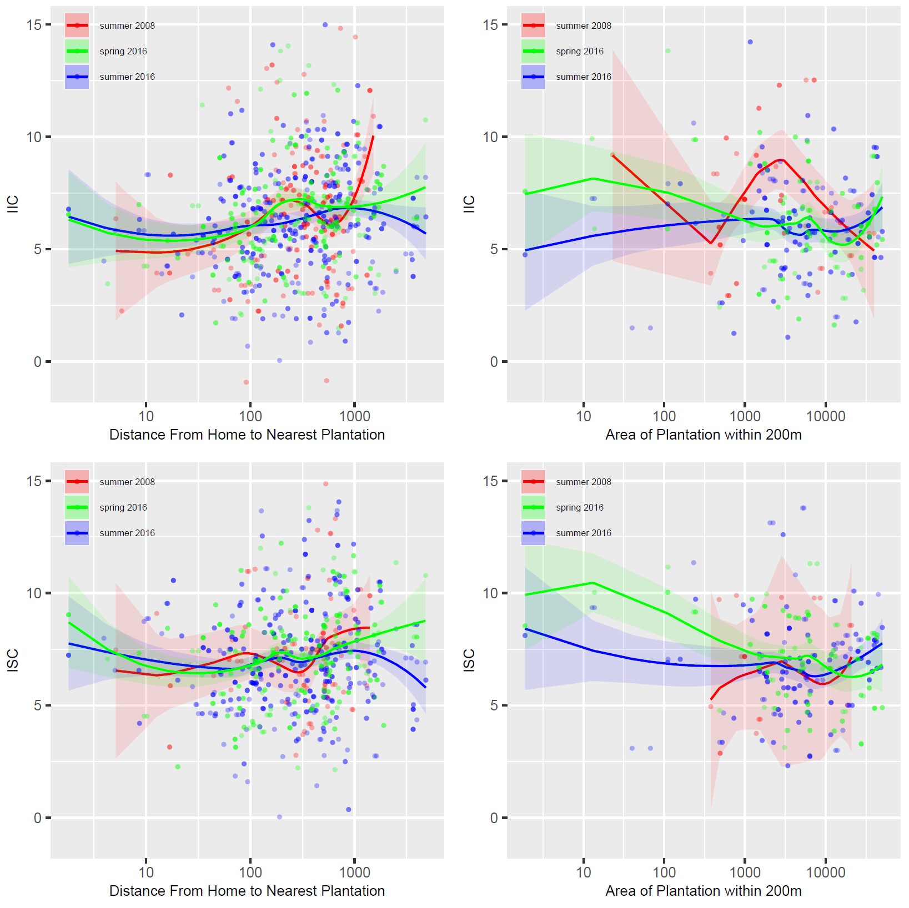
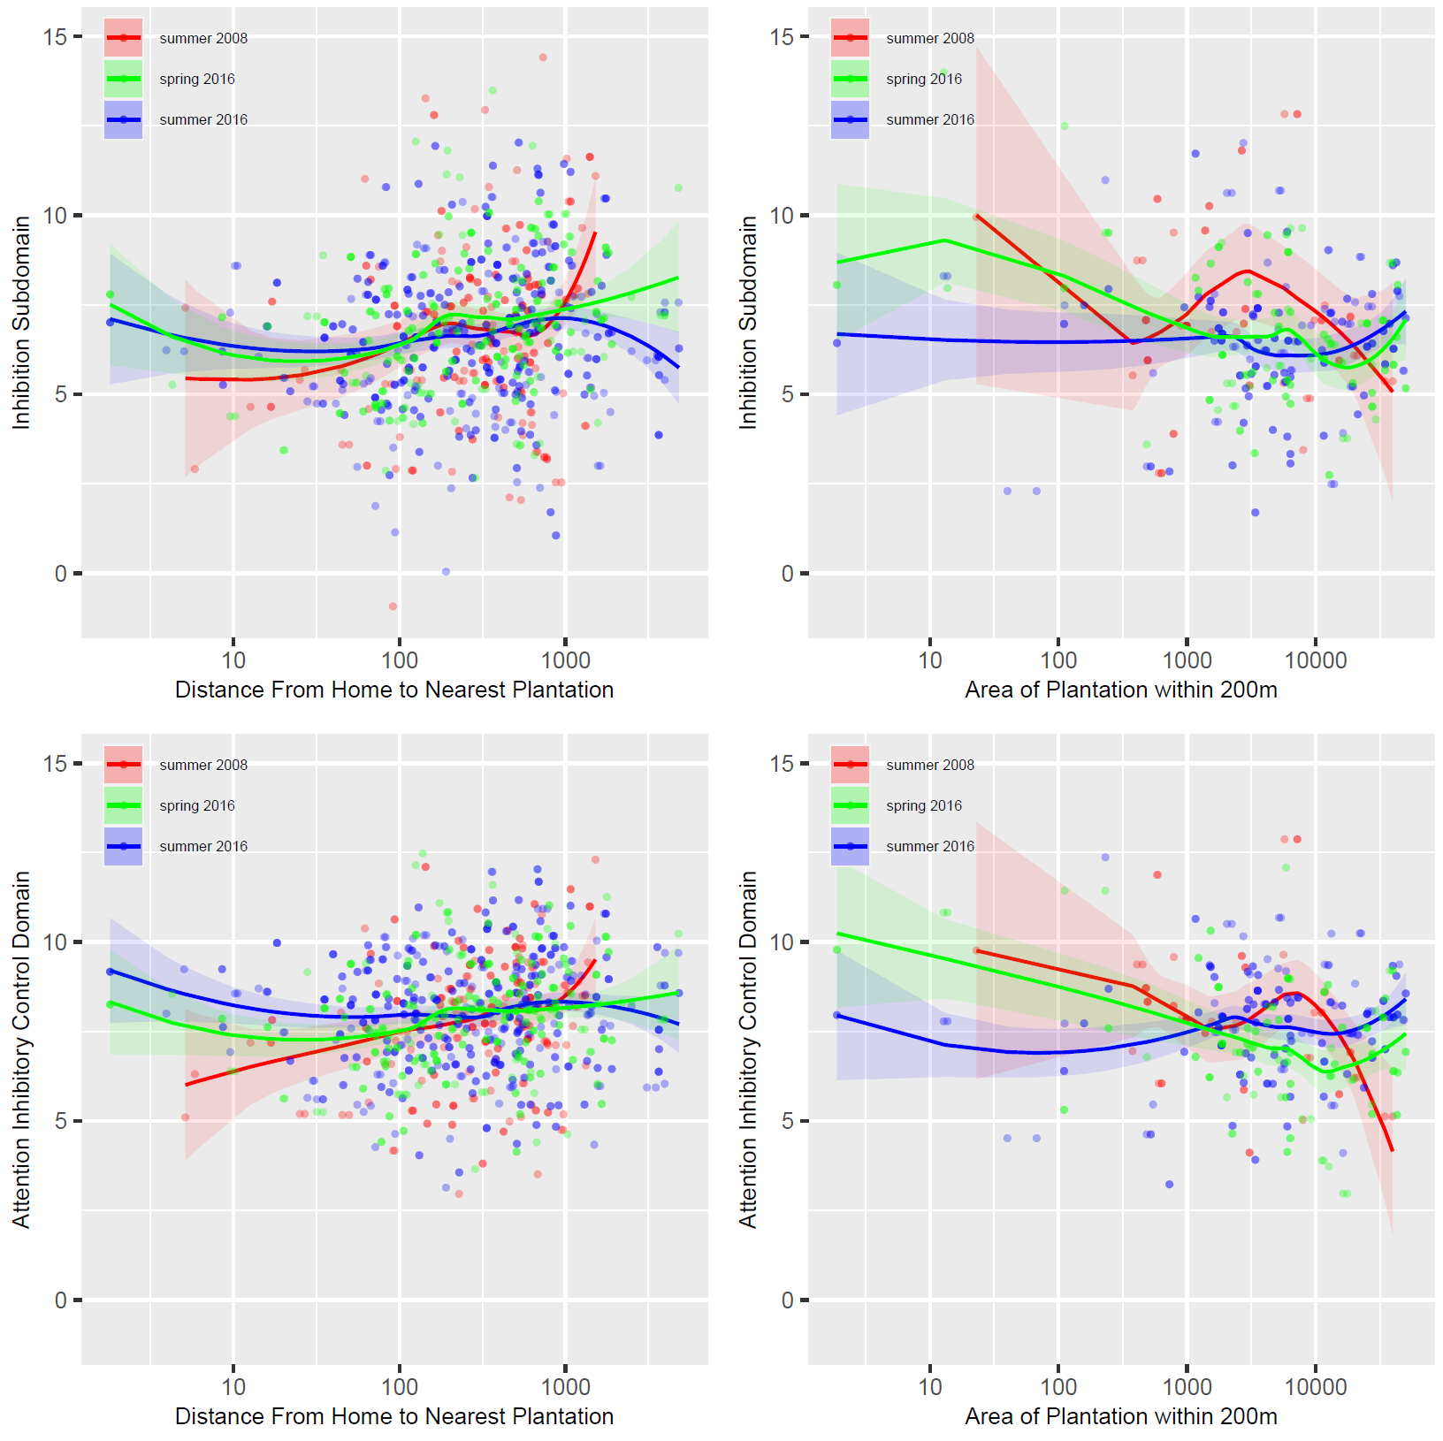
Supplementary Figure 1: Least Square Means LOESS Curves for distance and area variables with respect to select NEPSY scores. The LOESS Curves are adjusted for age, race, gender, days after Mother’s Day harvest z-score age-for-height, parental salary and education, and cohabitation with agricultural worker.

