Lumen Engine — Foundational Web Engine Architecture
Architecture Design Document
Date: 2026-08-25

Codename: Lumen — a single declarative core that compiles into multiple cinematic frontends.
Version: 1.0 (Draft) · Audience: Platform engineering, frontend architecture, tooling teams

1. Executive Overview

Vision
Lumen is a foundational web engine that turns a single declarative description — scenes, assets, interactions, and template selection — into four distinct classes of production frontends:
- Scroll-driven video engines — scrubbed, frame-accurate video playback bound to scroll position (e.g., product unveil pages).
- Single-page cinematic sites — full-bleed animated landing pages with choreographed camera moves, typography, and media.
- 3D product viewers — interactive GLB/USDZ viewers with hotspots, variants, and turntable/scroll orbit.
- Storytelling / scrollytelling engines — long-form narrative layouts where text, media, and data graphics advance through a shared timeline.

Design Principles
- Declarative scene description. Everything the engine renders is derived from a serializable scene graph plus a timeline. No imperative “draw” code lives in userland; behavior is configuration.
- Config-driven generation. One lumen.config.ts (or JSON/YAML) drives validation, code generation, and bundling. The same config can emit a static site, a widget, or an npm package.
- Progressive enhancement. Content is meaningful without JavaScript (SSR/semantic HTML), functional without WebGL (poster images, native <video>), and cinematic when capabilities allow.
- Performance budgets as contracts. Each output type ships with hard budgets (JS ≤ 170 KB gz for cinematic SPA, first-frame ≤ 2.5 s on 4G/Moto G-class, 60 fps sustained, 16 ms frame budget with 8 ms engine soft cap). Budgets are enforced in CI, not documented in prose.
- Accessibility by construction. Reduced-motion fallbacks, keyboard/screen-reader equivalents for every scroll-driven state, focus management in scrollytelling, and WCAG 2.2 AA contrast tokens in the theming system are generated, not bolted on.
- One kernel, many shells. The four output types differ in template and interaction bindings, never in core runtime code. This keeps the maintenance surface small and quality uniform.

Supported Output Types (Build Targets)
Target | Form | Primary consumer
Static site | Pre-rendered HTML + hashed assets | Marketing pages, campaigns
Embeddable widget | Self-contained Web Component (<lumen-player>) | CMS embedding, third-party sites
npm library | ESM/CJS package with typed React/vanilla bindings | Product teams composing experiences
Standalone runtime | lumen.min.js + JSON config fetched at runtime | A/B testing, config-only iteration

2. System Context & Data Flow

Pipeline Overview
The engine is organized as three phases with strictly one-directional data flow:
Authoring/Config → Build → Runtime
- Authoring: Humans (or CMS tooling) write declarative config: scenes, assets, interactions, template choice.
- Build: The configuration is validated, assets are transcoded into a manifest, a template descriptor composes the scene graph, and the code generator emits a tree-shaken bundle plus pre-rendered HTML.
- Runtime: The Kernel boots, the asset pipeline streams media, the renderer and scene graph execute the timeline driven by the interaction layer.

Module Interaction Diagram
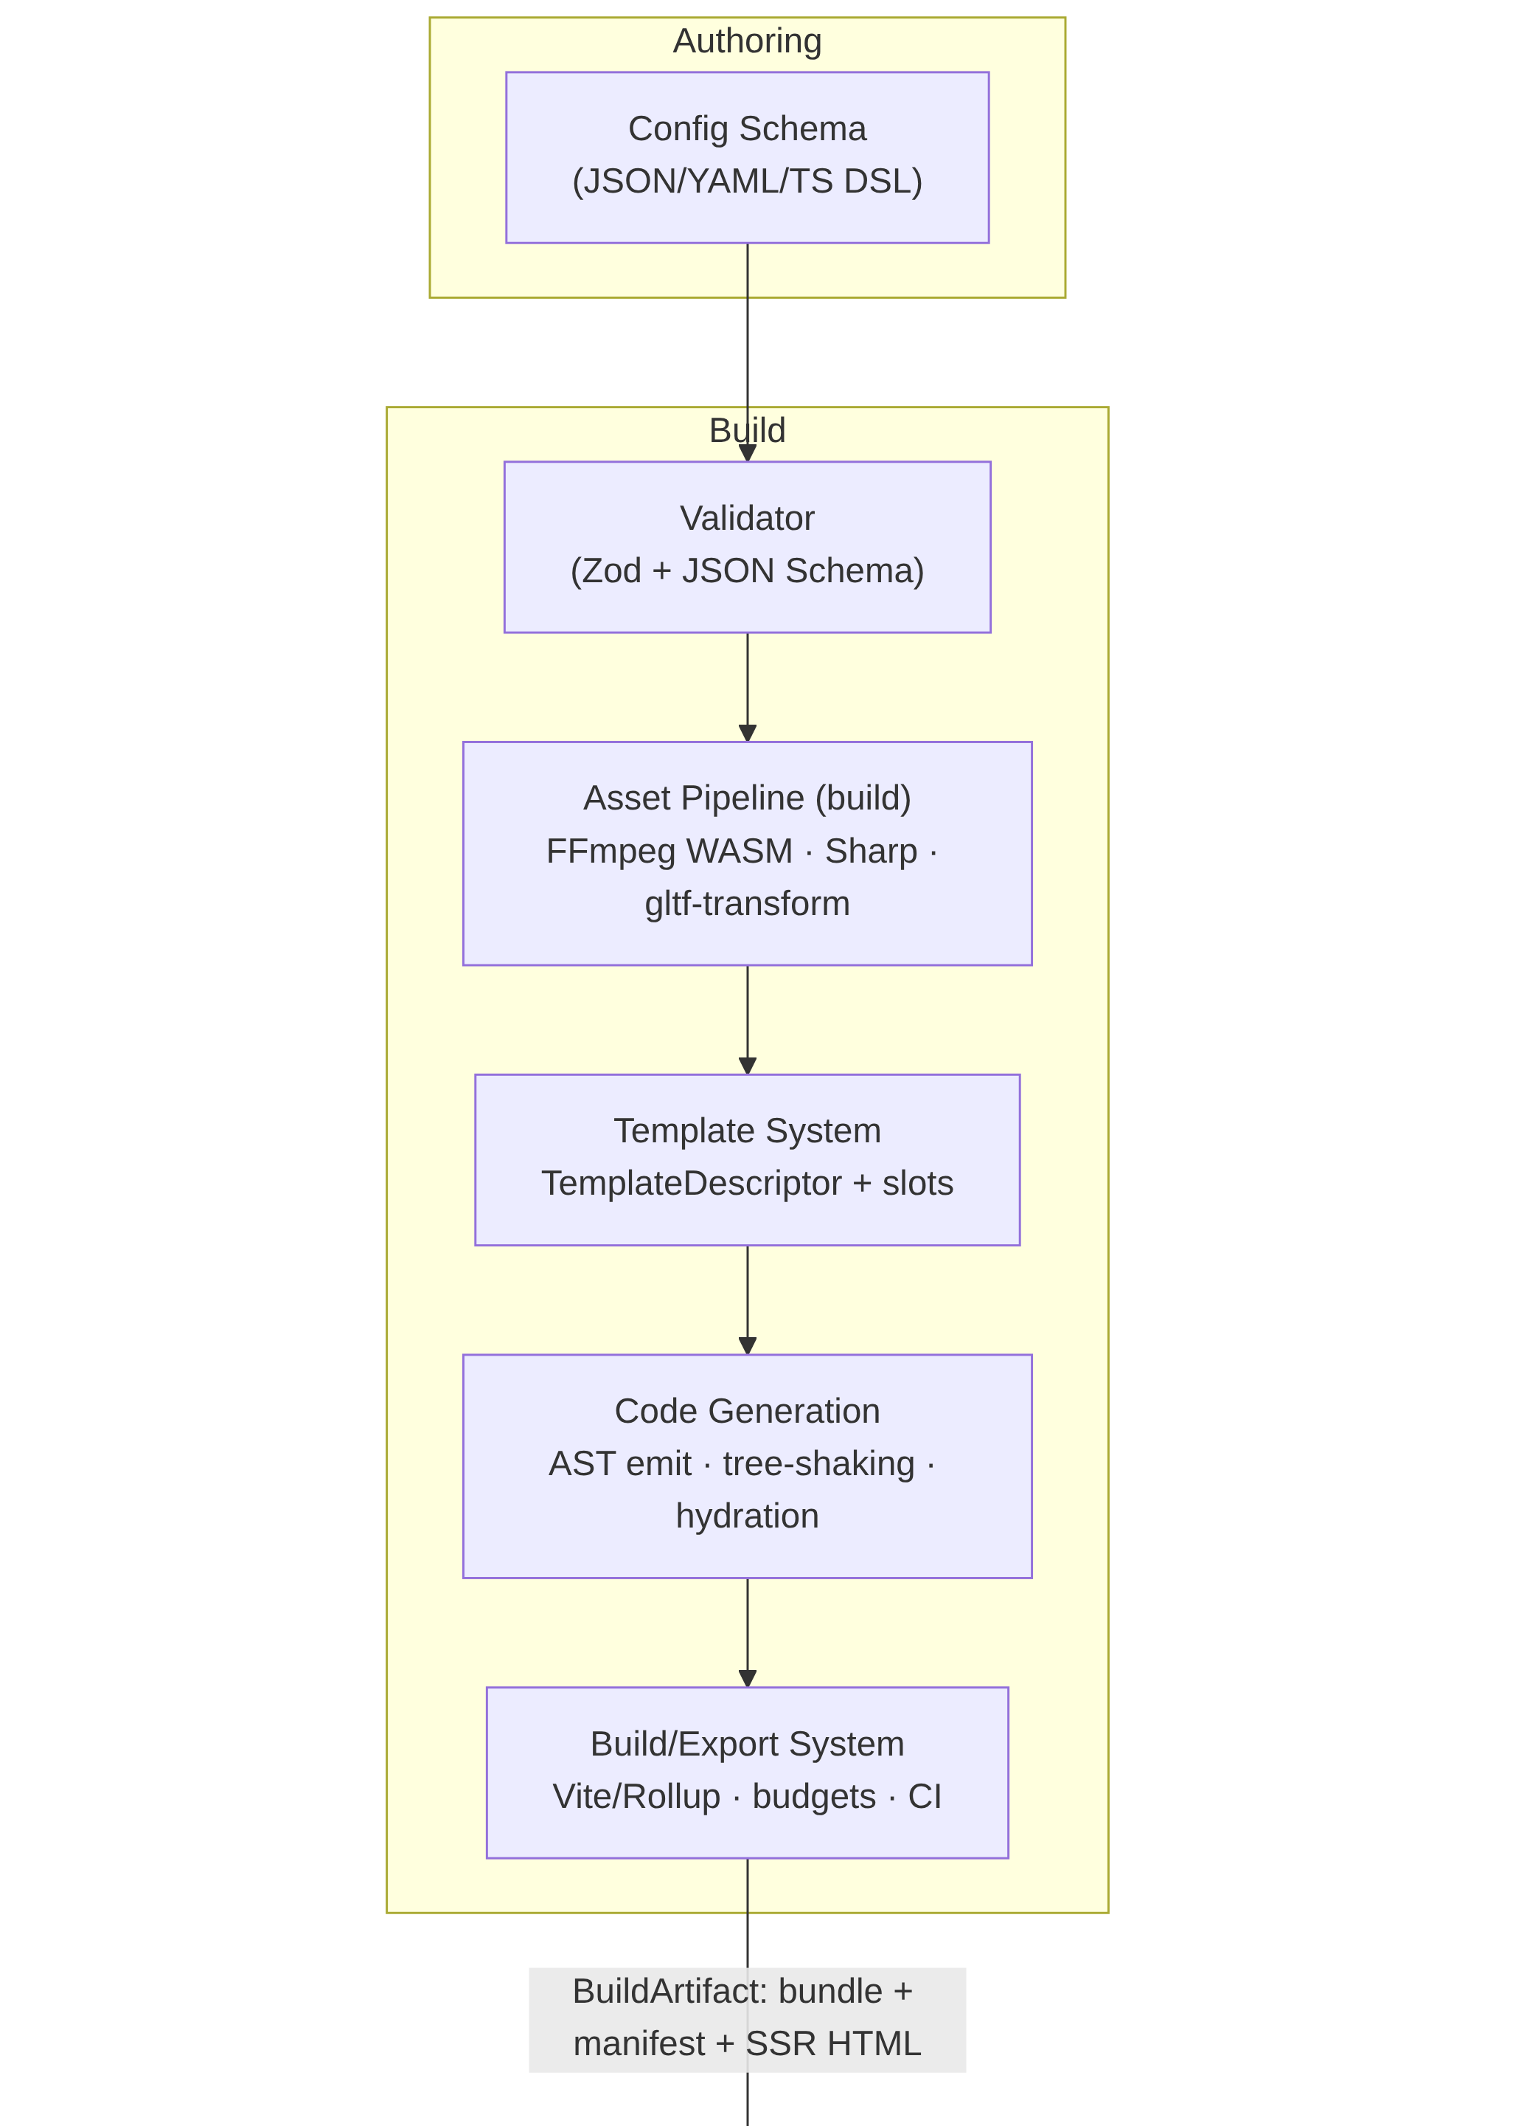
Lumen Engine module interaction diagram, part 1: Authoring/Config → Build pipeline.
Figure 1: Module interaction diagram — Authoring/Config → Build → Runtime (part 1 of 2).
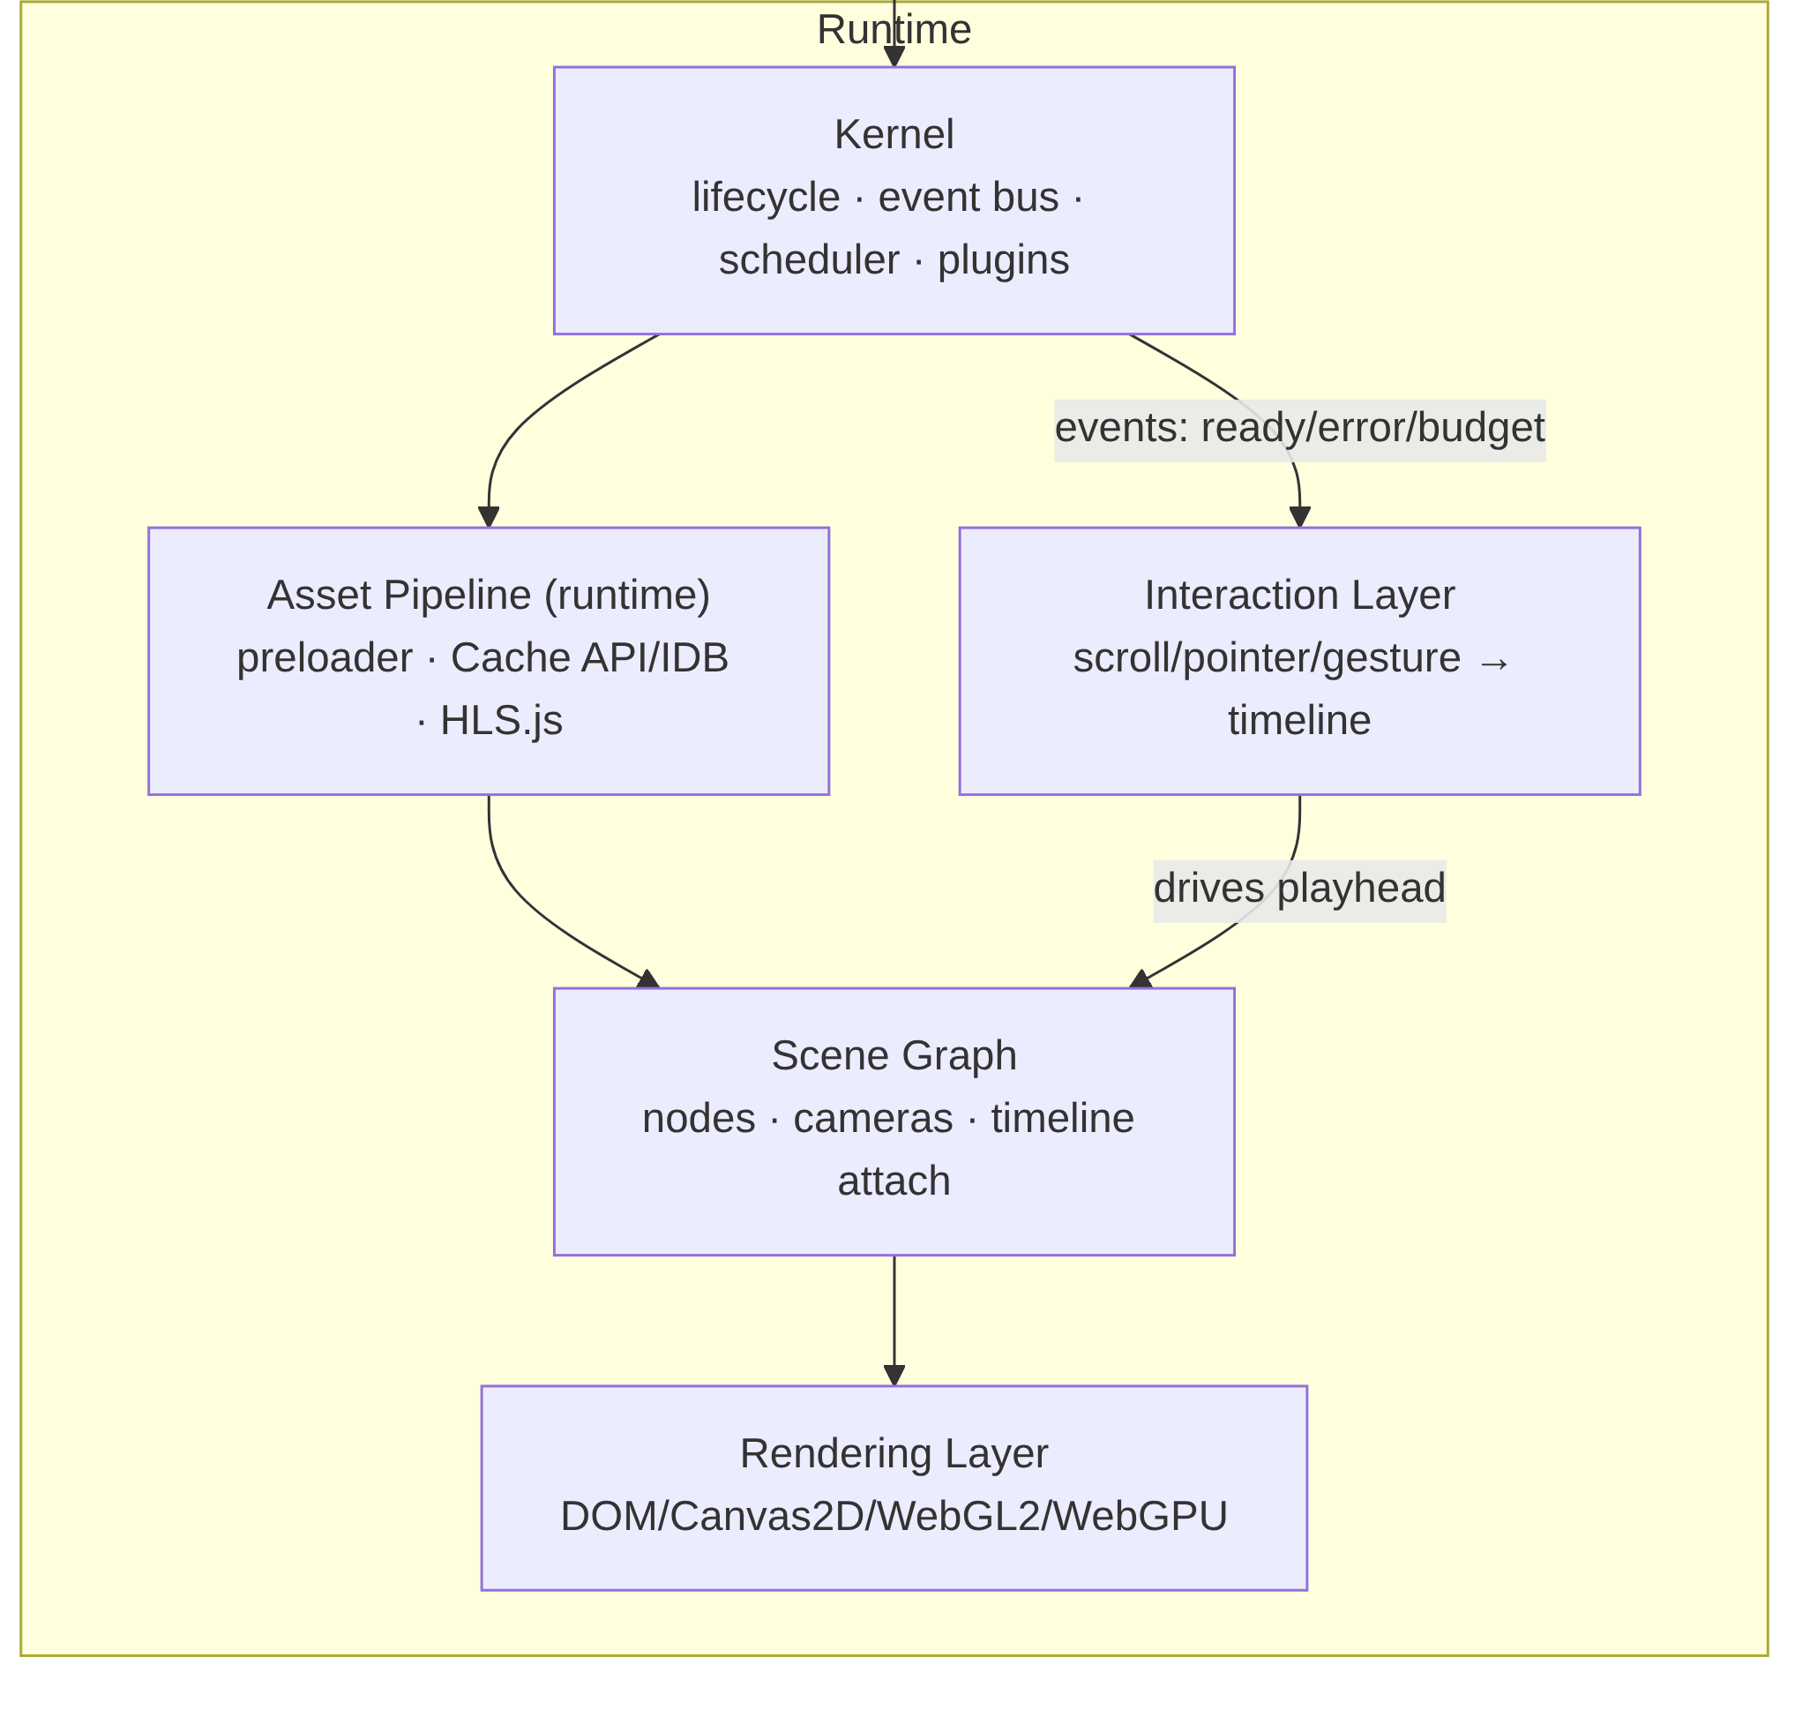
Lumen Engine module interaction diagram, part 2: Runtime kernel, scene graph, rendering, and interaction layers.
Figure 1 (continued): Runtime subsystem and build-to-runtime handoff.

Data Flow Contract
- Config is validated into a typed EngineConfig.
- Asset pipeline produces an AssetManifest (content-hashed URLs, variants, byte sizes).
- Template descriptor + config produce a serialized SceneNode tree and TimelineTrack[].
- Codegen emits a bundle containing only the modules the template exercises.
- At runtime, the Kernel hydrates: manifest → preloader → scene graph → renderer; interaction events advance timeline time; the scheduler renders frames within budget.

3. Module Specifications

3.1 Kernel
Responsibilities - Owns the engine lifecycle state machine: created → booting → loading → ready → active → paused → disposed. - Provides a typed pub/sub event bus; all cross-module communication flows through it (no direct module-to-module imports at runtime). - Maintains the plugin registry: plugins declare provides/consumes capabilities and lifecycle hooks; the Kernel resolves the dependency DAG and initializes them in topological order. - Runs the cooperative frame scheduler: a single requestAnimationFrame loop with prioritized queues (input → timeline → scene update → render → post). Work is budgeted; overflow defers to requestIdleCallback or a Worker. - Performs capability detection once, at boot: WebGL2/WebGPU support, codec support via MediaCapabilities.decodingInfo() (H.264/HEVC/AV1/VP9; audio AAC/Opus), OffscreenCanvas, prefers-reduced-motion, device memory/cores. Result is an immutable CapabilityProfile consumed by every other module. - Implements error boundaries: each module runs in a guarded zone; failures are contained, reported via engine:error, and trigger the configured fallback (e.g., WebGL → Canvas2D → poster image).
Inputs / Outputs - Inputs: EngineConfig (validated), CapabilityProfile probes, plugin modules. - Outputs: KernelHandle (lifecycle control), event bus instance, CapabilityProfile, scheduler tick events.
Data Structures
export type LifecyclePhase =
| 'created' | 'booting' | 'loading' | 'ready'
| 'active' | 'paused' | 'disposed';
export interface CapabilityProfile {
readonly webgl2: boolean;
readonly webgpu: boolean;
readonly offscreenCanvas: boolean;
readonly codecs: Record<'h264' | 'hevc' | 'av1' | 'vp9', CodecSupport>;
readonly maxTextureSize: number;
readonly deviceMemoryGB: number | null;
readonly reducedMotion: boolean;
readonly dpr: { min: number; max: number; current: number };
}
export interface CodecSupport {
supported: boolean;
smooth: boolean; // MediaCapabilities: smooth playback
powerEfficient: boolean;
}
export interface EngineEventMap {
'lifecycle:change': { from: LifecyclePhase; to: LifecyclePhase };
'scheduler:budget-exceeded': { frameMs: number; phase: string };
'engine:error': EngineError;
'asset:progress': { loaded: number; total: number };
'timeline:seek': { time: number; source: 'user' | 'programmatic' };
}
export interface LumenPlugin {
readonly name: string;
readonly version: string;
readonly provides?: string[]; // capability tokens, e.g. 'renderer:webgpu'
readonly consumes?: string[];
init(ctx: KernelContext): void | Promise<void>;
dispose(): void | Promise<void>;
}
export interface EngineError {
module: string;
code: string;
recoverable: boolean;
cause?: unknown;
}
export interface KernelHandle {
readonly phase: LifecyclePhase;
readonly capabilities: CapabilityProfile;
start(): Promise<void>;
pause(): void;
resume(): void;
dispose(): Promise<void>;
on<K extends keyof EngineEventMap>(
event: K,
handler: (payload: EngineEventMap[K]) => void,
): () => void;
}
export interface KernelContext {
readonly capabilities: CapabilityProfile;
readonly events: KernelHandle['on'];
reportError(err: EngineError): void;
}
Tech Stack - Custom event bus (~1 KB) instead of RxJS/mitt: we need typed maps, once-listeners, and priority ordering; a purpose-built emitter is smaller and tree-shakeable. - Native MediaCapabilities API for codec detection (async, spec-standard); with a static fallback table for older Safari. - scheduler.postTask() where available (Chrome/Edge) for prioritized scheduling, polyfilled with a rAF + MessageChannel queue elsewhere. We deliberately avoid a full custom micro-scheduler framework — complexity outweighs gains. - No framework dependency. The Kernel is vanilla TS so every template and every embedding host can adopt it.

3.2 Rendering Layer
Responsibilities - Abstracts four render backends behind one IRenderer interface: DOM/CSS (transforms, composited layers), Canvas2D, WebGL2 (default for 3D and video compositing), WebGPU (opt-in, compute-heavy scenes). - Implements renderer selection: consults CapabilityProfile, template hints, and scene requirements, then picks the highest-fidelity backend with a working fallback chain. - Manages render targets: canvas pools, MSAA offscreen targets for post-processing, ImageBitmap handoff from the asset pipeline, and WebGPU swapchain configuration. - Enforces frame budgeting: instruments per-phase render cost and reports overruns to the Kernel. - Runs adaptive quality: dynamically scales render resolution (DPR scaling 0.5–2.0), MSAA level, and post-processing passes based on a rolling frame-time EMA, with hysteresis to avoid oscillation.
Inputs / Outputs - Inputs: RenderFrame (resolved scene draw list from the scene graph), CapabilityProfile, quality directives. - Outputs: Pixels to canvas; frame statistics to the Kernel; RenderTarget handles to the asset pipeline for texture upload.
Data Structures
export type RendererBackend = 'dom' | 'canvas2d' | 'webgl2' | 'webgpu';
export interface IRenderer {
readonly backend: RendererBackend;
init(surface: HTMLCanvasElement | OffscreenCanvas): Promise<void>;
createTarget(desc: RenderTargetDesc): RenderTarget;
uploadTexture(asset: TextureAsset): TextureHandle;
render(frame: RenderFrame, stats: FrameStats): void;
setQuality(q: QualityLevel): void; // adaptive quality controller
resize(width: number, height: number, dpr: number): void;
dispose(): void;
}
export interface RenderFrame {
time: number;
camera: CameraState;
drawList: DrawCall[];
post: PostProcessPass[]; // e.g. bloom, grain, vignette
clearColor: [number, number, number, number];
}
export interface QualityLevel {
dprScale: number; // 0.5..2.0
msaa: 0 | 2 | 4 | 8;
postPasses: string[]; // passes currently enabled
shadowMapSize?: number;
}
export interface FrameStats {
cpuMs: number;
gpuMsEstimate: number;
drawCalls: number;
overBudget: boolean;
}
Tech Stack - Three.js (r160+) for WebGL2 and WebGPU via WebGPURenderer. Rationale: mature scene utilities, maintained WebGPU backend, and TSL node materials give us one shader authoring path across both APIs. We wrap it behind IRenderer so the dependency is swappable and tree-shaken per template (DOM-only templates never import Three). - Raw WebGL2 only for the video-compositing path (YUV→RGB shader, sub-1 KB): pulling in Three for a single fullscreen quad is unjustified bundle weight in the scroll-video template. - Adaptive quality: custom controller using an exponential moving average of frame time with a 500 ms cooldown between steps. Libraries like detect-gpu inform the initial quality tier. - OffscreenCanvas + Worker rendering is supported for the 3D viewer template when OffscreenCanvas is available, keeping the main thread free for scroll/input.

3.3 Scene Graph
Responsibilities - Maintains the node hierarchy (SceneNode) with local/world transforms, visibility, and render-layer ordering. - Supports hybrid scenes: spatial (3D) nodes and DOM nodes coexist; DOM nodes may be anchored to 3D positions (e.g., hotspot labels projected to screen space). - Attaches timeline tracks to animatable properties (transform, opacity, material params, camera, video playhead). - Performs dirty-flag updates: only nodes whose local state changed recompute world transforms; unchanged subtrees are skipped each frame. - Serializes/deserializes: the build pipeline emits the scene graph as compact JSON; runtime rehydrates it without executing author code.
Inputs / Outputs - Inputs: serialized SceneNode tree, TimelineTrack[], camera descriptors, tick time from the scheduler. - Outputs: RenderFrame (draw list + camera state) to the rendering layer; DOM mutation instructions for hybrid nodes.
Data Structures
export interface SceneNode {
id: string;
kind: 'group' | 'mesh' | 'video-plane' | 'dom' | 'camera' | 'light' | 'sprite';
transform: Transform3D; // local; world computed
visible: boolean;
layer: number; // render ordering
bindings: PropertyBinding[]; // timeline attachments
children: SceneNode[];
payload?: MeshPayload | DomPayload | VideoPayload;
meta?: Record<string, unknown>; // template-specific, namespaced
}
export interface Transform3D {
position: [number, number, number];
rotationQuat: [number, number, number, number];
scale: [number, number, number];
}
export interface PropertyBinding {
trackId: string; // references TimelineTrack.id
property: string; // e.g. 'transform.position.y', 'material.opacity'
easing?: EasingName | CubicBezier;
}
export interface TimelineTrack {
id: string;
target: string; // SceneNode.id
keyframes: Keyframe[]; // sparse, sorted
driver: 'time' | 'scroll' | 'pointer' | 'playback';
range: [number, number]; // seconds or scroll units
}
export interface Keyframe {
t: number;
value: number | number[] | string;
easing?: EasingName;
}
export type EasingName =
| 'linear' | 'ease-in' | 'ease-out' | 'ease-in-out' | 'step';
export type CubicBezier = [number, number, number, number]; // x1, y1, x2, y2
Tech Stack - Custom scene graph, not Three’s Object3D as the source of truth: we need DOM/3D hybrid nodes, serialization, and template-agnostic semantics. Three objects are derived views per renderer. This indirection is the single most important architectural decision in the engine — it is what lets one scene description power four output types. - Transform math: gl-matrix (SIMD-friendly, tiny, battle-tested). - Dirty flags: epoch counters per subtree; a node stores localEpoch and worldEpoch, and world recomputation walks only paths where localEpoch > lastComputedEpoch. - Serialization: flat node array with parent indices (not nested JSON) for 30–50% smaller payloads and O(n) rehydration.

3.4 Asset Pipeline
Responsibilities - Build-time ingestion: accepts images, video, GLTF/GLB, fonts, and Lottie JSON; validates, probes (dimensions, duration, color space), and fingerprints each asset. - Transcoding: video → HLS (fMP4 segments, multi-bitrate ladder) plus a poster frame; images → AVIF/WebP with responsive srcset widths; models → Draco/meshopt compression with KTX2/BasisU textures; fonts → subset WOFF2. - Manifest generation: emits a content-hashed AssetManifest mapping logical IDs to variant URLs, byte sizes, and preload priorities. - Runtime preloading: priority queue (critical → eager → lazy) driven by the scene graph’s entry view; integrates with the Kernel’s loading phase and progress events. - Caching: Cache API for segments and textures with LRU eviction in IndexedDB metadata; versioned cache keys bound to the content hash. - CDN layout: stable, hash-addressed paths (/assets/<hash>/<name>.<ext>) enabling immutable caching headers.
Inputs / Outputs - Inputs (build): raw asset files, transcode profiles from config. - Outputs (build): transcoded asset tree, AssetManifest JSON. - Inputs (runtime): AssetManifest, preload hints from the scene graph. - Outputs (runtime): ImageBitmap/VideoTexture/ArrayBuffer handles, progress events.
Data Structures
export interface AssetManifest {
version: 1;
generatedAt: string;
assets: Record<string, AssetEntry>;
}
export type AssetEntry =
| ImageAssetEntry | VideoAssetEntry | ModelAssetEntry
| FontAssetEntry | LottieAssetEntry;
export interface VideoAssetEntry {
type: 'video';
id: string;
duration: number;
poster: string; // hashed URL
variants: {
hls?: { playlist: string; bandwidths: number[] };
mp4?: { url: string; bytes: number; codec: 'h264' | 'hevc' | 'av1' };
webm?: { url: string; bytes: number };
};
preload: 'critical' | 'eager' | 'lazy';
scrubOptimized: boolean; // all-keyframe / low-GOP encode for scroll scrubbing
}
export interface ModelAssetEntry {
type: 'model';
id: string;
url: string; // .glb, meshopt-compressed
bytes: number;
textures: 'ktx2' | 'webp-fallback';
draco: boolean;
bounds: { min: [number, number, number]; max: [number, number, number] };
preload: 'critical' | 'eager' | 'lazy';
}
Tech Stack - FFmpeg compiled to WASM for in-CI/local transcoding of the default ladders; production pipelines can swap in server-side FFmpeg behind the same profile interface. HLS output is fMP4 (single codec family, works natively on Safari 17+ and via HLS.js elsewhere). - HLS.js at runtime for non-Safari; native HLS on Safari. For scroll-scrub video specifically we prefer low-GOP MP4 + requestVideoFrameCallback scrubbing or, at the extreme, canvas blitting of a preloaded video element — HLS latency is unsuitable for frame-scrubbing; HLS is for linear playback segments. - @gltf-transform/cli (Draco + meshopt + KTX2) for model optimization — the de-facto standard, scriptable in CI. - Sharp for AVIF/WebP responsive image generation. - Runtime cache: Cache API + small IndexedDB LRU index via idb-keyval; we avoid Workbox to keep bundle weight and behavior fully deterministic.

3.5 Interaction Layer
Responsibilities - Normalizes all input — wheel, touch, pointer, keyboard, deviceorientation, and scroll — into a unified InputEvent stream with consistent coordinate spaces and timestamps. - Provides gesture recognizers: pan, pinch, swipe, tap, long-press; recognizers are composable and conflict-resolved by priority. - Implements scroll virtualization and smoothing: maps raw scroll into a smoothed, clamped virtual playhead (with lerp/inertia) so timeline scrubbing is frame-consistent across browsers and input devices. - Binds interactions to the scene timeline: an InteractionBinding maps input domain (scroll range, drag delta) to timeline range, optionally with snap points. - Ships accessibility fallbacks: when prefers-reduced-motion or assistive-tech mode is active, scroll-binding degrades to discrete, keyboard-navigable steps; every timeline state is reachable via buttons/keys.
Inputs / Outputs - Inputs: DOM events (wheel/touch/pointer/keyboard), CapabilityProfile, binding declarations from config. - Outputs: normalized timeline time/delta to the scene graph; semantic navigation events (scene:next, scene:prev) to the Kernel.
Data Structures
export type Vec2 = [number, number];
export type InputSource =
| 'wheel' | 'touch' | 'pointer' | 'keyboard' | 'deviceorientation' | 'script';
export interface NormalizedInputEvent {
source: InputSource;
timestamp: number;
delta: Vec2; // normalized to viewport units
position: Vec2;
velocity: Vec2;
modifiers: { shift: boolean; ctrl: boolean; alt: boolean };
}
export interface InteractionBinding {
id: string;
source: InputSource | 'gesture';
gesture?: 'pan' | 'pinch' | 'swipe' | 'tap' | 'longpress';
targetTrack: string; // TimelineTrack.id
inputRange: [number, number]; // px, radians, or unit deltas
outputRange: [number, number]; // timeline seconds
smoothing: { type: 'lerp' | 'spring'; factor: number };
snap?: number[]; // snap points in outputRange
a11yFallback: 'steps' | 'static' | 'native-video';
}
export interface VirtualScroller {
attach(el: HTMLElement): void;
readonly progress: number; // 0..1 smoothed
seek(p: number, opts?: { animate?: boolean }): void;
setEnabled(on: boolean): void;
}
Tech Stack - Custom normalization layer (~3 KB) rather than hammer.js: modern Pointer Events cover 95% of gestures; we only hand-roll pinch and inertia math. Hammer’s mutation-heavy API doesn’t fit our event-bus model. - Scroll smoothing: custom lerp-based virtual scroller, not Lenis/GSAP ScrollSmoother, because we need deterministic mapping between scroll units and timeline seconds for scrub-accurate video — library smoothers optimize for feel, not frame determinism. (Lenis is supported as a plugin for templates that don’t scrub video.) - requestVideoFrameCallback (with timeupdate fallback) for binding video frames to the virtual scroll playhead. - Keyboard/AT path: generated step-navigation uses roving tabindex and aria-live="polite" region announcements of scene titles.

3.6 Template System
Responsibilities - Defines one TemplateDescriptor per frontend type: scroll-video, cinematic SPA, 3D viewer, storytelling. - Declares slots/regions (hero, chapter, gallery, hotspot-layer…) and the composition rules that map config sections into scene graph subtrees. - Owns theming tokens: color, type scale, spacing, motion curves — expressed as CSS custom properties and material uniforms simultaneously. - Declares module requirements: which renderers, asset features, and interaction bindings the template needs (drives tree-shaking in codegen). - Declares per-template performance budgets.
Inputs / Outputs - Inputs: validated EngineConfig, AssetManifest. - Outputs: serialized scene graph + timeline, hydration hints, theming token map, module requirement set for codegen.
Data Structures
export type TemplateKind = 'scroll-video' | 'cinematic-spa' | 'viewer-3d' | 'storytelling';
export interface TemplateDescriptor {
kind: TemplateKind;
version: string;
slots: SlotDefinition[];
tokens: ThemeTokens;
requires: ModuleRequirement; // tree-shaking contract
budgets: PerformanceBudget;
compose(cfg: EngineConfig, manifest: AssetManifest): ComposedScene;
}
export interface SlotDefinition {
id: string;
accepts: SceneNode['kind'][]; // what may be placed here
min: number; max: number; // cardinality
region: 'dom' | 'spatial' | 'hybrid';
}
export interface ThemeTokens {
colors: Record<string, string>; // CSS var names
typeScale: Record<string, { size: string; lineHeight: number; weight: number }>;
spacing: Record<string, string>;
motion: { standard: CubicBezier; emphasized: CubicBezier; duration: Record<string, number> };
}
export interface ModuleRequirement {
renderers: RendererBackend[]; // e.g. ['webgl2'] or ['dom','canvas2d']
assetFeatures: ('hls' | 'draco' | 'lottie' | 'ktx2')[];
interactions: InputSource[];
}
export interface ComposedScene {
sceneGraph: SceneNode[];
tracks: TimelineTrack[];
bindings: InteractionBinding[];
hydration: { ssr: boolean; islands: string[] };
}
Tech Stack - Templates are plain TypeScript modules (functions over config), not a string-templating language: full type-checking, unit-testable composition, and no parser to maintain. - Theme tokens compile to CSS custom properties (DOM regions) and a uniform block (WebGL regions) from one source, guaranteeing visual parity between hybrid layers. - Composition rules validated with the same Zod schemas as config (see 3.8), so a template can never emit an invalid scene graph.

3.7 Code Generation Layer
Responsibilities - Transforms validated config + composed scene into executable, tree-shaken bundles: only modules listed in ModuleRequirement are imported. - Emits TypeScript throughout, with template AST codegen (via ts-morph/TS compiler API) for the entry module, hydration manifest, and typed config accessors. - Implements the hydration strategy: SSR/static HTML is pre-rendered at build; runtime hydrates islands (the canvas surface and interactive bindings) rather than the whole document. - Emits per-target entry points (static site, Web Component wrapper, npm ESM entry, runtime loader).
Inputs / Outputs - Inputs: ComposedScene, TemplateDescriptor, target descriptor. - Outputs: CodegenResult — entry modules, hydration manifest, type declarations (.d.ts), SSR HTML fragments.
Data Structures
export interface CodegenTarget {
target: 'static-site' | 'web-component' | 'npm-lib' | 'runtime-json';
minify: boolean;
ssr: boolean;
moduleFormat: 'esm' | 'cjs' | 'iife';
}
export interface CodegenResult {
entryModules: GeneratedModule[]; // path + TS source
hydrationManifest: HydrationManifest;
typeDeclarations: string; // bundled .d.ts
ssrHtml: string; // pre-rendered shell
importGraph: string[]; // for bundle analysis
}
export interface GeneratedModule {
path: string; // e.g. 'runtime/entry.scroll-video.ts'
source: string;
imports: string[]; // module specifiers actually used
}
export interface HydrationManifest {
islands: Array<{
id: string; // DOM anchor id
module: string; // chunk to load
trigger: 'eager' | 'visible' | 'interaction';
props: Record<string, unknown>;
}>;
}
Tech Stack - TS compiler API via ts-morph for AST-level codegen: precise, refactor-safe emission of typed entry modules; string templating (Handlebars/EJS) is explicitly rejected — it produces untypeable, drift-prone output. - Vite (Rollup under the hood) as the bundling substrate, driven programmatically; per-target configs are generated, not hand-maintained. - Islands hydration (Astro-style) with visible/interaction triggers via IntersectionObserver — the DOM shell is interactive immediately, the heavy canvas boots on approach. - SSR: template-specific renderers produce static HTML for DOM regions and <img> posters for spatial regions; there is intentionally no SSR of WebGL.

3.8 Configuration Schema
Responsibilities - Defines the declarative DSL (JSON, YAML, or TS) describing scenes, assets, interactions, theming, and template selection. - Enforces validation: Zod schemas are the single source of truth; JSON Schema is generated from Zod for external tooling and CMS validation. - Handles versioning and migrations: every config carries schemaVersion; a migration registry upgrades older configs at load time, with deprecation warnings surfaced in build logs.
Inputs / Outputs - Inputs: author-authored config files. - Outputs: typed, validated EngineConfig; JSON Schema artifact for CMS/editors; migration reports.
Data Structures
export interface EngineConfig {
schemaVersion: 3;
id: string;
template: TemplateKind;
meta: { title: string; description: string; locale: string; ogImage?: string };
theme: Partial<ThemeTokens>;
assets: AssetRef[];
scenes: SceneConfig[];
interactions: InteractionConfig[];
output: CodegenTarget;
}
export interface SceneConfig {
id: string;
slot: string; // references SlotDefinition.id
nodes: SceneNodeConfig[]; // declarative subset of SceneNode
track: { driver: TimelineTrack['driver']; durationOrRange: number };
a11y: { label: string; summary?: string };
}
export interface AssetRef {
id: string;
src: string; // local path or URL
kind: 'image' | 'video' | 'model' | 'font' | 'lottie';
profile?: string; // transcode profile name
preload?: 'critical' | 'eager' | 'lazy';
}
export interface Migration {
from: number; to: number;
migrate(cfg: Record<string, unknown>): Record<string, unknown>;
}
Tech Stack - Zod for validation (best-in-class inference: the TS types above are derived from schemas, eliminating drift) + zod-to-json-schema to emit JSON Schema for CMS-side validation and editor autocompletion. - YAML support via yaml parser feeding the same Zod pipeline; TS config via vite-node-style evaluation in the build only. - Migrations: linear, versioned, pure functions — testable in isolation, applied at build with a hard error if a gap exists.

3.9 Build / Export System
Responsibilities - Orchestrates the full compile: config validation → asset transcoding → template composition → codegen → bundling → artifact emission. - Emits the four output targets from one invocation graph with maximal caching (content-addressed build cache; unchanged assets/config sections are never reprocessed). - Performs code splitting: kernel chunk, renderer chunk(s), template chunk, per-island chunks; shared chunk deduplication across multi-scene sites. - Applies asset hashing and immutable-URL rewriting; generates manifest.json for deploy tooling. - Enforces size budgets in CI: bundlesize-style gates per target; build fails if JS gz size, critical asset bytes, or first-frame budget regress beyond threshold. Emits a budget report (PR comment JSON).
Inputs / Outputs - Inputs: repo workspace (config, assets, templates, plugins), target list, CI environment. - Outputs: BuildArtifact[] per target; budget report; deploy manifest.
Data Structures
export interface BuildArtifact {
target: CodegenTarget['target'];
outDir: string;
entry: string; // html | js | json depending on target
files: ArtifactFile[];
budgets: BudgetReport;
sourcemaps: boolean;
}
export interface ArtifactFile {
path: string;
hash: string; // content hash, also in filename
bytes: number;
gzipBytes: number;
role: 'entry' | 'chunk' | 'asset' | 'ssr' | 'worker';
}
export interface BudgetReport {
passed: boolean;
checks: Array<{
metric: 'js-gz' | 'css-gz' | 'critical-assets' | 'first-frame-ms' | 'lighthouse-a11y';
budget: number;
actual: number;
deltaFromBaseline?: number;
}>;
}
Tech Stack - Vite programmatic API + Rollup plugins for bundling; esbuild for TS transpile, SWC not needed given Vite 5+ speed. - Content-addressed incremental cache on disk (Turborepo-compatible remote cache optional): cache key = hash(config slice + asset bytes + template version + toolchain version). - Web Component target: emitted with customElements.define('lumen-player', …), Shadow DOM, and constructable stylesheets; the entire runtime self-registers from a single <script src>. - CI hooks: GitHub Actions / GitLab CI templates shipped in-repo; budget failures block merge; a --report=json mode feeds dashboards.

4. Cross-Cutting Concerns
Event flow contract. All runtime cross-module communication uses the Kernel’s typed bus. Modules never import each other at runtime; they declare capabilities (provides/consumes) in the plugin registry. Events are namespaced (asset:, timeline:, lifecycle:, scheduler:), payloads are immutable, and every event carries a monotonically increasing sequence number for debugging. Build-time modules may import shared types freely but never runtime state.
Lifecycle phases. Uniform contract across modules and plugins: init (allocate, no I/O blocking), load (fetch/decode, report progress), activate (join frame loop), pause, dispose (idempotent, releases GPU handles, aborts fetches). The Kernel guarantees dispose is called exactly once and tolerates partial initialization.
Performance budgets. Frame budget 16 ms (engine soft cap 8 ms, leaving headroom for browser work); input-to-paint latency ≤ 100 ms; JS ≤ 170 KB gz (cinematic SPA / storytelling), ≤ 220 KB gz (3D viewer incl. Three.js), ≤ 90 KB gz (scroll-video minimal template); critical assets ≤ 1.2 MB on first paint; Lighthouse a11y ≥ 95 enforced in CI. Adaptive quality must recover 55 fps within 1 s of a sustained drop.
Error handling. Recoverable errors (codec missing, WebGL context lost, asset 404) trigger the declared fallback chain and emit engine:error with recoverable: true. Non-recoverable errors (invalid config at runtime, plugin init throw) halt to a static SSR/poster state — never a blank page. WebGL context loss is handled explicitly: render targets are rebuilt from the asset manifest without re-fetching network resources where cache permits.
Analytics hooks. A single opt-in analytics plugin receives throttled lifecycle/timeline/interaction events (scene:enter, timeline:milestone, scheduler:budget-exceeded) with a user-supplied transport. No analytics code ships in core bundles; the plugin is tree-shaken unless configured.
SSR/SEO. DOM regions and scene metadata are pre-rendered; spatial/video regions render as poster <img> with structured data (VideoObject, Product for 3D viewers). Canonical URLs, hreflang, and OpenGraph tags derive from EngineConfig.meta. SSR output is valid HTML without JS; hydration is strictly additive.
Accessibility. Every scroll/timeline interaction has a keyboard-operable step equivalent; prefers-reduced-motion swaps scrubbed timelines for crossfade steps; all text content lives in the DOM (never canvas-only); hotspot labels are real buttons; contrast tokens are validated at build; focus order follows scene order. These behaviors are generated by the template system, so they cannot be forgotten per-project.

5. Frontend-Type Mapping
Module | Scroll-video | Cinematic SPA | 3D Viewer | Storytelling
Kernel | ●● | ●● | ●● | ●●
Rendering layer | ○ (Canvas2D/raw WebGL quad) | ● (DOM+WebGL) | ●● (WebGL2/WebGPU, OffscreenCanvas) | ○ (mostly DOM)
Scene graph | ● (shallow, video-plane centric) | ●● (hybrid DOM+spatial) | ●● (full 3D) | ● (DOM-centric)
Asset pipeline | ●● (scrub-optimized MP4, RVFC, posters) | ●● (HLS, responsive images, fonts) | ●● (Draco/meshopt, KTX2) | ● (images, Lottie, light video)
Interaction layer | ●● (scroll virtualization ↔ video playhead) | ● (scroll + pointer) | ●● (orbit/pinch gestures) | ●● (scroll steps, keyboard/AT navigation)
Template system | scroll-video descriptor | cinematic-spa descriptor | viewer-3d descriptor | storytelling descriptor
Codegen | minimal islands bundle | SSR + islands | worker + WebGPU flags | SSR-heavy, smallest runtime
Config schema | track driver playback/scroll | full hybrid nodes | camera/hotspot schema | chapter/step schema
Build/export | static site or embed widget | static site | npm lib / web component | static site
Legend: ●● = heavily exercised / defining dependency, ● = moderate, ○ = minimal.
Key readings: scroll-video’s critical path is asset pipeline (scrub encodes) + interaction (scroll→playhead); the 3D viewer’s is WebGL/WebGPU renderer + scene graph; storytelling leans on SSR + accessibility fallbacks; the cinematic SPA exercises everything moderately and is the reference integration target.

6. Evolution & Extensibility
Plugin API. Third parties extend Lumen through LumenPlugin with capability tokens. Example surfaces: custom gesture recognizers (provides: ['gesture:air-swipe']), analytics transports, CMS-backed config sources, custom transcode profiles. Plugins are versioned against a semver Kernel API; the registry detects capability conflicts at init and fails loudly with a resolution hint.
Custom renderers. Any object satisfying IRenderer can register as a backend (e.g., a SVG renderer for print exports, a Canvas2D fallback for kiosks, a future WebGPU-native renderer bypassing Three). The scene graph’s renderer-agnostic draw list makes this a drop-in exercise: implement render(frame), reuse texture/asset handles through the pipeline’s upload interface.
Custom templates. A template is a typed module implementing TemplateDescriptor. Teams can ship private templates as npm packages; the build system discovers them via template: 'pkg:acme/launch-template@^2'. The Zod-validated composition contract guarantees custom templates cannot emit structurally invalid scenes, keeping quality uniform across first- and third-party output types.
WebGPU migration path. Phase 1 (current): WebGPU available behind the Three.js WebGPURenderer, opt-in per template, with automatic WebGL2 fallback — scene graph and timelines are untouched. Phase 2: TSL node materials replace hand-written GLSL so shaders compile to both WGSL and GLSL from one source. Phase 3: GPU compute (particle systems, video post-processing) moves to WebGPU compute shaders where CapabilityProfile.webgpu is true, gated by per-scene flags. Because capability detection, renderer abstraction, and quality scaling are already centralized in the Kernel and rendering layer, the migration touches no authoring surface — existing configs gain WebGPU acceleration transparently.
Longer-horizon hooks. The serialized scene graph and manifest formats are versioned independently of code, enabling future server-side scene composition, edge-rendered SSR islands, and WASM-accelerated timeline evaluation (the timeline evaluator’s pure-function design is deliberately WASM-portable) without breaking existing projects.

Document ends. Architecture questions and RFCs should be raised against the Kernel event contract first — it is the stability boundary for everything else.

