**1) Install RStudio and get some R libraries**

* Go to the following link and install RStudio for your Operating System.
  + <https://www.rstudio.com/products/rstudio/download2/>
  + Choose RStudio Desktop (Open Source License)
* Open Rstudio
* In the ***console***, copy and paste the following commands:

source("http://bioconductor.org/biocLite.R")

biocLite("DESeq2")

install.packages(“ggplot2”)

install.packages(“biomaRt”)

install.packages(“knitr”)

- Make sure you press Enter!!

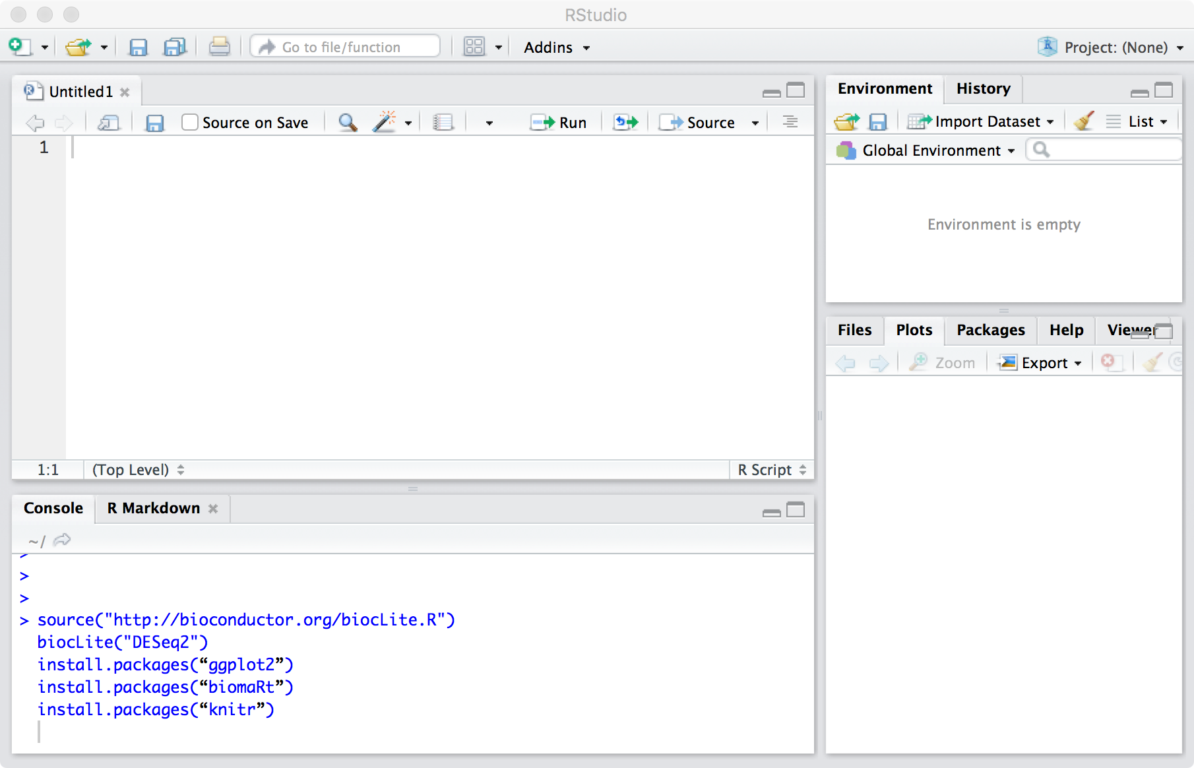

During the installation, it might ask you something like “Update all/some/none”. Type *n* and press enter, because updates are for the weak.

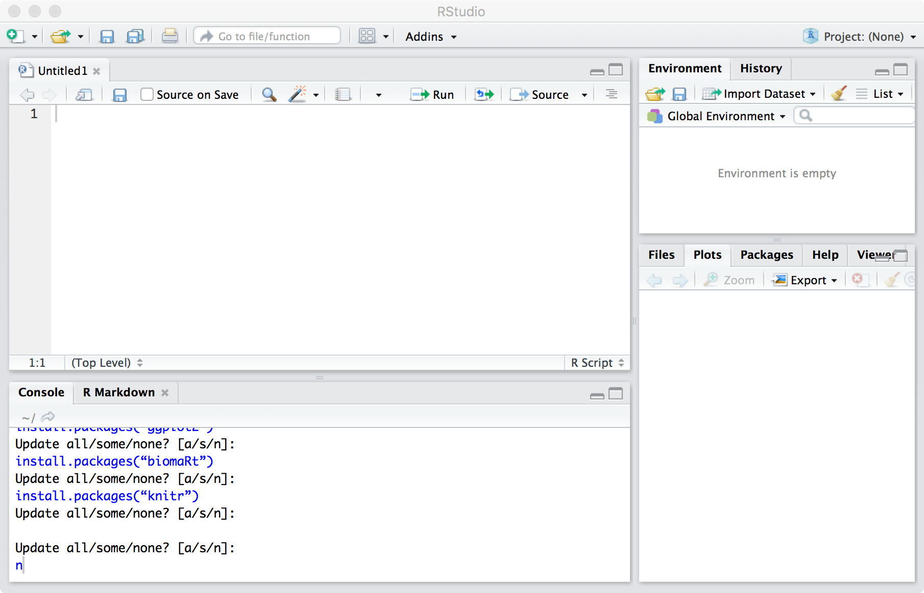

**2) Get Data Files**

* You should have downloaded 2 files:
  + ILS_ISS_saline_HTSeq_nostats.txt
  + ILS_ISS_saline_HTSeq_nostats_covars.txt
* Make sure you save these files in **the same directory**.

**3) Get Analysis Script (Rmarkdown)**

* Go to <https://github.com/jasgrewal/common/tree/master/seminars/r_deseq2_beginners_14062017/scripts>
* Right click “Rtutorial_RNAseq_clustering_DE_ILS_ISS.Rmd”
* Click ‘Save Link As’
* In the pop-up menu, save the file to **the same directory** as your data files. (see Step 2 above).

**4) Open Analysis Script (Rmarkdown)**

At this point, you should have a folder with the following 3 files in it:

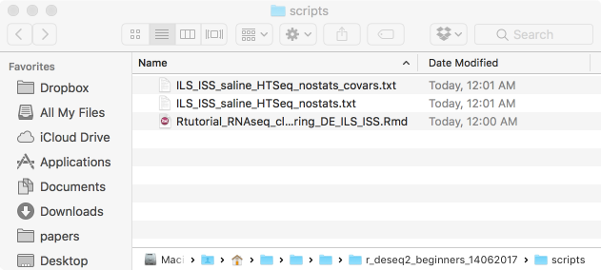

Double-click the .Rmd file to open it. It will open automatically in RStudio (provided you already installed it, in Step 1!).

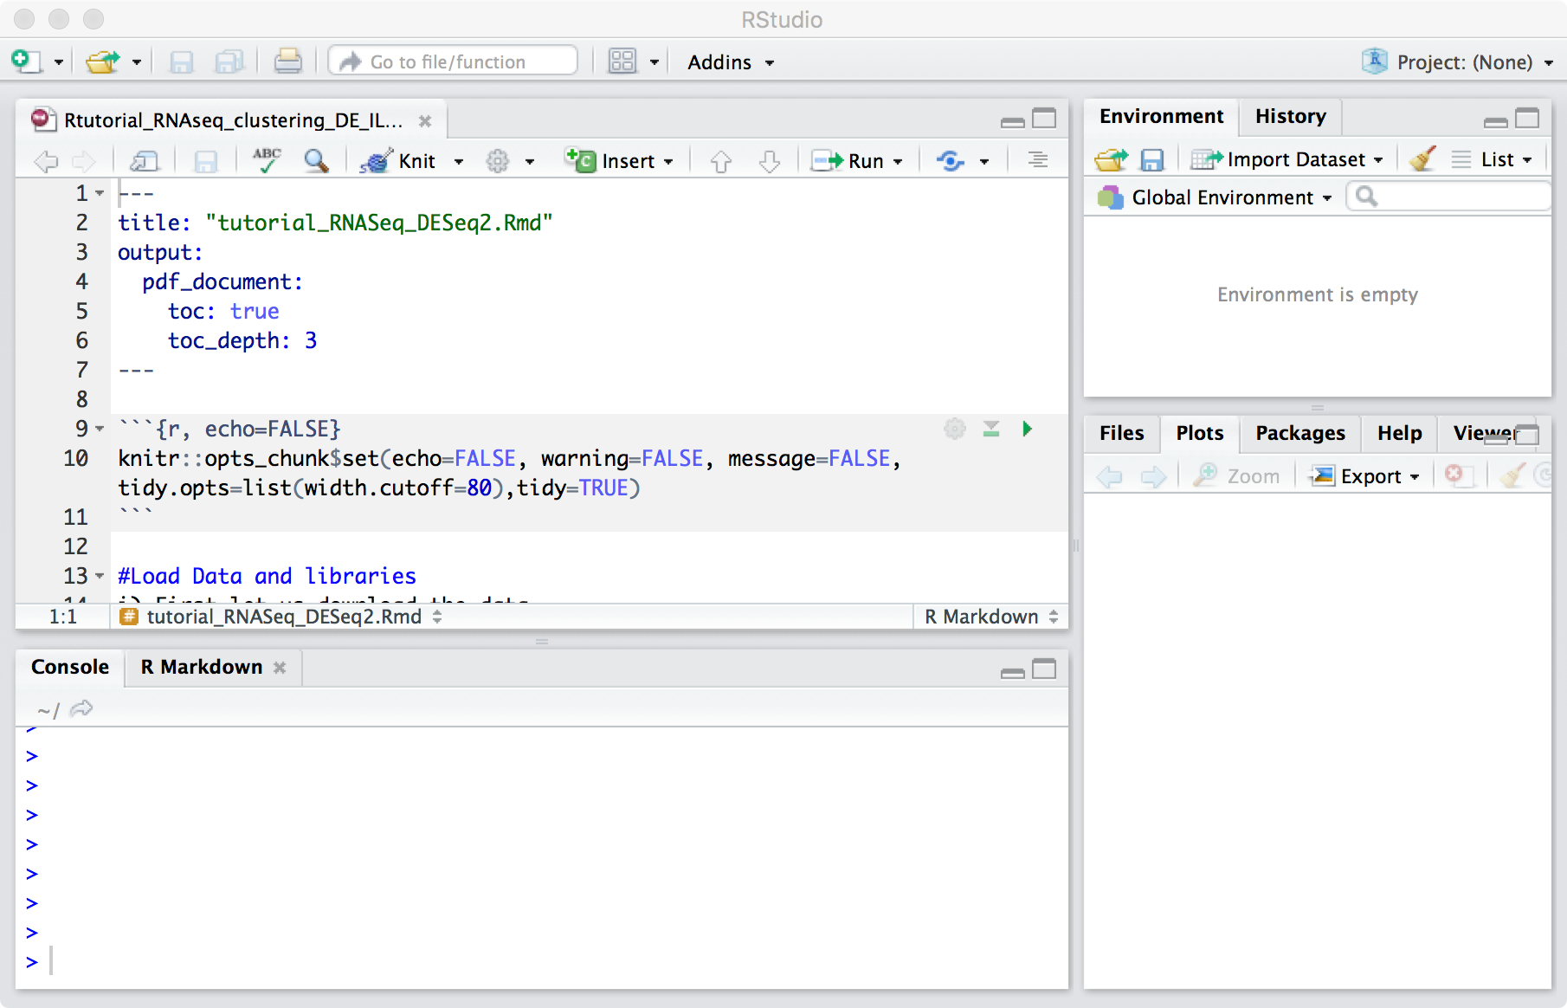

You can follow along with me in-person as I walk through this Rmd and show you how to *execute* the lines of code in it (the lines of code show up in grey, within the triple-quote sections).

*Recommended for beginners:* Alternatively, you can follow along with the pdf version of this file, which already has the different lines of code executed. That way, you can see the output from each line of code. At the end of this presentation, you will ‘knit’ your copy of the rmarkdown file and generate a similar pdf.

**5) Get follow-along pdf version**

* Go to <https://github.com/jasgrewal/common/tree/master/seminars/r_deseq2_beginners_14062017/scripts>
* Click “Rtutorial_RNAseq_clustering_DE_ILS_ISS.**pdf**”
* 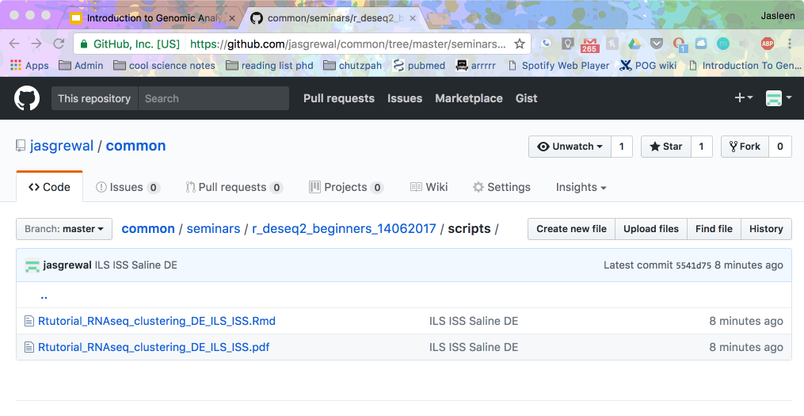
* Click ‘Download’ if you want to download the pdf and follow along. You can also view the pdf in the browser, as shown below in the screenshot.
* 