In the context of bond futures, the concept of "delivery of the cheapest" refers to the practice known as "cheapest-to-deliver" (CTD). Here’s a detailed explanation

Bond Futures Contracts and Delivery
A bond futures contract is an agreement to buy or sell a bond at a future date at a predetermined price. When the contract reaches its delivery date, the holder of the short position (the seller) is obligated to deliver a bond to the holder of the long position (the buyer). Here, again, the delivery price is the price that the buyer agrees to pay for the bond at a point in the future e.g. $100 and the price which the seller is agreeing to sell a bond to the buyer for in the future. We note that the buyer is expecting a 6% guaranteed return from the bond (as standard), we also note that the value of the bond as far as the buyer is concerned is called the 'face value'.
Paul Wilmott states the following in the introduction to quantitative finance: 'bond futures may allow a range of bonds to be delivered. Since the holder of the short position gets to choose which bond to deliver he naturally chooses the cheapest '

what does that mean? How can someone selling (the seller) a contract to guarantee the delivery of a bond of a specified value (principle and the monthly interest/coupon) be able to choose from a range of bonds of various prices to satisfy this order or requirement for the buyer? recall that when someone is buying a bond they are essentially buying someone elses debt, bonds are essentially where a company or a government raises cash by selling (for example) a $100 bond in exchange for $100 in cash and promises to pay that $100 (the principle) plus interest (paid monthly as coupons). Very often the bonds are 10 year bonds, and so the income is basically some entity paying you (as the bond owner) interest payments on their debt because you now own the right be repaid – you are the recipient of the money/loan to be paid back which was borrowed – you're now the person who is owed as being the bond owner.
So really if you're buying a futures contract for a $100 bond then you are buying a contract which gives you the definite assurance/guarantee that on a specific day in the future in exchange for $100 you will get a bond at that value. The futures contract is essentially a 'certificate of guarantee' that you will get the goods that you want (that you signed the contract for) on a day in the future, that could be for oil, wheat or gold, but in this case the 'goods' you have signed for and requested from the seller is a bond, i.e. a company's or governments debt that need to be repaid plus interest. In other words you are investing in the repayment of someone's debt plus interest.

What would fox anyone on the face of looking at this scenario is how on earth the seller on getting hold of a bond with a face value of $100 to satisfy the buyer order could wind up choosing from a range of bonds with a range of prices. Surely a $100 bond is always and everywhere $100 and that's that, and there is no such thing as the 'cheapest $100 bond' which sounds counter intutive. Well we have to differentitate between the 'adjusted price' and the 'face value' and 'market price' taking account of the following equation:

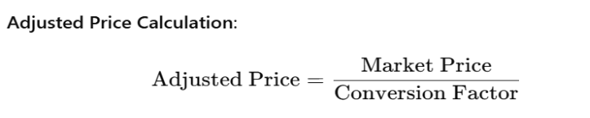
and it is the adjusted price which the seller of the bond takes account of when looking to supply the cheapest-to-deliver bond with a face value of $100.

To get to the root of an example and the idea, we ask chatGPT the following question:

'can you give a simple example of fulfilling a futures contract for a bond 1 year from now for $100 with an expected 6% return and how the seller might use cheapest to deliver and conversion factor to fulfill the futures contract in the cheapest way and how'

and chatGPT gives the following response:

Let's walk through a simplified example of fulfilling a bond futures contract using the cheapest-to-deliver (CTD) concept and conversion factors.

Example Scenario
- Futures Contract Details:
  - The contract specifies delivery of a bond one year from now for $100.
  - The expected return (yield) is 6%.

Bonds Available for Delivery
Assume there are three bonds that meet the eligibility criteria for delivery under the futures contract:
- Bond A:
  - Face Value: $100
  - Coupon Rate: 5%
  - Years to Maturity: 10 years
  - Market Price: $95
  - Conversion Factor: 0.98
- Bond B:
  - Face Value: $100
  - Coupon Rate: 6%
  - Years to Maturity: 10 years
  - Market Price: $100
  - Conversion Factor: 1.00
- Bond C:
  - Face Value: $100
  - Coupon Rate: 7%
  - Years to Maturity: 10 years
  - Market Price: $105
  - Conversion Factor: 1.05

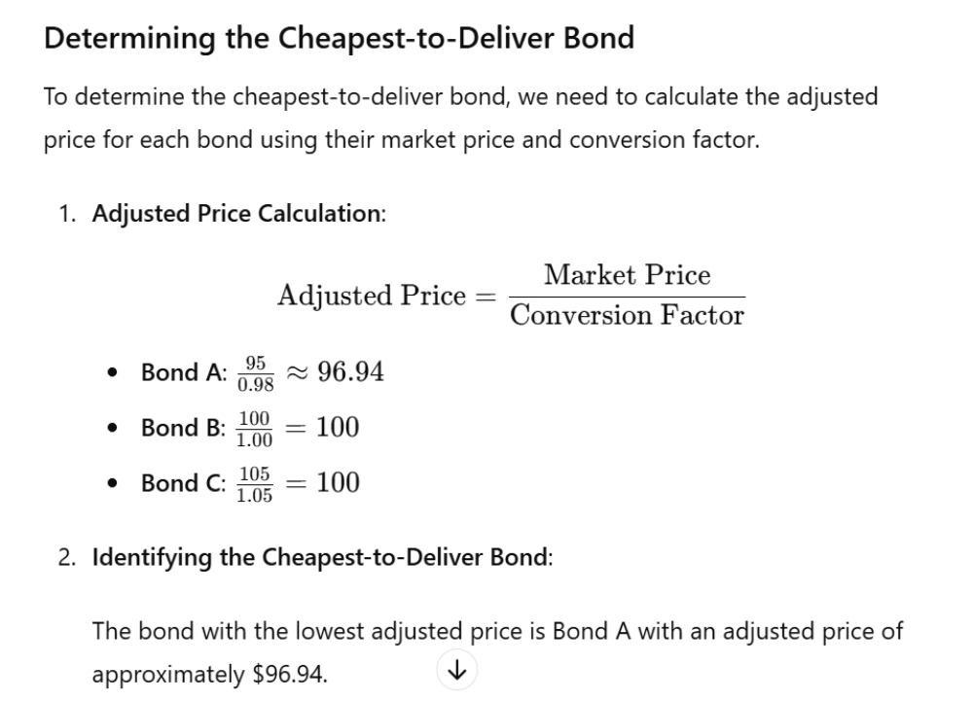

Fulfilling the Futures Contract
The holder of the short position will choose Bond A to fulfill the futures contract because it has the lowest adjusted price and therefore represents the least cost in terms of market price relative to the conversion factor.

Delivery Process
- Futures Contract Settlement Price: $100 (specified in the futures contract)
- Conversion Factor for Bond A: 0.98
To fulfill the contract, the short position holder will deliver Bond A. The futures price to bond price relationship is governed by the conversion factor.

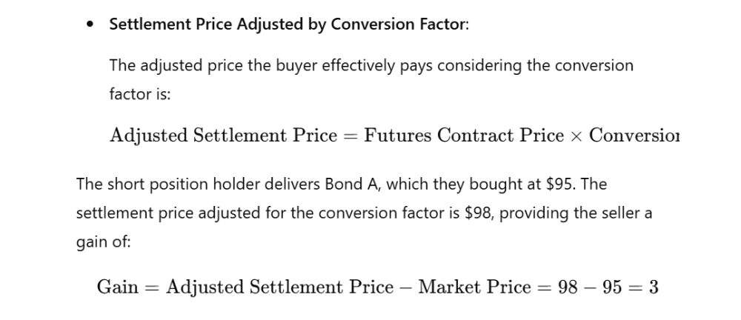
But lets's go into a bit more detail about why (although the face value of the bond is the same, the market price for the bond can be different), what we're really interested to know is: what are the factors effecting the market prices of bonds with the same face value:

Bonds with the same face value can have different market prices due to several factors that affect their perceived value and attractiveness to investors. Here are the main factors that contribute to differences in market prices:

1. Coupon Rate
The coupon rate is the annual interest payment made by the bond relative to its face value. Bonds with higher coupon rates generally have higher market prices because they offer more attractive periodic interest payments compared to bonds with lower coupon rates.

2. Time to Maturity
The time remaining until the bond matures affects its price. Generally, the longer the time to maturity, the more sensitive the bond is to interest rate changes. Investors demand higher yields (and hence, lower prices) for bonds with longer maturities to compensate for the increased risk.

3. Credit Quality
The credit quality or credit rating of the bond issuer impacts the bond’s price. Bonds issued by entities with higher credit ratings (indicating lower default risk) are more attractive to investors and tend to have higher prices. Conversely, bonds with lower credit ratings (indicating higher default risk) have lower prices.

4. Interest Rate Environment
Prevailing interest rates significantly impact bond prices. When interest rates rise, existing bonds with lower coupon rates become less attractive, leading to a decline in their prices. Conversely, when interest rates fall, existing bonds with higher coupon rates become more attractive, leading to an increase in their prices.

5. Market Demand and Supply
The supply and demand for specific bonds in the market also affect their prices. High demand for a particular bond can drive its price up, while low demand can drive its price down.

6. Inflation Expectations
Investors consider expected inflation when buying bonds. If inflation is expected to rise, the real return on bonds (adjusted for inflation) decreases, leading to lower bond prices. Conversely, if inflation is expected to decrease, bond prices may rise.

7. Liquidity
The ease with which a bond can be bought or sold without affecting its price (liquidity) influences its market price. Bonds that are more liquid tend to have higher prices because investors value the ability to quickly enter or exit positions.

Example to Illustrate Differences
Let’s consider three bonds with the same face value of $100 but different market prices:
- Bond A:
  - Face Value: $100
  - Coupon Rate: 5%
  - Years to Maturity: 10 years
  - Market Price: $95
- Bond B:
  - Face Value: $100
  - Coupon Rate: 6%
  - Years to Maturity: 10 years
  - Market Price: $100
- Bond C:
  - Face Value: $100
  - Coupon Rate: 7%
  - Years to Maturity: 10 years
  - Market Price: $105
In this example:
- Bond A has a lower coupon rate of 5% compared to Bond B (6%) and Bond C (7%). Investors are less attracted to Bond A because it offers lower periodic interest payments, resulting in a lower market price of $95.
- Bond B has a coupon rate of 6%, which matches the prevailing market interest rate, so its market price is equal to its face value, $100.
- Bond C has a higher coupon rate of 7%, making it more attractive to investors. This higher demand drives up its market price to $105.
In summary, differences in coupon rates, time to maturity, credit quality, prevailing interest rates, market demand and supply, inflation expectations, and liquidity all contribute to why bonds with the same face value can have different market prices.
On the conversion factor

The conversion factor ensures that the value of the bond delivered is adjusted to be comparable across different bonds. And this all relates to the standardised yield: as standard we can expect to get 6% in coupon payments from investing a 10 year bond (that is the standard market rate of interest return for bonds).
What the conversion factor does is adjust the price of the bond (relative to its face value or principle) by looking at it's coupon payment interest rate and comparing that rate to the standard coupon rate. Clearly if the rate for the bonds coupon payments is lower, then over time i'm going to get less return from that bond than for a bond which has coupon payments which are the same as the standard market rate of bond coupon payments or for a bond with higher coupon payments.
So what we actually do here is we compute how much payment we're going to get over the 10 years from the bond coupons - so the cashflow – and we take that total amount and compare that value against the amount that we would expect to get from a standard bond. And this gives us a comparative rate.
Clearly if I get more money from a $100 bond because of higher coupon payments than the comparative rate of return against the standard bond for that bond (the conversion factor) should be higher.
And clearly if I get less money from a $100 bond because of lower coupon payments than the comparative rate of return against the standard bond for that bond (the conversion factor) should be lower.

Thus for:

Bond A
- Coupon Rate: 5%
- Years to Maturity: 10 years
- Face Value: $100
- Standardized Yield: 6%

Bond B
- Coupon Rate: 6%
- Years to Maturity: 10 years
- Face Value: $100
- Standardized Yield: 6%

Bond C
- Coupon Rate: 7%
- Years to Maturity: 10 years
- Face Value: $100
- Standardized Yield: 6%

we have:

- Bond A: 0.98 (because it has a lower coupon rate than the standardized yield)
- Bond B: 1.00 (coupon rate matches the standardized yield)
- Bond C: 1.05 (higher coupon rate than the standardized yield)

and finally (for reference) here is the conversion factor calculation:

