Futures Contracts: Storage Cost and Convenience Yield 15/07/2024

we ask ChatGPT the following question:

'what is the concept of storage (s) and the convenience yield (c) with respect to futures contracts?'

and we get the following answer:

The concepts of storage and convenience yield are crucial in understanding the pricing and behavior of futures contracts, especially for commodities. Here's a detailed explanation of each:

Storage Costs
Storage costs refer to the expenses associated with storing a physical commodity until it is delivered under a futures contract. These costs can include:
- Warehousing Fees: Charges for physically storing the commodity.
- Insurance: Costs to insure the commodity against loss or damage.
- Financing Costs: The opportunity cost of capital tied up in the inventory.
Storage costs are important because they affect the futures price. The more expensive it is to store a commodity, the higher the futures price relative to the spot price.
Clearly if whoever is holding the commodity endures a cost for 'holding' that commodity up and until the delivery date of the commodity to the buyer, then that 'holding' or storage cost must necessarily be factored into the price of the commodity at a future date as the cost of storage over time has to be factored in to the price of the commodity/the asset underlying the futures contract. Hence storage is given as an increase factor on price for the buyer.

Convenience Yield
Convenience yield is a return that holders of the physical commodity receive from holding the inventory. It represents the benefits or utility gained from physically holding the commodity rather than holding a futures contract for future delivery. These benefits can include:
- Insurance Against Shortages: Having the physical commodity on hand provides insurance against potential supply disruptions or shortages.
- Production Benefits: For manufacturers or producers, having immediate access to raw materials can be crucial for continuous production.
- Speculative Benefits: In times of market stress or volatility, physical possession of the commodity might provide speculative advantages.
In a sense this is the reverse of the 'storage' cost because here holding or storing the commodity is beneficial to the holder of the commodity – such as immediate (on demand) access to a raw material without the need to ship/procure it or indeed suffer a shortage of it, all of which would incovenience the company and likely cost a company time and money. Hence the convenience yield in calculating the cost of a future is given as a reduction factor on the price in relation to the buyer.

The Relationship of Storage and Convenience with Futures Prices (the 'cost of carry' model)
The relationship between futures prices, spot prices, storage costs, and convenience yield can be described through the cost of carry model. This model helps explain the pricing of futures contracts with the additional aspects of storage and convenience factored into the price:
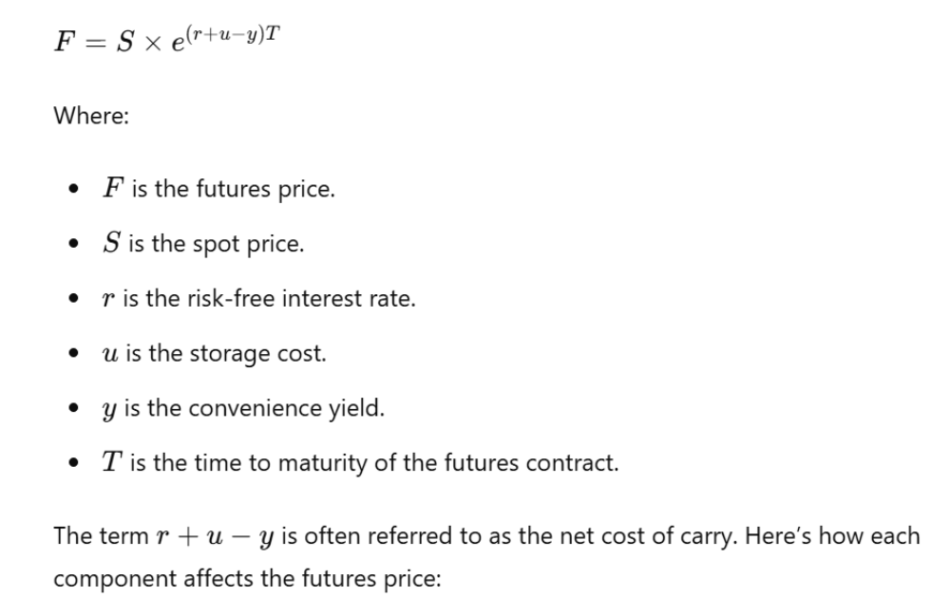

Now lets focus on r+u-y for a moment as being the 'net cost of carry' – clearly if the holder sold the asset for cash and put that money in the bank (a hypothetical situation but we can imagine that happening) that would result in an interest yield of 'r' which the holder of the asset could otherwise obtain, so in a sense that 'absence of cash interest gain opportunity' is a cost to the holder of the asset. Similarly 'u' is the cost of storage in a warehouse or otherwise as space and storage tends to cost be it rental of space or missing out on using the space for other purposes or indeed labour/security costs associated with the storage. But 'y' the convenience yield – that is to say the convenience for the company of having the raw commodity 'on tap' so to speak is a benefit in terms of time and cost and therefore can be subtracted from the loss in potential interest/cash gain and the costs of storage. Thus r+u-y becomes the net impact on holding the product over time before it is delivered to the buyer in the future, these are therefore very practical considerations when pricing the futures contract.

In detail then we have:

- Risk-Free Interest Rate (r): The cost of financing the purchase of the commodity – I would say this more about loss of potential interest rate to the seller (as they are not cashing in the commodity for cash and therefore unable to access the potential interest gain)
- Storage Costs (u)/(s): Directly increase the cost of carrying the commodity, thus increasing the futures price.
- Convenience Yield (y)/(c): Represents the benefits of holding the physical commodity, which effectively lowers the net cost of carry and can decrease the futures price.

Key Points to Remember
- Higher Storage Costs: Lead to higher futures prices, all else being equal.
- Higher Convenience Yield: Leads to lower futures prices, as the benefit of holding the commodity offsets some of the carrying costs.
- Net Cost of Carry: The combination of interest rate, storage costs, and convenience yield determines the relationship between spot and futures prices.
Understanding these concepts is vital for traders and investors in commodities futures as they influence hedging strategies, arbitrage opportunities, and overall market behavior.

If the actual cost of the futures contract factoring the above and time in is therefore:

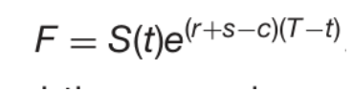
(where s is the storage cost and c is the convenience yield).

Then if we track the price of the underlying asset with interest over time against the price of the Future (which should in theory have a linear relationship) we can get the following situations:


This is when the overall price of the Futures contract (F) having factored in storage and convenience costs tracks to be a lower cost than the money we would get if we cashed the underlying asset in to the bank and added the conventional central banking interest rate (the so-called 'risk free' rate – which is typically around 5-6% compounded). This can only mean that the convenience factor (as being the only cost reductive factor) has pulled the cost down over time. This is a good thing for the buyer because they can short the asset now, cash the money in to the bank accrue the interest on the cash, buy the asset back in future which will be less than the cash plus interest and therefore pocket the difference.
When the price of the Future is tracking to be less than the underlying plus risk free interest compiunded over the same period of time the market is said to be in 'backwardisation' because the value of the contract in relation to the progressive value of the underlying is diminishing with time.
But when we have:

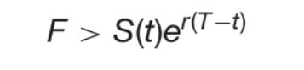
Or in other words when the value of the contract exceeds the value of the underlying plus the interest free risk rate compounded over time then the market is set to be in 'contango' and clearly here the value of the Futures contract (F) is appreciating with respect to the value of the underlying asset plus interest over time, which can only be happening because of the additional storage costs. Is Is there room for arbitrage again? Apparently here we short the futures contract (F), get the cash, put it in the bank, get a greater return on the base amount (F) than we would on the underlying (S) because (F) as a base amount is higher than the underlying (S), so we don't get a greater return on (F) because of a higher interest rate (r), we get a greater return because our principle (F) is greater than the principle (S).

