Interest – Continous Compunding Interest vs Discrete Interest 02/07/2024

I will first discuss what I consider to be the idea of continuous compounding Interest drawing from some of the formulae and text in chapter 1 of 'Introduction to QF' and below we will outline further links, explanations and text taken from other websites such as investopedia explaining the concept and giving examples.
Essentially discrete interest (or a discrete interest rate) involves calculating interest at specific points in time e.g. annually, monthly or weekly. With continous compound interest (conversely) we have to imagine time chopped up into infinitesimally tiny moments, an infinite number of teeny, tiny moments in fact, this is why Paul Wilmott states the following (where 'm' means 'number of payment intervals):

“Now I am going to imagine that these interest payments come at increasingly frequent intervals, but at an increasingly smaller interest rate: I am going to take the limit m →∞.”

What he is saying is that we are moving from a specific (discrete) number of payments within a time period (typically 1 year) to an infinite (hence the squiggly symbol) number of payments within the time period which switches the calculation to be continuous rather than discrete. In other words the base stated rate of 10% over 1 year (or whatever that rate might be) is divided up into an infinite number of slices of the overall 10%. The idea of paying a slice of interest at every single conceivable waking/blinking moment seems pretty awful to me when I reflect on it (well if you're the person having to pay the interest at least) , but recall that this notion of infinite time-slices of payments is still based on an overall interest rate e.g. 12% per year, so in other words the payment of interest at each inifinitely tiny moment is actually inifinitely tiny (if that is any consolation!), in this case the payment of interest at each infinitely tiny moment is an infinitely tiny slice of 12%.

Let us elaborate upon this further, taking the distinction of discrete compounding interest vs continously compounding interest.

First discrete compounding interest:

Let 'n' be the number of specific (discrete) interest payments within a year and let 'r' be the interest rate.
A bank states that it is going to pay interest on $100 4 times over a year (n = 4) at a rate of 10% (r = 0.1), note that as the interest is added at each period the next increase factors in (adds to) the increase in interest already applied in the prior period (which is why we call this compounding interest). The formula (calculation) is as follows:

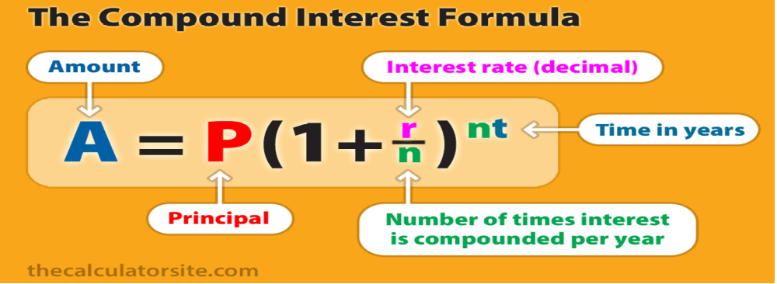

Thus (for a principle of $100 with an interest rate of 10% compounded 4 times in the year over 1 year) we have:
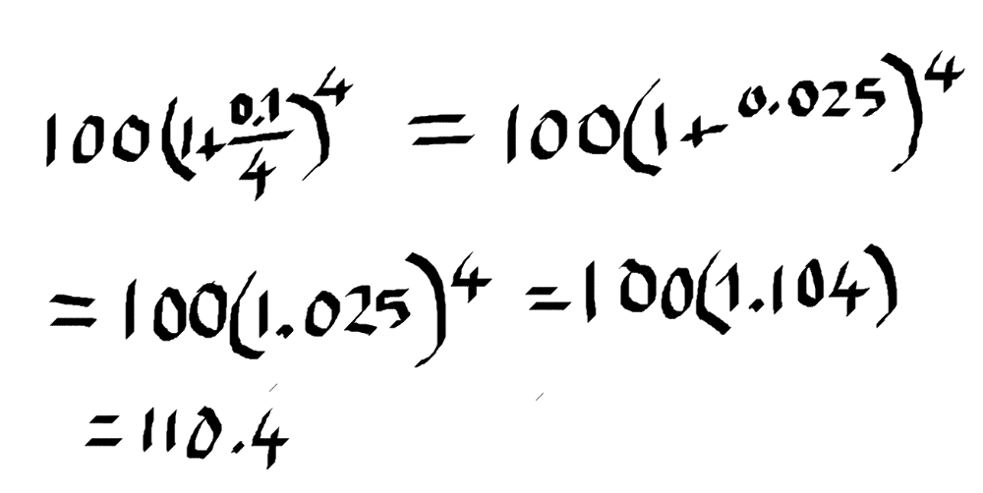

In a spreadsheet (here I have used open office), the formula for the above calculation would look like this:

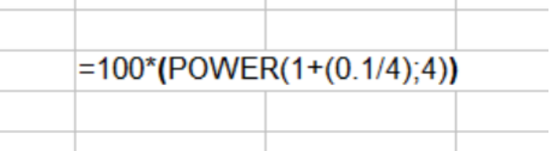
Note (in the example) I have left t (time in years) implicitly as being '1' i.e. 1 year, which is fairly usual in interest rate calculations (the time tends to be left as/assumed to be 1 year).

Now for the continuously compounded interest rate formula:

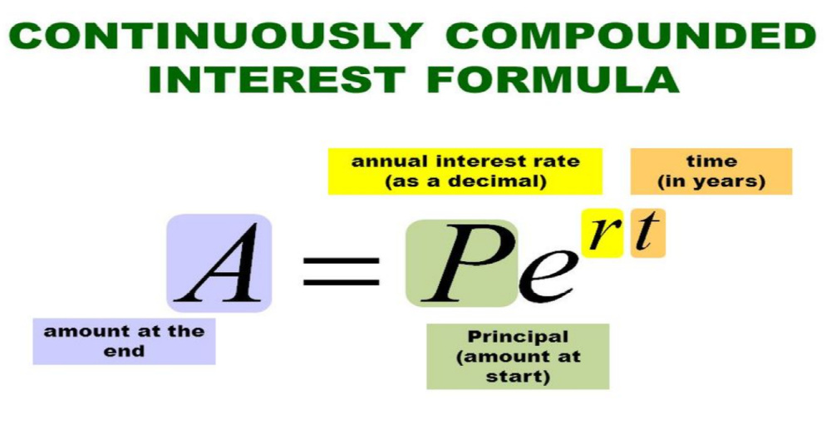

notice the use of euler's constant (e) as the base for the power in the calculation, clearly from here (by some apparent magic) we can state that by using euler's constant as a base and raising that to the power of the interest rate, that gives us the compounded totality of inifinitely tiny slices of the interest rate over 1 year multipled by the principal (in this case $100), which gives us (going straight to the spreadsheet for the calculation):

=100*(EXP(0.1))

or if you want to do it more literally (taking e as being the base constant 2.7183 – see below) we have:

=100*(POWER(2.7183;(0.1)))

from both we get the result: $110.517

(note the mathematical constant, eulers constant used as a based for compounding over 1 year is 2.7183 and therefore we can say that eulers constant raised to a power clearly has the property of continous compounding)

also note that this feature of using eulers constant to achieve continous compounding over a given time period (typically a year) will feature repeatedly in other formula as we work through the discipline of Quantitative finance.

Thus (for example) in the black sholed merton formula calculating the price of a stock at maturity the same idea is at play:

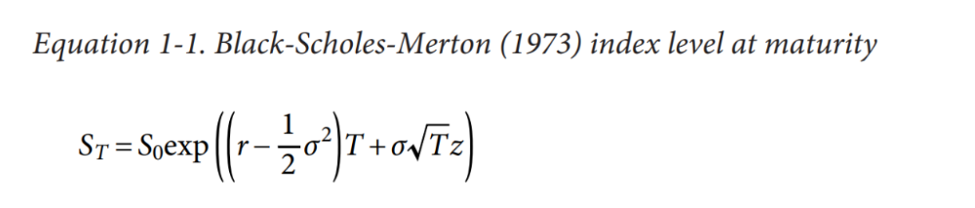

the exp function is this:

exp(x) or e^{x}
??

In other words, in a more simplified form, what the Black Scholes Merton equation for working out a stock price at a time in the future is exactly doing is this:

ST = S0*exp^{(rt)}

Or to put it another way, what we have is the present stock price (S0) multipled by eulers constant raised to the power of the annualised interest rate adjusted by the time factor (t). In other words the black scholes merton formula is arriving at the future stock price using a continously compounding interest rate – its the same idea at work
More on this:

from:

https://www.investopedia.com/articles/07/continuously_compound.asp

What Is the Difference Between Discrete and Continuous Compounding?
Discrete compounding applies interest at specific times, such as daily, monthly, quarterly, or annually. Discrete compounding explicitly defines the time when interest will be applied. Continuous compounding applies interest continuously, at every moment in time.

Does Compounded Continuously Mean Daily?

Compounded continuously means that interest compounds every moment, at even the smallest quantifiable period of time. Therefore, compounded continuously occurs more frequently than daily. However, daily compounding is considered close enough to continuous compounding for most purposes.

Why Is Continuous Compounding Used?
Continuous compounding is used to show how much a balance can earn when interest is constantly accruing. This allows investors to calculate how much they expect to receive from an investment earning a continuously compounding rate of interest.

When Do You Use Continuous Compound Interest?

You are unlikely to encounter continuous compound interest in consumer financial products, due to the difficulty of calculating interest growth over every minute and second. Continuous compound interest is most relevant to financial professionals and other specialists because the calculation is much simpler than the corresponding formula for discrete compounding interest.2

Risk Prep. "More About Continuous Compounding."

The Bottom Line
We can reformulate annual interest rates into semiannual, quarterly, monthly, or daily interest rates (or rates of return). The most frequent compounding is continuous compounding, which requires us to use a natural log and an exponential function, commonly used in finance due to its desirable properties. Compounding continuously provides a calculation that can scale easily over multiple periods and is time consistent.

Example of Continuous Compound Interest
Assume a loan with an annual interest rate of 12%. If we start the year with $100 and compound only once, at the end of the year, the principal grows to $112 ($100 x 1.12 = $112). Interest applied only to the principal is referred to as simple interest.

If we instead compound each month at 1%, we end up with more than $112 at the end of the year. That is, $100 x 1.01^12 equals $112.68. (It's higher because we compounded more frequently.)

Now assume interest is compounded continuously, starting immediately as the loan is signed. That means that the balance due grows by 0.0329% every day. Assuming 365 days in a year, the amount due will be $100 x 1.000328^365 by the end of the year, or $112.75.

It is possible to get the total interest even higher by compounding every hour, or even every minute, but such terms would be impractical for most financial institutions. In practice, the more frequently interest is compounded, the closer the total accumulation will be to the continuous compounding formula.

