On interest rates and inflation 08/07/2024

We have already noted that when a central bank of a given country increases interest rates that causes the value of a currency to rise/the demand for that country's currency to rise. Why? Well, recall that a higher interest rate offered by the central bank of a given country attracts investors to that country and prompts investors to exchange their native investment into the currency of the country which is offering the higher interest rate (effectively buying the currency of the country in question) and thereby enabling them to reap the benefits of that higher interest rate.

In Chapter 1 Paul Wilmott states that there is a relationship between inflation and interest rates. What link is this? The US CPI (consumer price index) shows changes in inflation (essentially an increase in the cost of living/how expensive goods are in the US – so fewer or less goods per unit of currency):

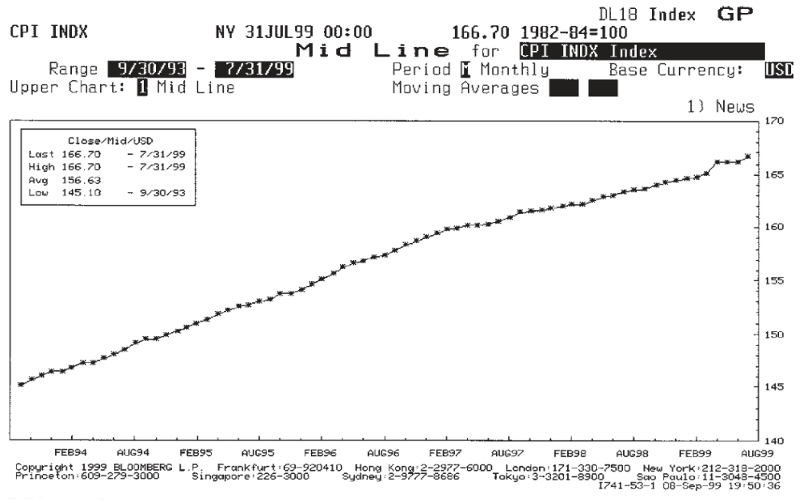
clearly the higher the CPI, the less goods per buck so-to-speak, in other words the higher the rate of inflation the less valuable the unit of currency is. If goods are more expensive, that must be because companies are charging more money for goods and if the price of goods keeps rising that must be because (in some senses) people are still prepared to pay the price for the goods in question i.e. that there is still high demand and people are continuing to pay the high prices demanded by companies.
But clearly ever increasing inflation rates is NOT a good thing – for if the cost of living persists in escalating then people cannot afford to live. Increasing costs of goods seems to imply ever increasing profits for companies from escalating prices and in turn ever increasing profits for shareholders and investors who are investing in the companies in question. The implication is that by raising interest rates the bank can reduce inflation.
This takes us back to our original question: how does an increase in interest rates lower inflation? An increase in interest rates attracts investors to invest in bonds and savings accounts with the central bank rather than buying shares in companies, furthermore increasing interest rates makes it more expensive for companies to raise cash by borrowing from banks because loans (owing to increased interest rates are now far more expensive). Given that bank loans are now too expensive how do companies (now) raise cash(?), they have to sell more shares; but investors are already selling off shares in order to put their money into banks and bonds (because of a higher return owing to the increased interest rate) thus demand for shares has already dropped even before companies start increasing the supply of shares by creating more shares, so what we're now seeing owing to an increase in interest rates is a drop in the demand for shares whilst simultaneously increasing the supply of shares which will inevitably spell a drop in share prices and a reduced cash-flow for companies, will such a drop in share value and company investment reduce the prices of the company's goods? Not necessarily... factors like demand and/or cost of raw materials are more likely to influence whether of not the company will reduce its prices so although it is interesting (here) to note the effect of interest on a companies share prices and why we still have not found a plausible link between interest rates and inflation.

A more plausible link between interest rate rise and a reduction in inflation is a reduction in consumer spending. This reduction of spending is attributed to a few factors:

- Increased interest rates mean people focus on saving their money because the interest rates are so high, so people spend less and save more
- Increased interest rates means the cost of credit and loans is too high so people borrow less and spend less

So the idea is that if interest rates are increased consumers stop spending so much and therefore spending and demand decreases. If demand decreases it logically follows that prices should fall and that therefore inflation should fall. Here then is one logical connection between interest rates and inflation.

One further question which we need to ask before moving on from the subject of interest and inflation, is this: 'why offer government bonds (gilts) indexed against inflation, whose return/interest rate therefore aligns with inflation rates?' In answer to this we can contrast Fixed Rate Bonds with a Bond whose rate of return varies according to an index of inflation e.g. (the retail price index). Clearly with an indexed bond the return will rise as inflation rises and the advantage with this is that as inflation rises the value of the fixed rate bond returns is depreciating because we're getting less bang per buck so-to-speak from our money as inflation increases because even though the cost of living is rising and the value per unit of currency is decreasing our return is not increasing because it is fixed rate. Not so with the indexed bond whose returns increase as inflation increases.

