Continously Compounding Interest – Computing the present value 08/07/2024

Assuming that we have a final amount after a given time (t) and that this final amount is as a result of continously compounding interest at an interest rate (r) what was the initial amount we invested? This is essentially the reverse of the computation which we already know which computes the amount from now into the future after time (t), which is:

e^{rt}

To revisit this computation in aspreadsheet land we have the following example:

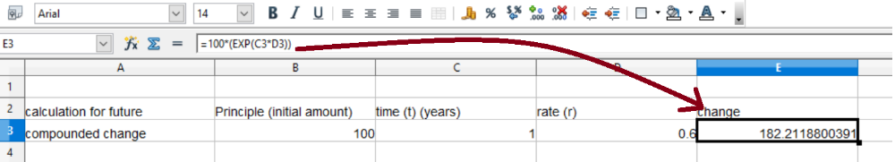
note the use of the function 'exp' for the exponent that is to say eulers constant raised to whichever power you specify which is t*r.

The reverse of the above computation which is from the future to now is given by:

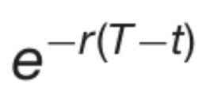
With the above example of present to future then reversed from future to present thus:

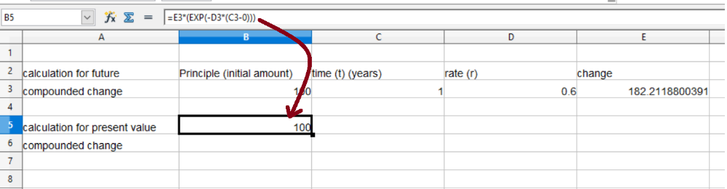
Note the future amount on the right hand side in cell E3 has its value retrograded so-to-speak back to its present value (which we already know is 100)

Another way to phrase the computation of a continously compounded change back to its present value is:

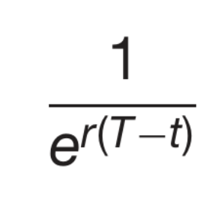
and that computation in spreadsheet land is as follows:

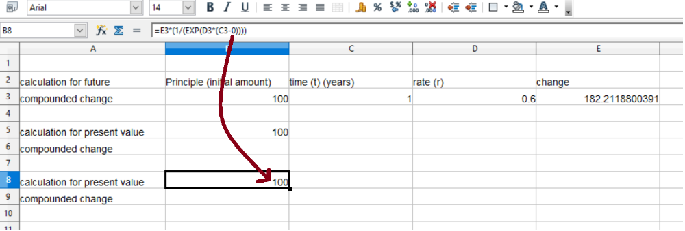

This is what is known in finance as calculating the present value of cashflows.

