建立OpenGL的檢視工具
- 在OpenGLView建立void Create3DAxis()、void SetupList()、GLPrintText(double x, double y, double z, const char *const string)、CreateFont()、Show3DAxis(int cx, int cy)、Draw3DAxis()、ModelToScreen(double x, double y, double z, int &cx, int &cy)。

- 在OpenGLView增加GLubyte AxisXColor[3]、AxisYColor[3]、AxisZColor[3]，GLuint AxisList、FontList，int Show3DAxisType、Show3DAxisSize。

- 在OpenGLView之建構式內給予AxisXColor、AxisYColor、AxisZColor、AxisList、FontList、Show3DAxisType、Show3DAxisSize初始值如下：
OpenGLView::OpenGLView()
{
GLHardAccel=FALSE;
m_pDC=NULL;
m_hRC=NULL;
AxisXColor[0]=255;AxisXColor[1]=128;AxisXColor[2]=128;//座標X軸:淡紅
AxisYColor[0]=128;AxisYColor[1]=255;AxisYColor[2]=128;//座標Y軸:淡青
AxisZColor[0]=128;AxisZColor[1]=128;AxisZColor[2]=255;//座標Z軸:淡紫
AxisList=0;
FontList=0;
Show3DAxisType=1;
Show3DAxisSize=120;
}

- 在OpenGLView::Create3DAxis加入如下：
void OpenGLView::Create3DAxis()
{
wglMakeCurrent(m_hDC,m_hRC);

glMatrixMode(GL_PROJECTION);
glPushMatrix();
glLoadIdentity();
glMatrixMode(GL_MODELVIEW);
glPushMatrix();
glLoadIdentity();
glNewList(AxisList,GL_COMPILE);
glBegin(GL_LINES);
glColor3ubv(AxisXColor);//x axis
glVertex3f(0.0f,0.0f,0.0f);
glVertex3f(1.0f,0.0f,0.0f);
glVertex3f(1.0f,0.0f,0.0f);
glVertex3f(0.9f,0.1f,0.0f);
glVertex3f(1.0f,0.0f,0.0f);
glVertex3f(0.9f,-0.1f,0.0f);

glColor3ubv(AxisYColor);//y axis
glVertex3f(0.0f,0.0f,0.0f);
glVertex3f(0.0f,1.0f,0.0f);
glVertex3f(0.0f,1.0f,0.0f);
glVertex3f(0.1f,0.9f,0.0f);
glVertex3f(0.0f,1.0f,0.0f);
glVertex3f(-0.1f,0.9f,0.0f);

glColor3ubv(AxisZColor);//z axis
glVertex3f(0.0f,0.0f,0.0f);
glVertex3f(0.0f,0.0f,1.0f);
glVertex3f(0.0f,0.0f,1.0f);
glVertex3f(0.0f,0.1f,0.9f);
glVertex3f(0.0f,0.0f,1.0f);
glVertex3f(0.0f,-0.1f,0.9f);

glEnd();
GLPrintText(0.,0.,1.,"Z");
glColor3ubv(AxisXColor);
GLPrintText(1.,0.,0.,"X");
glColor3ubv(AxisYColor);
GLPrintText(0.,1.,0.,"Y");
glEndList();
glPopMatrix();
glMatrixMode(GL_PROJECTION);
glPopMatrix();
wglMakeCurrent(NULL,NULL);
}

- 在OpenGLView:: SetupList加入如下：
void OpenGLView::SetupList()
{
wglMakeCurrent(m_hDC,m_hRC);
FontList=glGenLists(256);
AxisList=glGenLists(1);
wglMakeCurrent(NULL,NULL);
}

- 在OpenGLView:: GLPrintText加入如下：
void OpenGLView::GLPrintText(double x, double y, double z, const char *const string)
{
glListBase(FontList);
glRasterPos3d(x,y,z);
glCallLists(strlen(string),GL_UNSIGNED_BYTE,string);
glListBase(0);
}

- 在OpenGLView:: CreateFont加入如下：
void OpenGLView::CreateFont()
{
wglMakeCurrent(m_hDC,m_hRC);
SelectObject(m_hDC, GetStockObject (SYSTEM_FONT));
wglUseFontBitmaps(m_hDC,0,255,FontList);
wglMakeCurrent(NULL,NULL);
}

- 在OpenGLView:: Show3DAxis加入如下：
void OpenGLView::Show3DAxis(int cx, int cy)
{
glMatrixMode(GL_PROJECTION);
glPushMatrix();
glLoadIdentity();
glViewport((int)(cx-0.5*Show3DAxisSize),(int)(cy-0.5*Show3DAxisSize),Show3DAxisSize,Show3DAxisSize);
glOrtho(-1.3,1.3,-1.3,1.3,-1.3,1.3);
glCallList(AxisList);
glPopMatrix();
glViewport(0,0,ScrWidth,ScrHeight);
}

- 在OpenGLView:: Draw3DAxis加入如下：
void OpenGLView::Draw3DAxis()
{
if (Show3DAxisType>0)
{ int cx,cy;
glDisable(GL_DEPTH_TEST);
switch(Show3DAxisType)
{ case 1:cx=(int)(ScrWidth-0.5*Show3DAxisSize);
cy=(int)(0.5*Show3DAxisSize);
Show3DAxis(cx,cy);
break;//右下角
case 2:ModelToScreen(-ObjTransX,-ObjTransY,-ObjTransZ,cx,cy);
Show3DAxis(cx,cy);
break;//座標原點
case 3:cx=(int)(0.5*ScrWidth);
cy=(int)(0.5*ScrHeight);
Show3DAxis(cx,cy);
break;//螢幕中間
default:break;
}
glEnable(GL_DEPTH_TEST);
}
}

- 在OpenGLView:: ModelToScreen加入如下：
void OpenGLView::ModelToScreen(double x, double y, double z, int &cx, int &cy)
{
GLdouble a[16],b[16];
GLint c[4];
GLdouble wx,wy,wz;

glMatrixMode(GL_MODELVIEW);
glGetDoublev(GL_MODELVIEW_MATRIX,a);
glMatrixMode(GL_PROJECTION);
glGetDoublev(GL_PROJECTION_MATRIX,b);
glGetIntegerv(GL_VIEWPORT,c);
gluProject(x,y,z,a,b,c,&wx,&wy,&wz);
cx=(int)wx;
cy=(int)wy;
}

- 在OpenGLView::OnCreate加入：
int OpenGLView::OnCreate(LPCREATESTRUCT lpCreateStruct)
{
if (CView::OnCreate(lpCreateStruct) == -1)
return -1;

// TODO: Add your specialized creation code here
if (InitializeOpenGL()==FALSE)
return -1;
SetupList();
CreateFont();
Create3DAxis();
return 0;
}

- 在OpenGLView::OnDraw加入：
void OpenGLView::OnDraw(CDC* pDC)
{
CDocument* pDoc = GetDocument();
// TODO: add draw code here
wglMakeCurrent(m_hDC, m_hRC);
glFlush();
glClear(GL_COLOR_BUFFER_BIT | GL_DEPTH_BUFFER_BIT);// clear background
glMatrixMode(GL_MODELVIEW);
glPushMatrix();
glTranslated(ObjTransX,ObjTransY,ObjTransZ);
GLRender();
glPopMatrix();
Draw3DAxis();
glFinish();
SwapBuffers(m_hDC); // if double buffering is used it's time to swap the buffers
wglMakeCurrent(NULL,NULL);
}

- 在OpenGLView::OnDestroy中加入：
void OpenGLView::OnDestroy()
{
CView::OnDestroy();

// TODO: Add your message handler code here
wglMakeCurrent(m_hDC,m_hRC);
if (m_hRC!=NULL)
wglDeleteContext(m_hRC);
if (m_pDC)
delete m_pDC;// delete the DC
if (FontList>0)
glDeleteLists(FontList,256);
if (AxisList>0)
glDeleteLists(AxisList,1);
wglMakeCurrent(NULL,NULL);
}

- 執行結果：
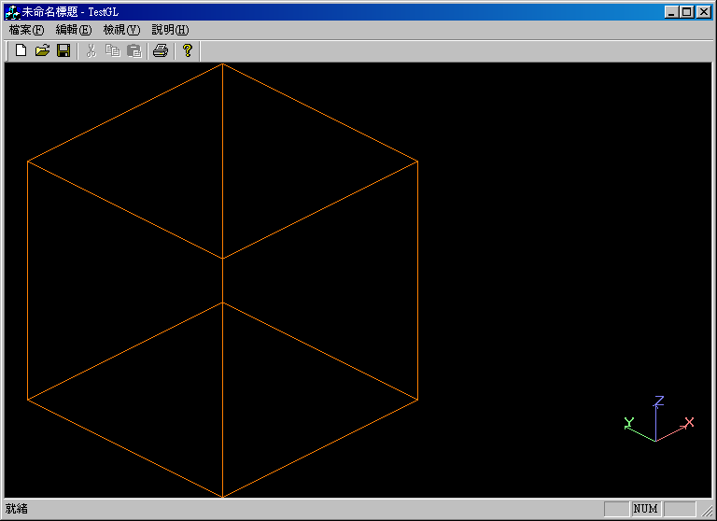
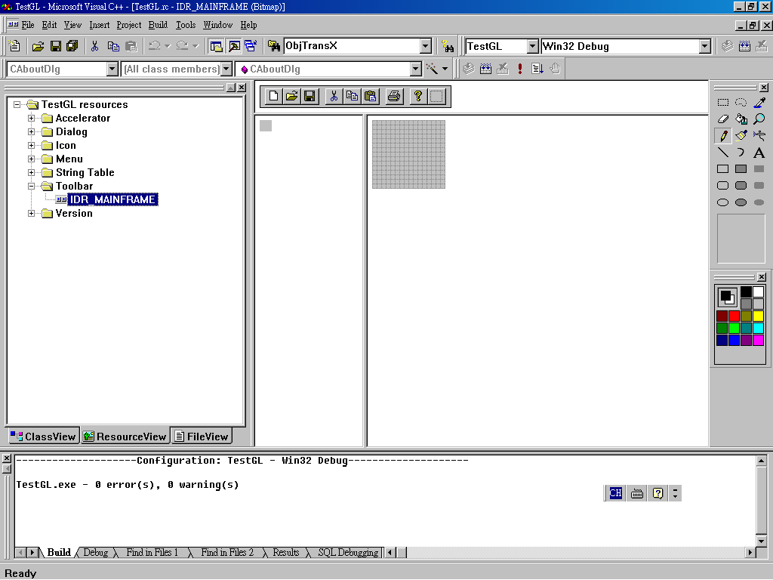
- 建立Toolbar上的檢視按鈕，依下圖的圖標順序點選：
1
2
3
4

- 彈出如下的對話框，在 ”ID” 欄位輸入ID_VIEW_ALL。
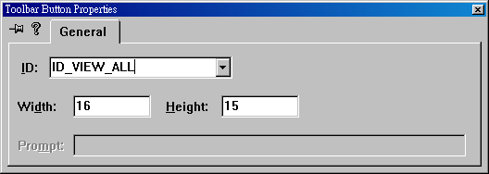
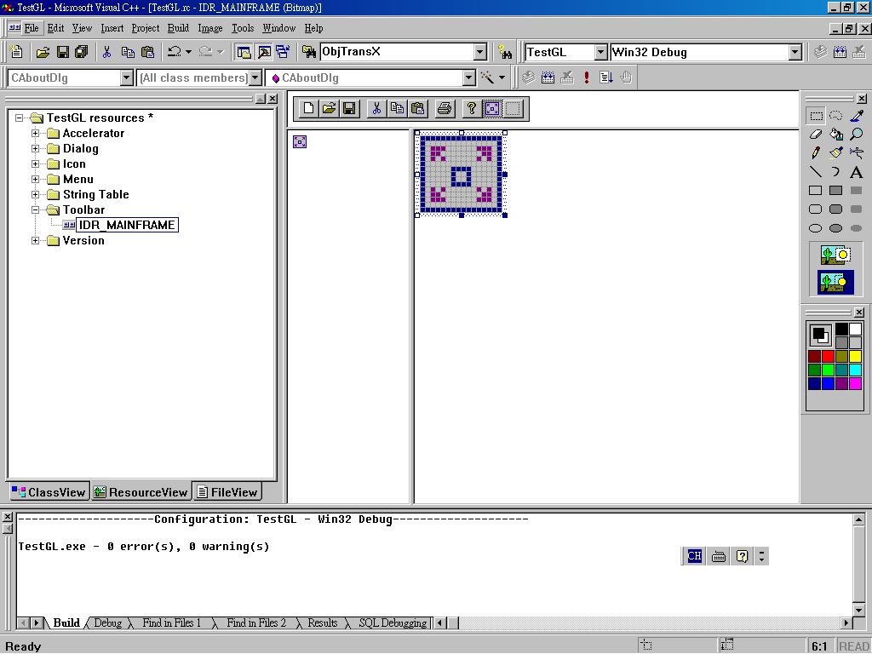
- 在圖標1處繪製ICON的圖示。
1

- 再點選該ICON，彈出如下之對話框，在 ”Prompt” 欄位輸入欲顯示的訊息文字。
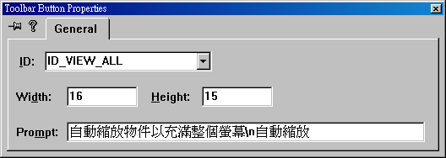
- 仿照步驟16、17、18建立其它檢視ICON如下圖所示：
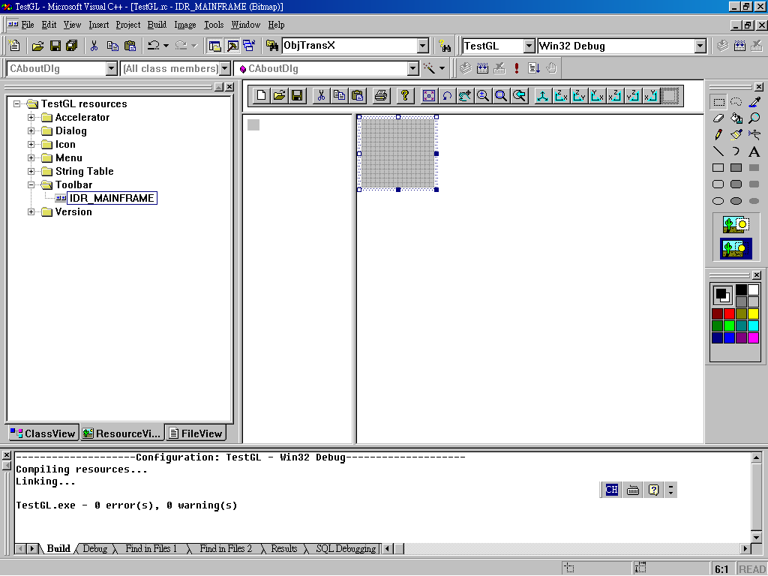
- 產生各檢視ICON的執行函式，如下圖點選CTestGLView，再按滑鼠右鍵，選擇 “Add Windows Message Handler…”。
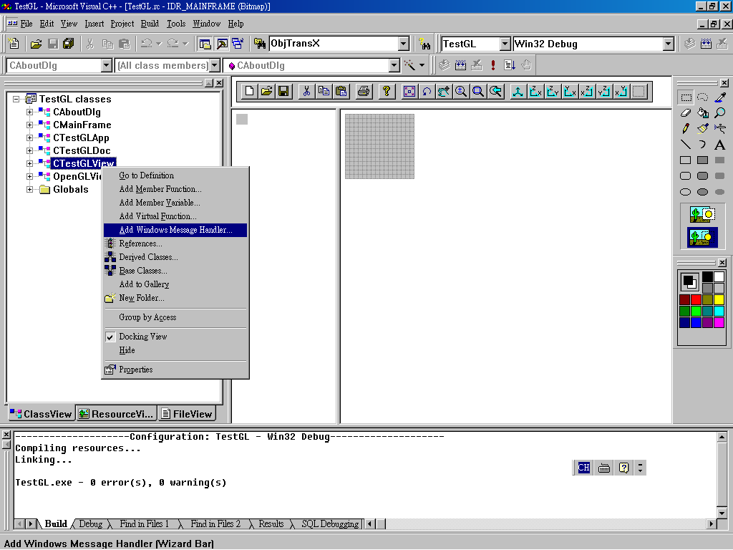
- 出現如下對話框，挑選 “Class or object to handle”，分別選取各檢視ICON的ID，再點選COMMAND，最後按 ”Add Handler” 按鈕。
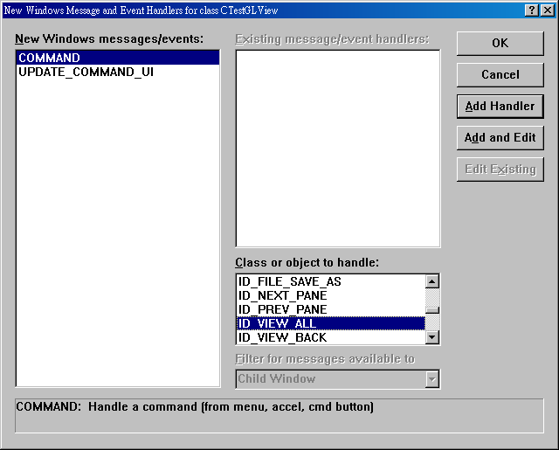
1
2
3
- 在各視角切換的執行函式編輯內容如下：
void CTestGLView::OnViewAll()
{
// TODO: Add your command handler code here
ViewAll();
}

void CTestGLView::OnViewIso()
{
// TODO: Add your command handler code here
SetModelViewMatrix(-60.,0.,45.);
}

void CTestGLView::OnViewLeft()
{
// TODO: Add your command handler code here
SetModelViewMatrix(-90.,0.,90.);
}

void CTestGLView::OnViewBack()
{
// TODO: Add your command handler code here
SetModelViewMatrix(-90.,0.,180.);
}

void CTestGLView::OnViewBottom()
{
// TODO: Add your command handler code here
SetModelViewMatrix(0.,180.,0.);
}

void CTestGLView::OnViewFront()
{
// TODO: Add your command handler code here
SetModelViewMatrix(-90.,0.,0.);
}

void CTestGLView::OnViewRight()
{
// TODO: Add your command handler code here
SetModelViewMatrix(-90.,0.,-90.);
}

void CTestGLView::OnViewTop()
{
// TODO: Add your command handler code here
SetModelViewMatrix(0.,0.,0.);
}

- 增加平移、選轉、縮放、局部放大等四個功能的UPDATE_COMMAND_UI，同步驟20，點選 “Add Windows Message Handler…”，會出現如下之對話框，挑選 “Class or object to handle”，分別選取平移、選轉、縮放、局部放大的ID，再點選UPDATE_COMMAND_UI，然後按 ”Add Handler” 按鈕。
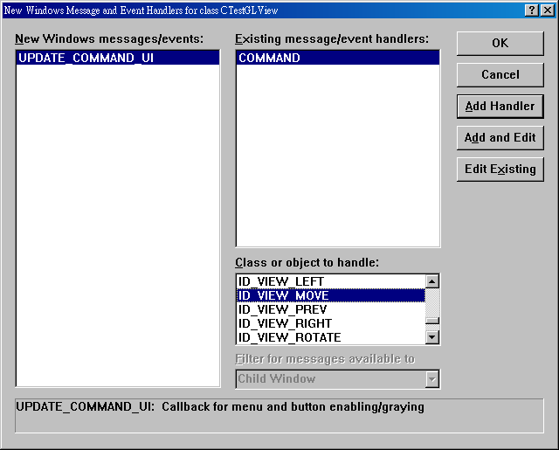
1
2
3
- 在OpenGLView增加int CurrentViewState，並在OpenGLView建構式中給予初始值0。

- 在OpenGLView增加void SwitchViewState(int state)，如下：
void OpenGLView::SwitchViewState(int state)
{
if (CurrentViewState==state)
CurrentViewState=0;
else
CurrentViewState=state;
}

- 在OpenGLView增加int GetViewState()，如下：
int OpenGLView::GetViewState()
{
return CurrentViewState;
}

- 在OpenGLView增加WM_LBUTTONDOWN、WM_LBUTTONUP、WM_MOUSEMOVE，同步驟20，點選 “Add Windows Message Handler…”，會出現如下之對話框，分別選擇WM_LBUTTONDOWN、WM_LBUTTONUP、WM_MOUSEMOVE，然後按 ”Add Handler” 按鈕。
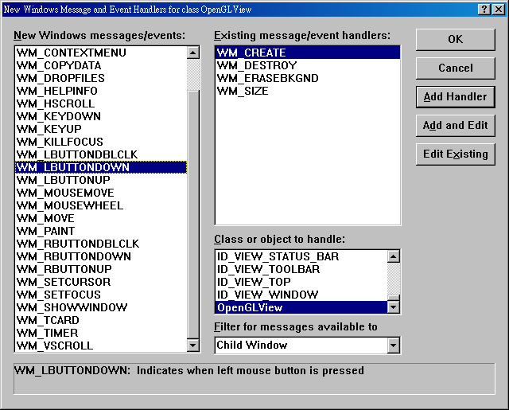
- 在OpenGLView::OnLButtonDown編輯如下：
void OpenGLView::OnLButtonDown(UINT nFlags, CPoint point)
{
// TODO: Add your message handler code here and/or call default

CView::OnLButtonDown(nFlags, point);
switch (CurrentViewState)
{ case 1:PointToVector(point.x,point.y,ScrWidth,ScrHeight,LastPosition);
break;//旋轉
case 2:MouseDownPoint=point;
break;//移動
case 3:MouseDownPoint=point;
break;//縮放
case 4:MouseCurPoint=point;
if (ZoomWinFlag==FALSE)
{ MouseDownPoint=point;
ZoomWinFlag=TRUE;
}
else
{ ZoomWindow();
ZoomWinFlag=FALSE;
}
break;//局部放大
default:break;
}
}

- 在OpenGLView:: OnLButtonUp編輯如下：
void OpenGLView::OnLButtonUp(UINT nFlags, CPoint point)
{
// TODO: Add your message handler code here and/or call default

CView::OnLButtonUp(nFlags, point);
switch (CurrentViewState)
{ case 1:RecordView();
break;//旋轉
case 2:RecordView();
break;//移動
case 3:RecordView();
break;//縮放
case 4:
break;//局部放大
default:break;
}
}

- 在OpenGLView:: OnMouseMove編輯如下：
void OpenGLView::OnMouseMove(UINT nFlags, CPoint point)
{
// TODO: Add your message handler code here and/or call default

CView::OnMouseMove(nFlags, point);
switch (CurrentViewState)
{ case 1:if (MK_LBUTTON & nFlags)
RotateView(point);
break;//旋轉
case 2:if (MK_LBUTTON & nFlags)
MoveView(point);
break;//移動
case 3:if (MK_LBUTTON & nFlags)
ScaleView(point);
break;//縮放
case 4:if (ZoomWinFlag==TRUE) //畫框
{ DrawRect(0,MouseDownPoint,MouseCurPoint); //清除上一次的框
MouseCurPoint=point;
DrawRect(1,MouseDownPoint,MouseCurPoint); //畫框
}
break;//局部放大
default:break;
}
}

- 在OpenGLView增加CPoint MouseDownPoint、MouseCurPoint，BOOL ZoomWinFlag，double LastPosition[3]，並在OpenGLView的建構式給予ZoomWinFlag的初始值。

- 在OpenGLView增加下列函式：
void RotateView(CPoint pt);
void PointToVector(int x, int y, int width, int height, double v[]);
void MoveView(CPoint pt);
void ScaleView(CPoint pt);
void ZoomWindow();
void DrawRect(int id, CPoint p1, CPoint p2);
void RecordView();

- 各函式內容如下：

void OpenGLView::RotateView(CPoint pt)
{
double current_position[3],axis[3],dx,dy,dz;
GLdouble transform[4][4];

PointToVector(pt.x,pt.y,ScrWidth,ScrHeight,current_position);
/* calculate the angle to rotate by (directly proportional to the length of the mouse movement */
dx=current_position[0]-LastPosition[0];
dy=current_position[1]-LastPosition[1];
dz=current_position[2]-LastPosition[2];
double angle=90.0*sqrt(dx*dx+dy*dy+dz*dz);
/* calculate the axis of rotation (cross product) */
axis[0]=LastPosition[1]*current_position[2]-LastPosition[2]*current_position[1];
axis[1]=LastPosition[2]*current_position[0]-LastPosition[0]*current_position[2];
axis[2]=LastPosition[0]*current_position[1]-LastPosition[1]*current_position[0];
/* reset for next time */
LastPosition[0]=current_position[0];
LastPosition[1]=current_position[1];
LastPosition[2]=current_position[2];
wglMakeCurrent(m_hDC,m_hRC);
glMatrixMode(GL_MODELVIEW);
glGetDoublev(GL_MODELVIEW_MATRIX, (GLdouble *)transform);
glLoadIdentity();
glRotated(angle,axis[0],axis[1],axis[2]);
glMultMatrixd((GLdouble *)transform);
wglMakeCurrent(NULL,NULL);
Invalidate();
}

void OpenGLView::PointToVector(int x, int y, int width, int height, double v[])
{
double d,a;

/* project x, y onto a hemi-sphere centered within width, height. */
v[0] = (2.0 * x - width) / width;
v[1] = (height - 2.0 * y) / height;
d = sqrt(v[0] * v[0] + v[1] * v[1]);
v[2] = cos((3.14159265 / 2.0) * ((d < 1.0) ? d : 1.0));
a = 1.0 / sqrt(v[0] * v[0] + v[1] * v[1] + v[2] * v[2]);
v[0] *= a;
v[1] *= a;
v[2] *= a;
}

void OpenGLView::MoveView(CPoint pt)
{
double dx,dy,step;

dx=pt.x-MouseDownPoint.x;
dy=pt.y-MouseDownPoint.y;
MouseDownPoint=pt;
if (ScrWidth>ScrHeight)
step=(EyeXMax-EyeXMin)/ScrWidth;
else
step=(EyeYMax-EyeYMin)/ScrHeight;
dx=-dx*step;
dy=dy*step;
CreateProjMatrix(EyeXMax+dx,EyeXMin+dx,EyeYMax+dy,EyeYMin+dy);
Invalidate();
}

void OpenGLView::ScaleView(CPoint pt)
{
double step,dx,dy,dist;

dx=pt.x-MouseDownPoint.x;
dy=pt.y-MouseDownPoint.y;
if (dx*dy>0)
dx=-dy;
if (fabs(dx)>fabs(dy))
dist=-dx;
else
dist=dy;
MouseDownPoint=pt;
double max=0.;
if (EyeXMax-EyeXMin>max)
max=EyeXMax-EyeXMin;
if (EyeYMax-EyeYMin>max)
max=EyeYMax-EyeYMin;
if (ScrWidth>ScrHeight)
step=max/ScrWidth;
else
step=max/ScrHeight;
dist=dist*step;
CreateProjMatrix(EyeXMax+dist,EyeXMin-dist,EyeYMax+dist,EyeYMin-dist);
Invalidate();
}

void OpenGLView::ZoomWindow()
{
double x1,y1,x2,y2,ymax,ymin,xmax,xmin;
if (MouseDownPoint.x>MouseCurPoint.x)
{ x1=MouseDownPoint.x;
x2=MouseCurPoint.x;
}
else
{ x2=MouseDownPoint.x;
x1=MouseCurPoint.x;
}
if (MouseDownPoint.y>MouseCurPoint.y)
{ y1=MouseDownPoint.y;
y2=MouseCurPoint.y;
}
else
{ y2=MouseDownPoint.y;
y1=MouseCurPoint.y;
}
xmax=EyeXMin+x1*(EyeXMax-EyeXMin)/ScrWidth;
xmin=EyeXMin+x2*(EyeXMax-EyeXMin)/ScrWidth;
ymax=EyeYMax-y2*(EyeYMax-EyeYMin)/ScrHeight;
ymin=EyeYMax-y1*(EyeYMax-EyeYMin)/ScrHeight;
CreateProjMatrix(xmax,xmin,ymax,ymin);
UpdateDrawView();
}

void OpenGLView::DrawRect(int id, CPoint p1, CPoint p2)
{
CPen *OldPen,Pen;

if (id==1)
Pen.CreatePen(PS_SOLID,0,RGB(255,255,255)); //白色
else
{ Pen.CreatePen(PS_SOLID,1,RGB(255,255,255)); //清除
m_pDC->SetROP2(R2_XORPEN); //作XOR運算
}
OldPen=m_pDC->SelectObject(&Pen);
m_pDC->MoveTo(p1.x,p1.y);
m_pDC->LineTo(p1.x,p2.y);
m_pDC->LineTo(p2.x,p2.y);
m_pDC->LineTo(p2.x,p1.y);
m_pDC->LineTo(p1.x,p1.y);
m_pDC->SelectObject(OldPen);
}
//記錄目前的VIEW
void OpenGLView::RecordView()
{
int i;
GLdouble a[16];
bool same=true;

wglMakeCurrent(m_hDC,m_hRC);
glMatrixMode(GL_MODELVIEW);
glGetDoublev(GL_MODELVIEW_MATRIX,a);
wglMakeCurrent(NULL,NULL);
if (CurrentViewID>=0&&CurrentViewID<MaxViewID)
{ for (i=0;i<16;i++)
if (a[i]!=RecordViewXYZ[CurrentViewID][i])
same=false;
if (RecordViewXYZ[CurrentViewID][16]==EyeXMin&&
RecordViewXYZ[CurrentViewID][17]==EyeXMax&&
RecordViewXYZ[CurrentViewID][18]==EyeYMin&&
RecordViewXYZ[CurrentViewID][19]==EyeYMax&&same==true)
return;
}
CurrentViewID=CurrentViewID+1;
if (CurrentViewID>MaxViewID-1)
CurrentViewID=0;
for (i=0;i<16;i++)
RecordViewXYZ[CurrentViewID][i]=a[i];
RecordViewXYZ[CurrentViewID][16]=EyeXMin;
RecordViewXYZ[CurrentViewID][17]=EyeXMax;
RecordViewXYZ[CurrentViewID][18]=EyeYMin;
RecordViewXYZ[CurrentViewID][19]=EyeYMax;
RecordViewF[CurrentViewID]=true;
}

- 在OpenGLView增加int CurrentViewID，bool RecordViewF[5]，double RecordViewXYZ[5][20]。

- 在OpenGLView增加void ResetRView()，void CallPreView()。

- 函式內容如下：
void OpenGLView::ResetRView()
{
for (int i=0;i<MaxViewID;i++)
{ RecordViewF[i]=false;
for (int j=0;j<20;j++)
RecordViewXYZ[i][j]=0.;
}
CurrentViewID=-1;
}

void OpenGLView::CallPreView()
{
int i,id;
GLdouble a[16];
bool exit=false;

if (CurrentViewID<0)
return;
id=CurrentViewID;
do
{ id=id-1;
if (id==CurrentViewID)
exit=true;
if (id<0)
id=4;
} while(RecordViewF[id]==false&&exit==false);
if (exit==true||RecordViewF[id]==false)
return;
CurrentViewID=id;
for (i=0;i<16;i++)
a[i]=RecordViewXYZ[CurrentViewID][i];
wglMakeCurrent(m_hDC,m_hRC);
glMatrixMode(GL_MODELVIEW);
glLoadMatrixd(a);
wglMakeCurrent(NULL,NULL);
EyeXMin=RecordViewXYZ[CurrentViewID][16];
EyeXMax=RecordViewXYZ[CurrentViewID][17];
EyeYMin=RecordViewXYZ[CurrentViewID][18];
EyeYMax=RecordViewXYZ[CurrentViewID][19];
CreateProjMatrix(EyeXMax,EyeXMin,EyeYMax,EyeYMin);
Invalidate();
}

- 在OpenGLView的建構式增加如下：
OpenGLView::OpenGLView()
{
GLHardAccel=FALSE;
m_pDC=NULL;
m_hRC=NULL;
AxisXColor[0]=255;AxisXColor[1]=128;AxisXColor[2]=128;//座標X軸:淡紅
AxisYColor[0]=128;AxisYColor[1]=255;AxisYColor[2]=128;//座標Y軸:淡青
AxisZColor[0]=128;AxisZColor[1]=128;AxisZColor[2]=255;//座標Z軸:淡紫
AxisList=0;
FontList=0;
Show3DAxisType=1;
Show3DAxisSize=120;
CurrentViewState=0;
ZoomWinFlag=FALSE;
ResetRView();
}

- 在CTestGLView::OnViewPrev增加如下：
void CTestGLView::OnViewPrev()
{
// TODO: Add your command handler code here
CallPreView();
}

- 最後程式執行如下：
