DOCUMENTATION

ubuntu – 16.04
Ros – kinetic
gazebo – version 7
Our project is intended towards making a simulation of a moving cycle and moving it according to the keys pressed. This is but our attempt at doing so.

Introduction :
- We have made use of gazebo to make the simulation of our cycle. Gazebo is a software that is used to make simulations of different bots. It can be used to create an environment that resembles our day to day events and to check the performance of our bot virtually.
- ROS has been implemented in our project to move the cycle.
- Our idea was to make even a mechanical model of the above mentioned cycle but for this project we focused only on its simulation.
- The idea can be improvised by adding proximity sensors for object detection and thereby making the cycle move to any desired location on its own.
- By this the cycle could be used by physically disabled people who can’t walk for getting their groceries and many other things.
- Even it could help the blind people to walk easily by using the sensors used in the model.

- First step is installing ROS :
If you know about installation process , you can directly do it from official website of ROS www.ros.org .
If not then you should go through one of the following :
1) https://youtu.be/9U6GDonGFHw by Justin Huang.
2) https://youtu.be/92Zz5nnd41c by Shawn Chen.

- Now to learn about ROS :
1) http://wiki.ros.org/ROS/Tutorials : complete ROS
2) for basic knowledge about ROS go through ROS kinetic tutorial for beginners by Shawn Chen containing 9 videos .
3) http://www.theconstructsim.com/ : to learn ROS by video tutorials.

- Now to learn about gazebo simulator :
1) http://gazebosim.org/ : To download latest version of gazebo simulator.
http://gazebosim.org/tutorials : To learn everything about gazebo simulator.

Something more :
1)http://moorerobots.com/blog/post/1
2)gazebo model editor tutorial: ​ http://gazebosim.org/tutorials?tut=guided_b3
3)​ gazebo plugins : http://gazebosim.org/tutorials?tut=ros_gzplugins
4) https://u.cs.biu.ac.il/~yehoshr1/89-685/Fall2015/ROS_Lesson10.pdf :
everything about turtlebot simulation

Above given links of tutorials and videos provide you detail knowledge about ROS and Gazebo .
Now come to our project of virtual cycle , main aim of this project is using ros and gazebo build a cycle and humanoid and also simulate them.
So we begin with cycle only then after we will build cycle and humanoid such that humanoid attach to cycle and then we will try to move them using ros.
Open a new terminal ( ctrl+alt+t ) and do as explained below.

1.Create a model directory:

mkdir -p ~/.gazebo/models/my_robot

2.Create a model config. file:

gedit ~/.gazebo/models/my_robot/model.config

3.Paste in the following contents:

<?xml version="1.0" ?>
<model>
<name>turtle1_New</name>
<version>1.0</version>
<sdf version="1.6">model.sdf</sdf>
<author>
<name></name>
<email></email>
</author>
<description></description>
</model>

4.Create a model sdf file:

gedit ~/.gazebo/models/my_robot/model.sdf

5.Paste in the following :

<?xml version='1.0'?>
<sdf version='1.6'>
<model name='turtle1_New'>
<link name='link_0'>
<pose frame=''>1.02325 -0 0.352338 1.5707 -0 0</pose>
<inertial>
<mass>1</mass>
<inertia>
<ixx>0.145833</ixx>
<ixy>0</ixy>
<ixz>0</ixz>
<iyy>0.145833</iyy>
<iyz>0</iyz>
<izz>0.125</izz>
</inertia>
<pose frame=''>0 0 0 0 -0 0</pose>
</inertial>
<self_collide>0</self_collide>
<kinematic>0</kinematic>
<visual name='visual'>
<pose frame=''>0 0 0 0 -0 0</pose>
<geometry>
<cylinder>
<radius>0.5</radius>
<length>0.12</length>
</cylinder>
</geometry>
<material>
<lighting>1</lighting>
<script>
<uri>file://media/materials/scripts/gazebo.material</uri>
<name>Gazebo/Grey</name>
</script>
<ambient>0.3 0.3 0.3 1</ambient>
<diffuse>0.7 0.7 0.7 1</diffuse>
<specular>0.01 0.01 0.01 1</specular>
<emissive>0 0 0 1</emissive>
<shader type='vertex'>
<normal_map>__default__</normal_map>
</shader>
</material>
<cast_shadows>1</cast_shadows>
<transparency>0</transparency>
</visual>
<collision name='collision'>
<laser_retro>0</laser_retro>
<max_contacts>10</max_contacts>
<pose frame=''>0 0 0 0 -0 0</pose>
<geometry>
<cylinder>
<radius>0.5</radius>
<length>0.12</length>
</cylinder>
</geometry>
<surface>
<friction>
<ode>
<mu>1</mu>
<mu2>1</mu2>
<fdir1>0 0 0</fdir1>
<slip1>0</slip1>
<slip2>0</slip2>
</ode>
<torsional>
<coefficient>1</coefficient>
<patch_radius>0</patch_radius>
<surface_radius>0</surface_radius>
<use_patch_radius>1</use_patch_radius>
<ode>
<slip>0</slip>
</ode>
</torsional>
</friction>
<bounce>
<restitution_coefficient>0</restitution_coefficient>
<threshold>1e+06</threshold>
</bounce>
<contact>
<collide_without_contact>0</collide_without_contact>
<collide_without_contact_bitmask>1</collide_without_contact_bitmask>
<collide_bitmask>1</collide_bitmask>
<ode>
<soft_cfm>0</soft_cfm>
<soft_erp>0.2</soft_erp>
<kp>1e+13</kp>
<kd>1</kd>
<max_vel>0.01</max_vel>
<min_depth>0</min_depth>
</ode>
<bullet>
<split_impulse>1</split_impulse>
<split_impulse_penetration_threshold>-0.01</split_impulse_penetration_threshold>
<soft_cfm>0</soft_cfm>
<soft_erp>0.2</soft_erp>
<kp>1e+13</kp>
<kd>1</kd>
</bullet>
</contact>
</surface>
</collision>
</link>
<link name='link_0_0'>
<pose frame=''>-0.625228 -0.12 0.648148 0 0.169207 0</pose>
<inertial>
<mass>0.0814675</mass>
<inertia>
<ixx>0.00720375</ixx>
<ixy>0</ixy>
<ixz>0</ixz>
<iyy>0.00720375</iyy>
<iyz>0</iyz>
<izz>0.00082962</izz>
</inertia>
<pose frame=''>0 0 0 0 -0 0</pose>
</inertial>
<self_collide>0</self_collide>
<kinematic>0</kinematic>
<visual name='visual'>
<pose frame=''>0 0 0 0 -0 0</pose>
<geometry>
<cylinder>
<radius>0.05</radius>
<length>0.75</length>
</cylinder>
</geometry>
<material>
<lighting>1</lighting>
<script>
<uri>file://media/materials/scripts/gazebo.material</uri>
<name>Gazebo/Grey</name>
</script>
<ambient>0.3 0.3 0.3 1</ambient>
<diffuse>0.7 0.7 0.7 1</diffuse>
<specular>0.01 0.01 0.01 1</specular>
<emissive>0 0 0 1</emissive>
<shader type='vertex'>
<normal_map>__default__</normal_map>
</shader>
</material>
<cast_shadows>1</cast_shadows>
<transparency>0</transparency>
</visual>
<collision name='collision'>
<laser_retro>0</laser_retro>
<max_contacts>10</max_contacts>
<pose frame=''>0 0 0 0 -0 0</pose>
<geometry>
<cylinder>
<radius>0.05</radius>
<length>0.75</length>
</cylinder>
</geometry>
<surface>
<friction>
<ode>
<mu>1</mu>
<mu2>1</mu2>
<fdir1>0 0 0</fdir1>
<slip1>0</slip1>
<slip2>0</slip2>
</ode>
<torsional>
<coefficient>1</coefficient>
<patch_radius>0</patch_radius>
<surface_radius>0</surface_radius>
<use_patch_radius>1</use_patch_radius>
<ode>
<slip>0</slip>
</ode>
</torsional>
</friction>
<bounce>
<restitution_coefficient>0</restitution_coefficient>
<threshold>1e+06</threshold>
</bounce>
<contact>
<collide_without_contact>0</collide_without_contact>
<collide_without_contact_bitmask>1</collide_without_contact_bitmask>
<collide_bitmask>1</collide_bitmask>
<ode>
<soft_cfm>0</soft_cfm>
<soft_erp>0.2</soft_erp>
<kp>1e+13</kp>
<kd>1</kd>
<max_vel>0.01</max_vel>
<min_depth>0</min_depth>
</ode>
<bullet>
<split_impulse>1</split_impulse>
<split_impulse_penetration_threshold>-0.01</split_impulse_penetration_threshold>
<soft_cfm>0</soft_cfm>
<soft_erp>0.2</soft_erp>
<kp>1e+13</kp>
<kd>1</kd>
</bullet>
</contact>
</surface>
</collision>
</link>
<link name='link_0_0_clone'>
<pose frame=''>-0.625228 0.12 0.648148 0 0.169207 0</pose>
<inertial>
<mass>0.0814675</mass>
<inertia>
<ixx>0.00720375</ixx>
<ixy>0</ixy>
<ixz>0</ixz>
<iyy>0.00720375</iyy>
<iyz>0</iyz>
<izz>0.00082962</izz>
</inertia>
<pose frame=''>0 0 0 0 -0 0</pose>
</inertial>
<self_collide>0</self_collide>
<kinematic>0</kinematic>
<visual name='visual_0'>
<pose frame=''>0 0 0 0 -0 0</pose>
<geometry>
<cylinder>
<radius>0.05</radius>
<length>0.75</length>
</cylinder>
</geometry>
<material>
<lighting>1</lighting>
<script>
<uri>file://media/materials/scripts/gazebo.material</uri>
<name>Gazebo/Grey</name>
</script>
<ambient>0.3 0.3 0.3 1</ambient>
<diffuse>0.7 0.7 0.7 1</diffuse>
<specular>0.01 0.01 0.01 1</specular>
<emissive>0 0 0 1</emissive>
<shader type='vertex'>
<normal_map>__default__</normal_map>
</shader>
</material>
<cast_shadows>1</cast_shadows>
<transparency>0</transparency>
</visual>
<collision name='collision'>
<laser_retro>0</laser_retro>
<max_contacts>10</max_contacts>
<pose frame=''>0 0 0 0 -0 0</pose>
<geometry>
<cylinder>
<radius>0.05</radius>
<length>0.75</length>
</cylinder>
</geometry>
<surface>
<friction>
<ode>
<mu>1</mu>
<mu2>1</mu2>
<fdir1>0 0 0</fdir1>
<slip1>0</slip1>
<slip2>0</slip2>
</ode>
<torsional>
<coefficient>1</coefficient>
<patch_radius>0</patch_radius>
<surface_radius>0</surface_radius>
<use_patch_radius>1</use_patch_radius>
<ode>
<slip>0</slip>
</ode>
</torsional>
</friction>
<bounce>
<restitution_coefficient>0</restitution_coefficient>
<threshold>1e+06</threshold>
</bounce>
<contact>
<collide_without_contact>0</collide_without_contact>
<collide_without_contact_bitmask>1</collide_without_contact_bitmask>
<collide_bitmask>1</collide_bitmask>
<ode>
<soft_cfm>0</soft_cfm>
<soft_erp>0.2</soft_erp>
<kp>1e+13</kp>
<kd>1</kd>
<max_vel>0.01</max_vel>
<min_depth>0</min_depth>
</ode>
<bullet>
<split_impulse>1</split_impulse>
<split_impulse_penetration_threshold>-0.01</split_impulse_penetration_threshold>
<soft_cfm>0</soft_cfm>
<soft_erp>0.2</soft_erp>
<kp>1e+13</kp>
<kd>1</kd>
</bullet>
</contact>
</surface>
</collision>
</link>
<link name='link_0_1'>
<pose frame=''>-0.358078 -0 1.18776 0.001566 0.170039 0.000158</pose>
<inertial>
<mass>0.0427594</mass>
<inertia>
<ixx>0.00153031</ixx>
<ixy>0</ixy>
<ixz>0</ixz>
<iyy>0.00153031</iyy>
<iyz>0</iyz>
<izz>0.00037209</izz>
</inertia>
<pose frame=''>0 0 0 0 -0 0</pose>
</inertial>
<self_collide>0</self_collide>
<kinematic>0</kinematic>
<visual name='visual'>
<pose frame=''>0 0 0 0 -0 0</pose>
<geometry>
<cylinder>
<radius>0.05</radius>
<length>0.307109</length>
</cylinder>
</geometry>
<material>
<lighting>1</lighting>
<script>
<uri>file://media/materials/scripts/gazebo.material</uri>
<name>Gazebo/Grey</name>
</script>
<ambient>0.3 0.3 0.3 1</ambient>
<diffuse>0.7 0.7 0.7 1</diffuse>
<specular>0.01 0.01 0.01 1</specular>
<emissive>0 0 0 1</emissive>
<shader type='vertex'>
<normal_map>__default__</normal_map>
</shader>
</material>
<cast_shadows>1</cast_shadows>
<transparency>0</transparency>
</visual>
<collision name='collision'>
<laser_retro>0</laser_retro>
<max_contacts>10</max_contacts>
<pose frame=''>0 0 0 0 -0 0</pose>
<geometry>
<cylinder>
<radius>0.05</radius>
<length>0.307109</length>
</cylinder>
</geometry>
<surface>
<friction>
<ode>
<mu>1</mu>
<mu2>1</mu2>
<fdir1>0 0 0</fdir1>
<slip1>0</slip1>
<slip2>0</slip2>
</ode>
<torsional>
<coefficient>1</coefficient>
<patch_radius>0</patch_radius>
<surface_radius>0</surface_radius>
<use_patch_radius>1</use_patch_radius>
<ode>
<slip>0</slip>
</ode>
</torsional>
</friction>
<bounce>
<restitution_coefficient>0</restitution_coefficient>
<threshold>1e+06</threshold>
</bounce>
<contact>
<collide_without_contact>0</collide_without_contact>
<collide_without_contact_bitmask>1</collide_without_contact_bitmask>
<collide_bitmask>1</collide_bitmask>
<ode>
<soft_cfm>0</soft_cfm>
<soft_erp>0.2</soft_erp>
<kp>1e+13</kp>
<kd>1</kd>
<max_vel>0.01</max_vel>
<min_depth>0</min_depth>
</ode>
<bullet>
<split_impulse>1</split_impulse>
<split_impulse_penetration_threshold>-0.01</split_impulse_penetration_threshold>
<soft_cfm>0</soft_cfm>
<soft_erp>0.2</soft_erp>
<kp>1e+13</kp>
<kd>1</kd>
</bullet>
</contact>
</surface>
</collision>
</link>
<link name='link_0_clone'>
<pose frame=''>-0.669823 -0 0.352338 1.5707 -0 0</pose>
<inertial>
<mass>1</mass>
<inertia>
<ixx>0.145833</ixx>
<ixy>0</ixy>
<ixz>0</ixz>
<iyy>0.145833</iyy>
<iyz>0</iyz>
<izz>0.125</izz>
</inertia>
<pose frame=''>0 0 0 0 -0 0</pose>
</inertial>
<self_collide>0</self_collide>
<kinematic>0</kinematic>
<visual name='visual'>
<pose frame=''>0 0 0 0 -0 0</pose>
<geometry>
<cylinder>
<radius>0.5</radius>
<length>0.12</length>
</cylinder>
</geometry>
<material>
<lighting>1</lighting>
<script>
<uri>file://media/materials/scripts/gazebo.material</uri>
<name>Gazebo/Grey</name>
</script>
<ambient>0.3 0.3 0.3 1</ambient>
<diffuse>0.7 0.7 0.7 1</diffuse>
<specular>0.01 0.01 0.01 1</specular>
<emissive>0 0 0 1</emissive>
<shader type='vertex'>
<normal_map>__default__</normal_map>
</shader>
</material>
<cast_shadows>1</cast_shadows>
<transparency>0</transparency>
</visual>
<collision name='collision'>
<laser_retro>0</laser_retro>
<max_contacts>10</max_contacts>
<pose frame=''>0 0 0 0 -0 0</pose>
<geometry>
<cylinder>
<radius>0.5</radius>
<length>0.12</length>
</cylinder>
</geometry>
<surface>
<friction>
<ode>
<mu>1</mu>
<mu2>1</mu2>
<fdir1>0 0 0</fdir1>
<slip1>0</slip1>
<slip2>0</slip2>
</ode>
<torsional>
<coefficient>1</coefficient>
<patch_radius>0</patch_radius>
<surface_radius>0</surface_radius>
<use_patch_radius>1</use_patch_radius>
<ode>
<slip>0</slip>
</ode>
</torsional>
</friction>
<bounce>
<restitution_coefficient>0</restitution_coefficient>
<threshold>1e+06</threshold>
</bounce>
<contact>
<collide_without_contact>0</collide_without_contact>
<collide_without_contact_bitmask>1</collide_without_contact_bitmask>
<collide_bitmask>1</collide_bitmask>
<ode>
<soft_cfm>0</soft_cfm>
<soft_erp>0.2</soft_erp>
<kp>1e+13</kp>
<kd>1</kd>
<max_vel>0.01</max_vel>
<min_depth>0</min_depth>
</ode>
<bullet>
<split_impulse>1</split_impulse>
<split_impulse_penetration_threshold>-0.01</split_impulse_penetration_threshold>
<soft_cfm>0</soft_cfm>
<soft_erp>0.2</soft_erp>
<kp>1e+13</kp>
<kd>1</kd>
</bullet>
</contact>
</surface>
</collision>
</link>
<link name='link_1'>
<pose frame=''>-0.51299 -0 1.28445 0 0.187784 0</pose>
<inertial>
<mass>0.778608</mass>
<inertia>
<ixx>0.0879975</ixx>
<ixy>0</ixy>
<ixz>0</ixz>
<iyy>0.0879975</iyy>
<iyz>0</iyz>
<izz>0.097326</izz>
</inertia>
<pose frame=''>0 0 0 0 -0 0</pose>
</inertial>
<self_collide>0</self_collide>
<kinematic>0</kinematic>
<visual name='visual'>
<pose frame=''>0 0 0 0 -0 0</pose>
<geometry>
<cylinder>
<radius>0.05</radius>
<length>0.622887</length>
</cylinder>
</geometry>
<material>
<lighting>1</lighting>
<script>
<uri>file://media/materials/scripts/gazebo.material</uri>
<name>Gazebo/Grey</name>
</script>
<ambient>0.3 0.3 0.3 1</ambient>
<diffuse>0.7 0.7 0.7 1</diffuse>
<specular>0.01 0.01 0.01 1</specular>
<emissive>0 0 0 1</emissive>
<shader type='vertex'>
<normal_map>__default__</normal_map>
</shader>
</material>
<cast_shadows>1</cast_shadows>
<transparency>0</transparency>
</visual>
<collision name='collision'>
<laser_retro>0</laser_retro>
<max_contacts>10</max_contacts>
<pose frame=''>0 0 0 0 -0 0</pose>
<geometry>
<cylinder>
<radius>0.05</radius>
<length>0.622887</length>
</cylinder>
</geometry>
<surface>
<friction>
<ode>
<mu>1</mu>
<mu2>1</mu2>
<fdir1>0 0 0</fdir1>
<slip1>0</slip1>
<slip2>0</slip2>
</ode>
<torsional>
<coefficient>1</coefficient>
<patch_radius>0</patch_radius>
<surface_radius>0</surface_radius>
<use_patch_radius>1</use_patch_radius>
<ode>
<slip>0</slip>
</ode>
</torsional>
</friction>
<bounce>
<restitution_coefficient>0</restitution_coefficient>
<threshold>1e+06</threshold>
</bounce>
<contact>
<collide_without_contact>0</collide_without_contact>
<collide_without_contact_bitmask>1</collide_without_contact_bitmask>
<collide_bitmask>1</collide_bitmask>
<ode>
<soft_cfm>0</soft_cfm>
<soft_erp>0.2</soft_erp>
<kp>1e+13</kp>
<kd>1</kd>
<max_vel>0.01</max_vel>
<min_depth>0</min_depth>
</ode>
<bullet>
<split_impulse>1</split_impulse>
<split_impulse_penetration_threshold>-0.01</split_impulse_penetration_threshold>
<soft_cfm>0</soft_cfm>
<soft_erp>0.2</soft_erp>
<kp>1e+13</kp>
<kd>1</kd>
</bullet>
</contact>
</surface>
</collision>
</link>
<link name='link_2'>
<pose frame=''>0.613954 0.12 0.352338 -1e-06 -1.5707 1e-06</pose>
<inertial>
<mass>1</mass>
<inertia>
<ixx>0.145833</ixx>
<ixy>0</ixy>
<ixz>0</ixz>
<iyy>0.145833</iyy>
<iyz>0</iyz>
<izz>0.125</izz>
</inertia>
<pose frame=''>0 0 0 0 -0 0</pose>
</inertial>
<self_collide>0</self_collide>
<kinematic>0</kinematic>
<visual name='visual'>
<pose frame=''>0 0 0 0 -0 0</pose>
<geometry>
<cylinder>
<radius>0.05</radius>
<length>0.75</length>
</cylinder>
</geometry>
<material>
<lighting>1</lighting>
<script>
<uri>file://media/materials/scripts/gazebo.material</uri>
<name>Gazebo/Grey</name>
</script>
<ambient>0.3 0.3 0.3 1</ambient>
<diffuse>0.7 0.7 0.7 1</diffuse>
<specular>0.01 0.01 0.01 1</specular>
<emissive>0 0 0 1</emissive>
<shader type='vertex'>
<normal_map>__default__</normal_map>
</shader>
</material>
<cast_shadows>1</cast_shadows>
<transparency>0</transparency>
</visual>
<collision name='collision'>
<laser_retro>0</laser_retro>
<max_contacts>10</max_contacts>
<pose frame=''>0 0 0 0 -0 0</pose>
<geometry>
<cylinder>
<radius>0.05</radius>
<length>0.75</length>
</cylinder>
</geometry>
<surface>
<friction>
<ode>
<mu>1</mu>
<mu2>1</mu2>
<fdir1>0 0 0</fdir1>
<slip1>0</slip1>
<slip2>0</slip2>
</ode>
<torsional>
<coefficient>1</coefficient>
<patch_radius>0</patch_radius>
<surface_radius>0</surface_radius>
<use_patch_radius>1</use_patch_radius>
<ode>
<slip>0</slip>
</ode>
</torsional>
</friction>
<bounce>
<restitution_coefficient>0</restitution_coefficient>
<threshold>1e+06</threshold>
</bounce>
<contact>
<collide_without_contact>0</collide_without_contact>
<collide_without_contact_bitmask>1</collide_without_contact_bitmask>
<collide_bitmask>1</collide_bitmask>
<ode>
<soft_cfm>0</soft_cfm>
<soft_erp>0.2</soft_erp>
<kp>1e+13</kp>
<kd>1</kd>
<max_vel>0.01</max_vel>
<min_depth>0</min_depth>
</ode>
<bullet>
<split_impulse>1</split_impulse>
<split_impulse_penetration_threshold>-0.01</split_impulse_penetration_threshold>
<soft_cfm>0</soft_cfm>
<soft_erp>0.2</soft_erp>
<kp>1e+13</kp>
<kd>1</kd>
</bullet>
</contact>
</surface>
</collision>
</link>
<link name='link_2_0'>
<pose frame=''>0.080962 0 1.21125 0 -1.3588 0</pose>
<inertial>
<mass>1.25519</mass>
<inertia>
<ixx>0.243245</ixx>
<ixy>0</ixy>
<ixz>0</ixz>
<iyy>0.243245</iyy>
<iyz>0</iyz>
<izz>0.156899</izz>
</inertia>
<pose frame=''>0 0 0 0 -0 0</pose>
</inertial>
<self_collide>0</self_collide>
<kinematic>0</kinematic>
<visual name='visual'>
<pose frame=''>0 0 0 0 -0 0</pose>
<geometry>
<cylinder>
<radius>0.05</radius>
<length>1.25519</length>
</cylinder>
</geometry>
<material>
<lighting>1</lighting>
<script>
<uri>file://media/materials/scripts/gazebo.material</uri>
<name>Gazebo/Grey</name>
</script>
<ambient>0.3 0.3 0.3 1</ambient>
<diffuse>0.7 0.7 0.7 1</diffuse>
<specular>0.01 0.01 0.01 1</specular>
<emissive>0 0 0 1</emissive>
<shader type='vertex'>
<normal_map>__default__</normal_map>
</shader>
</material>
<cast_shadows>1</cast_shadows>
<transparency>0</transparency>
</visual>
<collision name='collision'>
<laser_retro>0</laser_retro>
<max_contacts>10</max_contacts>
<pose frame=''>0 0 0 0 -0 0</pose>
<geometry>
<cylinder>
<radius>0.05</radius>
<length>1.25519</length>
</cylinder>
</geometry>
<surface>
<friction>
<ode>
<mu>1</mu>
<mu2>1</mu2>
<fdir1>0 0 0</fdir1>
<slip1>0</slip1>
<slip2>0</slip2>
</ode>
<torsional>
<coefficient>1</coefficient>
<patch_radius>0</patch_radius>
<surface_radius>0</surface_radius>
<use_patch_radius>1</use_patch_radius>
<ode>
<slip>0</slip>
</ode>
</torsional>
</friction>
<bounce>
<restitution_coefficient>0</restitution_coefficient>
<threshold>1e+06</threshold>
</bounce>
<contact>
<collide_without_contact>0</collide_without_contact>
<collide_without_contact_bitmask>1</collide_without_contact_bitmask>
<collide_bitmask>1</collide_bitmask>
<ode>
<soft_cfm>0</soft_cfm>
<soft_erp>0.2</soft_erp>
<kp>1e+13</kp>
<kd>1</kd>
<max_vel>0.01</max_vel>
<min_depth>0</min_depth>
</ode>
<bullet>
<split_impulse>1</split_impulse>
<split_impulse_penetration_threshold>-0.01</split_impulse_penetration_threshold>
<soft_cfm>0</soft_cfm>
<soft_erp>0.2</soft_erp>
<kp>1e+13</kp>
<kd>1</kd>
</bullet>
</contact>
</surface>
</collision>
</link>
<link name='link_2_0_clone'>
<pose frame=''>-0.455924 -0 1.10626 0.007437 -1.36178 -0.007383</pose>
<inertial>
<mass>0.23468</mass>
<inertia>
<ixx>0.0157446</ixx>
<ixy>0</ixy>
<ixz>0</ixz>
<iyy>0.0157446</iyy>
<iyz>0</iyz>
<izz>0.029335</izz>
</inertia>
<pose frame=''>0 0 0 0 -0 0</pose>
</inertial>
<self_collide>0</self_collide>
<kinematic>0</kinematic>
<visual name='visual'>
<pose frame=''>0 0 0 0 -0 0</pose>
<geometry>
<cylinder>
<radius>0.05</radius>
<length>0.23468</length>
</cylinder>
</geometry>
<material>
<lighting>1</lighting>
<script>
<uri>file://media/materials/scripts/gazebo.material</uri>
<name>Gazebo/Grey</name>
</script>
<ambient>0.3 0.3 0.3 1</ambient>
<diffuse>0.7 0.7 0.7 1</diffuse>
<specular>0.01 0.01 0.01 1</specular>
<emissive>0 0 0 1</emissive>
<shader type='vertex'>
<normal_map>__default__</normal_map>
</shader>
</material>
<cast_shadows>1</cast_shadows>
<transparency>0</transparency>
</visual>
<collision name='collision'>
<laser_retro>0</laser_retro>
<max_contacts>10</max_contacts>
<pose frame=''>0 0 0 0 -0 0</pose>
<geometry>
<cylinder>
<radius>0.05</radius>
<length>0.23468</length>
</cylinder>
</geometry>
<surface>
<friction>
<ode>
<mu>1</mu>
<mu2>1</mu2>
<fdir1>0 0 0</fdir1>
<slip1>0</slip1>
<slip2>0</slip2>
</ode>
<torsional>
<coefficient>1</coefficient>
<patch_radius>0</patch_radius>
<surface_radius>0</surface_radius>
<use_patch_radius>1</use_patch_radius>
<ode>
<slip>0</slip>
</ode>
</torsional>
</friction>
<bounce>
<restitution_coefficient>0</restitution_coefficient>
<threshold>1e+06</threshold>
</bounce>
<contact>
<collide_without_contact>0</collide_without_contact>
<collide_without_contact_bitmask>1</collide_without_contact_bitmask>
<collide_bitmask>1</collide_bitmask>
<ode>
<soft_cfm>0</soft_cfm>
<soft_erp>0.2</soft_erp>
<kp>1e+13</kp>
<kd>1</kd>
<max_vel>0.01</max_vel>
<min_depth>0</min_depth>
</ode>
<bullet>
<split_impulse>1</split_impulse>
<split_impulse_penetration_threshold>-0.01</split_impulse_penetration_threshold>
<soft_cfm>0</soft_cfm>
<soft_erp>0.2</soft_erp>
<kp>1e+13</kp>
<kd>1</kd>
</bullet>
</contact>
</surface>
</collision>
</link>
<link name='link_3'>
<pose frame=''>-0.045403 -0 0.712377 0 -0.736782 0</pose>
<inertial>
<mass>1.03685</mass>
<inertia>
<ixx>0.157694</ixx>
<ixy>0</ixy>
<ixz>0</ixz>
<iyy>0.157694</iyy>
<iyz>0</iyz>
<izz>0.129607</izz>
</inertia>
<pose frame=''>0 0 0 0 -0 0</pose>
</inertial>
<self_collide>0</self_collide>
<kinematic>0</kinematic>
<visual name='visual'>
<pose frame=''>0 0 0 0 -0 0</pose>
<geometry>
<cylinder>
<radius>0.05</radius>
<length>1.03685</length>
</cylinder>
</geometry>
<material>
<lighting>1</lighting>
<script>
<uri>file://media/materials/scripts/gazebo.material</uri>
<name>Gazebo/Grey</name>
</script>
<ambient>0.3 0.3 0.3 1</ambient>
<diffuse>0.7 0.7 0.7 1</diffuse>
<specular>0.01 0.01 0.01 1</specular>
<emissive>0 0 0 1</emissive>
<shader type='vertex'>
<normal_map>__default__</normal_map>
</shader>
</material>
<cast_shadows>1</cast_shadows>
<transparency>0</transparency>
</visual>
<collision name='collision'>
<laser_retro>0</laser_retro>
<max_contacts>10</max_contacts>
<pose frame=''>0 0 0 0 -0 0</pose>
<geometry>
<cylinder>
<radius>0.05</radius>
<length>1.03686</length>
</cylinder>
</geometry>
<surface>
<friction>
<ode>
<mu>1</mu>
<mu2>1</mu2>
<fdir1>0 0 0</fdir1>
<slip1>0</slip1>
<slip2>0</slip2>
</ode>
<torsional>
<coefficient>1</coefficient>
<patch_radius>0</patch_radius>
<surface_radius>0</surface_radius>
<use_patch_radius>1</use_patch_radius>
<ode>
<slip>0</slip>
</ode>
</torsional>
</friction>
<bounce>
<restitution_coefficient>0</restitution_coefficient>
<threshold>1e+06</threshold>
</bounce>
<contact>
<collide_without_contact>0</collide_without_contact>
<collide_without_contact_bitmask>1</collide_without_contact_bitmask>
<collide_bitmask>1</collide_bitmask>
<ode>
<soft_cfm>0</soft_cfm>
<soft_erp>0.2</soft_erp>
<kp>1e+13</kp>
<kd>1</kd>
<max_vel>0.01</max_vel>
<min_depth>0</min_depth>
</ode>
<bullet>
<split_impulse>1</split_impulse>
<split_impulse_penetration_threshold>-0.01</split_impulse_penetration_threshold>
<soft_cfm>0</soft_cfm>
<soft_erp>0.2</soft_erp>
<kp>1e+13</kp>
<kd>1</kd>
</bullet>
</contact>
</surface>
</collision>
</link>
<link name='link_4'>
<pose frame=''>0.613954 -0.12 0.352338 -1e-06 -1.5707 1e-06</pose>
<inertial>
<mass>1</mass>
<inertia>
<ixx>0.145833</ixx>
<ixy>0</ixy>
<ixz>0</ixz>
<iyy>0.145833</iyy>
<iyz>0</iyz>
<izz>0.125</izz>
</inertia>
<pose frame=''>0 0 0 0 -0 0</pose>
</inertial>
<self_collide>0</self_collide>
<kinematic>0</kinematic>
<visual name='visual'>
<pose frame=''>0 0 0 0 -0 0</pose>
<geometry>
<cylinder>
<radius>0.05</radius>
<length>0.75</length>
</cylinder>
</geometry>
<material>
<lighting>1</lighting>
<script>
<uri>file://media/materials/scripts/gazebo.material</uri>
<name>Gazebo/Grey</name>
</script>
<ambient>0.3 0.3 0.3 1</ambient>
<diffuse>0.7 0.7 0.7 1</diffuse>
<specular>0.01 0.01 0.01 1</specular>
<emissive>0 0 0 1</emissive>
<shader type='vertex'>
<normal_map>__default__</normal_map>
</shader>
</material>
<cast_shadows>1</cast_shadows>
<transparency>0</transparency>
</visual>
<collision name='collision'>
<laser_retro>0</laser_retro>
<max_contacts>10</max_contacts>
<pose frame=''>0 0 0 0 -0 0</pose>
<geometry>
<cylinder>
<radius>0.05</radius>
<length>0.75</length>
</cylinder>
</geometry>
<surface>
<friction>
<ode>
<mu>1</mu>
<mu2>1</mu2>
<fdir1>0 0 0</fdir1>
<slip1>0</slip1>
<slip2>0</slip2>
</ode>
<torsional>
<coefficient>1</coefficient>
<patch_radius>0</patch_radius>
<surface_radius>0</surface_radius>
<use_patch_radius>1</use_patch_radius>
<ode>
<slip>0</slip>
</ode>
</torsional>
</friction>
<bounce>
<restitution_coefficient>0</restitution_coefficient>
<threshold>1e+06</threshold>
</bounce>
<contact>
<collide_without_contact>0</collide_without_contact>
<collide_without_contact_bitmask>1</collide_without_contact_bitmask>
<collide_bitmask>1</collide_bitmask>
<ode>
<soft_cfm>0</soft_cfm>
<soft_erp>0.2</soft_erp>
<kp>1e+13</kp>
<kd>1</kd>
<max_vel>0.01</max_vel>
<min_depth>0</min_depth>
</ode>
<bullet>
<split_impulse>1</split_impulse>
<split_impulse_penetration_threshold>-0.01</split_impulse_penetration_threshold>
<soft_cfm>0</soft_cfm>
<soft_erp>0.2</soft_erp>
<kp>1e+13</kp>
<kd>1</kd>
</bullet>
</contact>
</surface>
</collision>
</link>
<link name='link_4_0'>
<pose frame=''>-0.456838 0.000116 1.5608 1.5707 -0 0</pose>
<inertial>
<mass>1</mass>
<inertia>
<ixx>0.145833</ixx>
<ixy>0</ixy>
<ixz>0</ixz>
<iyy>0.145833</iyy>
<iyz>0</iyz>
<izz>0.125</izz>
</inertia>
<pose frame=''>0 0 0 0 -0 0</pose>
</inertial>
<self_collide>0</self_collide>
<kinematic>0</kinematic>
<visual name='visual'>
<pose frame=''>0 0 0 0 -0 0</pose>
<geometry>
<cylinder>
<radius>0.05</radius>
<length>1</length>
</cylinder>
</geometry>
<material>
<lighting>1</lighting>
<script>
<uri>file://media/materials/scripts/gazebo.material</uri>
<name>Gazebo/Grey</name>
</script>
<ambient>0.3 0.3 0.3 1</ambient>
<diffuse>0.7 0.7 0.7 1</diffuse>
<specular>0.01 0.01 0.01 1</specular>
<emissive>0 0 0 1</emissive>
<shader type='vertex'>
<normal_map>__default__</normal_map>
</shader>
</material>
<cast_shadows>1</cast_shadows>
<transparency>0</transparency>
</visual>
<collision name='collision'>
<laser_retro>0</laser_retro>
<max_contacts>10</max_contacts>
<pose frame=''>0 0 0 0 -0 0</pose>
<geometry>
<cylinder>
<radius>0.05</radius>
<length>1</length>
</cylinder>
</geometry>
<surface>
<friction>
<ode>
<mu>1</mu>
<mu2>1</mu2>
<fdir1>0 0 0</fdir1>
<slip1>0</slip1>
<slip2>0</slip2>
</ode>
<torsional>
<coefficient>1</coefficient>
<patch_radius>0</patch_radius>
<surface_radius>0</surface_radius>
<use_patch_radius>1</use_patch_radius>
<ode>
<slip>0</slip>
</ode>
</torsional>
</friction>
<bounce>
<restitution_coefficient>0</restitution_coefficient>
<threshold>1e+06</threshold>
</bounce>
<contact>
<collide_without_contact>0</collide_without_contact>
<collide_without_contact_bitmask>1</collide_without_contact_bitmask>
<collide_bitmask>1</collide_bitmask>
<ode>
<soft_cfm>0</soft_cfm>
<soft_erp>0.2</soft_erp>
<kp>1e+13</kp>
<kd>1</kd>
<max_vel>0.01</max_vel>
<min_depth>0</min_depth>
</ode>
<bullet>
<split_impulse>1</split_impulse>
<split_impulse_penetration_threshold>-0.01</split_impulse_penetration_threshold>
<soft_cfm>0</soft_cfm>
<soft_erp>0.2</soft_erp>
<kp>1e+13</kp>
<kd>1</kd>
</bullet>
</contact>
</surface>
</collision>
</link>
<link name='link_5'>
<pose frame=''>0.258436 -0 0.352338 1.5707 -0 0</pose>
<inertial>
<mass>1.37224</mass>
<inertia>
<ixx>0.301094</ixx>
<ixy>0</ixy>
<ixz>0</ixz>
<iyy>0.301094</iyy>
<iyz>0</iyz>
<izz>0.17153</izz>
</inertia>
<pose frame=''>0 0 0 0 -0 0</pose>
</inertial>
<self_collide>0</self_collide>
<kinematic>0</kinematic>
<visual name='visual'>
<pose frame=''>0 0 0 0 -0 0</pose>
<geometry>
<cylinder>
<radius>0.05</radius>
<length>0.329338</length>
</cylinder>
</geometry>
<material>
<lighting>1</lighting>
<script>
<uri>file://media/materials/scripts/gazebo.material</uri>
<name>Gazebo/Grey</name>
</script>
<ambient>0.3 0.3 0.3 1</ambient>
<diffuse>0.7 0.7 0.7 1</diffuse>
<specular>0.01 0.01 0.01 1</specular>
<emissive>0 0 0 1</emissive>
<shader type='vertex'>
<normal_map>__default__</normal_map>
</shader>
</material>
<cast_shadows>1</cast_shadows>
<transparency>0</transparency>
</visual>
<collision name='collision'>
<laser_retro>0</laser_retro>
<max_contacts>10</max_contacts>
<pose frame=''>0 0 0 0 -0 0</pose>
<geometry>
<cylinder>
<radius>0.05</radius>
<length>0.329338</length>
</cylinder>
</geometry>
<surface>
<friction>
<ode>
<mu>1</mu>
<mu2>1</mu2>
<fdir1>0 0 0</fdir1>
<slip1>0</slip1>
<slip2>0</slip2>
</ode>
<torsional>
<coefficient>1</coefficient>
<patch_radius>0</patch_radius>
<surface_radius>0</surface_radius>
<use_patch_radius>1</use_patch_radius>
<ode>
<slip>0</slip>
</ode>
</torsional>
</friction>
<bounce>
<restitution_coefficient>0</restitution_coefficient>
<threshold>1e+06</threshold>
</bounce>
<contact>
<collide_without_contact>0</collide_without_contact>
<collide_without_contact_bitmask>1</collide_without_contact_bitmask>
<collide_bitmask>1</collide_bitmask>
<ode>
<soft_cfm>0</soft_cfm>
<soft_erp>0.2</soft_erp>
<kp>1e+13</kp>
<kd>1</kd>
<max_vel>0.01</max_vel>
<min_depth>0</min_depth>
</ode>
<bullet>
<split_impulse>1</split_impulse>
<split_impulse_penetration_threshold>-0.01</split_impulse_penetration_threshold>
<soft_cfm>0</soft_cfm>
<soft_erp>0.2</soft_erp>
<kp>1e+13</kp>
<kd>1</kd>
</bullet>
</contact>
</surface>
</collision>
</link>
<link name='link_5_clone'>
<pose frame=''>0.68483 0 1.05093 1.5707 -0 0</pose>
<inertial>
<mass>1.40201</mass>
<inertia>
<ixx>0.317275</ixx>
<ixy>0</ixy>
<ixz>0</ixz>
<iyy>0.317275</iyy>
<iyz>0</iyz>
<izz>0.175251</izz>
</inertia>
<pose frame=''>0 0 0 0 -0 0</pose>
</inertial>
<self_collide>0</self_collide>
<kinematic>0</kinematic>
<visual name='visual'>
<pose frame=''>0 0 0 0 -0 0</pose>
<geometry>
<cylinder>
<radius>0.05</radius>
<length>0.336481</length>
</cylinder>
</geometry>
<material>
<lighting>1</lighting>
<script>
<uri>file://media/materials/scripts/gazebo.material</uri>
<name>Gazebo/Grey</name>
</script>
<ambient>0.3 0.3 0.3 1</ambient>
<diffuse>0.7 0.7 0.7 1</diffuse>
<specular>0.01 0.01 0.01 1</specular>
<emissive>0 0 0 1</emissive>
<shader type='vertex'>
<normal_map>__default__</normal_map>
</shader>
</material>
<cast_shadows>1</cast_shadows>
<transparency>0</transparency>
</visual>
<collision name='collision'>
<laser_retro>0</laser_retro>
<max_contacts>10</max_contacts>
<pose frame=''>0 0 0 0 -0 0</pose>
<geometry>
<cylinder>
<radius>0.05</radius>
<length>0.336481</length>
</cylinder>
</geometry>
<surface>
<friction>
<ode>
<mu>1</mu>
<mu2>1</mu2>
<fdir1>0 0 0</fdir1>
<slip1>0</slip1>
<slip2>0</slip2>
</ode>
<torsional>
<coefficient>1</coefficient>
<patch_radius>0</patch_radius>
<surface_radius>0</surface_radius>
<use_patch_radius>1</use_patch_radius>
<ode>
<slip>0</slip>
</ode>
</torsional>
</friction>
<bounce>
<restitution_coefficient>0</restitution_coefficient>
<threshold>1e+06</threshold>
</bounce>
<contact>
<collide_without_contact>0</collide_without_contact>
<collide_without_contact_bitmask>1</collide_without_contact_bitmask>
<collide_bitmask>1</collide_bitmask>
<ode>
<soft_cfm>0</soft_cfm>
<soft_erp>0.2</soft_erp>
<kp>1e+13</kp>
<kd>1</kd>
<max_vel>0.01</max_vel>
<min_depth>0</min_depth>
</ode>
<bullet>
<split_impulse>1</split_impulse>
<split_impulse_penetration_threshold>-0.01</split_impulse_penetration_threshold>
<soft_cfm>0</soft_cfm>
<soft_erp>0.2</soft_erp>
<kp>1e+13</kp>
<kd>1</kd>
</bullet>
</contact>
</surface>
</collision>
</link>
<link name='link_5_clone_0'>
<pose frame=''>-0.562828 -0 1.00428 1.5707 -0 0</pose>
<inertial>
<mass>1.40306</mass>
<inertia>
<ixx>0.317861</ixx>
<ixy>0</ixy>
<ixz>0</ixz>
<iyy>0.317861</iyy>
<iyz>0</iyz>
<izz>0.175383</izz>
</inertia>
<pose frame=''>0 0 0 0 -0 0</pose>
</inertial>
<self_collide>0</self_collide>
<kinematic>0</kinematic>
<visual name='visual'>
<pose frame=''>0 0 0 0 -0 0</pose>
<geometry>
<cylinder>
<radius>0.05</radius>
<length>0.336735</length>
</cylinder>
</geometry>
<material>
<lighting>1</lighting>
<script>
<uri>file://media/materials/scripts/gazebo.material</uri>
<name>Gazebo/Grey</name>
</script>
<ambient>0.3 0.3 0.3 1</ambient>
<diffuse>0.7 0.7 0.7 1</diffuse>
<specular>0.01 0.01 0.01 1</specular>
<emissive>0 0 0 1</emissive>
<shader type='vertex'>
<normal_map>__default__</normal_map>
</shader>
</material>
<cast_shadows>1</cast_shadows>
<transparency>0</transparency>
</visual>
<collision name='collision'>
<laser_retro>0</laser_retro>
<max_contacts>10</max_contacts>
<pose frame=''>0 0 0 0 -0 0</pose>
<geometry>
<cylinder>
<radius>0.05</radius>
<length>0.336735</length>
</cylinder>
</geometry>
<surface>
<friction>
<ode>
<mu>1</mu>
<mu2>1</mu2>
<fdir1>0 0 0</fdir1>
<slip1>0</slip1>
<slip2>0</slip2>
</ode>
<torsional>
<coefficient>1</coefficient>
<patch_radius>0</patch_radius>
<surface_radius>0</surface_radius>
<use_patch_radius>1</use_patch_radius>
<ode>
<slip>0</slip>
</ode>
</torsional>
</friction>
<bounce>
<restitution_coefficient>0</restitution_coefficient>
<threshold>1e+06</threshold>
</bounce>
<contact>
<collide_without_contact>0</collide_without_contact>
<collide_without_contact_bitmask>1</collide_without_contact_bitmask>
<collide_bitmask>1</collide_bitmask>
<ode>
<soft_cfm>0</soft_cfm>
<soft_erp>0.2</soft_erp>
<kp>1e+13</kp>
<kd>1</kd>
<max_vel>0.01</max_vel>
<min_depth>0</min_depth>
</ode>
<bullet>
<split_impulse>1</split_impulse>
<split_impulse_penetration_threshold>-0.01</split_impulse_penetration_threshold>
<soft_cfm>0</soft_cfm>
<soft_erp>0.2</soft_erp>
<kp>1e+13</kp>
<kd>1</kd>
</bullet>
</contact>
</surface>
</collision>
</link>
<link name='link_6'>
<pose frame=''>0.838954 0.12 0.702338 0 -0.423857 0</pose>
<inertial>
<mass>1</mass>
<inertia>
<ixx>0.145833</ixx>
<ixy>0</ixy>
<ixz>0</ixz>
<iyy>0.145833</iyy>
<iyz>0</iyz>
<izz>0.125</izz>
</inertia>
<pose frame=''>0 0 0 0 -0 0</pose>
</inertial>
<self_collide>0</self_collide>
<kinematic>0</kinematic>
<visual name='visual'>
<pose frame=''>0 0 0 0 -0 0</pose>
<geometry>
<cylinder>
<radius>0.05</radius>
<length>0.8</length>
</cylinder>
</geometry>
<material>
<lighting>1</lighting>
<script>
<uri>file://media/materials/scripts/gazebo.material</uri>
<name>Gazebo/Grey</name>
</script>
<ambient>0.3 0.3 0.3 1</ambient>
<diffuse>0.7 0.7 0.7 1</diffuse>
<specular>0.01 0.01 0.01 1</specular>
<emissive>0 0 0 1</emissive>
<shader type='vertex'>
<normal_map>__default__</normal_map>
</shader>
</material>
<cast_shadows>1</cast_shadows>
<transparency>0</transparency>
</visual>
<collision name='collision'>
<laser_retro>0</laser_retro>
<max_contacts>10</max_contacts>
<pose frame=''>0 0 0 0 -0 0</pose>
<geometry>
<cylinder>
<radius>0.05</radius>
<length>0.8</length>
</cylinder>
</geometry>
<surface>
<friction>
<ode>
<mu>1</mu>
<mu2>1</mu2>
<fdir1>0 0 0</fdir1>
<slip1>0</slip1>
<slip2>0</slip2>
</ode>
<torsional>
<coefficient>1</coefficient>
<patch_radius>0</patch_radius>
<surface_radius>0</surface_radius>
<use_patch_radius>1</use_patch_radius>
<ode>
<slip>0</slip>
</ode>
</torsional>
</friction>
<bounce>
<restitution_coefficient>0</restitution_coefficient>
<threshold>1e+06</threshold>
</bounce>
<contact>
<collide_without_contact>0</collide_without_contact>
<collide_without_contact_bitmask>1</collide_without_contact_bitmask>
<collide_bitmask>1</collide_bitmask>
<ode>
<soft_cfm>0</soft_cfm>
<soft_erp>0.2</soft_erp>
<kp>1e+13</kp>
<kd>1</kd>
<max_vel>0.01</max_vel>
<min_depth>0</min_depth>
</ode>
<bullet>
<split_impulse>1</split_impulse>
<split_impulse_penetration_threshold>-0.01</split_impulse_penetration_threshold>
<soft_cfm>0</soft_cfm>
<soft_erp>0.2</soft_erp>
<kp>1e+13</kp>
<kd>1</kd>
</bullet>
</contact>
</surface>
</collision>
</link>
<link name='link_6_clone'>
<pose frame=''>0.838954 -0.12 0.702338 0 -0.423857 0</pose>
<inertial>
<mass>1</mass>
<inertia>
<ixx>0.145833</ixx>
<ixy>0</ixy>
<ixz>0</ixz>
<iyy>0.145833</iyy>
<iyz>0</iyz>
<izz>0.125</izz>
</inertia>
<pose frame=''>0 0 0 0 -0 0</pose>
</inertial>
<self_collide>0</self_collide>
<kinematic>0</kinematic>
<visual name='visual'>
<pose frame=''>0 0 0 0 -0 0</pose>
<geometry>
<cylinder>
<radius>0.05</radius>
<length>0.8</length>
</cylinder>
</geometry>
<material>
<lighting>1</lighting>
<script>
<uri>file://media/materials/scripts/gazebo.material</uri>
<name>Gazebo/Grey</name>
</script>
<ambient>0.3 0.3 0.3 1</ambient>
<diffuse>0.7 0.7 0.7 1</diffuse>
<specular>0.01 0.01 0.01 1</specular>
<emissive>0 0 0 1</emissive>
<shader type='vertex'>
<normal_map>__default__</normal_map>
</shader>
</material>
<cast_shadows>1</cast_shadows>
<transparency>0</transparency>
</visual>
<collision name='collision'>
<laser_retro>0</laser_retro>
<max_contacts>10</max_contacts>
<pose frame=''>0 0 0 0 -0 0</pose>
<geometry>
<cylinder>
<radius>0.05</radius>
<length>0.8</length>
</cylinder>
</geometry>
<surface>
<friction>
<ode>
<mu>1</mu>
<mu2>1</mu2>
<fdir1>0 0 0</fdir1>
<slip1>0</slip1>
<slip2>0</slip2>
</ode>
<torsional>
<coefficient>1</coefficient>
<patch_radius>0</patch_radius>
<surface_radius>0</surface_radius>
<use_patch_radius>1</use_patch_radius>
<ode>
<slip>0</slip>
</ode>
</torsional>
</friction>
<bounce>
<restitution_coefficient>0</restitution_coefficient>
<threshold>1e+06</threshold>
</bounce>
<contact>
<collide_without_contact>0</collide_without_contact>
<collide_without_contact_bitmask>1</collide_without_contact_bitmask>
<collide_bitmask>1</collide_bitmask>
<ode>
<soft_cfm>0</soft_cfm>
<soft_erp>0.2</soft_erp>
<kp>1e+13</kp>
<kd>1</kd>
<max_vel>0.01</max_vel>
<min_depth>0</min_depth>
</ode>
<bullet>
<split_impulse>1</split_impulse>
<split_impulse_penetration_threshold>-0.01</split_impulse_penetration_threshold>
<soft_cfm>0</soft_cfm>
<soft_erp>0.2</soft_erp>
<kp>1e+13</kp>
<kd>1</kd>
</bullet>
</contact>
</surface>
</collision>
</link>
<link name='link_7'>
<pose frame=''>0.576649 -0 0.910069 0 0.534039 0</pose>
<inertial>
<mass>1</mass>
<inertia>
<ixx>0.145833</ixx>
<ixy>0</ixy>
<ixz>0</ixz>
<iyy>0.145833</iyy>
<iyz>0</iyz>
<izz>0.125</izz>
</inertia>
<pose frame=''>0 0 0 0 -0 0</pose>
</inertial>
<self_collide>0</self_collide>
<kinematic>0</kinematic>
<visual name='visual'>
<pose frame=''>0 0 0 0 -0 0</pose>
<geometry>
<cylinder>
<radius>0.05</radius>
<length>1.4</length>
</cylinder>
</geometry>
<material>
<lighting>1</lighting>
<script>
<uri>file://media/materials/scripts/gazebo.material</uri>
<name>Gazebo/Grey</name>
</script>
<ambient>0.3 0.3 0.3 1</ambient>
<diffuse>0.7 0.7 0.7 1</diffuse>
<specular>0.01 0.01 0.01 1</specular>
<emissive>0 0 0 1</emissive>
<shader type='vertex'>
<normal_map>__default__</normal_map>
</shader>
</material>
<cast_shadows>1</cast_shadows>
<transparency>0</transparency>
</visual>
<collision name='collision'>
<laser_retro>0</laser_retro>
<max_contacts>10</max_contacts>
<pose frame=''>0 0 0 0 -0 0</pose>
<geometry>
<cylinder>
<radius>0.05</radius>
<length>1.4</length>
</cylinder>
</geometry>
<surface>
<friction>
<ode>
<mu>1</mu>
<mu2>1</mu2>
<fdir1>0 0 0</fdir1>
<slip1>0</slip1>
<slip2>0</slip2>
</ode>
<torsional>
<coefficient>1</coefficient>
<patch_radius>0</patch_radius>
<surface_radius>0</surface_radius>
<use_patch_radius>1</use_patch_radius>
<ode>
<slip>0</slip>
</ode>
</torsional>
</friction>
<bounce>
<restitution_coefficient>0</restitution_coefficient>
<threshold>1e+06</threshold>
</bounce>
<contact>
<collide_without_contact>0</collide_without_contact>
<collide_without_contact_bitmask>1</collide_without_contact_bitmask>
<collide_bitmask>1</collide_bitmask>
<ode>
<soft_cfm>0</soft_cfm>
<soft_erp>0.2</soft_erp>
<kp>1e+13</kp>
<kd>1</kd>
<max_vel>0.01</max_vel>
<min_depth>0</min_depth>
</ode>
<bullet>
<split_impulse>1</split_impulse>
<split_impulse_penetration_threshold>-0.01</split_impulse_penetration_threshold>
<soft_cfm>0</soft_cfm>
<soft_erp>0.2</soft_erp>
<kp>1e+13</kp>
<kd>1</kd>
</bullet>
</contact>
</surface>
</collision>
</link>
<link name='link_8'>
<pose frame=''>0.905063 -0 1.50739 0 -0 0</pose>
<inertial>
<mass>0.00828747</mass>
<inertia>
<ixx>4.28421e-05</ixx>
<ixy>0</ixy>
<ixz>0</ixz>
<iyy>0.00011523</iyy>
<iyz>0</iyz>
<izz>0.000147021</izz>
</inertia>
<pose frame=''>0 0 0 0 -0 0</pose>
</inertial>
<self_collide>0</self_collide>
<kinematic>0</kinematic>
<visual name='visual'>
<pose frame=''>0 0 0 0 -0 0</pose>
<geometry>
<box>
<size>0.398533 0.232426 0.089452</size>
</box>
</geometry>
<material>
<lighting>1</lighting>
<script>
<uri>file://media/materials/scripts/gazebo.material</uri>
<name>Gazebo/Grey</name>
</script>
<ambient>0.3 0.3 0.3 1</ambient>
<diffuse>0.7 0.7 0.7 1</diffuse>
<specular>0.01 0.01 0.01 1</specular>
<emissive>0 0 0 1</emissive>
<shader type='vertex'>
<normal_map>__default__</normal_map>
</shader>
</material>
<cast_shadows>1</cast_shadows>
<transparency>0</transparency>
</visual>
<collision name='collision'>
<laser_retro>0</laser_retro>
<max_contacts>10</max_contacts>
<pose frame=''>0 0 0 0 -0 0</pose>
<geometry>
<box>
<size>0.398533 0.232426 0.089452</size>
</box>
</geometry>
<surface>
<friction>
<ode>
<mu>1</mu>
<mu2>1</mu2>
<fdir1>0 0 0</fdir1>
<slip1>0</slip1>
<slip2>0</slip2>
</ode>
<torsional>
<coefficient>1</coefficient>
<patch_radius>0</patch_radius>
<surface_radius>0</surface_radius>
<use_patch_radius>1</use_patch_radius>
<ode>
<slip>0</slip>
</ode>
</torsional>
</friction>
<bounce>
<restitution_coefficient>0</restitution_coefficient>
<threshold>1e+06</threshold>
</bounce>
<contact>
<collide_without_contact>0</collide_without_contact>
<collide_without_contact_bitmask>1</collide_without_contact_bitmask>
<collide_bitmask>1</collide_bitmask>
<ode>
<soft_cfm>0</soft_cfm>
<soft_erp>0.2</soft_erp>
<kp>1e+13</kp>
<kd>1</kd>
<max_vel>0.01</max_vel>
<min_depth>0</min_depth>
</ode>
<bullet>
<split_impulse>1</split_impulse>
<split_impulse_penetration_threshold>-0.01</split_impulse_penetration_threshold>
<soft_cfm>0</soft_cfm>
<soft_erp>0.2</soft_erp>
<kp>1e+13</kp>
<kd>1</kd>
</bullet>
</contact>
</surface>
</collision>
</link>
<joint name='link_0_0_JOINT_0' type='revolute'>
<parent>link_0_0</parent>
<child>link_0_clone</child>
<pose frame=''>0 0 0 0 -0 0</pose>
<axis>
<xyz>0 0 1</xyz>
<use_parent_model_frame>0</use_parent_model_frame>
<limit>
<lower>-1.79769e+308</lower>
<upper>1.79769e+308</upper>
<effort>-1</effort>
<velocity>-1</velocity>
</limit>
<dynamics>
<spring_reference>0</spring_reference>
<spring_stiffness>0</spring_stiffness>
<damping>0</damping>
<friction>0</friction>
</dynamics>
</axis>
<physics>
<ode>
<limit>
<cfm>0</cfm>
<erp>0.2</erp>
</limit>
<suspension>
<cfm>0</cfm>
<erp>0.2</erp>
</suspension>
</ode>
</physics>
</joint>
<joint name='link_0_0_clone_JOINT_1' type='revolute'>
<parent>link_0_0_clone</parent>
<child>link_0_clone</child>
<pose frame=''>0 0 0 0 -0 0</pose>
<axis>
<xyz>0 0 1</xyz>
<use_parent_model_frame>0</use_parent_model_frame>
<limit>
<lower>-1.79769e+308</lower>
<upper>1.79769e+308</upper>
<effort>-1</effort>
<velocity>-1</velocity>
</limit>
<dynamics>
<spring_reference>0</spring_reference>
<spring_stiffness>0</spring_stiffness>
<damping>0</damping>
<friction>0</friction>
</dynamics>
</axis>
<physics>
<ode>
<limit>
<cfm>0</cfm>
<erp>0.2</erp>
</limit>
<suspension>
<cfm>0</cfm>
<erp>0.2</erp>
</suspension>
</ode>
</physics>
</joint>
<joint name='link_0_1_JOINT_1' type='fixed'>
<parent>link_0_1</parent>
<child>link_3</child>
<pose frame=''>0 0 0 0 -0 0</pose>
<physics>
<ode>
<limit>
<cfm>0</cfm>
<erp>0.2</erp>
</limit>
<suspension>
<cfm>0</cfm>
<erp>0.2</erp>
</suspension>
</ode>
</physics>
</joint>
<joint name='link_1_JOINT_11' type='fixed'>
<parent>link_1</parent>
<child>link_4_0</child>
<pose frame=''>0 0 0 0 -0 0</pose>
<physics>
<ode>
<limit>
<cfm>0</cfm>
<erp>0.2</erp>
</limit>
<suspension>
<cfm>0</cfm>
<erp>0.2</erp>
</suspension>
</ode>
</physics>
</joint>
<joint name='link_1_JOINT_4' type='fixed'>
<parent>link_1</parent>
<child>link_5_clone_0</child>
<pose frame=''>0 0 0 0 -0 0</pose>
<physics>
<ode>
<limit>
<cfm>0</cfm>
<erp>0.2</erp>
</limit>
<suspension>
<cfm>0</cfm>
<erp>0.2</erp>
</suspension>
</ode>
</physics>
</joint>
<joint name='link_2_0_JOINT_0' type='fixed'>
<parent>link_2_0</parent>
<child>link_0_1</child>
<pose frame=''>0 0 0 0 -0 0</pose>
<physics>
<ode>
<limit>
<cfm>0</cfm>
<erp>0.2</erp>
</limit>
<suspension>
<cfm>0</cfm>
<erp>0.2</erp>
</suspension>
</ode>
</physics>
</joint>
<joint name='link_2_0_JOINT_4' type='revolute'>
<parent>link_2_0</parent>
<child>link_1</child>
<pose frame=''>0 0 0 0 -0 0</pose>
<axis>
<xyz>0 0 1</xyz>
<use_parent_model_frame>0</use_parent_model_frame>
<limit>
<lower>-1.79769e+308</lower>
<upper>1.79769e+308</upper>
<effort>-1</effort>
<velocity>-1</velocity>
</limit>
<dynamics>
<spring_reference>0</spring_reference>
<spring_stiffness>0</spring_stiffness>
<damping>0</damping>
<friction>0</friction>
</dynamics>
</axis>
<physics>
<ode>
<limit>
<cfm>0</cfm>
<erp>0.2</erp>
</limit>
<suspension>
<cfm>0</cfm>
<erp>0.2</erp>
</suspension>
</ode>
</physics>
</joint>
<joint name='link_2_0_JOINT_6' type='fixed'>
<parent>link_2_0</parent>
<child>link_7</child>
<pose frame=''>0 0 0 0 -0 0</pose>
<physics>
<ode>
<limit>
<cfm>0</cfm>
<erp>0.2</erp>
</limit>
<suspension>
<cfm>0</cfm>
<erp>0.2</erp>
</suspension>
</ode>
</physics>
</joint>
<joint name='link_2_0_clone_JOINT_2' type='fixed'>
<parent>link_2_0_clone</parent>
<child>link_3</child>
<pose frame=''>0 0 0 0 -0 0</pose>
<physics>
<ode>
<limit>
<cfm>0</cfm>
<erp>0.2</erp>
</limit>
<suspension>
<cfm>0</cfm>
<erp>0.2</erp>
</suspension>
</ode>
</physics>
</joint>
<joint name='link_2_0_clone_JOINT_3' type='fixed'>
<parent>link_2_0_clone</parent>
<child>link_0_1</child>
<pose frame=''>0 0 0 0 -0 0</pose>
<physics>
<ode>
<limit>
<cfm>0</cfm>
<erp>0.2</erp>
</limit>
<suspension>
<cfm>0</cfm>
<erp>0.2</erp>
</suspension>
</ode>
</physics>
</joint>
<joint name='link_2_0_clone_JOINT_6' type='revolute'>
<parent>link_2_0_clone</parent>
<child>link_1</child>
<pose frame=''>0 0 0 0 -0 0</pose>
<axis>
<xyz>0 0 1</xyz>
<use_parent_model_frame>0</use_parent_model_frame>
<limit>
<lower>-1.79769e+308</lower>
<upper>1.79769e+308</upper>
<effort>-1</effort>
<velocity>-1</velocity>
</limit>
<dynamics>
<spring_reference>0</spring_reference>
<spring_stiffness>0</spring_stiffness>
<damping>0</damping>
<friction>0</friction>
</dynamics>
</axis>
<physics>
<ode>
<limit>
<cfm>0</cfm>
<erp>0.2</erp>
</limit>
<suspension>
<cfm>0</cfm>
<erp>0.2</erp>
</suspension>
</ode>
</physics>
</joint>
<joint name='link_2_JOINT_0' type='revolute'>
<parent>link_2</parent>
<child>link_0</child>
<pose frame=''>0 0 0 0 -0 0</pose>
<axis>
<xyz>0 0 1</xyz>
<use_parent_model_frame>0</use_parent_model_frame>
<limit>
<lower>-1.79769e+308</lower>
<upper>1.79769e+308</upper>
<effort>-1</effort>
<velocity>-1</velocity>
</limit>
<dynamics>
<spring_reference>0</spring_reference>
<spring_stiffness>0</spring_stiffness>
<damping>0</damping>
<friction>0</friction>
</dynamics>
</axis>
<physics>
<ode>
<limit>
<cfm>0</cfm>
<erp>0.2</erp>
</limit>
<suspension>
<cfm>0</cfm>
<erp>0.2</erp>
</suspension>
</ode>
</physics>
</joint>
<joint name='link_3_JOINT_10' type='fixed'>
<parent>link_3</parent>
<child>link_7</child>
<pose frame=''>0 0 0 0 -0 0</pose>
<physics>
<ode>
<limit>
<cfm>0</cfm>
<erp>0.2</erp>
</limit>
<suspension>
<cfm>0</cfm>
<erp>0.2</erp>
</suspension>
</ode>
</physics>
</joint>
<joint name='link_3_JOINT_9' type='fixed'>
<parent>link_3</parent>
<child>link_5</child>
<pose frame=''>0 0 0 0 -0 0</pose>
<physics>
<ode>
<limit>
<cfm>0</cfm>
<erp>0.2</erp>
</limit>
<suspension>
<cfm>0</cfm>
<erp>0.2</erp>
</suspension>
</ode>
</physics>
</joint>
<joint name='link_4_JOINT_1' type='revolute'>
<parent>link_4</parent>
<child>link_0</child>
<pose frame=''>0 0 0 0 -0 0</pose>
<axis>
<xyz>0 0 1</xyz>
<use_parent_model_frame>0</use_parent_model_frame>
<limit>
<lower>-1.79769e+308</lower>
<upper>1.79769e+308</upper>
<effort>-1</effort>
<velocity>-1</velocity>
</limit>
<dynamics>
<spring_reference>0</spring_reference>
<spring_stiffness>0</spring_stiffness>
<damping>0</damping>
<friction>0</friction>
</dynamics>
</axis>
<physics>
<ode>
<limit>
<cfm>0</cfm>
<erp>0.2</erp>
</limit>
<suspension>
<cfm>0</cfm>
<erp>0.2</erp>
</suspension>
</ode>
</physics>
</joint>
<joint name='link_5_JOINT_2' type='fixed'>
<parent>link_5</parent>
<child>link_4</child>
<pose frame=''>0 0 0 0 -0 0</pose>
<physics>
<ode>
<limit>
<cfm>0</cfm>
<erp>0.2</erp>
</limit>
<suspension>
<cfm>0</cfm>
<erp>0.2</erp>
</suspension>
</ode>
</physics>
</joint>
<joint name='link_5_JOINT_3' type='fixed'>
<parent>link_5</parent>
<child>link_2</child>
<pose frame=''>0 0 0 0 -0 0</pose>
<physics>
<ode>
<limit>
<cfm>0</cfm>
<erp>0.2</erp>
</limit>
<suspension>
<cfm>0</cfm>
<erp>0.2</erp>
</suspension>
</ode>
</physics>
</joint>
<joint name='link_5_JOINT_8' type='fixed'>
<parent>link_5</parent>
<child>link_7</child>
<pose frame=''>0 0 0 0 -0 0</pose>
<physics>
<ode>
<limit>
<cfm>0</cfm>
<erp>0.2</erp>
</limit>
<suspension>
<cfm>0</cfm>
<erp>0.2</erp>
</suspension>
</ode>
</physics>
</joint>
<joint name='link_5_clone_0_JOINT_2' type='fixed'>
<parent>link_5_clone_0</parent>
<child>link_0_0_clone</child>
<pose frame=''>0 0 0 0 -0 0</pose>
<physics>
<ode>
<limit>
<cfm>0</cfm>
<erp>0.2</erp>
</limit>
<suspension>
<cfm>0</cfm>
<erp>0.2</erp>
</suspension>
</ode>
</physics>
</joint>
<joint name='link_5_clone_0_JOINT_3' type='fixed'>
<parent>link_5_clone_0</parent>
<child>link_0_0</child>
<pose frame=''>0 0 0 0 -0 0</pose>
<physics>
<ode>
<limit>
<cfm>0</cfm>
<erp>0.2</erp>
</limit>
<suspension>
<cfm>0</cfm>
<erp>0.2</erp>
</suspension>
</ode>
</physics>
</joint>
<joint name='link_5_clone_JOINT_6' type='fixed'>
<parent>link_5_clone</parent>
<child>link_6_clone</child>
<pose frame=''>0 0 0 0 -0 0</pose>
<physics>
<ode>
<limit>
<cfm>0</cfm>
<erp>0.2</erp>
</limit>
<suspension>
<cfm>0</cfm>
<erp>0.2</erp>
</suspension>
</ode>
</physics>
</joint>
<joint name='link_5_clone_JOINT_7_0' type='fixed'>
<parent>link_5_clone</parent>
<child>link_2_0</child>
<pose frame=''>0 0 0 0 -0 0</pose>
<physics>
<ode>
<limit>
<cfm>0</cfm>
<erp>0.2</erp>
</limit>
<suspension>
<cfm>0</cfm>
<erp>0.2</erp>
</suspension>
</ode>
</physics>
</joint>
<joint name='link_5_clone_JOINT_7' type='fixed'>
<parent>link_5_clone</parent>
<child>link_6</child>
<pose frame=''>0 0 0 0 -0 0</pose>
<physics>
<ode>
<limit>
<cfm>0</cfm>
<erp>0.2</erp>
</limit>
<suspension>
<cfm>0</cfm>
<erp>0.2</erp>
</suspension>
</ode>
</physics>
</joint>
<joint name='link_5_clone_JOINT_9' type='fixed'>
<parent>link_5_clone</parent>
<child>link_7</child>
<pose frame=''>0 0 0 0 -0 0</pose>
<physics>
<ode>
<limit>
<cfm>0</cfm>
<erp>0.2</erp>
</limit>
<suspension>
<cfm>0</cfm>
<erp>0.2</erp>
</suspension>
</ode>
</physics>
</joint>
<joint name='link_6_JOINT_5' type='fixed'>
<parent>link_6</parent>
<child>link_2</child>
<pose frame=''>0 0 0 0 -0 0</pose>
<physics>
<ode>
<limit>
<cfm>0</cfm>
<erp>0.2</erp>
</limit>
<suspension>
<cfm>0</cfm>
<erp>0.2</erp>
</suspension>
</ode>
</physics>
</joint>
<joint name='link_6_clone_JOINT_4' type='fixed'>
<parent>link_6_clone</parent>
<child>link_4</child>
<pose frame=''>0 0 0 0 -0 0</pose>
<physics>
<ode>
<limit>
<cfm>0</cfm>
<erp>0.2</erp>
</limit>
<suspension>
<cfm>0</cfm>
<erp>0.2</erp>
</suspension>
</ode>
</physics>
</joint>
<joint name='link_8_JOINT_10' type='fixed'>
<parent>link_8</parent>
<child>link_7</child>
<pose frame=''>0 0 0 0 -0 0</pose>
<physics>
<ode>
<limit>
<cfm>0</cfm>
<erp>0.2</erp>
</limit>
<suspension>
<cfm>0</cfm>
<erp>0.2</erp>
</suspension>
</ode>
</physics>
</joint>
<static>0</static>
<allow_auto_disable>1</allow_auto_disable>
<plugin name='differential_drive_controller' filename='libgazebo_ros_diff_drive.so'>
<alwaysOn>true</alwaysOn>
<updateRate>50</updateRate>
<legacyMode>false</legacyMode>
<leftJoint>link_0_0_JOINT_0</leftJoint>
<rightJoint>link_2_JOINT_0</rightJoint>
<wheelSeparation>2</wheelSeparation>
<wheelDiameter>0.24</wheelDiameter>
<torque>1</torque>
<commandTopic>cmd_vel</commandTopic>
<odometryTopic>odom</odometryTopic>
<odometryFrame>odom</odometryFrame>
<robotBaseFrame>base_footprint</robotBaseFrame>
</plugin>
</model>
</sdf>

6.Open a terminal and copy following content and paste in it :

roslaunch gazebo_ros empty_world.launch

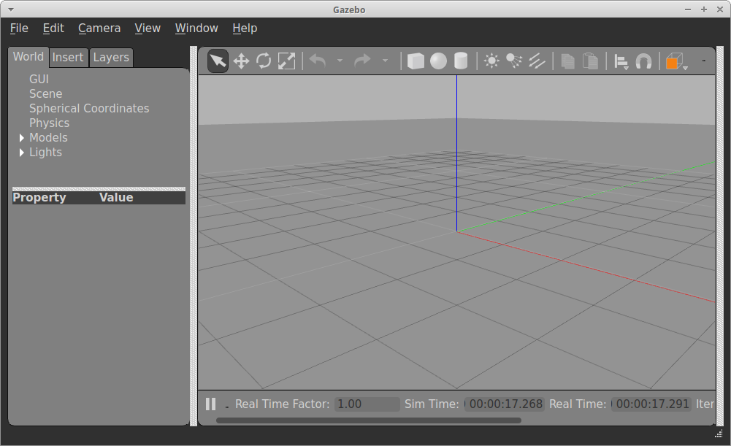

Now click on insert tab and add cycle .

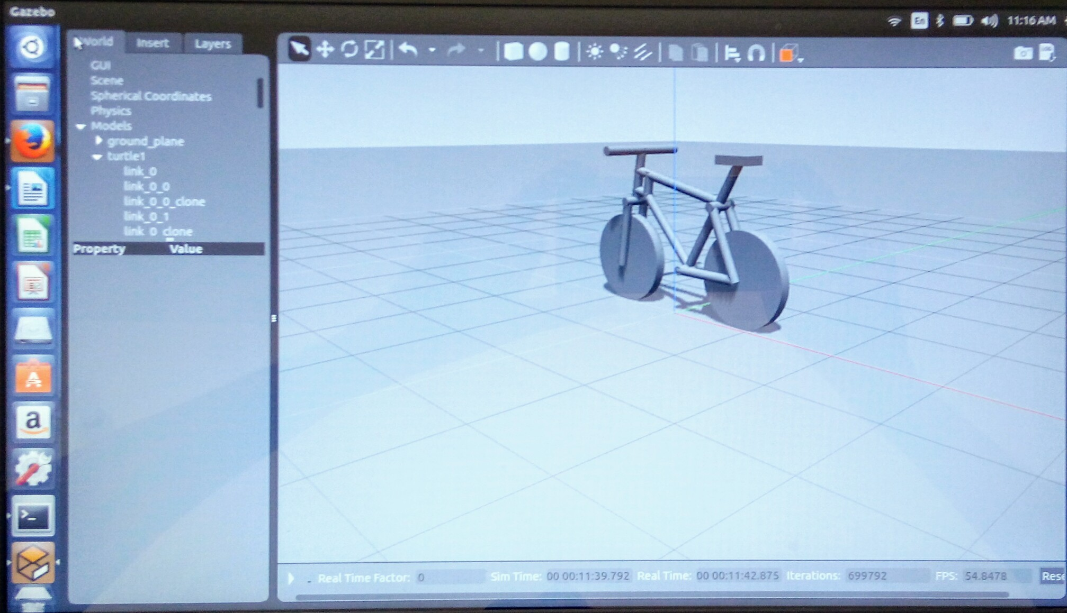
Sometimes wheels of cycle little bit inside the ground so that before unpausing the simulation drag cycle such that it is completely above the ground .Now using shortcut key “ ctrl+alt+t ” open a new terminal so that it will be a new node to move the cycle .
When you are moving a cycle using arrow keys this new terminal must opened and curser on terminal otherwise it will not move also take care that simulation is unpaused.

7. Open new terminal and paste following in it :

rosrun turtlesim turtle_teleop_key

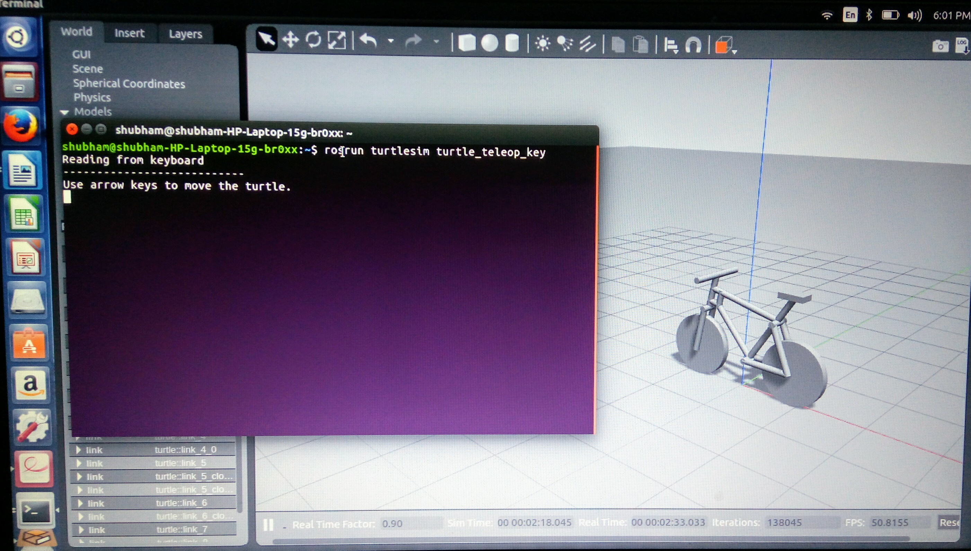
So our cycle is moving , now repeating the same procedure and building cycle with humanoid. Here I am going to use same directory(folder) if you want to use same directory first delete everything in it . I suggest you to creat your own new directory.

Open a new terminal ( ctrl+alt+t ) and do as explained below.

1.Create a model directory:

mkdir -p ~/.gazebo/models/my_robot

2.Create a model config. file:

gedit ~/.gazebo/models/my_robot/model.config

3.Paste in the following contents:
Model.config2
Download code from github link.
https://github.com/shreyash184/sra_code.git.

4.Create a model sdf file:

gedit ~/.gazebo/models/my_robot/model.sdf

5.Paste in the following :

model.sdf2
download code from github link.
https://github.com/shreyash184/sra_code.git.

6.Open a terminal and copy following content and paste in it :

roslaunch gazebo_ros empty_world.launch

Now click on insert tab and add model.

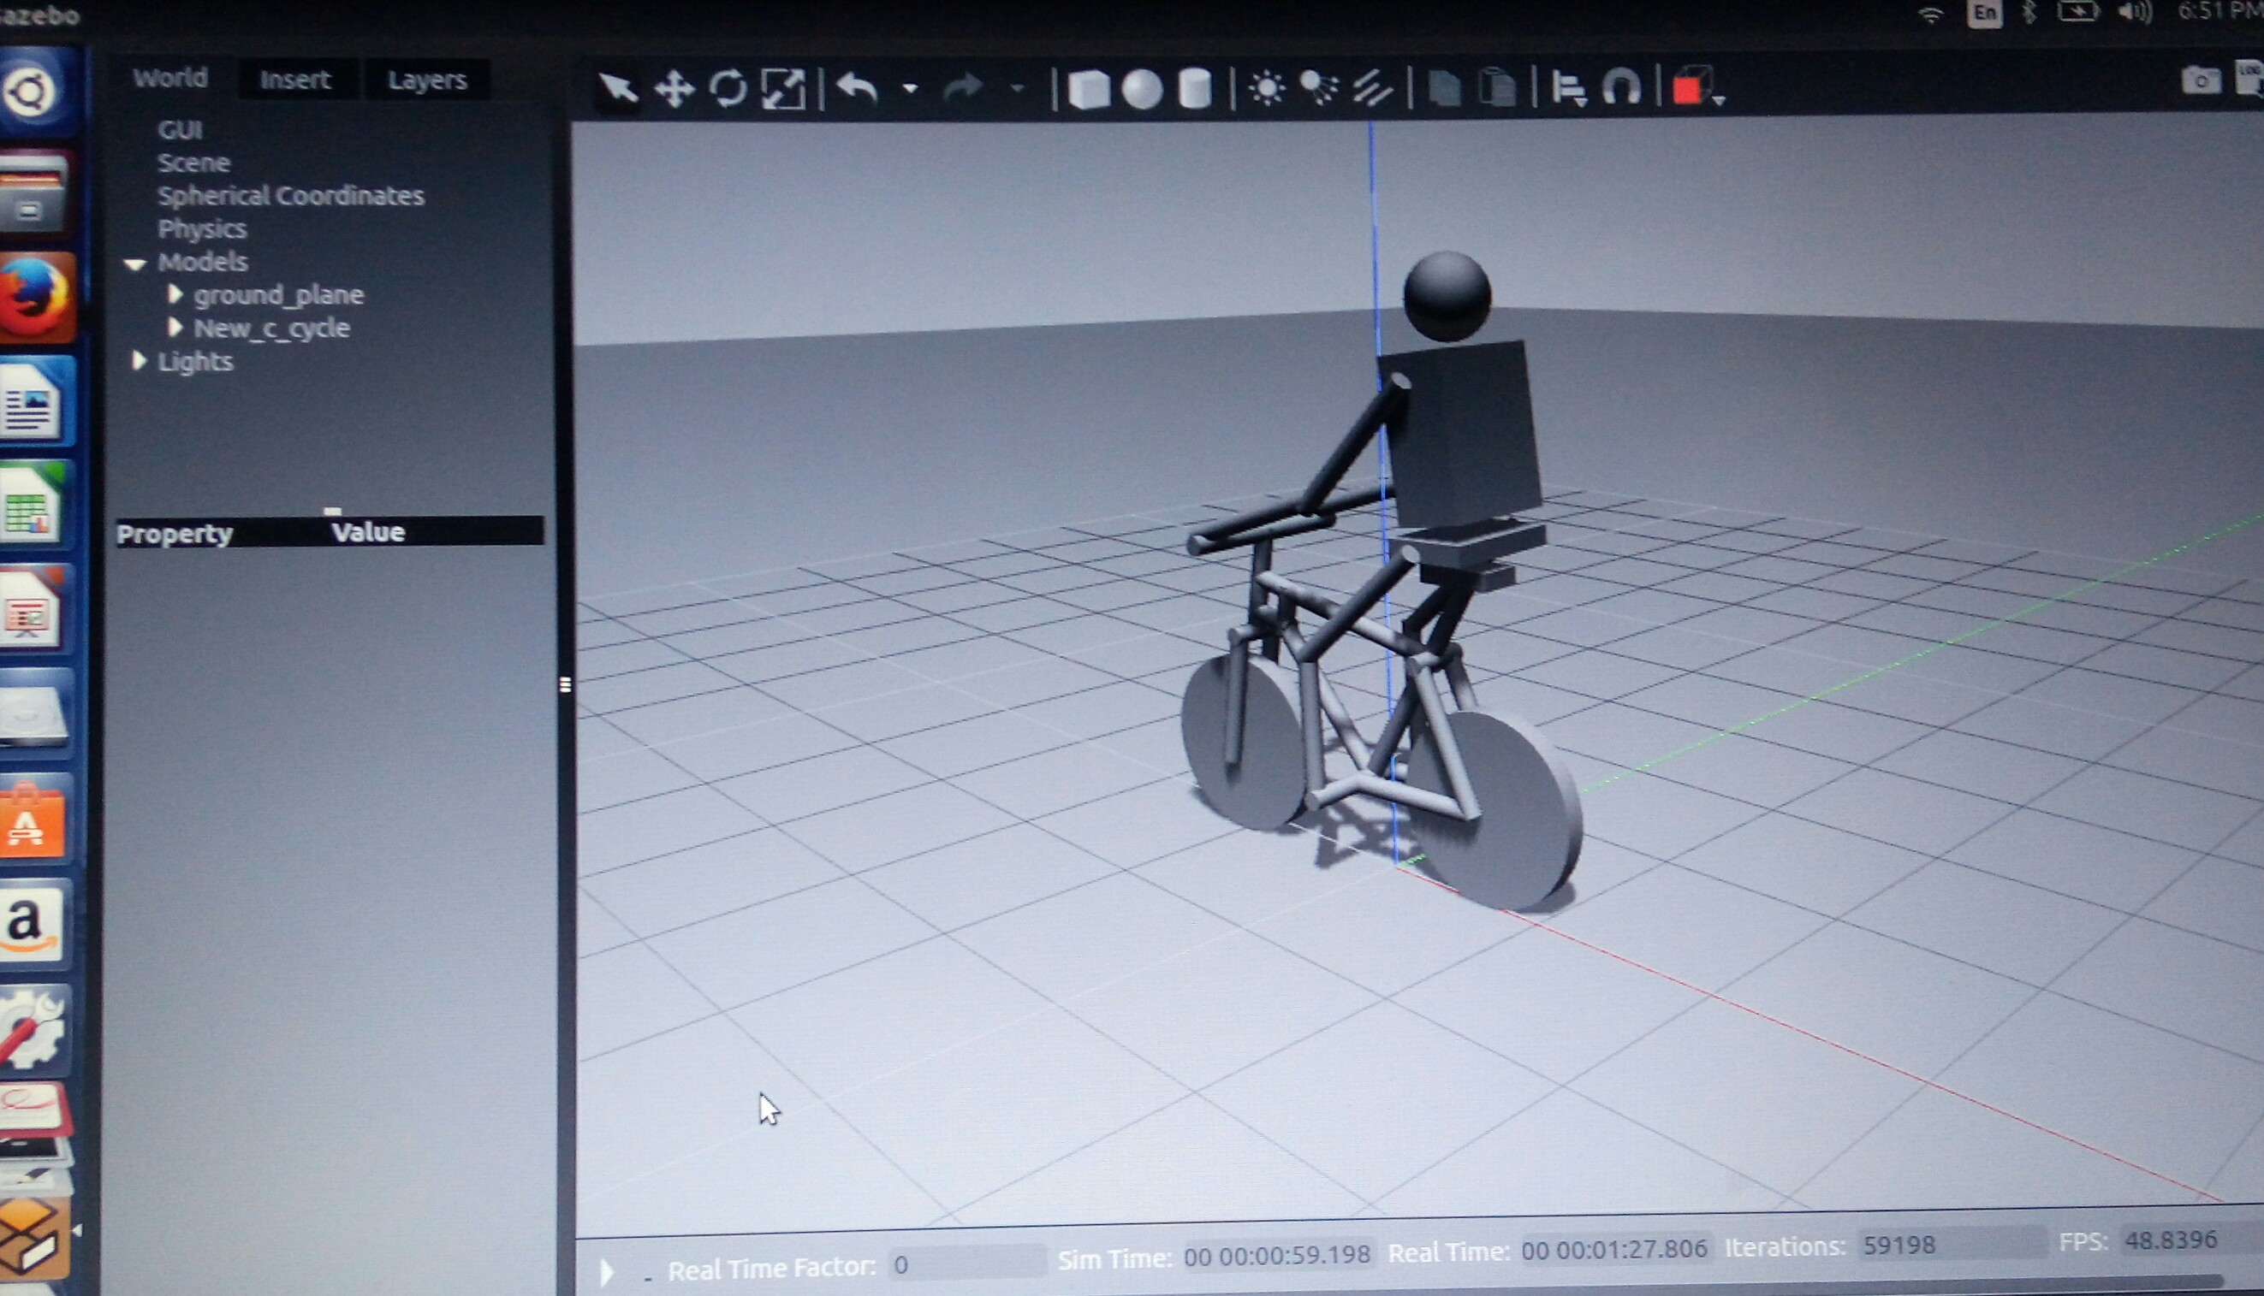

7. Open new terminal and paste following in it :

rosrun turtlesim turtle_teleop_key

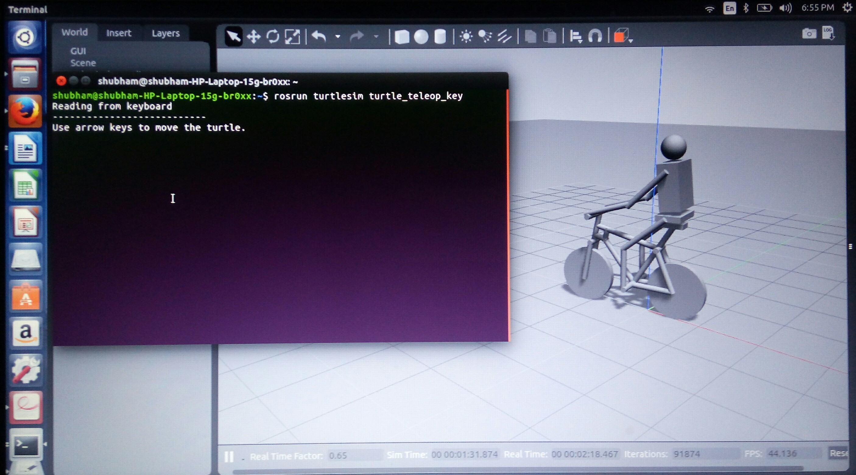
In this xml file model.sdf there is plugin added through which we can add forward and backward motion to the cycle.Plugin used in this model.sdf is differential drive controller.
now next step to turn the cycle.
Make a new folder in the gazebo models and name turn cycle and put model.cofig and model.sdf
Download this code and vedios of turning the cycle from github link is given below
https://github.com/shreyash184/sra_code.git.
You don’t need to github all the time, download from any link in this documentation given for github once you will get all the files.

