Data Acquisition, Cleaning, and Preprocessing
A Case Study Using the Titanic Passenger Dataset
Week 1 Task — Data Cleaning & Preprocessing Report
Prepared: August 2026 By : Jashanpreet Singh

Table of Contents
1. Executive Summary
2. Introduction and Objective
3. Data Acquisition
4. Initial Data Exploration
5. Data Quality Issues Identified
6. Data Cleaning and Preprocessing Methodology
7. Before vs. After Comparison
8. Challenges Faced and How They Were Overcome
9. Impact of Preprocessing on Subsequent Analysis
10. Conclusion
Appendix A: Full Exploration Script
Appendix B: Full Cleaning & Preprocessing Script

1. Executive Summary
This report documents the end to end process of acquiring, exploring, cleaning, and preprocessing a publicly available dataset using Python. The dataset selected is the Titanic passenger manifest (891 records, 12 original fields), a widely used and reliably sourced dataset that exhibits realistic data quality issues, including missing values, right skewed numerical distributions with outliers, mixed data types, and free text fields requiring feature extraction.
Three fields contained missing data: Cabin (77.1% missing), Age (19.9% missing), and Embarked (0.22% missing). Each was treated with a different strategy appropriate to its missingness mechanism and downstream utility, rather than a single blanket approach. Fare exhibited significant right skew and 116 statistical outliers under the IQR method; these were investigated, found to be legitimate extreme values rather than data entry errors, and handled through feature engineering (capping and log transformation) rather than deletion. The final deliverable includes a fully documented, reproducible cleaning pipeline, a cleaned dataset retaining full traceability, and a model ready dataset with engineered features.
Key Outcomes
0 missing Age values (from 177), 0 missing Embarked values (from 2), Cabin sparsity converted into two usable engineered features (HasCabin, Deck), Fare outliers retained but stabilized via log transformation, and 6 new engineered features added (Title, AgeGroup, FamilySize, IsAlone, FareCapped, FareLog) to support downstream analysis.

2. Introduction and Objective
Reliable analysis and modeling depend on the quality of the underlying data. Real world datasets are rarely delivered in an analysis ready state — they typically contain missing observations, inconsistent formatting, outliers of ambiguous origin, and fields that require transformation before they are useful to downstream statistical or machine learning workflows. The objective of this task was to select a publicly available dataset, perform a rigorous exploratory assessment of its structure and quality, and design and implement a cleaning and preprocessing pipeline that addresses identified issues in a transparent, justified, and reproducible way.
This report walks through that process step by step: how the dataset was obtained, what exploratory checks were run and what they revealed, how each data quality issue was diagnosed and treated, what trade offs were considered, and what impact the preprocessing choices are likely to have on any subsequent analysis performed on the cleaned data.

3. Data Acquisition

3.1 Dataset Selection
The dataset used is the Titanic passenger manifest, sourced from a public, version controlled GitHub repository maintained for data science education (datasciencedojo/datasets). This is a well established reference dataset with a stable schema and a long history of use in exploratory data analysis and classification modeling coursework, which makes it appropriate for demonstrating a cleaning and preprocessing workflow while still containing genuine, unaltered data quality issues (as opposed to a synthetic or pre cleaned dataset).
Attribute | Detail
Source | GitHub — datasciencedojo/datasets (public repository)
Retrieval URL | raw.githubusercontent.com/datasciencedojo/datasets/master/titanic.csv
Retrieval method | Direct HTTP download via curl into a local CSV file
Format | CSV (comma separated values)
Records | 891 passengers
Original fields | 12 (PassengerId, Survived, Pclass, Name, Sex, Age, SibSp, Parch, Ticket, Fare, Cabin, Embarked)
License / usage | Publicly available for educational and research use

3.2 Acquisition Code
The dataset was retrieved directly via command line and immediately verified for successful, complete download before any processing began:
curl sL o titanic_raw.csv \
"https://raw.githubusercontent.com/datasciencedojo/datasets/master/titanic.csv"

# Sanity check: confirm row count and header
wc l titanic_raw.csv
head 5 titanic_raw.csv
The download returned 892 lines (891 data rows plus one header row), consistent with the documented size of the dataset, confirming a complete and uncorrupted transfer.

4. Initial Data Exploration
Before any cleaning was performed, the raw dataset was loaded into a pandas Data Frame and examined systematically: shape, column data types, summary statistics, missing value counts, duplicate records, and the distribution of key variables.

4.1 Exploration Code
import pandas as pd
import numpy as np

df = pd.read_csv('titanic_raw.csv')

print(df.shape) # (891, 12)
print(df.dtypes) # data types per column
print(df.describe()) # numeric summary statistics
print(df.describe(include=['object'])) # categorical summary

missing = df.isnull().sum()
missing_pct = (missing / len(df) * 100).round(2)
print(pd.DataFrame({'missing_count': missing, 'missing_pct': missing_pct})
.query('missing_count > 0').sort_values('missing_count', ascending=False))

print("Exact duplicate rows:", df.duplicated().sum())
print("Duplicate PassengerId:", df['PassengerId'].duplicated().sum())

4.2 Structural Findings
- Shape: 891 rows × 12 columns. No structural corruption (ragged rows, encoding errors) was found.
- Data types: 5 numeric columns (PassengerId, Survived, Pclass, SibSp, Parch as int64; Age and Fare as float64) and 5 text columns (Name, Sex, Ticket, Cabin, Embarked). Survived, Pclass, and Sex are semantically categorical despite being stored as numeric/text this was corrected during preprocessing.
- Duplicates: 0 exact duplicate rows and 0 duplicate PassengerId values no de duplication was necessary.
- Cardinality: Name and Ticket are high cardinality free text fields (891 and 681 unique values respectively), signalling they are identifiers or require feature extraction rather than direct use as model inputs.

4.3 Missing Value Summary (Raw Data)
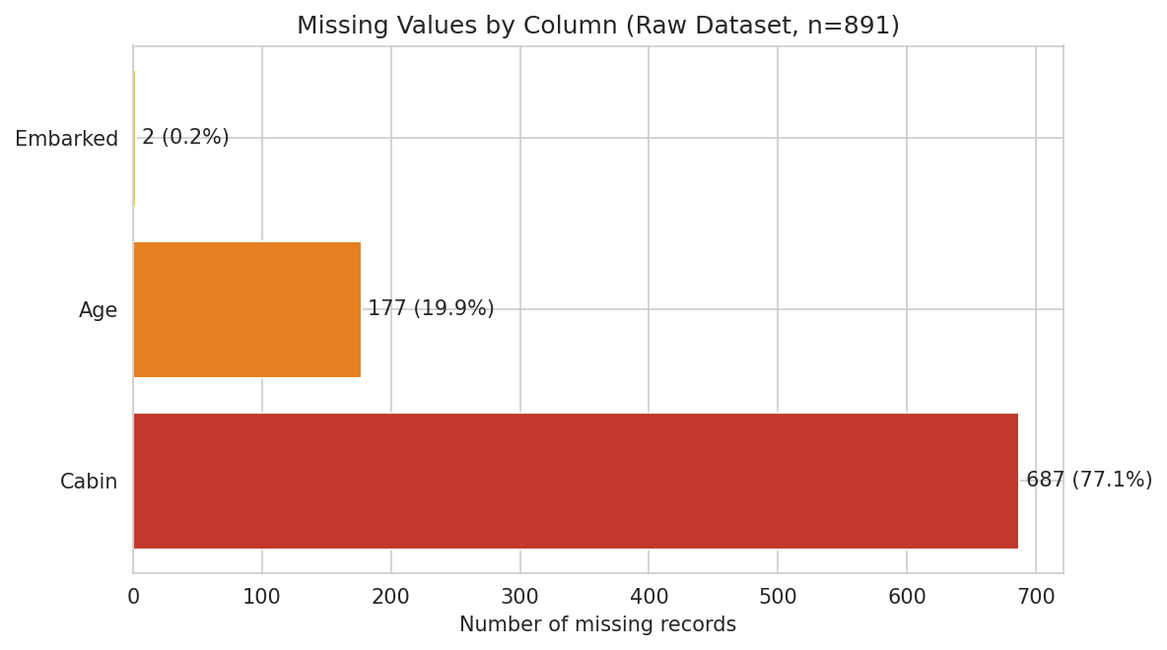
Figure 1. Count and percentage of missing values by column in the raw dataset.
Column | Missing Count | Missing % | Likely Cause
Cabin | 687 | 77.10% | Cabin numbers were only recorded for passengers whose accommodations were logged in surviving records (disproportionately 1st class); largely unrecorded for others.
Age | 177 | 19.87% | Age was not captured or not recoverable for a subset of passengers, especially those without close family aboard to report it.
Embarked | 2 | 0.22% | Isolated clerical omission two records missing port of embarkation.

4.4 Distribution and Outlier Screening
Age and Fare the two continuous numerical variables were visually and statistically screened for outliers using histograms, boxplots, and the interquartile range (IQR) rule (values beyond Q1 − 1.5×IQR or Q3 + 1.5×IQR).
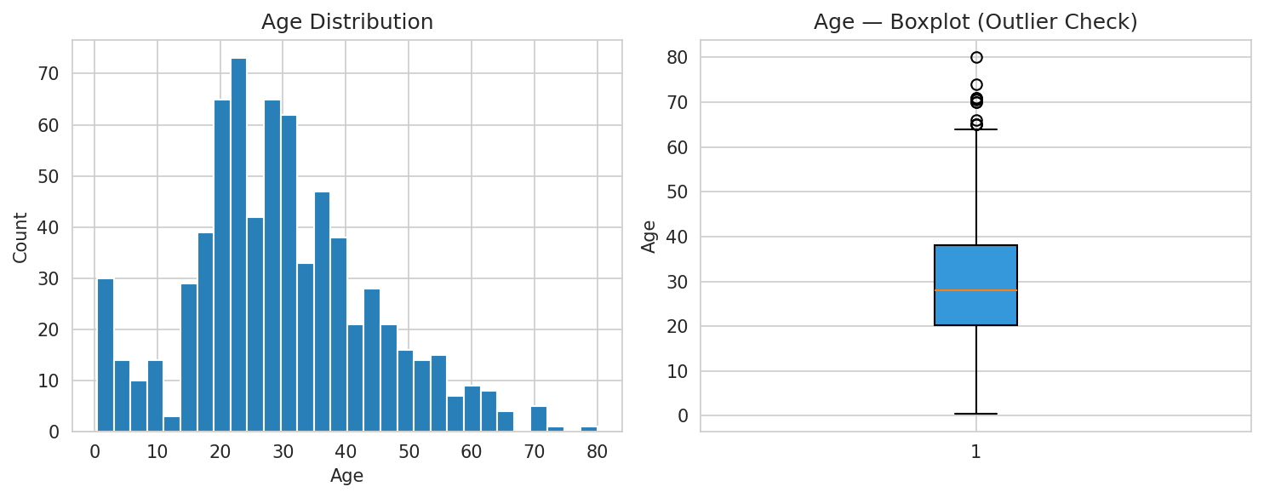
Figure 2. Age distribution (left) and boxplot (right) for the raw dataset. Age ranges from 0.42 to 80 with 11 IQR outliers, mostly at the upper (elderly) end plausible values, not errors.
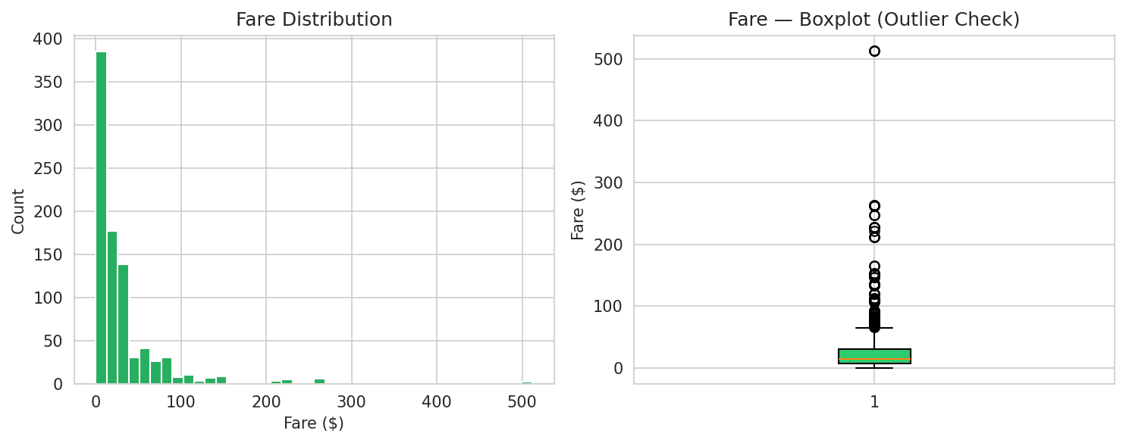
Figure 3. Fare distribution (left) and boxplot (right). Fare is heavily right skewed, with 116 IQR outliers, including a cluster of three tickets at $512.33 the maximum fare paid, associated with a known first class group booking.
A close inspection of the Age field also revealed fractional values (e.g., 0.42, 0.83, 0.67) rather than data errors these represent the standard convention of recording infant ages in fractions of a year, and were preserved as valid.
Fifteen passengers were recorded with a Fare of exactly $0.00. Cross referencing these records against the Name and Ticket fields (e.g., Thomas Andrews, the ship's builder, and several employees of the White Star Line and American Line traveling on ticket numbers beginning "LINE") confirmed these are legitimate zero fare employee/guaranteed passages rather than erroneous or missing entries, so they were retained rather than treated as missing or invalid.

5. Data Quality Issues Identified
Based on the exploratory analysis above, the following data quality issues were catalogued prior to designing the cleaning strategy:
# | Issue | Severity | Affected Field(s)
1 | Missing values — high proportion | High | Cabin (77.1%)
2 | Missing values — moderate proportion | Medium | Age (19.9%)
3 | Missing values — negligible proportion | Low | Embarked (0.22%)
4 | Right skewed distribution with statistical outliers | Medium | Fare
5 | Semantically categorical fields stored as raw numeric/string types | Low | Survived, Pclass, Sex
6 | High cardinality free text fields not directly usable by models | Low | Name, Ticket
7 | Embedded structured information inside free text (title, cabin deck) | Medium | Name, Cabin
Each issue above was matched to a specific, justified treatment in Section 6, rather than being addressed with a single generic strategy this distinction mattered because the three missing data fields differ substantially in both missingness proportion and mechanism, and a one size fits all approach (e.g., dropping every row with any missing value) would have discarded the majority of the dataset.

6. Data Cleaning and Preprocessing Methodology
The full cleaning pipeline is presented below as a sequence of discrete, independently justified steps. Each step includes the Python code used, and the rationale behind the chosen approach.

6.1 Step 1 — Duplicate Verification
Although the initial exploration found zero exact duplicate rows and zero duplicate PassengerId values, a secondary check excluding the identifier column was run to catch cases where the same passenger might have been logged twice under a new ID:
n_dupes = df.duplicated(subset=[c for c in df.columns if c != 'PassengerId']).sum()
print(f"Duplicate rows (excluding ID): {n_dupes}") # > 0
No duplicates were found by either method, so no rows were removed at this stage.

6.2 Step 2 — Data Type Correction
Survived, Pclass, and Sex are categorical by nature but were loaded as raw numeric or object types. Casting them to pandas' category dtype makes this explicit, reduces memory footprint, and ensures downstream grouping/plotting functions treat them correctly rather than as continuous quantities:
df['Survived'] = df['Survived'].astype('category')
df['Pclass'] = df['Pclass'].astype('category')
df['Sex'] = df['Sex'].astype('category')

6.3 Step 3 — Embarked: Mode Imputation
With only 2 of 891 records missing (0.22%), Embarked's missingness is negligible and unlikely to bias results regardless of treatment. Imputing with the mode (the single most common port, "S" Southampton, 644 of 889 known records) is a standard, low risk approach for a low missingness categorical field:
mode_embarked = df['Embarked'].mode()[0]
df['Embarked'] = df['Embarked'].fillna(mode_embarked)
# > 2 records (PassengerId 62, 830) filled with 'S'

6.4 Step 4 — Age: Grouped Median Imputation
At 19.9% missing, Age required a more considered approach than a single global median fill, since a passenger's age correlates strongly with both passenger class (Pclass) and title (a proxy for age related social status extracted from the Name field, e.g. "Master" reliably denotes a young boy). A title was first extracted via regular expression and consolidated into five categories, then Age was imputed using the median within each Pclass × Sex × Title group, with a Pclass × Sex fallback for any group that had no non missing ages of its own:
df['Title'] = df['Name'].str.extract(r',\s*([^\.]+)\.')
title_map = {
'Mlle': 'Miss', 'Ms': 'Miss', 'Mme': 'Mrs',
'Lady': 'Rare', 'Countess': 'Rare', 'the Countess': 'Rare', 'Capt': 'Rare',
'Col': 'Rare', 'Don': 'Rare', 'Dr': 'Rare', 'Major': 'Rare', 'Rev': 'Rare',
'Sir': 'Rare', 'Jonkheer': 'Rare', 'Dona': 'Rare'
}
df['Title'] = df['Title'].replace(title_map)

df['Age'] = df.groupby(['Pclass', 'Sex', 'Title'], observed=True)['Age'] \
.transform(lambda x: x.fillna(x.median()))

# Fallback for any group with no known ages at all
if df['Age'].isnull().sum() > 0:
df['Age'] = df.groupby(['Pclass', 'Sex'], observed=True)['Age'] \
.transform(lambda x: x.fillna(x.median()))
This reduced Age's missing count from 177 to 0. A grouped median approach was preferred over a single global median because it preserves more of the true variation in the data a 3rd class "Master" (young boy) and a 1st class "Mr" have very different typical ages, and collapsing both to one dataset wide median would distort the distribution and understate the relationship between age and other variables. An AgeGroup bucket field (Child / Teen / Young Adult / Adult / Senior) was also derived to support categorical downstream analysis:
df['AgeGroup'] = pd.cut(df['Age'], bins=[0,12,18,35,60,100],
labels=['Child','Teen','Young Adult','Adult','Senior'])

6.5 Step 5 — Cabin: Feature Engineering Instead of Imputation
At 77.1% missing, Cabin is too sparse for reliable imputation any imputation method would be manufacturing values for over three quarters of the field with no reliable basis, and would risk introducing false signal into later analysis. Rather than imputing or simply dropping the column outright (which would discard the information carried by the 22.9% of records that do have it), two engineered features were derived instead: a binary indicator of whether a cabin was recorded, and the deck letter (first character of the cabin code) where available:
df['HasCabin'] = df['Cabin'].notnull().astype(int)
df['Deck'] = df['Cabin'].str[0]
df['Deck'] = df['Deck'].fillna('Unknown')
This treatment converts an unreliable, mostly missing free text field into two clean, fully populated features that retain its useful signal (cabin record availability turns out to correlate with passenger class and, downstream, with survival see Section 7) without fabricating specific cabin numbers that cannot be known.

6.6 Step 6 — Fare: Outlier Handling
116 of 891 Fare values (13%) fell outside the IQR outlier bounds. As established in Section 4.4, these are legitimate high fares (first class and group bookings) rather than data entry errors, so they were not deleted or treated as missing doing so would remove real, informative variation and bias any downstream analysis of fare or class. Instead, two engineered variants were added alongside the original Fare column: a winsorized (capped) version for methods sensitive to extreme values, and a log1p transformed version to reduce right skew for statistical modeling:
q1, q3 = df['Fare'].quantile([.25, .75])
iqr = q3 q1
upper_bound = q3 + 1.5 * iqr # 65.63

df['FareCapped'] = df['Fare'].clip(upper=upper_bound)
df['FareLog'] = np.log1p(df['Fare'])
df['FareIsZero'] = (df['Fare'] == 0).astype(int)
Retaining the original Fare column alongside the transformed variants preserves full traceability and gives any downstream analyst the choice of representation appropriate to their method, rather than silently discarding information.

6.7 Step 7 — Consistency and Plausibility Checks
Two further checks were run to catch logical inconsistencies that summary statistics alone would not surface. First, a family size feature was derived from SibSp (siblings/spouses aboard) and Parch (parents/children aboard) and checked for implausibly large values; second, extracted titles were cross checked against the Sex field to catch any mislabeling:
df['FamilySize'] = df['SibSp'] + df['Parch'] + 1
df['IsAlone'] = (df['FamilySize'] == 1).astype(int)

mismatch = df[((df['Title'].isin(['Mr','Master'])) & (df['Sex']=='female')) |
((df['Title'].isin(['Mrs','Miss'])) & (df['Sex']=='male'))]
print(len(mismatch)) # > 0
Seven records had a Family Size greater than 8; on inspection these correspond to two genuinely large families known to be aboard (the Sage and Goodwin families), so they were retained as valid rather than treated as errors. No title/sex mismatches were found.

6.8 Step 8 — Finalizing Output Datasets
Two output files were produced from the pipeline: a fully traceable cleaned dataset retaining every original and engineered column (including the raw Cabin, Ticket, and Name fields for auditability), and a model ready dataset with the high cardinality, non-predictive identifier columns removed:
df_cleaned_full = df.copy()
df_model_ready = df.drop(columns=['Cabin', 'Ticket', 'Name']).copy()

df_cleaned_full.to_csv('titanic_cleaned_full.csv', index=False)
df_model_ready.to_csv('titanic_model_ready.csv', index=False)
Name, Ticket, and (raw) Cabin were dropped only from the model ready file Name and Ticket are near unique free text identifiers with no direct predictive structure once Title has been extracted, and Cabin's usable signal was already captured in Has Cabin and Deck. All three remain in the full cleaned file for traceability and any future re derivation of features.

7. Before vs. After Comparison
The figures below summarize the effect of the cleaning pipeline on the dataset's completeness and distributions.
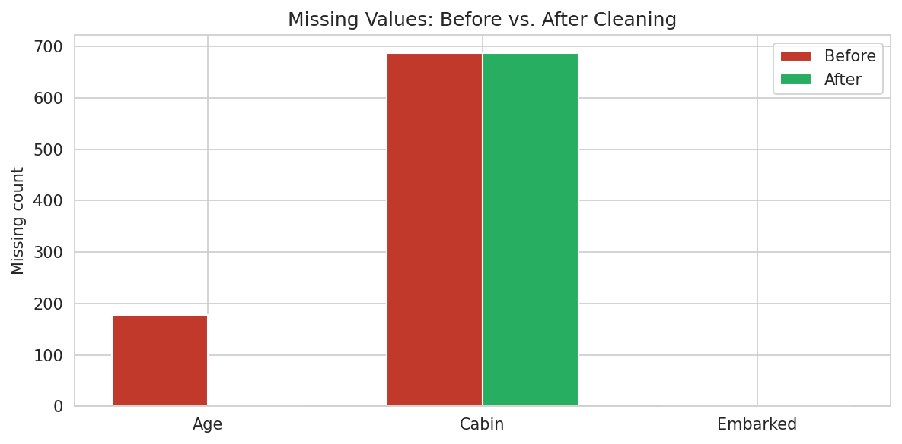
Figure 4. Missing value counts before and after cleaning. Age and Embarked reach zero missing; Cabin's raw missingness is unchanged by design (see Section 6.5) but is now fully captured via Has Cabin/Deck.
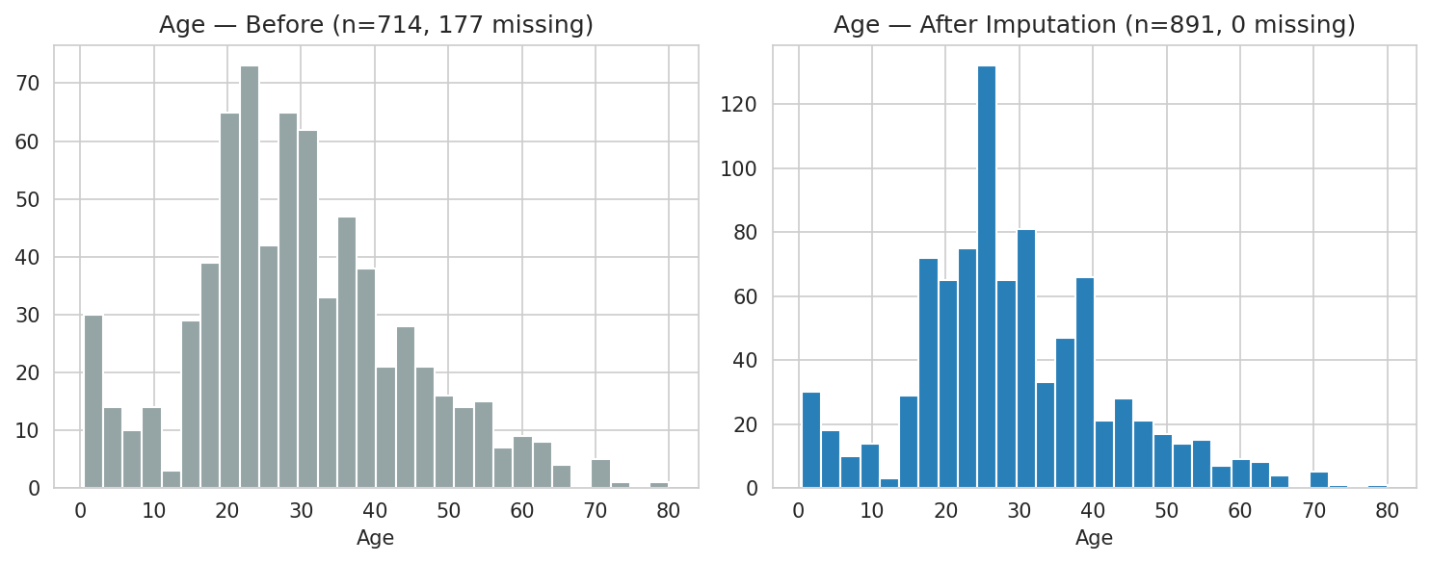
Figure 5. Age distribution before (177 missing, left) and after grouped median imputation (0 missing, right). The overall shape is preserved; imputed values reinforce the existing distribution rather than distorting it.
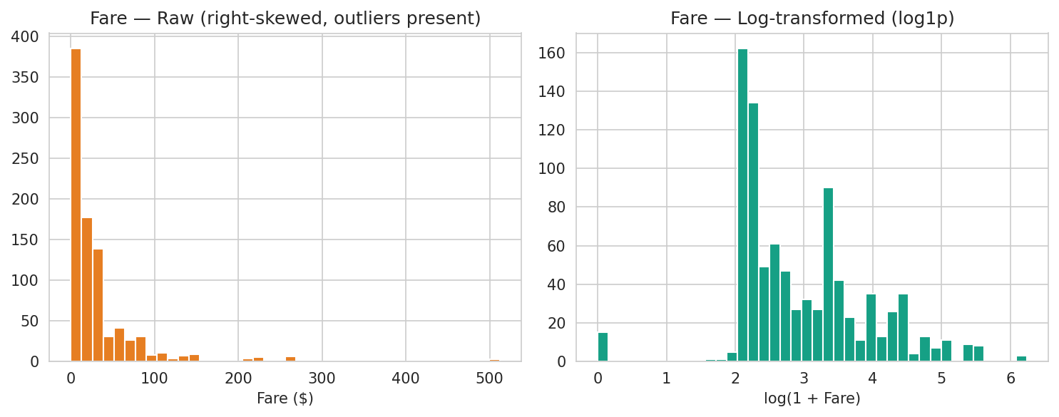
Figure 6. Raw Fare (left, right skewed with outliers) versus the engineered log transformed Fare Log feature (right), which is markedly closer to a symmetric distribution and better suited to methods that assume approximate normality.

7.1 Illustrative Downstream Analysis
To confirm the cleaned dataset supports meaningful analysis, two quick illustrative views were produced using the cleaned data these are not part of the cleaning pipeline itself, but demonstrate that the engineered features carry real signal:
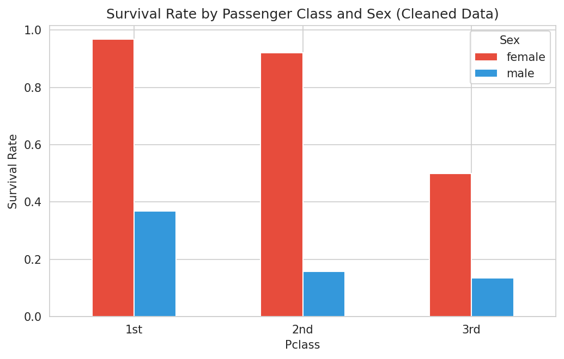
Figure 7. Survival rate by passenger class and sex, computed on the cleaned dataset.
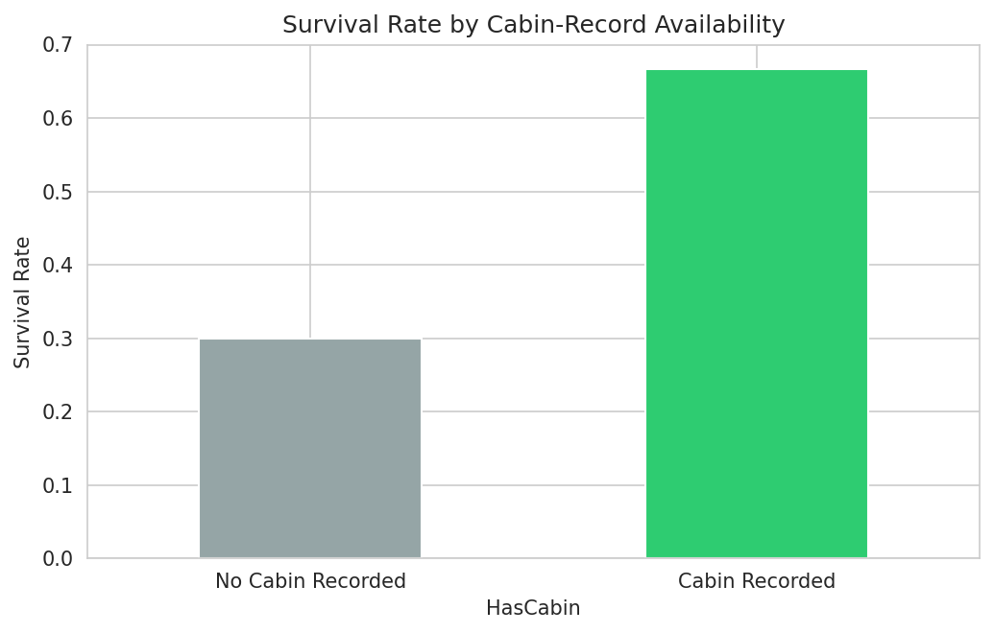
Figure 8. Survival rate by whether a cabin was recorded the engineered HasCabin feature, derived to handle Cabin's 77% missingness, shows a clear association with survival and would have been lost had Cabin simply been dropped outright.

8. Challenges Faced and How They Were Overcome

Challenge 1: Deciding how to treat Cabin's extreme missingness (77.1%)
A field missing for over three quarters of records is not reliably imputable, but dropping it outright discards real signal from the ~23% of records where it is present. This was resolved by reframing the problem: instead of asking "how do we fill in Cabin," the question became "what usable signal can we extract without fabricating unknown values." This led to the HasCabin/Deck engineering approach in Section 6.5, which Figure 8 confirms retained predictive value.

Challenge 2: Distinguishing genuine outliers from statistical outliers
The IQR method flagged 116 Fare values and 11 Age values as statistical outliers, but a mechanical rule cannot distinguish an error from an unusual but true observation. Each outlier cluster was manually cross referenced against contextual fields (Name, Ticket, Pclass) rather than being deleted automatically. The zero fare and high fare clusters were both confirmed as legitimate through this process (Section 4.4, Section 6.6), which prevented the accidental removal of real, informative extreme values.

Challenge 3: Choosing an imputation strategy for Age that avoided flattening the distribution
An initial attempt at single global median imputation was considered but rejected after comparing group level age statistics: median age varies by more than 20 years between, for example, 1st class "Mr" passengers and 3rd class "Master" passengers. A single median would have imputed implausible ages for large parts of the missing population. The grouped Pclass × Sex × Title approach in Section 6.4 was adopted specifically to address this, with a coarser Pclass × Sex fallback to guarantee no group was left with unresolved missing values.

Challenge 4: Extracting structured information from unstructured text
The Name field embeds a courtesy title (e.g., "Mr.", "Master.", "the countess") in inconsistent free text form. A regular expression was used to isolate the title, but rare titles (military ranks, nobility) needed to be manually mapped into a consolidated "Rare" bucket to avoid creating imputation groups with only one or two members, which would have made the grouped median approach in Challenge 3 unstable for those passengers.

9. Impact of Preprocessing on Subsequent Analysis
Every cleaning and preprocessing decision has downstream consequences, and it is worth making these explicit rather than treating cleaning as a neutral, assumption free step.
- Age imputation: Grouped median imputation reduces the variance of Age within each group relative to what true (unobserved) ages would show, which can subtly narrow confidence intervals in any downstream statistical test that uses Age. Analysts using the cleaned data for inferential (not just descriptive or predictive) purposes should be aware that imputed values carry more certainty than they should and consider multiple imputation methods if this matters to their conclusions.
- Fare outlier retention: Choosing to retain outliers rather than remove them means models sensitive to extreme values (e.g., ordinary least squares regression) may be disproportionately influenced by the small number of very high fares. The FareCapped and FareLog engineered columns are provided specifically so downstream analysts can select a representation matched to their method's sensitivity, rather than forcing a single choice on all future analysis.
- HasCabin as a proxy variable: Because cabin recording likelihood correlates with passenger class (wealthier, higher-class passengers were more likely to have a recorded cabin), HasCabin is partially confounded with Pclass and Fare. Any model using HasCabin as a predictor should be interpreted with this correlation in mind rather than treated as an independent signal.
- Zero fare and mode imputed records: The 15 zero fare and 2 mode imputed Embarked records are a small fraction of the dataset (under 2% combined) and are unlikely to materially bias aggregate statistics, but they remain flagged (via FareIsZero) so they can be excluded easily if a specific downstream analysis requires it.
In general, the guiding principle applied throughout this pipeline was to prefer transformations that are transparent and reversible (adding new columns alongside originals) over destructive ones (deleting rows or overwriting the only copy of a value), so that any consumer of the cleaned dataset can trace exactly what was changed and why, and can adapt the treatment to their specific downstream method.

10. Conclusion
This report has documented a complete data acquisition, exploration, cleaning, and preprocessing pipeline applied to the Titanic passenger dataset. Starting from 891 records with three fields containing missing data and one field with significant statistical outliers, the pipeline produced a fully populated (for Age and Embarked), traceable, and feature enriched dataset ready for downstream statistical analysis or predictive modeling. Each treatment decision mode imputation for a near complete field, grouped median imputation for a moderately incomplete field, feature engineering rather than imputation for a mostly missing field, and outlier preserving transformation rather than deletion for a skewed continuous field was chosen deliberately based on the specific characteristics of the issue at hand, and documented with its rationale so the choices can be audited or revisited as analytical needs evolve.

Appendix A: Full Exploration Script
import pandas as pd
import numpy as np

pd.set_option('display.max_columns', None)
pd.set_option('display.width', 120)

df = pd.read_csv('titanic_raw.csv')

print("="*70)
print("SHAPE")
print("="*70)
print(df.shape)

print("\n" + "="*70)
print("DTYPES")
print("="*70)
print(df.dtypes)

print("\n" + "="*70)
print("HEAD")
print("="*70)
print(df.head(10))

print("\n" + "="*70)
print("DESCRIBE (numeric)")
print("="*70)
print(df.describe())

print("\n" + "="*70)
print("DESCRIBE (categorical)")
print("="*70)
print(df.describe(include=['object']))

print("\n" + "="*70)
print("MISSING VALUES")
print("="*70)
missing = df.isnull().sum()
missing_pct = (missing / len(df) * 100).round(2)
missing_table = pd.DataFrame({'missing_count': missing, 'missing_pct': missing_pct})
missing_table = missing_table[missing_table.missing_count > 0].sort_values('missing_count', ascending=False)
print(missing_table)

print("\n" + "="*70)
print("DUPLICATE ROWS")
print("="*70)
print("Exact duplicate rows:", df.duplicated().sum())
print("Duplicate PassengerId:", df['PassengerId'].duplicated().sum())

print("\n" + "="*70)
print("UNIQUE VALUES key categoricals")
print("="*70)
for col in ['Survived','Pclass','Sex','SibSp','Parch','Embarked']:
print(f"\n{col}:")
print(df[col].value_counts(dropna=False))

print("\n" + "="*70)
print("RANGE CHECKS")
print("="*70)
print("Age min/max:", df['Age'].min(), df['Age'].max())
print("Fare min/max:", df['Fare'].min(), df['Fare'].max())
print("Fare == 0 count:", (df['Fare']==0).sum())
print("Age fractional values (children under 1yr encoded as fractions):")
print(df.loc[df['Age'] % 1 != 0, 'Age'].dropna().unique())

Appendix B: Full Cleaning & Preprocessing Script
import pandas as pd
import numpy as np

df = pd.read_csv('titanic_raw.csv')
print(f"Starting shape: {df.shape}")

# Step 1: Handle duplicate check (none found, but verify programmatically)
n_dupes = df.duplicated(subset=[c for c in df.columns if c != 'PassengerId']).sum()
print(f"Duplicate rows (excluding ID): {n_dupes}")

# Step 2: Fix data types
df['Survived'] = df['Survived'].astype('category')
df['Pclass'] = df['Pclass'].astype('category')
df['Sex'] = df['Sex'].astype('category')
print("Dtypes converted for categorical columns: Survived, Pclass, Sex")

# Step 3: Missing Embarked (2 records) — impute with mode
mode_embarked = df['Embarked'].mode()[0]
missing_embarked_ids = df.loc[df['Embarked'].isnull(), 'PassengerId'].tolist()
df['Embarked'] = df['Embarked'].fillna(mode_embarked)
print(f"Embarked: filled {len(missing_embarked_ids)} missing values (PassengerId {missing_embarked_ids}) with mode '{mode_embarked}'")

# Step 4: Missing Age (177 records, ~19.9%)
# Strategy: median imputation grouped by Pclass + Sex + Title (extracted from Name),
# since age correlates strongly with passenger class and social title.
df['Title'] = df['Name'].str.extract(r',\s*([^\.]+)\.')
title_map = {
'Mlle': 'Miss', 'Ms': 'Miss', 'Mme': 'Mrs',
'Lady': 'Rare', 'Countess': 'Rare', 'Capt': 'Rare', 'Col': 'Rare',
'Don': 'Rare', 'Dr': 'Rare', 'Major': 'Rare', 'Rev': 'Rare',
'Sir': 'Rare', 'Jonkheer': 'Rare', 'Dona': 'Rare', 'the Countess': 'Rare'
}
df['Title'] = df['Title'].replace(title_map)
print("\nTitle extracted from Name; counts:")
print(df['Title'].value_counts())

age_before_missing = df['Age'].isnull().sum()
df['Age'] = df.groupby(['Pclass', 'Sex', 'Title'], observed=True)['Age'] \
.transform(lambda x: x.fillna(x.median()))
# Fallback for any remaining NaN (rare Title/Pclass/Sex combos with all NaN age)
still_missing = df['Age'].isnull().sum()
if still_missing > 0:
df['Age'] = df.groupby(['Pclass', 'Sex'], observed=True)['Age'] \
.transform(lambda x: x.fillna(x.median()))
final_missing_age = df['Age'].isnull().sum()
print(f"\nAge: {age_before_missing} missing > grouped median imputation (Pclass+Sex+Title) "
f" > {still_missing} remained > Pclass+Sex fallback > {final_missing_age} missing")

# Age bucket / IsChild flag for downstream analysis (useful derived feature)
df['AgeGroup'] = pd.cut(df['Age'], bins=[0,12,18,35,60,100],
labels=['Child','Teen','Young Adult','Adult','Senior'])

# Step 5: Cabin — 77% missing, too sparse to impute meaningfully
# Rather than dropping the column (loses signal), engineer a binary "HasCabin" indicator
# and extract the Deck letter where available.
df['HasCabin'] = df['Cabin'].notnull().astype(int)
df['Deck'] = df['Cabin'].str[0]
df['Deck'] = df['Deck'].fillna('Unknown')
print(f"\nCabin: 77.1% missing > engineered HasCabin (binary) and Deck (first letter, 'Unknown' if missing)")
print(df['Deck'].value_counts())

# Step 6: Outliers in Fare
# Investigate zero fare records: these correspond to crew/employees (e.g. Thomas Andrews,
# the Titanic's builder) traveling on employee passage, not data entry errors.
zero_fare = df[df['Fare'] == 0]
print(f"\nZero fare passengers: {len(zero_fare)} — verified as legitimate (staff/guaranteed passage),"
" retained but flagged")
df['FareIsZero'] = (df['Fare'] == 0).astype(int)

# High fare outliers (IQR method) — legitimate first class/group fares, not errors.
# We do NOT delete outliers (they are real, valid extreme values), but we create a
# winsorized/capped fare feature and a log transformed feature for modeling stability.
q1, q3 = df['Fare'].quantile([.25, .75])
iqr = q3 q1
upper_bound = q3 + 1.5*iqr
n_outliers = (df['Fare'] > upper_bound).sum()
print(f"Fare: {n_outliers} values exceed IQR upper bound ({upper_bound:.2f}); "
f"retained as valid, added FareCapped (winsorized) and FareLog (log1p) features")
df['FareCapped'] = df['Fare'].clip(upper=upper_bound)
df['FareLog'] = np.log1p(df['Fare'])

# Step 7: Consistency checks
# SibSp/Parch sanity: family size feature, check for implausible values
df['FamilySize'] = df['SibSp'] + df['Parch'] + 1
df['IsAlone'] = (df['FamilySize'] == 1).astype(int)
implausible_family = df[df['FamilySize'] > 8]
print(f"\nFamilySize derived (SibSp+Parch+1). Records with FamilySize>8 (plausibility check): {len(implausible_family)}")

# Name/Sex consistency: verify title aligns with sex (e.g., no 'Mr.' tagged female)
mismatch = df[((df['Title'].isin(['Mr','Master'])) & (df['Sex']=='female')) |
((df['Title'].isin(['Mrs','Miss'])) & (df['Sex']=='male'))]
print(f"Title/Sex mismatches found: {len(mismatch)}")

# Step 8: Drop columns not useful for downstream modeling
# Ticket is a high cardinality free text identifier with no consistent structure; Cabin
# retained info already captured via HasCabin/Deck, so raw Cabin can be dropped for the
# modeling ready dataset (kept in the "cleaned but full" version).
df_cleaned_full = df.copy() # cleaned, all columns retained (for reporting/traceability)

df_model_ready = df.drop(columns=['Cabin', 'Ticket', 'Name']).copy()

print(f"\nFinal cleaned shape (full): {df_cleaned_full.shape}")
print(f"Final model ready shape: {df_model_ready.shape}")
print(f"\nRemaining missing values (full):\n{df_cleaned_full.isnull().sum()[df_cleaned_full.isnull().sum()>0]}")

df_cleaned_full.to_csv('titanic_cleaned_full.csv', index=False)
df_model_ready.to_csv('titanic_model_ready.csv', index=False)
print("\nSaved: titanic_cleaned_full.csv, titanic_model_ready.csv")

