Clustering Global Well-being
An Unsupervised Learning Approach to Socioeconomic Segmentation of Countries
Week 3 Task | Python + Scikit-learn | Jupyter Notebook Workflow
By: Jashanpreet Singh

Dataset | World Happiness Report 2024 country-level indicators
Observations | 143 countries/territories
Clustering methods | K-Means and Agglomerative Hierarchical Clustering
Selected substantive solution | 3 clusters, validated against k=2 to k=8

Executive Summary
This study applies unsupervised learning to a country-level well-being dataset to identify groups of countries that share similar socioeconomic characteristics. The analysis uses six clustering variables: GDP per capita, social support, healthy life expectancy, freedom to make life choices, generosity, and perceptions of corruption. The published happiness score is deliberately excluded from model fitting and is used afterwards as an interpretive outcome. This design makes the clustering exercise more meaningful because the algorithm discovers structural profiles rather than reproducing a pre-existing happiness ranking.
The validation exercise compared k=2 through k=8. k=2 produced the highest silhouette score (0.340), while k=3 produced the lowest Davies-Bouldin score (1.077) and created a clearer three-level segmentation. The final report therefore uses k=3 while openly acknowledging the metric trade-off. The three clusters contain 77, 45, and 21 countries respectively.
The substantive result is a gradient of development and well-being. Cluster 2 represents high-well-being, affluent systems; Cluster 0 is a broad middle group with mixed development characteristics; and Cluster 1 is a lower-well-being group with weaker average income, social support, health, and freedom indicators. The findings demonstrate how clustering can reveal multidimensional country segments that are not identical to geographic regions or happiness rankings.

1. Introduction
Unsupervised learning is useful when the analyst does not have a labelled target and instead wants an algorithm to discover structure in the observations. Clustering is one of its most practical applications because it groups observations that are similar across several dimensions. In economics and business analytics, this can support market segmentation, policy targeting, comparative development analysis, and identification of countries with comparable operating environments.
The World Happiness Report is a suitable setting because the country-level data combine economic, social, health, agency, generosity, and corruption-perception indicators. The report is produced by the Wellbeing Research Centre at the University of Oxford with Gallup and other partners, and its data-sharing page provides publicly accessible report data.

2. Research Question and Objectives
Research question: Can countries be segmented into meaningful socioeconomic well-being groups using unsupervised learning without directly using the published happiness score as a clustering input?
- Prepare a public country-level dataset for clustering.
- Standardize the multidimensional indicators so variables measured on different scales contribute fairly to distance calculations.
- Compare alternative values of k using established clustering-validation metrics.
- Apply K-Means and hierarchical clustering and assess whether they provide broadly similar structures.
- Visualize the final clusters using PCA and profile the groups using descriptive statistics.
- Translate the clusters into potential policy, research, and business implications.

3. Dataset Description
The dataset used in this project is a country-level CSV representation of World Happiness Report 2024 indicators. It contains 143 observations and nine columns: country, region, happiness score, and six socioeconomic well-being factors. The World Happiness Report data-sharing page states that the report is powered by the Gallup World Poll and that data for key report figures are available for download. The project CSV used for reproducibility is a public mirror of the 2024 country-level table.
Country | Happiness Score | Gdp Per Capita | Social Support | Healthy Life Expectancy
Finland | 7.741 | 1.844 | 1.572 | 0.695
Denmark | 7.583 | 1.908 | 1.52 | 0.699
Iceland | 7.525 | 1.881 | 1.617 | 0.718
Sweden | 7.344 | 1.878 | 1.501 | 0.724
Israel | 7.341 | 1.803 | 1.513 | 0.74
Netherlands | 7.319 | 1.901 | 1.462 | 0.706
Norway | 7.302 | 1.952 | 1.517 | 0.704
Luxembourg | 7.122 | 2.141 | 1.355 | 0.708
Example records from the supplied CSV are shown above. The analysis uses all available country observations after preprocessing rather than a training/test split, because clustering is an exploratory unsupervised task rather than a supervised prediction exercise.

4. Methodology

4.1 Feature Selection
The six explanatory indicators were selected because they represent distinct dimensions of socioeconomic well-being. The happiness score was excluded from the clustering inputs. Region was also excluded because geographic labels would impose a pre-existing grouping structure rather than allowing the algorithm to discover similarities from the numeric indicators.
features = ['gdp_per_capita','social_support','healthy_life_expectancy',
'freedom_to_make_life_choices','generosity','perceptions_of_corruption']

4.2 Data Preprocessing
The raw table contains missing values in the clustering variables: GDP per capita, social support, healthy life expectancy, freedom to make life choices, generosity, and perceptions of corruption have 18 missing entries in total. A small number of cells also contain zero values in variables where zero is not substantively plausible. Those specific zeroes are converted to missing values, after which median imputation is applied. Finally, StandardScaler transforms the features to mean zero and unit variance.
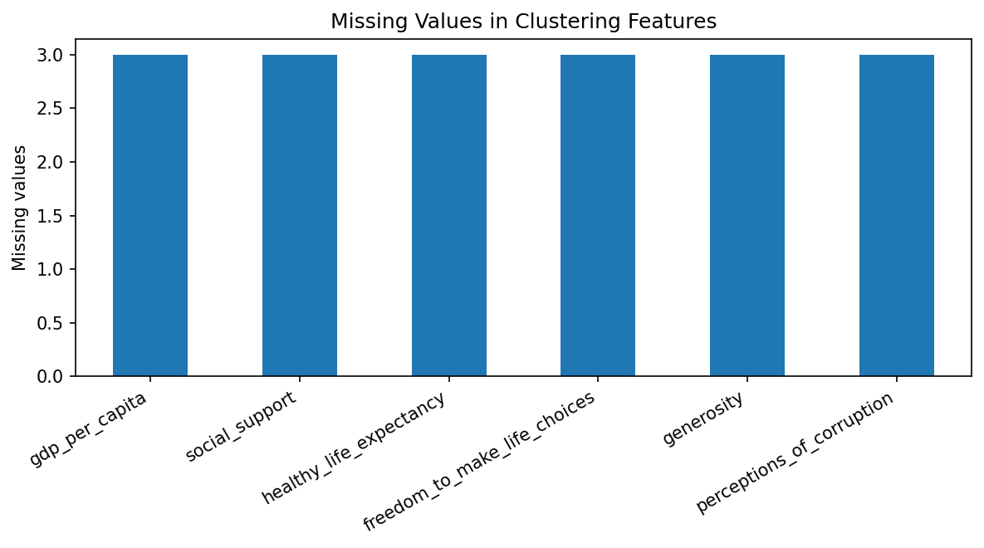
Figure 1. Missing values in the raw clustering features. The preprocessing step handles these values before scaling.
for c in ['gdp_per_capita','social_support','healthy_life_expectancy','freedom_to_make_life_choices']:
df[c] = df[c].replace(0, np.nan)
for c in features:
df[c] = df[c].fillna(df[c].median())
X_scaled = StandardScaler().fit_transform(df[features])

4.3 K-Means Clustering
K-Means partitions observations into k groups by minimizing within-cluster squared distance to the assigned centroid. It is appropriate here because the variables are continuous, standardized, and the goal is to create interpretable segments. The model uses random_state=42 for reproducibility and n_init=20 to make the centroid initialization more robust.

4.4 Selecting k
The analysis evaluates k values from 2 through 8 using silhouette score, Calinski-Harabasz score, and Davies-Bouldin score. Higher silhouette and Calinski-Harabasz values generally indicate more compact and separated clusters, whereas a lower Davies-Bouldin value is preferred.
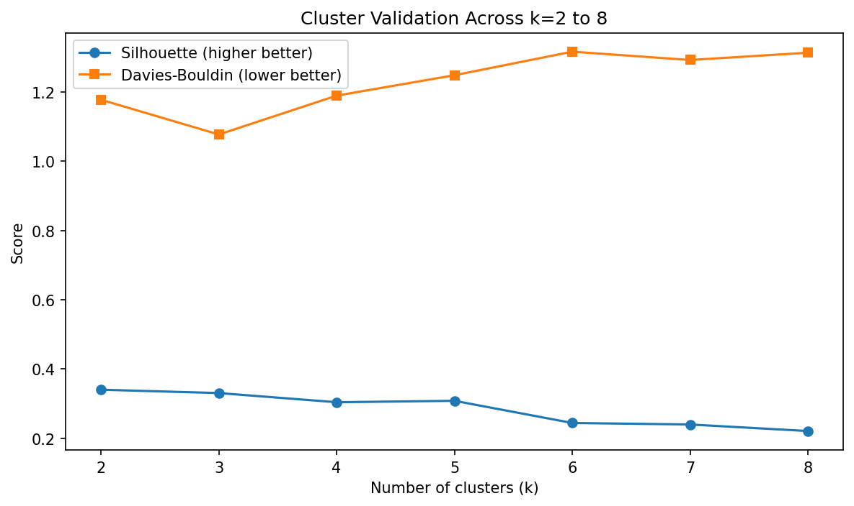
Figure 2. Cluster-validation metrics for k=2 to k=8. The final substantive solution uses k=3 after considering both statistical quality and interpretability.
The highest silhouette score occurs at k=2 (0.340). However, k=3 has the lowest Davies-Bouldin score (1.077) and produces a useful three-tier profile. This is an important methodological point: the selected solution is not claimed to be the single mathematically optimal answer under every metric; it is the most useful compromise for the task.

4.5 Hierarchical Clustering
Agglomerative hierarchical clustering with Ward linkage is used as a secondary method. It starts with individual observations and merges groups iteratively. The resulting dendrogram provides a visual view of how observations combine as the distance threshold increases.
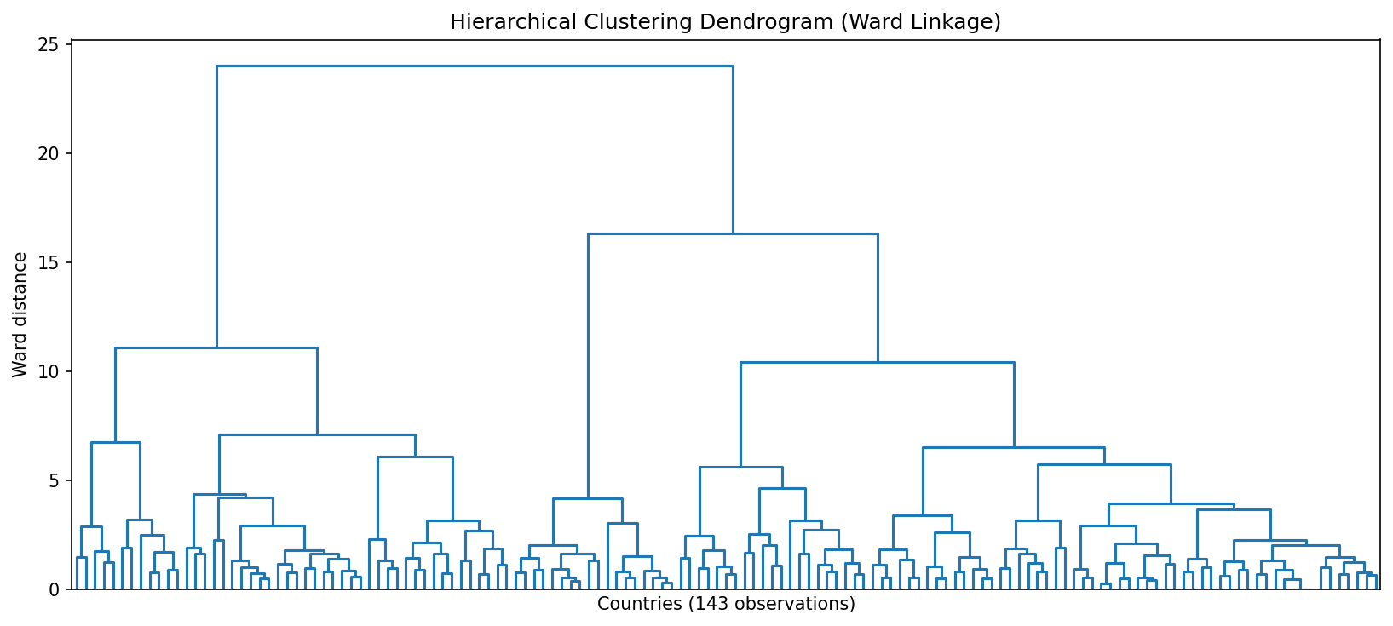
Figure 3. Ward-linkage dendrogram. The tree provides a model-independent visual check on the existence of broad group structure.

5. Results

5.1 Final K-Means Solution
The three-cluster K-Means solution creates cluster sizes of 77, 45, and 21 countries. Cluster 2 is the smallest but has the highest average values across most structural well-being indicators. Cluster 1 is the lowest on average across GDP per capita, social support, healthy life expectancy, and freedom. Cluster 0 sits between the two and is the most heterogeneous middle group.
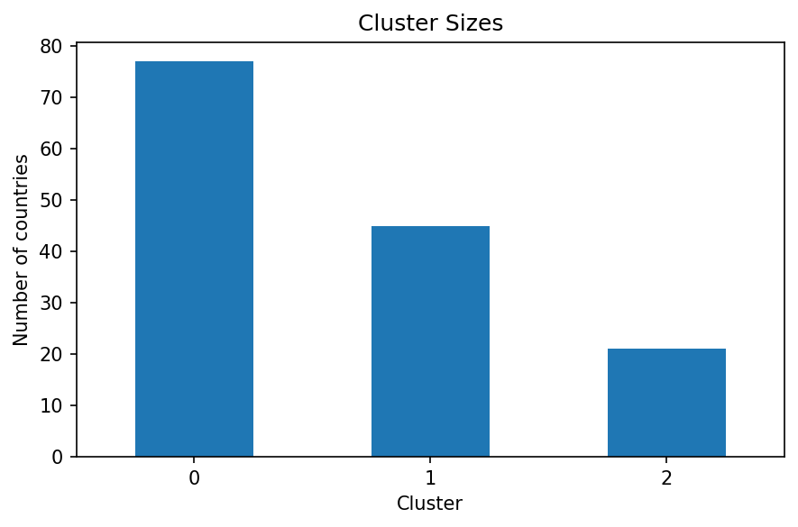
Figure 4. Number of countries assigned to each cluster.
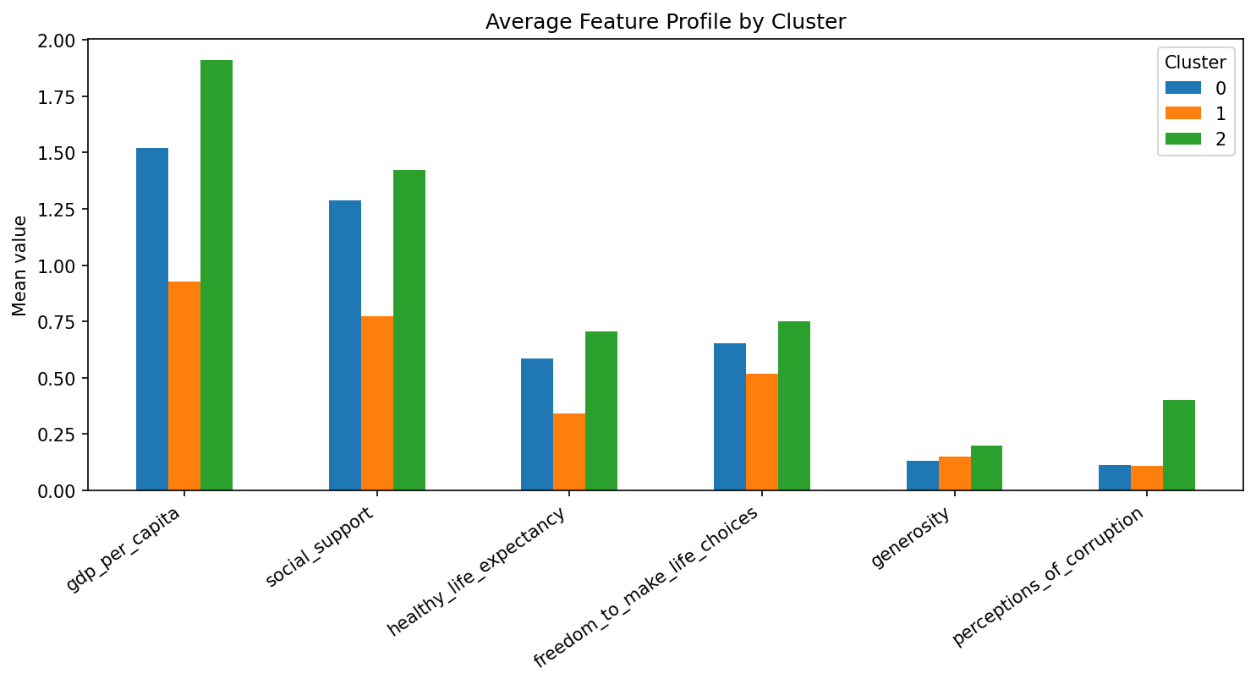
Figure 5. Average feature profiles across the three clusters.
Cluster | Interpretation | Countries | Happiness | GDP pc | Social support | Life expectancy | Freedom
0 | Middle Well-being and Mixed Development | 77 | 5.91 | 1.52 | 1.29 | 0.58 | 0.65
1 | Lower Well-being and Structural Constraints | 45 | 4.22 | 0.93 | 0.77 | 0.34 | 0.52
2 | High Well-being and Affluent Systems | 21 | 6.94 | 1.91 | 1.42 | 0.70 | 0.75

5.2 Cluster Visualization with PCA
Principal Component Analysis reduces the six standardized features to two dimensions for visualization. The first two components explain 50.9% and 19.5% of the standardized variance respectively, for a combined 70.4%. PCA is used only for visualization; the K-Means algorithm is fitted on the full six-dimensional standardized feature space.
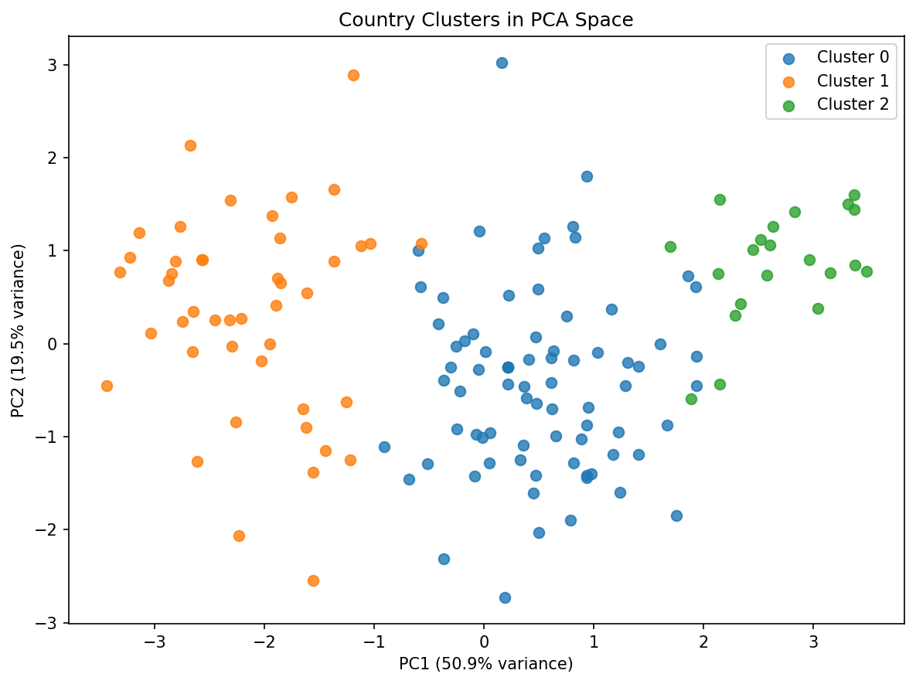
Figure 6. PCA visualization of the K-Means clusters. The overlap also shows why the solution should be treated as meaningful segmentation rather than perfectly separated natural classes.

5.3 Hierarchical Cross-check
The adjusted Rand index between the K-Means and hierarchical cluster assignments is 0.737. This indicates partial agreement rather than perfect identity between the two methods. The result supports the existence of broad structure while also showing that cluster membership near boundaries is method-sensitive.

6. Cluster Interpretation

Cluster 2: High Well-being and Affluent Systems
This cluster contains 21 countries and has an average happiness score of 6.94. Mean GDP per capita is 1.91, social support is 1.42, healthy life expectancy is 0.70, and freedom is 0.75. Countries closest to the K-Means centroid include Germany, Ireland, Canada, Netherlands, Australia.
The profile is characterized by comparatively strong economic resources, social support, health outcomes, and freedom. This makes it the clearest high-capability well-being segment. For business analysis, these countries may represent mature markets with stronger purchasing capacity and institutional capacity, while for policy research they provide useful comparison cases for high-performing welfare systems.

Cluster 0: Middle Well-being and Mixed Development
This cluster contains 77 countries and has an average happiness score of 5.91. Mean GDP per capita is 1.52, social support is 1.29, healthy life expectancy is 0.58, and freedom is 0.65. Countries closest to the K-Means centroid include Bahrain, Tajikistan, State of Palestine, Montenegro, Brazil.
This is the broad middle segment. It includes countries with moderate economic and social indicators but substantial internal variation. Its average happiness is materially below Cluster 2 but well above Cluster 1. The group is especially useful for comparative research because countries can arrive at similar overall profiles through different combinations of income, health, freedom, and social support.

Cluster 1: Lower Well-being and Structural Constraints
This cluster contains 45 countries and has an average happiness score of 4.22. Mean GDP per capita is 0.93, social support is 0.77, healthy life expectancy is 0.34, and freedom is 0.52. Countries closest to the K-Means centroid include Cameroon, Congo (Brazzaville), Pakistan, Senegal, Mali.
This segment has the weakest average structural indicators, particularly income, health, social support, and freedom. Lower average happiness accompanies that profile. Business implications include greater sensitivity to affordability and infrastructure constraints, while policy implications include the potential value of interventions that strengthen basic health, economic opportunity, social protection, and agency.
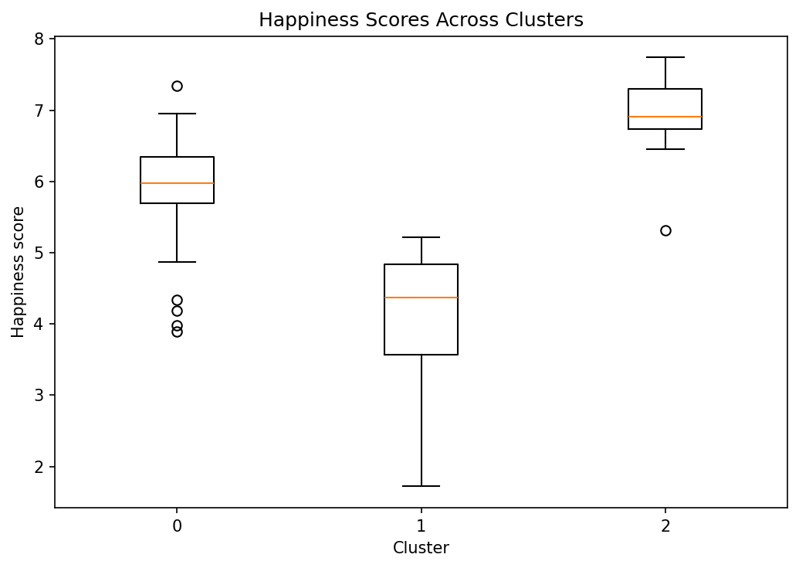
Figure 7. Distribution of published happiness scores within the three discovered clusters. The score is used after clustering to interpret the groups, not to create them.

7. Key Findings
- Clustering is driven primarily by economic, health, and social-support differences rather than geography alone.
- Cluster 2 combines the strongest structural indicators and the highest average happiness score, making it the high-well-being benchmark group.
- Cluster 1 shows a substantially lower mean across several foundational indicators and also has the lowest average happiness.
- Cluster 0 is a large middle segment, demonstrating that countries can share comparable multidimensional profiles even when they come from different regions.
- Generosity contributes relatively little to the separation of the final three clusters, indicating that not every published well-being factor is equally important for segmentation.
- The overlap visible in PCA space and the imperfect agreement between K-Means and hierarchical clustering show that the clusters are analytical segments, not rigid natural categories.

8. Business and Research Implications
The segmentation can be useful beyond an academic exercise. A multinational firm could use similar clustering logic to group countries with comparable socioeconomic operating conditions instead of relying only on geographic regions or GDP. Marketing, pricing, product localization, and expansion priorities could then be tailored by cluster profile. International organizations could similarly use the segments to compare policy peers and identify countries facing similar combinations of economic, health, and social constraints.
For research, the clusters create a compact framework for studying heterogeneous development paths. A researcher could examine whether countries in the same cluster respond similarly to shocks, demographic change, digitalization, or public-health interventions. The next step would be to combine the 2024 cross-section with multiple years of data and use longitudinal clustering to study how countries move between profiles over time.

9. Limitations
- The data are a cross-sectional snapshot and therefore cannot establish causal relationships.
- Clustering results depend on feature selection, preprocessing decisions, scaling, distance measure, and the selected value of k.
- Median imputation preserves the sample size but can reduce natural variation in variables with missing observations.
- Country-level averages hide within-country inequality and regional differences.
- The happiness score is a useful interpretive outcome but should not be treated as an objective measure of all dimensions of welfare.

10. Conclusion
This project demonstrates how unsupervised learning can transform a multidimensional public dataset into interpretable country segments without imposing labels in advance. K-Means, supported by hierarchical clustering and PCA visualization, reveals three useful socioeconomic profiles: high-well-being and affluent systems, middle well-being and mixed development, and lower well-being and structural constraints. The exercise also demonstrates an important practical lesson in machine learning: model selection should balance statistical validation with the analytical purpose of the problem. For this dataset, k=2 is the tightest solution by silhouette score, but k=3 provides a more informative segmentation for interpretation and policy or business use.

11. Jupyter Notebook Implementation
The companion notebook provided with this report is designed to run in Jupyter Notebook. Keep `WHR2024.csv` in the same directory as the `.ipynb` file, open Jupyter Notebook, and run the cells from top to bottom. The notebook recreates the preprocessing, validation metrics, K-Means model, hierarchical clustering, PCA plot, cluster summary, and CSV export.
df = pd.read_csv('WHR2024.csv')
# ... run the notebook cells sequentially ...
df.to_csv('WHR2024_clustered.csv', index=False)

12. References
Helliwell, J. F., Layard, R., Sachs, J. D., De Neve, J.-E., Aknin, L. B., & Wang, S. (Eds.). (2024). World Happiness Report 2024. University of Oxford: Wellbeing Research Centre.
World Happiness Report. (n.d.). Data Sharing. https://worldhappiness.report/data-sharing/
Public data mirror used for reproducibility: https://raw.githubusercontent.com/pplonski/datasets-for-start/master/world_happiness_report/WHR_2024.csv
Pedregosa, F., et al. (2011). Scikit-learn: Machine Learning in Python. Journal of Machine Learning Research, 12, 2825-2830.

Appendix A. Core Jupyter Code
from sklearn.preprocessing import StandardScaler
from sklearn.cluster import KMeans, AgglomerativeClustering
from sklearn.metrics import silhouette_score
from sklearn.decomposition import PCA
features = ['gdp_per_capita','social_support','healthy_life_expectancy',
'freedom_to_make_life_choices','generosity','perceptions_of_corruption']
X = df[features].copy()
scaler = StandardScaler()
X_scaled = scaler.fit_transform(X)
kmeans = KMeans(n_clusters=3, random_state=42, n_init=20)
df['cluster'] = kmeans.fit_predict(X_scaled)
pca = PCA(n_components=2, random_state=42)
pca_data = pca.fit_transform(X_scaled)

