Curriculum Intelligence Engine — Week 7: Integration, UI and Demo
Group 9 · Roll Nos: J048, J049, J050, J052, J053 · AI University NLP Course Project 2026 · Week 7

CODE
Repository : https://github.com/jainamsethia/Curriculum-Intelligence-Engine
Tag : week-7
Commit : 559a29d888b2705776e4edaced4c8e4dea1b3b4d
Install : pip install -e .[dev]
Serve : uvicorn curriculum_engine.api:app --port 8000 (OpenAPI docs at /docs)
UI : streamlit run app/committee_ui.py (calls the API; CE_API_URL, default http://localhost:8000)
Reproduce : python -m curriculum_engine.run all (data → week2 … week7; NMIMS_ZIP or data/processed/courses.jsonl)
Tests : python -m pytest -q (unit, API and UI tests on a synthetic fixture)
New : curriculum_engine/modernize.py, integrations.py, experiments/week7.py, app/committee_ui.py, demo/jds/,
docs/INTEGRATION.md, RESPONSIBLE_AI.md, ARCHITECTURE.md, DEMO_SCRIPT.md
Folders :
.gitignore
README.md
app
curriculum_engine/ the NLP engine (parser, data, overlap, redundancy, prerequisites, diff, Bloom, evaluation)
demo
docs/ documentation
labels/ LLM-annotated reference labels (ids + labels per pass + consensus)
legacy/ old Week 3-4 scripts and reports (history only)
legacy_mit/ old MIT OCW scripts (not used)
pyproject.toml
reports/ report templates (numbers are placeholders)
requirements.txt
results/ metrics JSON + figures per week
submissions/ per-week submission folders
tests/ unit tests (pytest)
tools/ report builder, report checker, submission packer

Feedback addressed
Comment | What we changed | Evidence
Week 7 brief: demonstrate at least one interaction with another project's component | The draft syllabus goes to Group 11 as a notice in their /process-notice format and to Group 4 as passages in their knowledge-base schema; both run from the UI. | docs/INTEGRATION.md, results/week7/group11_handoff.json, data/week7/group4_chunks.csv (Teams zip)
Demo plan for 31 October: five JDs on fine-tuning LLMs + current NLP syllabi → overlapping content + a newly structured curriculum | New endpoint POST /modernize-curriculum and the UI tab "Modernise curriculum (demo)". | data/week7/new_curriculum.docx (Teams zip), docs/DEMO_SCRIPT.md
Week 7 brief: UI, API integration, documentation, responsible AI, place in the AI University architecture | Streamlit committee UI over the API, architecture diagram, responsible-AI analysis with a per-programme table. | app/, docs/ARCHITECTURE.md, docs/RESPONSIBLE_AI.md
Our Week 6 limitation: emerging-topic coverage looked too lenient | Coverage now uses the unit-match threshold instead of the prerequisite-topic threshold, measured on the labelled emerging-topic decisions. | results/week7/emerging_threshold.json

Progress vs previous week
Item | Week 6 | Week 7
API | 7 endpoints | 9 endpoints (adds POST /modernize-curriculum, GET /courses)
User interface | OpenAPI page only | Streamlit committee UI: demo tab + five analysis tabs
Interaction with other groups | planned | Group 11 notice (mode: mock), Group 4 passages (17 rows)
Emerging-topic coverage accuracy (labelled decisions) | 0.388 | 0.896
Responsible AI | limitations list | fairness per programme, hallucination guard, human-in-the-loop, misuse analysis

1. Demo capability: job descriptions + current syllabi → overlaps and a new syllabus
Input. 5 job descriptions on fine-tuning LLMs (synthetic samples written for the demo and marked as such; real JDs can be pasted) and 5 current syllabi: Natural Language Processing as taught in AI, COMP / CSE-DS / IT and EXTC, Speech and Natural Language Processing (DS) and Generative AI (AI). Method (modernize.py, no LLM at run time):
- JDs are split into 35 requirement statements; spaCy noun chunks give skill phrases (verbs, determiners and generic words removed).
- Phrases are clustered (MiniLM embeddings, cosine, average linkage) into 70 skill themes; 15 are named by at least two JDs.
- A theme is already taught if a unit topic of the selected syllabi reaches the unit-match threshold (0.55, chosen on validation pairs in Week 3 and reused here); the closest unit is shown as evidence.
- Overlap between the syllabi uses the Week 4 fusion score and unit-level MaxSim. Units taught in two or more syllabi form shared topics.
- The draft keeps each shared topic once (from the most recent syllabus), keeps existing units that teach demanded skills, adds new units for demanded gaps, moves tools (Python, cloud GPUs) to the lab environment, reuses source outcomes, takes prerequisites from the sources with the checker-v2 phrase cleaning, and checks the hours. Unit text is copied or templated, never generated, and every unit names its source (traceability check: True).
Result. 3 of the 10 syllabus pairs are identical: the same NLP syllabus is taught in several programmes. Speech and NLP overlaps it strongly; Generative AI hardly overlaps. Of the 15 demanded themes, 6 are taught and 9 are gaps:
Skill theme (from JDs) | Asked for by | Already taught? | Closest unit topic (course)
large language models | JD1, JD2, JD3, JD4, JD5 | yes | Large Language Models (Generative AI)
learning | JD2, JD4, JD5 | yes | Machine Learning and NLP (Speech and NLP)
tokenization | JD1, JD2, JD4 | yes | Basic Text Processing Tokenization (Speech and NLP)
fine-tuned models | JD1, JD4 | yes | Parameter Efficient Fine Tuning (Generative AI)
training transformer models | JD1, JD4 | yes | Generative Pretrained Transformer (Generative AI)
automatic metrics | JD1, JD3 | gap | Information retrieval (NLP)
cloud GPUs | JD1, JD5 | gap | PCFG (Speech and NLP)
human evaluation | JD1, JD3 | gap | Evaluating Language Models (Speech and NLP)
prompts | JD1, JD3 | gap | Feature Engineering (NLP)
PyTorch and REST API development | JD3, JD5 | gap | Practice with ipython Notebooks (Speech and NLP)
attention | JD1, JD4 | yes | Overview of attention mechanisms (Generative AI)
bias | JD2, JD5 | gap | multi-head attention (Generative AI)
guardrails | JD3, JD5 | gap | RoPE (Generative AI)
Python | JD1, JD3 | gap | Practice with ipython Notebooks (Speech and NLP)
quantization | JD4, JD5 | gap | Clustering and Distributional Semantics (Speech and NLP)

The draft syllabus has 11 units (5 shared, 2 existing units demanded by the JDs, 4 new) and 8 outcomes. Its units add up to 62 hours, more than one semester's lecture hours, so the draft itself tells the committee to trim it or split the course. It is marked "DRAFT for the Board of Studies".
# | Unit of the draft syllabus | Kind | Hours | Source
1 | Introduction to Natural Language Processing | shared topic (deduplicated) | 2 | NLP ×3, Speech and NLP
2 | Semantic Analysis and Vector Space Models | shared topic (deduplicated) | 7 | NLP ×3, Speech and NLP
3 | Text Pre-processing and Text Representation | shared topic (deduplicated) | 5 | NLP ×3, Speech and NLP
4 | Pragmatic and Discourse Analysis | shared topic (deduplicated) | 4 | NLP ×3
5 | Large Language Models (LLM) | shared topic (deduplicated) | 8 | Generative AI, Speech and NLP
6 | Basic Text Processing | existing unit, demanded by industry | 6 | Speech and NLP; JD2, JD4, JD5
7 | RAG and Fine Tuning | existing unit, demanded by industry | 6 | Generative AI; JD1, JD4
8 | Recall and ranking metrics | new unit from job descriptions | 6 | JD1, JD3
9 | Human evaluation | new unit from job descriptions | 6 | JD1, JD3
10 | Prompt engineering | new unit from job descriptions | 6 | JD1, JD3
11 | Bias | new unit from job descriptions | 6 | JD2, JD5

How good is the "taught / gap" decision? All 70 themes were judged taught or not taught against the syllabus text with LLM-annotated reference labels (two Claude passes with different wording, pass 3 for 2, 0 uncertain; no scores shown). Accuracy 0.857; gap precision 0.896 (n = 48), "taught" precision 0.773 (n = 22). On the demanded themes only: gap precision 0.778 (n = 9), "taught" precision 1.000 (n = 6); the samples are small and the JDs were also used while building the method, so these numbers are indicative. Weak spots are visible in the table: a generic theme ("learning") and new units titled from one phrase ("Bias").

2. Interaction with Group 11 and Group 4
- Group 11, University Communications Intelligence (Ar-Srivas/uni-comms-intelligence): their FastAPI POST /process-notice takes {doc_id, text} and returns title, category, audience, entities and per-audience summaries. We turn the draft into a notice and send it; request and response are validated with their Pydantic models (request valid: True, response valid: True), and the reply becomes one email per audience. Their service cannot be started from the repository because the fine-tuned summariser weights are not committed, so this run used a documented mock (mode: mock; every mock reply carries a _mock marker). Setting GROUP11_URL (or the URL box in the UI) switches to the live call for the joint demo.
- Group 4, University Knowledge Assistant (vedantkokate2104-ux/SNLP_CHATBOT): no HTTP API; their knowledge base is a passage table (chunk_id, page, section, part, text) cut into word windows with overlap. We export the draft as 17 passages in exactly that schema (columns valid: True; longest passage 86 words) for them to add to their knowledge base. To test the hand-off without their data, a stand-in that imitates their offline extractive mode (hybrid BM25 + MiniLM with their keyword weight) answered 4 of 5 student questions (prerequisites, lab work, credits, fine-tuning topics, assessment) from the right section. The miss: for fine-tuning topics it quoted the LLM unit, not "RAG and Fine Tuning". The stand-in is not Group 4's system; their assistant answers in the joint demo.

3. User interface and architecture
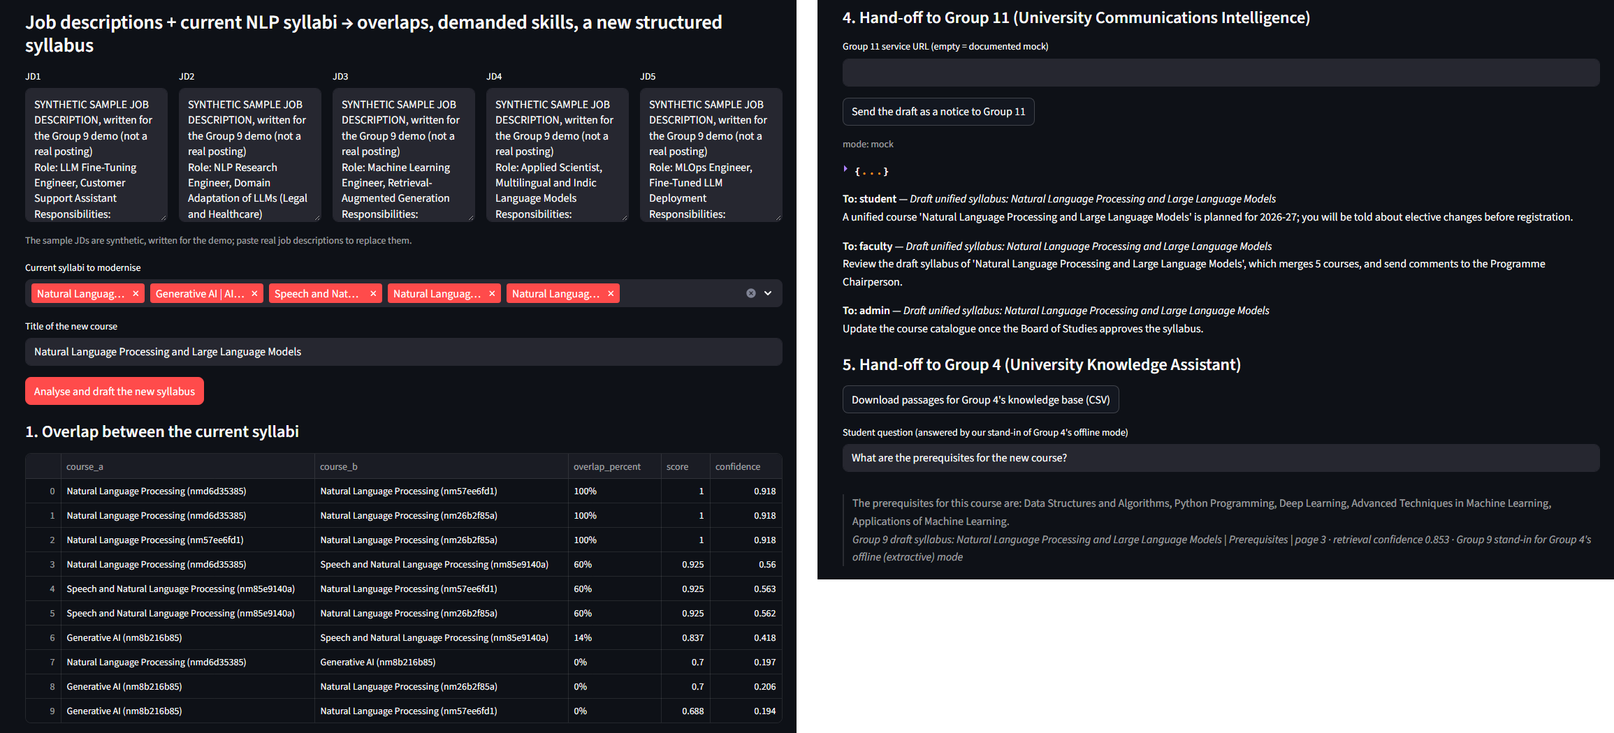
Committee UI (Streamlit, calling the API). Left: the five JDs, the selected syllabi and the overlap table. Right: the Group 11 notice turned into emails (mock mode) and the Group 4 hand-off with a stand-in answer and its source.
The UI has a demo tab (JDs, syllabus selection, overlaps, skills table, draft with .docx / .md / .json download, both hand-offs) and tabs for comparing two courses, two years of a programme, prerequisites, redundancy and emerging topics. A sidebar shows the API health and a fixed warning that outputs are drafts. Group 9 sits between the syllabus data and the student- and faculty-facing services of the AI University application:
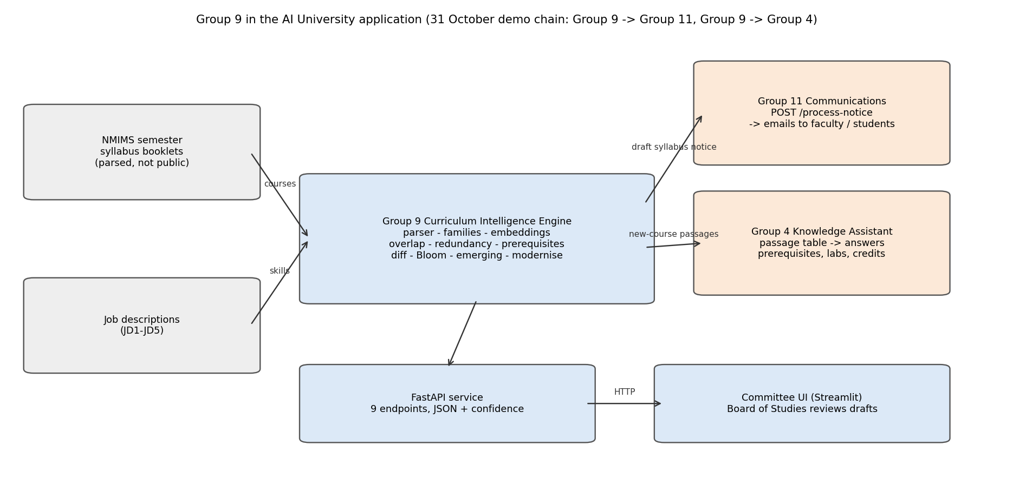
Group 9 in the AI University application (Mermaid source in docs/ARCHITECTURE.md).

4. Responsible-AI analysis
Risk | What we do | Evidence
Privacy, confidentiality | Raw booklets and parsed data are never in the public repository (Teams zip only); the Week 1 scan found no student or faculty personal data; the JDs are synthetic. | .gitignore, docs/RESPONSIBLE_AI.md
Hallucination | The draft is copied or templated from syllabi and JDs, never generated; every unit names its source; the mock is marked. | traceability check, _mock marker
Transparency | Every answer shows its evidence (closest unit, source course, JD) and a confidence measured on the evaluation, with the engine version. | docs/API.md
Human in the loop, misuse | Outputs are drafts for the Board of Studies; the UI warns against cutting or merging courses automatically; the hours check flags overload. | UI sidebar, draft status
Fairness across departments | Quality differs by programme (table below); programmes with too little parsed data get no prerequisite checks. | results/week7/fairness.json

Programme | Parsed course versions | Prerequisite checks | Overlap ROC-AUC | Bloom accuracy | Removal recall
AI | 258 | yes | n/a | 0.696 | 1.000
CIVIL | 234 | yes | 1.000 | 0.842 | 1.000
COMP | 213 | yes | 0.950 | 0.692 | 1.000
CSBS | 248 | yes | 0.990 | 0.692 | 0.833
CSE-CYBER | 254 | yes | 1.000 | 0.722 | 1.000
CSE-DS | 202 | yes | 0.944 | 0.778 | 0.800
DS | 394 | yes | 0.960 | 0.775 | 1.000
ELECTRICAL | 8 | no (too little parsed data) | n/a | n/a | n/a
EXTC | 169 | yes | 0.933 | 0.743 | 0.800
IT | 283 | yes | 0.875 | 0.696 | 1.000
MECHANICAL | 422 | yes | 0.975 | 0.857 | 0.714
MECHATRONICS | 244 | yes | 1.000 | 0.857 | 0.889

Bloom accuracy ranges from 0.692 (COMP) to 0.857 (MECHATRONICS); "n/a": not enough labelled items or parsed data. The emerging-topic fix: at the old threshold (0.40) almost every topic counted as taught (gap recall 0.109 on 67 labelled decisions); at 0.55 gap recall is 0.935 and gap precision 0.915. The threshold was picked after seeing these labels, so these numbers are optimistic.

5. Limitations and next steps
- Data: NMIMS semester syllabus booklets; 531 of 2,413 non-exam PDFs are parsed, the rest are scanned and need OCR (future work), so a topic can look missing when it sits in an unread booklet.
- Labels come from LLM-annotated reference labels. No human annotators were used; results are indicative. For 94 of 200 pairs the second labeller was a Claude prompt rather than Phi-3, so agreement on those items is not independent. Detector flags (Week 3 onwards) were labelled by two Claude passes with different wording plus a pass 3, with no Phi-3, so agreement on flags is not independent; the same holds for the Week 7 skill-coverage labels.
- The draft syllabus and the Group 4 passages quote NMIMS syllabus text, so they are in the Teams code zip (data/week7/) and not in the public repository.
- The JDs are synthetic; the draft is a starting point for faculty, not a finished syllabus (hours over budget, terse new-unit titles).
- Peer services: Group 11's model and Group 4's knowledge base are not runnable from their repositories, so the interactions are checked against their schemas, with a marked mock and a stand-in; the live run is planned for the joint demo on 31 October.
- Week 8: final testing, final report, README, presentation and the live demo with Group 4 and Group 11.

AI assistance
Code and report text were written with AI assistance (Claude). Reference labels are LLM-annotated (Claude, Phi-3). Every number is generated from results/*.json by tools/build_report.py and verified by tools/check_reports.py.

