University Administrative Copilot
Week 2: Dataset and Baseline (NMIMS)
Revised submission - dataset rebuilt from official NMIMS sources
Group 10 | Roll No. J054, J055, J056, J057, J059
Repository: github.com/jashan7305/university_administrative_copilot

Summary
This revision replaces our earlier template-generated dataset with a dataset grounded in official sources of SVKM's NMIMS (Mumbai, Vile Parle; MPSTME). We collected the university's student pages, examination procedures, Student Resource Books, forms, circulars and policies, extracted 269 verifiable facts, wrote questions from those facts, and trained and evaluated baseline classifiers.
Table 1. Week 2 at a glance
Item | Value
Official NMIMS sources collected | 65 of 66 (28 PDFs)
Verified facts (each with a verbatim quote re-checked against the source) | 269
Queries: from official NMIMS sources / rule-generated variants / total | 1973 / 3890 / 5863
Intents / sub-intents / routing departments | 12 / 95 / 23
NER spans / knowledge-base passages | 6800 / 727
Baseline intent macro-F1 (core test / full test) | 0.880 / 0.863
Out-of-scope recall on 1,000 real CLINC150 queries | 0.945
Sub-intent (routing) baseline accuracy, core test | 0.725

1. Task
Students and faculty ask administrative questions in natural language. The NLP component must recognise the request (intent and sub-intent), extract details (entities), and route it to the responsible NMIMS department with the documents and next step stated in official sources. Week 2 builds the dataset and baseline classifier.

2. Data collection
Sources were limited to official NMIMS domains (nmims.edu, engineering.nmims.edu, navimumbai.nmims.edu, upload.nmims.edu): the 20 pages named in the project brief plus relevant NMIMS pages linked from them. robots.txt was checked for every host and the crawl used a polite 1.5 s delay. HTML main text was extracted with trafilatura; PDFs with pypdf; scanned PDFs (revaluation guide, circulars, 2026-27 academic calendars) were OCR'd with RapidOCR, regrouping text boxes into lines so table rows stay intact.
Table 2. Sources by type
Source type | Count
WEBPAGE | 27
PROCEDURE | 10
FORM | 6
POLICY | 5
STUDENT_RESOURCE_BOOK | 5
FAQ | 4
NOTICE | 4
OTHER | 2
ACADEMIC_CALENDAR | 2
HANDBOOK | 1

Table 3. Most-used sources
source_id | title | academic_year | facts_cited
SRC052 | MPSTME Student Resource Book 2026 (Part I + Part II) | 2026-27 | 152
SRC021 | Hostel Application Form - Mumbai Campus (rules, fees 2025-26) | 2025-26 | 22
SRC002 | NMIMS Examinations page (procedures, FAQs, document timelines) | nan | 18
SRC010 | NMIMS Library (Prof. Y. K. Bhushan IKRC) | nan | 9
SRC029 | FAQ for NEW Revaluation process | 2025-26 | 6
SRC008 | Online Admission Cancellation | 2026-27 | 5
SRC028 | Your Guide to the Exam Revaluation Process (2025-26) | 2025-26 | 5

Each source has an academic year and a CURRENT/HISTORICAL flag. The MPSTME Student Resource Book 2026 (effective July 2026) is the primary source; the 2024 and 2025 books are kept as historical versions and never merged with current rules (for example, the 2024 rule allowing a Dean's exemption at 70-80% attendance was replaced by an 80%-per-course rule). Fourteen contradictions or duplicates between sources were found and documented with the resolution used (reports/dataset/dataset_quality_report.md).

3. Fact extraction and verification
We read the sources and recorded 269 facts. Each fact paraphrases one passage and stores the source id, page, sub-intent, department and a verbatim quote. The validation script re-finds every quote in the extracted source text; a fact whose quote cannot be found fails the build. Fees, deadlines, emails and procedures in the dataset come only from these facts. Requests for which no official source exists (for example failed payments, education loans, scholarship status) are kept as UNVERIFIED queries with no answer attached.

4. Query dataset
Because collecting real queries was not possible, questions were built from the verified facts of the official NMIMS sources in varied student styles (short, informal, typos, Hinglish, formal emails, parents, alumni, faculty, employers), including ambiguous and multi-intent questions. Each core question links to the fact(s) that answer it. To enlarge the training set, each core question received up to two rule-generated variants (casual, abbreviation, typo, formal, polite, Hinglish). These provenance details are recorded per row (query_kind, is_variant, variant_type).
Table 4. Rows by kind
Kind | Rows
ambiguous | 229
multi_fact | 45
multi_intent | 120
single | 5274
unverified | 195

Table 5. Rows by variant type
Variant type | Rows
original | 1973
polite | 1504
typo | 1469
formal | 466
abbrev | 406
hinglish | 40
casual | 5

5. Cleaning, validation and annotation
- Checks: exact and near-duplicate removal; label consistency (same text, same label); taxonomy and department validity; every verified row has a retrievable source URL; every cited fact's quote is present in its source; unverified rows carry no answer; NER spans are well-formed; no group crosses splits. All 19 checks pass.
- Labels: intent and sub-intent from the linked facts; canonical department (23 routing targets); required documents and next action only where the source states them; confidence and requires_current_verification flags for OCR'd, historical, contradicted or time-sensitive facts.
- NER: 6800 entity spans over 28 types (DOCUMENT, CERTIFICATE, EXAMINATION, FEE, SCHOLARSHIP, PROGRAM, SEMESTER, STUDENT_ID, PURPOSE, ...), produced by a dictionary/regex labeller built from the sources (silver labels, used for the Week 3 NER model).

6. Train / validation / test split
Table 6. Records per intent and split
intent | train_count | validation_count | test_count
ACADEMIC_REGISTRATION | 329 | 81 | 80
ATTENDANCE | 238 | 62 | 57
CERTIFICATES | 376 | 96 | 96
EXAMINATIONS | 873 | 199 | 209
FEES | 293 | 80 | 75
HOSTEL | 393 | 98 | 102
ID_CARDS | 124 | 30 | 30
LIBRARY | 235 | 63 | 63
SCHOLARSHIPS | 77 | 27 | 21
STUDENT_SERVICES | 347 | 83 | 84
STUDENT_WELFARE | 357 | 87 | 81
TRANSCRIPTS | 365 | 80 | 83
TOTAL | 4007 | 986 | 981

Splits are made by group: a core question and all its variants are always in the same split, stratified by sub-intent, so no rewording of a test question is seen in training. test_core holds only the test questions. The out-of-scope class uses real CLINC150 data: its out-of-scope queries plus a sample of its other-domain queries (banking, travel, home) for training/validation; the official CLINC150 out-of-scope test set (1,000 queries) is used only for evaluation.

7. Exploratory analysis
Table 7. Corpus statistics
Statistic | Value
Training rows | 5499
Vocabulary | 3165
Mean / median / max tokens | 8.35 / 8 / 47
Largest / smallest class ratio | 21.62
OOV rate: core test / variants | 6.2% / 5.5%

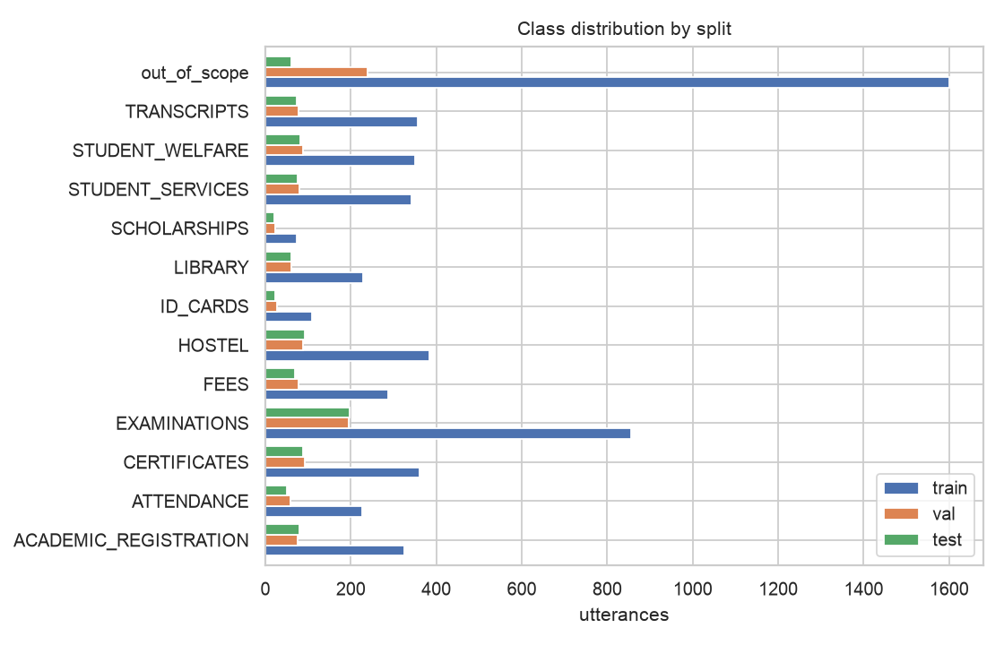
Figure 1. Class distribution by split
Table 8. Most discriminative terms
Intent | Top chi-squared terms
ACADEMIC_REGISTRATION | break, elective, academic break, academic, semester, odd
ATTENDANCE | attendance, absence, attendance rule, sick, mark absent, short
CERTIFICATES | certificate, degree, migration, migration certificate, verification, provisional
EXAMINATIONS | revaluation, exam, re exam, re, answer, mark
FEES | refund, cancellation, admission, fee, cancel, fee receipt
HOSTEL | hostel, hostel fee, hostel form, in hostel, flat, room
ID_CARDS | id card, id, card, my id, duplicate id, barrier
LIBRARY | library, borrow, lib, book, fine, in library
SCHOLARSHIPS | scholarship, nsp, my scholarship, scholarship for, pragati, pragati scholarship
STUDENT_SERVICES | exchange, for exchange, nusc, exchange program, password, mentor
STUDENT_WELFARE | grievance, committee, rag, ombudsman, counsellor, grievance committee
TRANSCRIPTS | transcript, percentage, wes, cgpa, percentage letter, letter
out_of_scope | you, me, can you, tell me, my, on my

8. Preprocessing ablation
Table 9. Cumulative preprocessing steps (TF-IDF logistic regression)
Configuration | Val macro-F1 | Variants macro-F1
raw (tokenise only) | 0.893 | 0.8102
+ lowercase | 0.893 | 0.81
+ contractions | 0.8941 | 0.8113
+ abbreviations | 0.894 | 0.8041
+ entity masking | 0.8904 | 0.7968
+ spelling correction | 0.896 | 0.8074
+ lemmatisation (full pipeline) | 0.8989 | 0.8056
full, stemming instead of lemma | 0.8933 | 0.8062
full + stopword removal | 0.9031 | 0.7971

Steps are added one at a time and judged on validation. Spelling correction, lemmatisation and stopword removal with a keep-list (wh-words and negations are kept) gave the best validation score (0.903); the differences between steps are small (about 1 point), so the gains are indicative rather than conclusive.

9. Baseline models
Table 10. Model comparison (5-fold GroupKFold CV on train + validation)
Model | CV macro-F1 | CV sd | Val accuracy | Val macro-F1
majority | 0.0347 | 0.0 | 0.2027 | 0.0259
complement_nb | 0.8291 | 0.0128 | 0.8666 | 0.8591
logreg_word | 0.8469 | 0.0101 | 0.8961 | 0.8937
linear_svm | 0.8754 | 0.014 | 0.8961 | 0.8943
logreg_word_char_unweighted | 0.8545 | 0.0182 | 0.8936 | 0.8931
logreg_word_char | 0.8673 | 0.0095 | 0.9062 | 0.9031

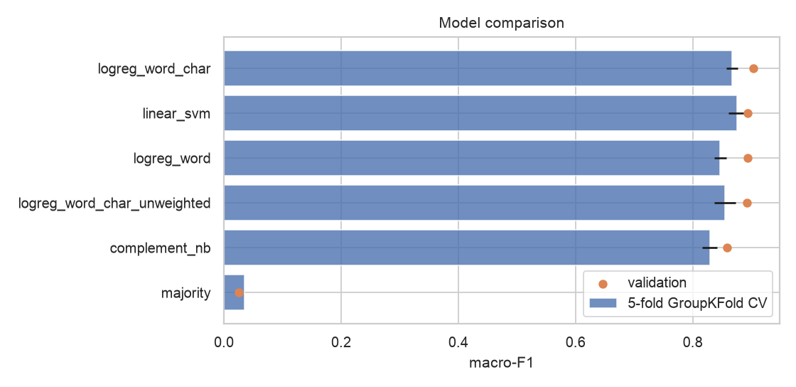
Figure 2. Cross-validation and validation macro-F1
Selected: class-balanced logistic regression on word + character TF-IDF, C = 10 (best CV score); out-of-scope rejection threshold 0.0 chosen on validation (the explicit out_of_scope class already separates unrelated queries).

10. Results
Table 11. Intent classification, test sets scored once
Test set | n | Accuracy [95% CI] | Macro-F1 [95% CI]
Test (core + variants) | 972 | 0.860 [0.839, 0.883] | 0.863 [0.840, 0.886]
Test core (official NMIMS sources) | 365 | 0.882 [0.847, 0.912] | 0.880 [0.838, 0.914]
Test variants (rule-generated) | 607 | 0.847 [0.816, 0.875] | 0.797 [0.768, 0.821]
CLINC150 out-of-scope (recall) | 1000 | 0.945 [0.930, 0.958] | -

Table 12. Per-intent results on the core test set
Intent | P | R | F1 | n
ACADEMIC_REGISTRATION | 0.852 | 0.852 | 0.852 | 27
ATTENDANCE | 0.867 | 0.765 | 0.812 | 17
CERTIFICATES | 0.867 | 0.897 | 0.881 | 29
EXAMINATIONS | 0.919 | 0.864 | 0.891 | 66
FEES | 0.840 | 0.913 | 0.875 | 23
HOSTEL | 0.931 | 0.871 | 0.900 | 31
ID_CARDS | 0.727 | 1.000 | 0.842 | 8
LIBRARY | 1.000 | 0.850 | 0.919 | 20
SCHOLARSHIPS | 1.000 | 1.000 | 1.000 | 7
STUDENT_SERVICES | 0.864 | 0.760 | 0.809 | 25
STUDENT_WELFARE | 0.828 | 0.889 | 0.857 | 27
TRANSCRIPTS | 0.955 | 0.840 | 0.894 | 25
out_of_scope | 0.855 | 0.983 | 0.915 | 60

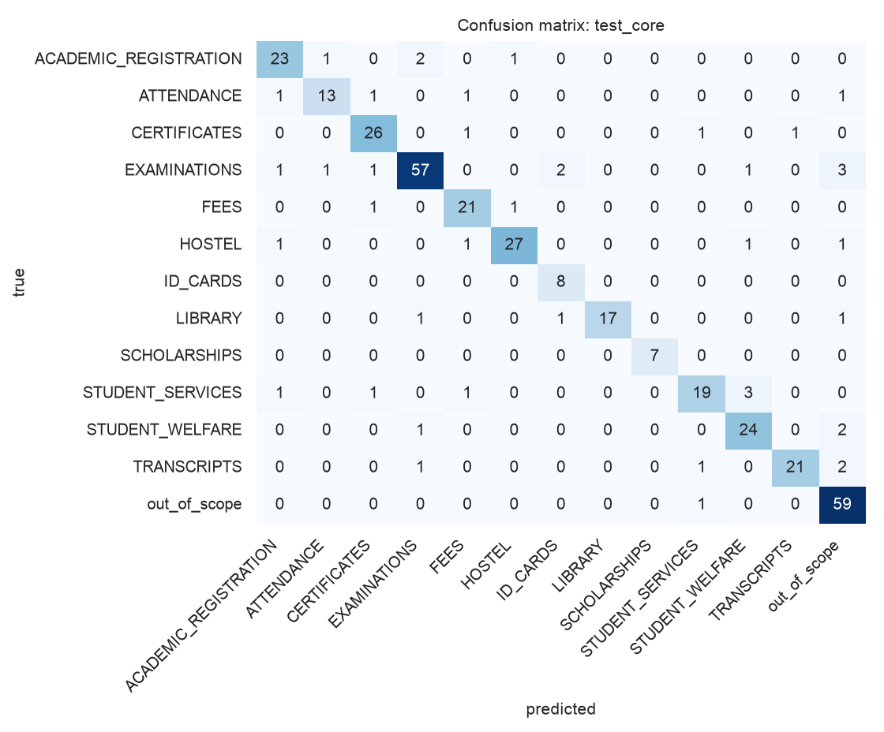
Figure 3. Confusion matrix, core test set
A second baseline routes queries to one of 95 sub-intents (the unit that determines department and documents): accuracy 0.725 / macro-F1 0.627 on the core test set. This harder task is improved in Week 3.

11. Error analysis
Table 13. Most frequent confusions (core test)
true | pred | errors
EXAMINATIONS | out_of_scope | 3
STUDENT_SERVICES | STUDENT_WELFARE | 3
TRANSCRIPTS | out_of_scope | 2
ACADEMIC_REGISTRATION | EXAMINATIONS | 2
STUDENT_WELFARE | out_of_scope | 2
EXAMINATIONS | ID_CARDS | 2
ACADEMIC_REGISTRATION | ATTENDANCE | 1
LIBRARY | out_of_scope | 1

- Overlapping vocabulary: neighbouring intents share vocabulary: transcripts vs certificates (grade sheets, degree), fees vs hostel (hostel fees, deposits), examinations vs attendance (exam eligibility).
- Noise: variants score lower than core questions (macro-F1 0.80 vs 0.88), mainly from typos in short queries.
- Ambiguity: very short questions such as "when is it" or "fees" are genuinely ambiguous; they are marked in the ambiguity column and evaluated separately in Week 3.

12. Limitations
- Core questions are built from official NMIMS sources rather than collected from students, so accuracy on real traffic may be lower than reported here.
- About two thirds of the rows are rule-generated variants; test_core results are the more realistic figure.
- NER labels are silver (rule-generated); a hand-corrected NER test set is future work.
- Category sizes follow the sources: scholarships and ID cards have few official facts and fewer questions.
- Some facts are time-sensitive (2026-27 dates, fees, committee members) and are flagged for re-verification.

13. Reproducibility
uv sync
python -m dataset.phase1_sources # collect, extract, inventory, knowledge base
python -m dataset.phase2_annotate # facts + queries -> labelled core queries + NER
python -m dataset.phase3_expand # variants, group-aware split
python -m dataset.phase4_validate # 19 checks + dataset reports
python -m nlp.intent.experiments # this report's baseline results

