University Administrative Copilot
Week 3: Core NLP Pipeline - Version 2
Classification, NER, embeddings, semantic similarity, RAG, summarization and information extraction on official NMIMS data
Group 10 | Roll No. J054, J055, J056, J057, J059
Repository: github.com/jashan7305/university_administrative_copilot

Summary
This report presents version 2 of the NLP pipeline. Compared with the first Week 3 submission, every component now runs on the official NMIMS dataset and knowledge base built in Week 2, summarization has been added, embeddings and semantic similarity are evaluated in their own right, and each component is compared against at least one alternative. The pipeline is served by the FastAPI backend.
Table 1. Pipeline v2 at a glance
Component | Selected method | Result
Intent classification (13 classes) | ensemble_tfidf_bge | macro-F1 0.890 (core test); OOS recall 0.946
Sub-intent routing (95 classes) | ensemble_tfidf_minilm (flat) | accuracy 0.794 end-to-end
NER (28 entity types) | crf + gazetteer (full) | span F1 0.941
Embeddings / semantic similarity | BGE-small sentence embeddings | same-fact question match acc@5 0.835
RAG retrieval (727 NMIMS passages) | hybrid + predicted intent & sub-intent boost | recall@3 0.615, MRR 0.524
Summarization (new) | MMR query-focused extractive | ROUGE-L 0.382 (lead baseline 0.131)
Information extraction (service request) | routing + entities + source facts | department 0.773, documents Jaccard 0.799

1. Progress since the previous submission
The feedback on our first Week 3 submission was that it showed minimal incremental progress. This section lists exactly what changed between Week 2, the first Week 3 submission (v1) and this version (v2).
Table 2. Change log
Area | v1 (first Week 3 submission) | v2 (this report)
Data | Template-generated queries, 27 procedure documents | 5863 NMIMS queries grounded in 269 verified facts; 727 official NMIMS passages as knowledge base
Intent classification | TF-IDF baseline; embeddings tried on generated data | 5 models + kNN compared on NMIMS splits; TF-IDF+embedding ensemble selected; out-of-scope trained on real CLINC150 data
Routing | Intent only; procedure chosen by retrieval | 95-class sub-intent router (flat vs hierarchical chosen on validation)
NER | CRF on generated sentences (21 types) | CRF on NMIMS annotations (28 types), compared with dictionary baseline
Embeddings / semantic similarity | Used only inside retrieval | Evaluated separately: paraphrase matching and same-fact question retrieval, TF-IDF vs MiniLM vs BGE
RAG retrieval | Hybrid over 27 invented documents, 81 queries | 5 retrievers over 727 real passages, 870 queries; intent + sub-intent boosting
Summarization | Not implemented | Lead vs TextRank vs MMR, evaluated with ROUGE and embedding similarity
Information extraction | Service request from invented procedure metadata | Service catalogue built from verified facts; every answer cites source URLs
Engineering | Scripts per task | Phase-based repo (src/dataset, src/nlp, src/backend), 21 automated tests, reports generated from results

Table 3. v1 vs v2 end-to-end
End-to-end metric | v1 | v2
Intent accuracy (end-to-end) | 0.802 | 0.876
Procedure / sub-intent correct | 0.728 | 0.794
Relevant passage in top 3 | 0.864 | 0.632
Out-of-scope declined (200 CLINC150) | 0.960 | 0.950
Knowledge base | 27 procedure documents | 727 official NMIMS passages
Evaluation questions | 81 held-out | 291 held-out NMIMS core questions

The two versions are evaluated on different question sets (v1 on 81 questions about invented procedures, v2 on held-out questions about real NMIMS procedures), so the comparison shows the direction of change rather than a controlled difference. On the larger, real-source task v2 improves intent accuracy and the share of correctly routed requests. Passage retrieval looks lower in v2 because v1 searched 27 procedure documents (one per procedure) while v2 searches 727 real pages and counts a hit only for the exact page a fact came from; Section 7 compares retrievers on the same v2 data, where the new boosting raises recall@3 from 0.42 to 0.61.
Table 4. Coverage of the Week 3 brief
Component listed in the brief | Where it is implemented and evaluated
NER | Section 6
Classification | Section 4
Embeddings | Sections 4, 5, 7
Semantic similarity | Section 5
RAG | Sections 7, 9
Summarization | Section 8
Information extraction | Section 9

2. Pipeline architecture
query
-> intent classifier (TF-IDF + sentence-embedding ensemble, 12 intents + out_of_scope)
-> out_of_scope: polite fallback
-> sub-intent router (95 sub-intents) -> service catalogue (department, documents, next action, facts)
-> entity extraction (CRF + regex rules) -> extracted details, missing information, priority
-> hybrid retrieval (BM25 + embeddings, RRF, intent/sub-intent boost) over official NMIMS passages
-> answer = MMR summary of verified facts + retrieved passages, with source citations
-> structured service request (JSON) via POST /copilot/query

3. Data and knowledge base
Training and evaluation use the Week 2 NMIMS dataset (group-aware train/validation/test splits; test_core = held-out questions from official NMIMS sources). The knowledge base has 727 page-level passages from official NMIMS pages and PDFs; each passage keeps its URL, page, academic year and the ids of verified facts that cite it. A service catalogue is built for each sub-intent from the verified facts.

4. Classification
Table 5. Intent classification
Model | Val macro-F1 | Core test | Variants | OOS recall
tfidf_logreg (week 2 best) | 0.9031 | 0.8805 | 0.7977 | 0.945
minilm_logreg | 0.8355 | 0.8499 | 0.7763 | 0.872
bge_small_logreg | 0.8192 | 0.8192 | 0.7667 | 0.827
ensemble_tfidf_minilm | 0.895 | 0.8886 | 0.8143 | 0.946
ensemble_tfidf_bge | 0.9042 | 0.8873 | 0.8091 | 0.942
minilm_knn (k=5) | 0.818 | 0.8623 | 0.7724 | 0.683

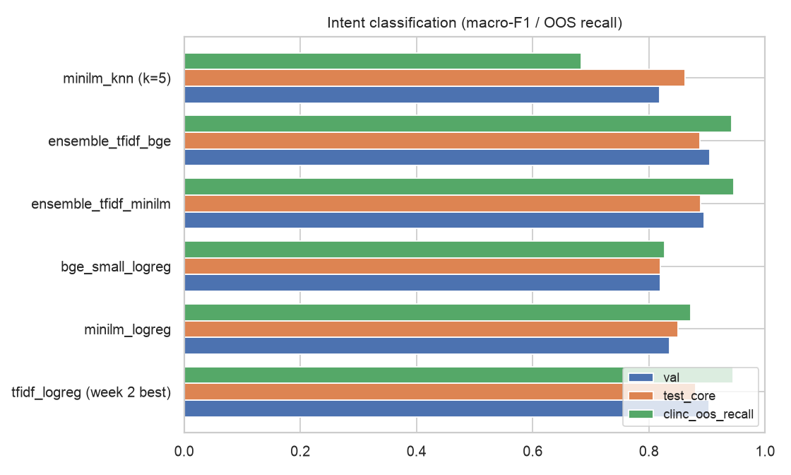
Figure 1. Intent models
Selected on validation: ensemble_tfidf_bge. Sentence embeddings alone are weaker than TF-IDF on this data, but averaging their probabilities with TF-IDF helps on rewordings and core questions; kNN over embeddings (classification by semantic similarity) is competitive in-scope but rejects out-of-scope queries poorly. Final: accuracy 0.890 and macro-F1 0.890 on core test; out-of-scope recall 0.946 on 1,000 real CLINC150 queries.
Table 6. Sub-intent routing (95 classes, accuracy)
Model | Val flat | Val hierarchical | Core flat | Core hierarchical | Core macro-F1
tfidf_logreg | 0.7256 | 0.7256 | 0.7246 | 0.718 | 0.6275
minilm_logreg | 0.7299 | 0.7458 | 0.7869 | 0.7639 | 0.7419
ensemble_tfidf_minilm | 0.7627 | 0.7542 | 0.7902 | 0.7639 | 0.7129

Week 2's TF-IDF router reached 0.725 on core test; the ensemble with sentence embeddings raises routing accuracy (selected: ensemble_tfidf_minilm, flat routing). Hierarchical routing (only sub-intents of the predicted intent) did not beat flat routing on validation.

5. Embeddings and semantic similarity
Two retrieval-style tasks measure how well each representation captures meaning:
- Task A, paraphrase matching: match 629 rule-generated rewordings to their original among 1973 core questions.
- Task B, same-fact retrieval: for 303 held-out core questions, retrieve a training question about the same verified fact (different wording written independently, so no shared template).
Table 7. Task A
Method | Acc@1 | Acc@5 | MRR
tfidf word cosine | 0.9714 | 1.0 | 0.9848
tfidf char cosine | 0.9952 | 1.0 | 0.9972
minilm embedding cosine | 0.9587 | 0.9952 | 0.975
bge-small embedding cosine | 0.9841 | 0.9968 | 0.9906

Table 8. Task B
Method | Acc@1 | Acc@5
tfidf word cosine | 0.3597 | 0.6733
minilm embedding cosine | 0.538 | 0.8218
bge-small embedding cosine | 0.571 | 0.835

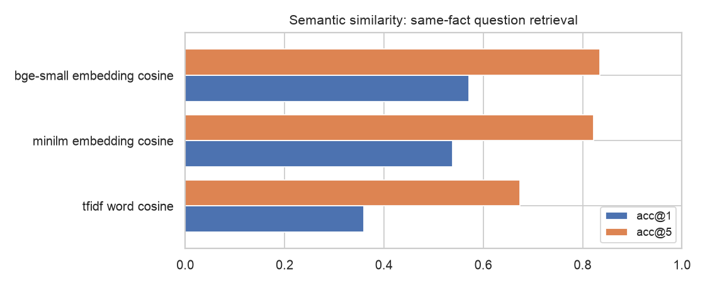
Figure 2. Same-fact question retrieval
Rule-generated rewordings are surface edits, so character n-grams already match them almost perfectly (Task A). On independently written paraphrases (Task B) sentence embeddings clearly outperform TF-IDF (0.571 vs 0.360 acc@1), which is why embeddings are used for retrieval and in the classification ensemble.

6. Named entity recognition
Table 9. NER (strict span F1, seqeval)
Model | Val F1 | Test F1 | Core test F1 | Variants F1
gazetteer (dictionary) | 0.9218 | 0.9312 | 0.9288 | 0.9324
crf | 0.9095 | 0.9135 | 0.9096 | 0.9156
crf + gazetteer (full) | 0.9267 | 0.9414 | 0.9386 | 0.9429
crf + gazetteer (value cross-fit) | 0.9246 | 0.9451 | 0.9416 | 0.9469

Table 10. Per-type results of the selected model (test)
Entity | P | R | F1 | n
ACTION | 1.0 | 1.0 | 1.0 | 139
DOCUMENT | 0.978 | 0.964 | 0.971 | 139
EXAMINATION | 0.976 | 0.976 | 0.976 | 124
ISSUE | 0.972 | 0.963 | 0.967 | 107
DEPARTMENT | 1.0 | 0.903 | 0.949 | 93
FEE | 0.978 | 0.967 | 0.973 | 92
UNIVERSITY | 1.0 | 0.912 | 0.954 | 68
CERTIFICATE | 0.967 | 0.879 | 0.921 | 66
DATE | 1.0 | 0.723 | 0.839 | 65
SCHOOL | 1.0 | 1.0 | 1.0 | 41
PROGRAM | 1.0 | 0.757 | 0.862 | 37
DEADLINE | 1.0 | 1.0 | 1.0 | 25
SEMESTER | 1.0 | 0.739 | 0.85 | 23
ORGANIZATION | 1.0 | 0.739 | 0.85 | 23

Selected: crf + gazetteer (full). A CRF with lexical, shape and context features plus a cross-fitted gazetteer generalises beyond the dictionary. Labels are silver (rule-generated), so scores measure agreement with those labels; regex rules add DATE, AMOUNT, PHONE, EMAIL, PERCENTAGE and STUDENT_ID at inference.

7. Retrieval-augmented generation (RAG)
Table 11. Retrieval over 727 passages (870 test queries)
Retriever | R@1 | R@3 | R@5 | MRR | R@3 core
bm25 | 0.2425 | 0.3851 | 0.492 | 0.3576 | 0.4467
dense (minilm) | 0.2161 | 0.3414 | 0.3989 | 0.3084 | 0.3505
hybrid (RRF) | 0.2483 | 0.423 | 0.5103 | 0.3742 | 0.4399
hybrid + predicted-intent boost | 0.3448 | 0.5506 | 0.608 | 0.4713 | 0.5601
hybrid + predicted intent & sub-intent boost | 0.3874 | 0.6149 | 0.6736 | 0.5241 | 0.6357

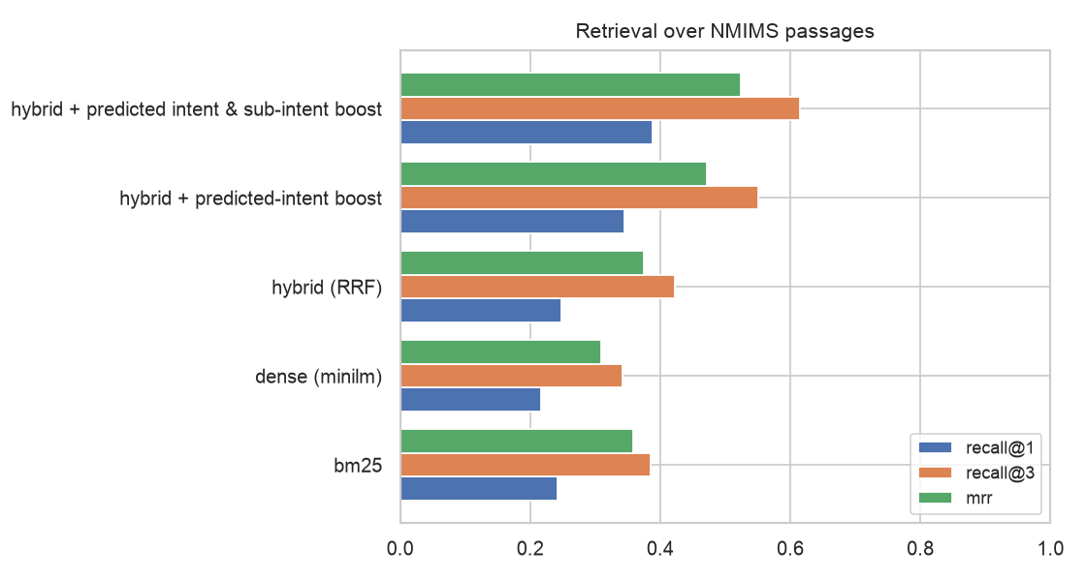
Figure 3. Retrieval
A passage counts as relevant if it is the page a verified fact for the question was taken from - a strict criterion, since other pages often also answer. Fusing BM25 and embeddings (reciprocal rank fusion) beats either alone, and boosting passages of the predicted intent and sub-intent adds the largest gain (recall@3 0.615). Generation is grounded: the answer is built only from verified facts and retrieved passages (Section 8), with an optional Claude rewrite restricted to the same evidence.

8. Summarization
Table 12. Query-focused summarization (291 core test questions)
Summarizer | ROUGE-1 | ROUGE-2 | ROUGE-L | Embedding sim. | Avg words
lead | 0.1781 | 0.0419 | 0.1307 | 0.4368 | 54.0378
textrank | 0.2311 | 0.0917 | 0.18 | 0.5344 | 55.6564
mmr | 0.4168 | 0.3296 | 0.3822 | 0.7265 | 55.3024

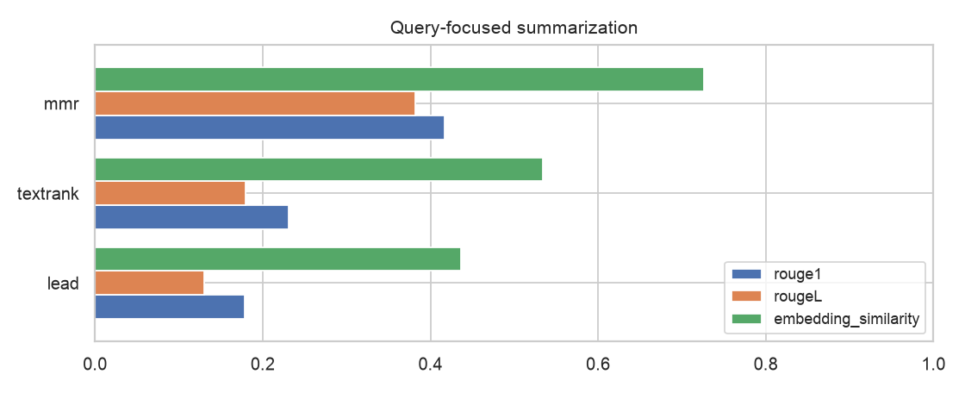
Figure 4. Summarization
Input: top-3 hybrid passages + facts of the PREDICTED sub-intent's service (lead: passages only). Reference: gold verified fact(s) linked to the query. MMR selects sentences relevant to the question while avoiding repetition, and clearly beats taking the first sentences of the best passage (lead) or query-agnostic TextRank. All summaries are extractive, so every sentence is copied from an official source or a verified fact.

9. Information extraction: structured service request
Table 13. End-to-end evaluation on held-out core questions
Metric | Value
Questions evaluated | 291
Intent accuracy | 0.876
Sub-intent accuracy | 0.794
Department routing accuracy | 0.773
Answer backed by the question's gold fact | 0.797
Required documents (Jaccard vs gold) | 0.799
Relevant passage in top 3 sources | 0.632
Out-of-scope declined (200 CLINC150) | 0.950
Status: ready / needs information / needs confirmation | 170 / 83 / 30
Latency median / p95 (ms, CPU) | 100.4 / 219.3

Example - query: "I lost my ID card and my SAP ID is 70022300145, what should I do? It's urgent"
{
"intent": "ID_CARDS",
"sub_intent": "DUPLICATE_ID_CARD",
"entities": [
[
"ISSUE",
"lost"
],
[
"DOCUMENT",
"ID card"
],
[
"STUDENT_NUMBER",
"SAP ID"
],
[
"DATE",
"70022300145"
]
],
"department": "School Academic Office (Course Coordinator / AR / DR)",
"required_documents": [],
"next_action": "Apply to the school for a duplicate ID card and pay the prescribed fee",
"missing_information": [],
"priority": "high",
"status": "ready",
"source_urls": [
"https://engineering.nmims.edu/wp-content/uploads/2026/08/SRB_2026_compressed.pdf"
]
}
Answer: Any grievances related to ID Card should be raised to biometricregistration@svkm.ac.in. Step 1: Log in to the SAP Student Portal Login Details URL: Pro-Tips & Troubleshooting https://sdcspcs.svkm.ac.in:44300/iri/portal Pop-ups Required: You must disable your browser's pop-up blockerfor the User ID: Your 11-digit student SAP number. grievancepage and payment gateway First-time users: The default password is to open correctly. Department: School Academic Office (Course Coordinator / AR / DR). Required documents: none stated in the sources. Next step: Apply to the school for a duplicate ID card and pay the prescribed fee.

10. Limitations
- Questions are built from official NMIMS sources; real student phrasing may be harder.
- NER labels are silver; a hand-corrected test set would give a true NER score.
- Retrieval relevance counts only the page a fact came from; actual answer coverage is higher than recall@k suggests.
- Sub-intent routing is the weakest link (95 classes, some with few questions); errors propagate to department and documents.
- Time-sensitive facts (2026-27 dates, fees, committee members) must be re-verified before deployment.

11. Next steps (Week 4)
- Improve routing with retrieval-informed re-ranking of sub-intents and a clarification question for low confidence.
- Multi-turn dialogue using the missing-information questions; multi-intent handling.
- Hand-correct an NER and routing test set; evaluate the optional LLM rewrite for faithfulness.
- Front-end for the API and a user study with NMIMS students.

12. Reproducibility
python -m nlp.intent.experiments # Week 2 baselines (also used by v2)
python -m nlp.pipeline.train_eval # trains and evaluates every v2 component (~6 min CPU)
python -m nlp.reports # regenerates these reports from the saved results
uvicorn backend.main:app --reload # POST /copilot/query

