University Administrative Copilot
Week 4: Improved Models - Baseline vs Improved
Sentence transformers, transformer NER, vector retrieval with re-ranking, LLM-assisted summarization
Group 10 | Roll No. J054, J055, J056, J057, J059
Repository: github.com/jashan7305/university_administrative_copilot
Code: submitted as Group10_Week4_code.zip (and in the repository under src/)

Summary
For each component of the copilot we keep the earlier model as the baseline, implement an improved model of the kind suggested in the brief, and compare both on the same held-out NMIMS test data. Every table reports baseline, improved and the change (delta). All code is attached and listed in Section 8.
Table 1. Baseline vs improved at a glance (held-out test data)
Component | Baseline | Improved | Metric | Baseline | Improved | Delta
Intent / routing | TF-IDF + LogReg | Fine-tuned transformer (blend) | Routing accuracy (core test) | 0.725 | 0.797 | +0.072
Intent / routing | TF-IDF + LogReg | Fine-tuned transformer (blend) | Intent macro-F1 (core test) | 0.880 | 0.901 | +0.020
NER | Rule-based | Transformer NER | Span F1 on gold set (relaxed) | 0.670 | 0.672 | +0.002
Retrieval | BM25 keyword search | Hybrid (fine-tuned vector) + boost | Recall@3 | 0.385 | 0.787 | +0.402
Summarization | Lead (basic) | LLM-assisted | Embedding similarity to gold | 0.416 | 0.664 | +0.249
Summarization | MMR extractive (Week 3) | LLM-assisted | Embedding similarity to gold | 0.721 | 0.664 | -0.057
End to end | Week 3 pipeline (v2) | Week 4 pipeline (v3) | Department routing accuracy | 0.773 | 0.783 | +0.010

1. Response to the feedback
- "Where is the code?": the full code for this week is attached as Group10_Week4_code.zip and is in the repository. Section 8 lists every file and what it does; code for Weeks 2 and 3 is attached to those submissions in the same way.
- "Incremental improvement is barely seen": each section compares the baseline and the improved model on identical data and reports the delta; the improved models are new this week (fine-tuning, transformer NER, re-ranking, LLM summarization), not re-runs of earlier code.

2. Experimental setup
Data: the NMIMS dataset (group-aware train / validation / test split; test_core = held-out questions, test_variants = rule-generated rewordings) plus real CLINC150 queries as the out-of-scope class. Training and model selection use only train and validation; test sets are scored once. Hardware: Apple M5 laptop GPU (MPS); every model trains in minutes. The baselines are the saved Week 2/3 models.

3. Classification: TF-IDF -> sentence transformer
Improved models: (a) SetFit - the sentence-transformer encoder is fine-tuned with a batch-all triplet loss so questions with the same sub-intent embed close together, then a logistic-regression head is trained; (b) a BGE-small transformer (33M parameters) fine-tuned end to end with a classification head on 95 sub-intents plus out_of_scope (square-root class weighting, a higher learning rate for the new classification head, best epoch chosen on validation). One joint model gives both the sub-intent (routing) and the intent (by summing its sub-intents' probabilities); (c) the selected model blends the fine-tuned transformer's probabilities with the Week 3 models, with blend weights chosen on validation. On its own the fine-tuned transformer is competitive but not better than the Week 3 ensemble on this small, fine-grained label set (about 40 questions per sub-intent); combined, the two make different errors and the blend is the best model.
Table 2. Classification (13 intents incl. out-of-scope; 95 sub-intents)
Model | Intent F1 core | Intent F1 variants | OOS recall | Routing acc core | Routing F1 core | Train s
TF-IDF + LogReg (Week 2) | 0.8805 | 0.7971 | 0.945 | 0.7246 | 0.6273 | -
TF-IDF + frozen embeddings ensemble (Week 3) | 0.8873 | 0.8091 | 0.942 | 0.7902 | 0.7129 | -
SetFit: fine-tuned sentence transformer + LogReg | 0.8501 | 0.7862 | 0.491 | 0.7475 | 0.6922 | 104.2
Fine-tuned transformer (BGE-small, joint sub-intent + OOS) | 0.8894 | 0.8183 | 0.92 | 0.7672 | 0.6999 | 1253.9
Fine-tuned transformer + Week 3 ensemble (blend) | 0.9009 | 0.8258 | 0.958 | 0.7967 | 0.7156 | 1253.9

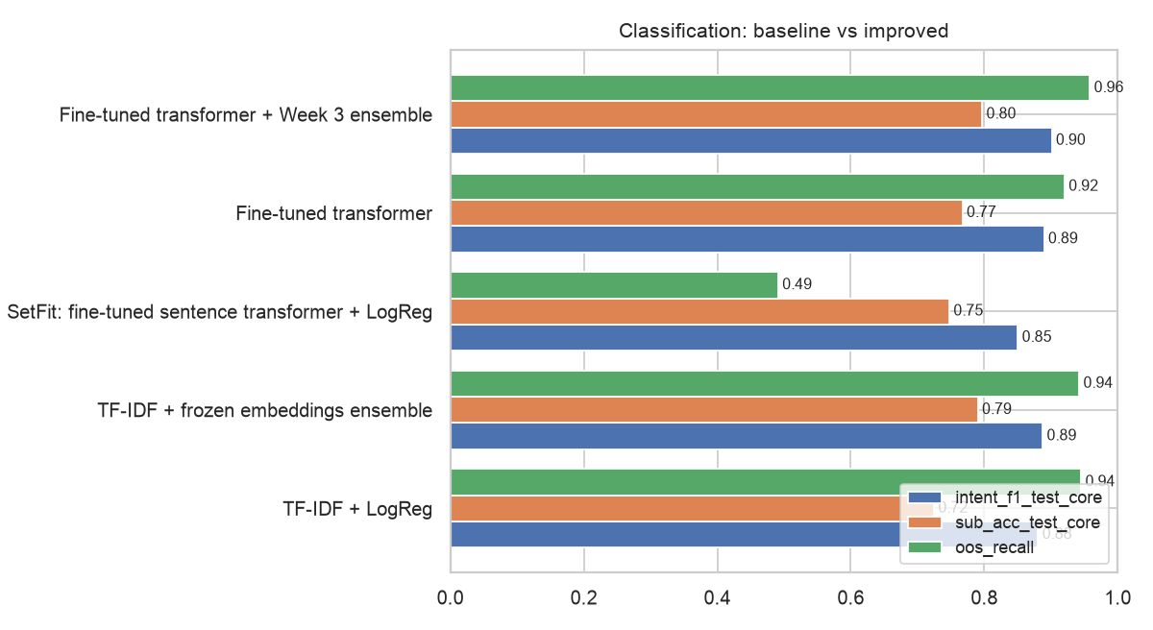
Figure 1. Classification: baseline vs improved
Change vs Week 2 TF-IDF: routing accuracy +0.072, routing macro-F1 +0.088, intent macro-F1 +0.020 on core test; on rewordings +0.029. Change vs the Week 3 ensemble: routing accuracy +0.006. The fine-tuned transformer alone: routing accuracy 0.767, intent macro-F1 0.889.
Table 3. Fine-tuning curve of the transformer router
Epoch | Train loss | Validation macro-F1 (sub-intent)
1 | 655.99 | 0.2282
2 | 272.48 | 0.496
3 | 100.7 | 0.612
4 | 32.86 | 0.6155
5 | 10.51 | 0.6504
6 | 4.03 | 0.6723
7 | 1.64 | 0.644
8 | 0.93 | 0.6573
9 | 0.75 | 0.6556
10 | 0.69 | 0.657

4. NER: rule-based -> transformer NER
The NER training labels were produced by our rule-based labeller, so scoring it on those labels would be circular (it scores 1.000). We therefore hand-annotated a gold test set of 120 test questions (245 spans; half core questions from official NMIMS sources, half rewordings with typos). Strict = exact span and type; relaxed = same type and overlapping span. The transformer is a BGE-small token classifier fine-tuned on the training labels with BIO tags aligned to word pieces.
Table 4. NER on the hand-annotated gold set
Model | Strict P | Strict R | Strict F1 | Relaxed F1 | Relaxed F1 core | Relaxed F1 typos/variants
Rule-based labeller (dictionary + regex) | 0.7692 | 0.449 | 0.567 | 0.6701 | 0.732 | 0.6082
Gazetteer (dictionary from training data) | 0.7576 | 0.4082 | 0.5305 | 0.6154 | 0.6772 | 0.5532
CRF (Week 3) | 0.7615 | 0.4041 | 0.528 | 0.6133 | 0.6702 | 0.5561
Fine-tuned transformer NER (Week 4) | 0.6948 | 0.4367 | 0.5363 | 0.6717 | 0.7538 | 0.59

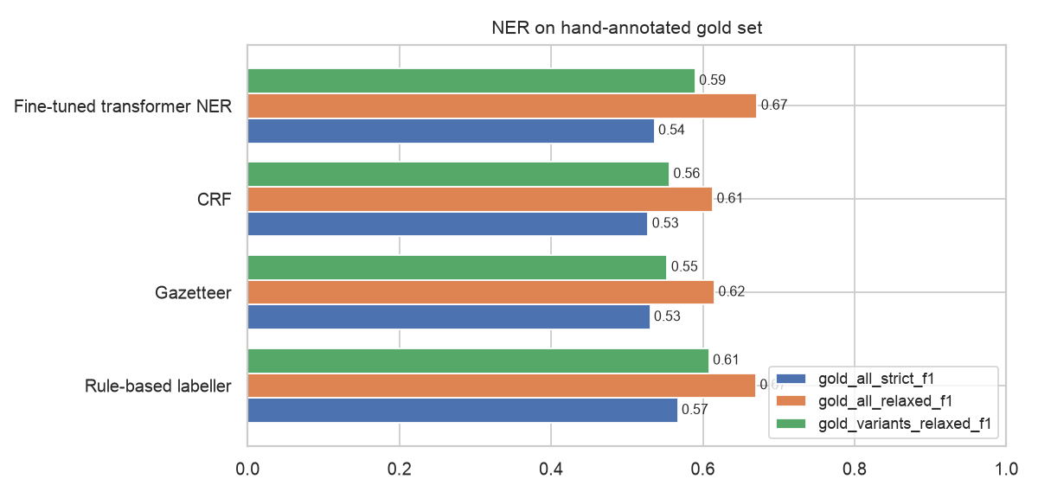
Figure 2. NER on gold data
Change vs rule-based: relaxed F1 +0.002, on rewordings with typos -0.018; vs the Week 3 CRF +0.058. Strict scores are lower for all systems because the gold annotation marks some longer phrases (for example "re exam form") than the training labels.

5. Retrieval: keyword search -> vector retrieval -> re-ranking
Improved models: the BGE-small bi-encoder fine-tuned on 3779 (training question, relevant NMIMS passage) pairs with in-batch negatives, combined with BM25 and the intent/sub-intent boost; then a cross-encoder that reads question and passage together re-scores the top 20, used zero-shot and fine-tuned on 11292 positive / hard-negative pairs. Evaluated on 870 test questions over 727 passages.
Table 5. Retrieval
Retriever | R@1 | R@3 | R@5 | MRR@20 | R@3 core | ms/query
BM25 keyword search | 0.2425 | 0.3851 | 0.492 | 0.354 | 0.4467 | 0.4
Vector, frozen MiniLM | 0.2161 | 0.3414 | 0.3989 | 0.3053 | 0.3505 | 3.0
Vector, frozen BGE-small | 0.1954 | 0.3391 | 0.4333 | 0.2992 | 0.3711 | 6.9
Vector, fine-tuned BGE-small | 0.3414 | 0.5448 | 0.6655 | 0.4752 | 0.5979 | 7.2
Week 3 v2: hybrid + intent/sub-intent boost | 0.3977 | 0.6287 | 0.6839 | 0.5312 | 0.6495 | 5.0
Hybrid (fine-tuned vector) + boost | 0.4966 | 0.7874 | 0.8506 | 0.6513 | 0.8213 | 7.3
+ cross-encoder re-rank (zero-shot) | 0.2448 | 0.4034 | 0.4805 | 0.3721 | 0.4536 | 117.6
+ cross-encoder re-rank (fine-tuned) | 0.246 | 0.569 | 0.7575 | 0.4486 | 0.5876 | 113.4

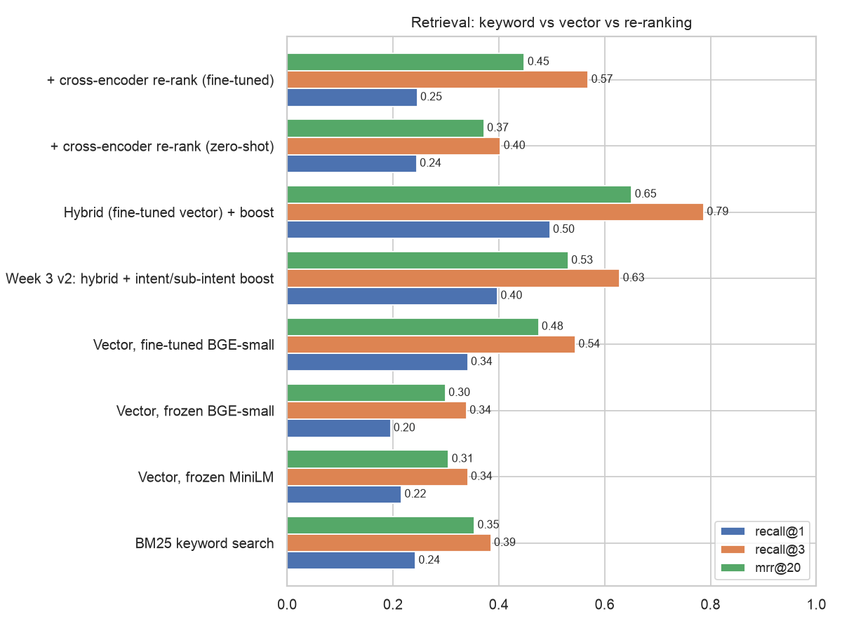
Figure 3. Retrieval
Change vs BM25: recall@3 +0.402, MRR +0.297; vs the Week 3 hybrid: recall@3 +0.159 (best: Hybrid (fine-tuned vector) + boost).
Negative result: cross-encoder re-ranking lowered recall@3 to 0.569 (fine-tuned) and 0.403 (zero-shot), and is about 15x slower. The ms-marco cross-encoder was trained on web search and ignores the intent/sub-intent routing signal that the hybrid retriever uses; one epoch on our training pairs was not enough to recover it. The Week 4 copilot therefore uses the fine-tuned hybrid retriever without re-ranking.

6. Summarization: basic -> LLM-assisted
Input: top-3 passages from the fine-tuned hybrid retriever + facts of the predicted service. Reference: gold verified fact(s) of the question. LLM: Qwen2.5-1.5B-Instruct (local, greedy decoding) over MMR-selected evidence; the prompt restricts the model to the evidence and asks it to copy fees, dates and emails exactly. Unsupported-number rate = share of numbers / emails in the answer that do not appear in the evidence (a hallucination check).
Table 6. Summarization (120 core test questions)
Summarizer | ROUGE-1 | ROUGE-2 | ROUGE-L | Emb. sim. | Words | Unsupported nums
lead | 0.1787 | 0.044 | 0.1322 | 0.4156 | 53.3167 | 0.0036
mmr | 0.4036 | 0.3056 | 0.3672 | 0.7213 | 55.8417 | 0.0
llm_local | 0.3892 | 0.2057 | 0.3264 | 0.6643 | 30.65 | 0.0144

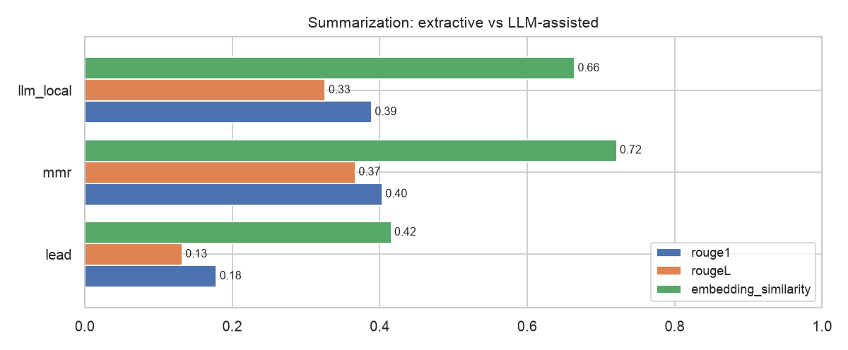
Figure 4. Summarization
Example - Q: do i need to give back my original degree for correction
MMR: For a correction, the original degree/grade sheet must be surrendered to the school examination department; university records must be corrected by the Admission office first. Corrections on degree certificates or grade sheets are routed through the University Admission Department, and the original must be surrendered.
LLM-assisted: Yes, you need to surrender your original degree to the School Examination Dept for obtaining a revised document.
Example - Q: watch allowed in exam?
MMR: 7.1.4 Students, who are not in their seats by the time notified, will not, be permitted to appear for the examination. Possessing an electronic device such as a mobile phone or smart watch in the exam hall leads to annulment of performance at the examination in full. E.g. for the examination of two hours, 40 minutes extra time will be allowed.
LLM-assisted: No, students are not allowed to use smartwatches in exams according to the rules provided.
Extractive MMR copies source sentences, so its ROUGE overlap with the reference facts is high; the LLM writes shorter, more readable answers, which lowers exact word overlap even when the meaning matches. The embedding similarity and unsupported-number columns show how close in meaning and how faithful the answers are.
Result: the LLM-assisted summarizer clearly beats basic lead summarization (embedding similarity +0.249, ROUGE-L +0.194) and gives answers about half as long (31 vs 56 words), but it does not beat our Week 3 MMR extractive summarizer on faithfulness, and 1.4% of the numbers it writes are not in the evidence. The copilot therefore keeps MMR as its default answer generator; the LLM is available as an option for more readable answers.

7. End to end: Week 3 pipeline vs Week 4 pipeline
Table 7. Copilot end to end on 291 held-out questions (+200 real out-of-scope queries)
Metric | Week 3 (v2) | Week 4 (v3) | Delta
intent acc | 0.8763 | 0.8969 | +0.021
sub intent acc | 0.7938 | 0.811 | +0.017
department acc | 0.7732 | 0.7835 | +0.010
documents jaccard | 0.799 | 0.799 | +0.000
relevant passage top3 | 0.6323 | 0.8144 | +0.182
oos declined 200 | 0.95 | 0.96 | +0.010
latency ms median | 114.5 | 130.7 | +16.2

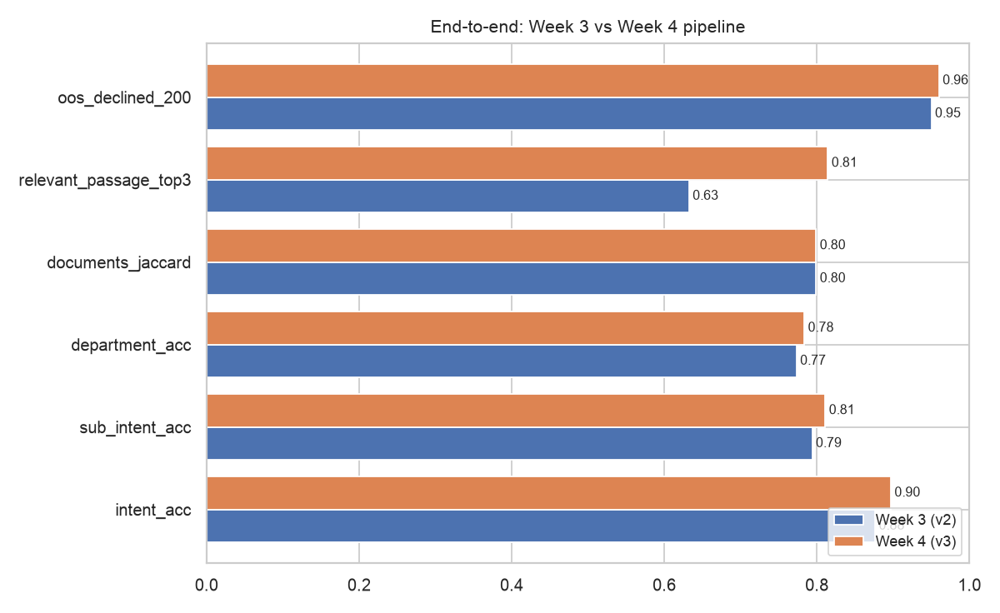
Figure 5. End to end
Example (v3) - "I lost my ID card and my SAP ID is 70022300145, what should I do? It's urgent"
{
"intent": "ID_CARDS",
"sub_intent": "DUPLICATE_ID_CARD",
"entities": [
[
"ISSUE",
"lost"
],
[
"DOCUMENT",
"ID card"
],
[
"ORGANIZATION",
"SAP"
],
[
"STUDENT_NUMBER",
"ID"
],
[
"PERCENTAGE",
"70022300145"
]
],
"department": "School Academic Office (Course Coordinator / AR / DR)",
"next_action": "Apply to the school for a duplicate ID card and pay the prescribed fee",
"priority": "high"
}

8. Code
Table 8. Week 4 code
File | Purpose | Lines
src/nlp/intent/finetune.py | Fine-tuned transformer classifier, SetFit classifier, joint intent adapter | 196
src/nlp/ner/transformer_ner.py | Transformer token-classification NER (word-piece BIO alignment, span decoding) | 158
src/nlp/retrieval/rerank.py | Bi-encoder fine-tuning, cross-encoder fine-tuning, re-ranking retriever | 70
src/nlp/pipeline/summarize.py | LLM-assisted summarizer (local Qwen2.5 or Claude) next to the extractive baselines | 145
src/nlp/pipeline/copilot.py | Copilot v3: loads the improved models (v2 kept for comparison) | 244
src/nlp/pipeline/compare_week4.py | Trains improved models and runs every baseline vs improved comparison | 430
data/annotations/ner_gold.yaml | Hand-annotated gold NER test set (120 questions) | 140
tests/test_week4.py | Tests for the Week 4 components | 51

uv sync
python -m nlp.pipeline.compare_week4 # trains improved models, runs all comparisons (~40 min, Apple GPU)
python -m nlp.reports week4 code # this report + code zips
COPILOT_VERSION=v3 uvicorn backend.main:app # serve the improved pipeline

9. Limitations
- The gold NER set is small (120 questions) and annotated by the team; confidence intervals are wide.
- Questions are built from official NMIMS sources rather than collected from students.
- The local LLM (1.5B parameters) is limited; a larger model or Claude (supported in code) should write better answers.
- Transformer models are slower than TF-IDF (see latency) and need a GPU-equipped machine to train in minutes.

10. Next steps
- Multi-turn clarification for ambiguous and low-confidence questions.
- Evaluation with real NMIMS student questions and a larger gold set.
- Deployment: front-end for the API, caching of embeddings, monitoring of time-sensitive facts.

