University Administrative Copilot
Week 5: Evaluation & Error Analysis
Quantitative evaluation, test sets, robustness, error analysis and failure cases
Group 10 | Roll No. J054, J055, J056, J057, J059
Repository: github.com/jashan7305/university_administrative_copilot
Code: submitted as Group10_Week5_code.zip (and in the repository under src/)

Summary
We evaluated the final copilot (Week 4, v3) end to end and component by component, with the Week 2 and Week 3 systems as reference points. Beyond headline metrics we report confidence intervals and significance tests, calibration, behaviour under controlled perturbations, a new challenge test set of hard queries, an automatic error taxonomy, a set of analysed failure cases and two error-driven fixes measured before and after.
- Final system is the most accurate on every held-out set. Intent accuracy 0.912 vs 0.890 (Week 3) and 0.882 (Week 2); the intent gain over Week 3 is statistically significant (McNemar p = 0.039) and routing beats Week 2 significantly (30 queries fixed, 8 broken, p < 0.001). The routing gain over Week 3 is small and not significant (p = 0.69) - we report this rather than overstate it.
- Retrieval is the clearest improvement. Recall@3 0.783 [0.756, 0.809] vs 0.616 [0.582, 0.648] for Week 3 - the confidence intervals do not overlap - and the gap widens under typos (0.658 vs 0.520).
- Confidence is trustworthy for ranking. No routing errors at all above 0.9 confidence, 61% error below 0.3. Answering only the 64% most confident questions gives 90.7% routing accuracy and catches 71% of routing errors before they reach a student.
- Main weaknesses found. Near-domain out-of-scope questions (only 3 of 12 rejected - e.g. IIT cut-offs are routed to NMIMS registration), heavy typos and truncated questions, negation (the models rely on keywords: shuffling word order barely changes predictions), and sibling sub-intents with few training examples.
- Error-driven fix works where it should. Typo normalisation recovers +6.6 points of routing accuracy on questions with three typos (0.679 -> 0.744) at a cost of 0.3 points on clean questions.

1. Response to earlier feedback
Weeks 3 and 4 were marked down for missing code and for improvements that were hard to see. This week: all evaluation code is attached (Group10_Week5_code.zip, listed in Section 9) and reruns with one command; every number in this report is generated from that run; each result is compared with a baseline and given a 95% confidence interval so that improvements are visible and verifiable.

2. Test sets
Table 1. Test sets used in this evaluation (none is used for training or model selection)
Test set | Size | What it measures
test_core | 365 | held-out questions from official NMIMS sources (+ CLINC150 out-of-scope test queries); no group overlaps training
test_variants | 607 | rule-generated rewordings of held-out questions (typos, abbreviations, polite/formal, Hinglish)
test_clinc_oos | 1000 | real out-of-scope user queries from CLINC150
challenge (new) | 96 | hard queries from official NMIMS sources: near-domain OOS, very short, heavy typos, code-mixed, negation, multi-intent, ambiguous, long
gold NER | 120 | hand-annotated entity spans (half core questions, half rewordings)
retrieval | 870 | verified test questions with the passages that cite their facts
robustness | 3050 | 10 controlled perturbations of every in-scope test_core question

test_core covers 12 of 12 intents and 95 of 95 sub-intents. The split is group-aware: a question and all its rewordings are in the same split, so no rewording of a test question was seen in training. The challenge set was written this week, after the models were frozen, to target the weaknesses we expected from Week 4.
Table 2. Challenge set composition
Challenge category | Queries
near domain oos | 12
very short | 12
heavy typos | 10
hinglish | 10
unseen phrasing | 10
negation | 8
multi intent | 8
ambiguous | 8
general oos | 6
long rambling | 6
entity rich | 6

3. Quantitative evaluation

3.1 Classification and routing
Table 3. Test_core (365 queries; routing on the 305 in-scope ones). CI = bootstrap, 1,000 resamples
System | Intent acc [95% CI] | Intent macro-F1 [95% CI] | Routing acc [95% CI] | Routing macro-F1 | OOS recall | ECE
Week 2 TF-IDF | 0.882 [0.847, 0.912] | 0.880 [0.838, 0.914] | 0.725 [0.672, 0.774] | 0.627 | 0.945 | 0.127
Week 3 pipeline (v2) | 0.890 [0.860, 0.920] | 0.890 [0.852, 0.922] | 0.790 [0.744, 0.836] | 0.713 | 0.946 | 0.184
Week 4 final (v3) | 0.912 [0.882, 0.940] | 0.903 [0.866, 0.934] | 0.797 [0.751, 0.843] | 0.716 | 0.961 | 0.174

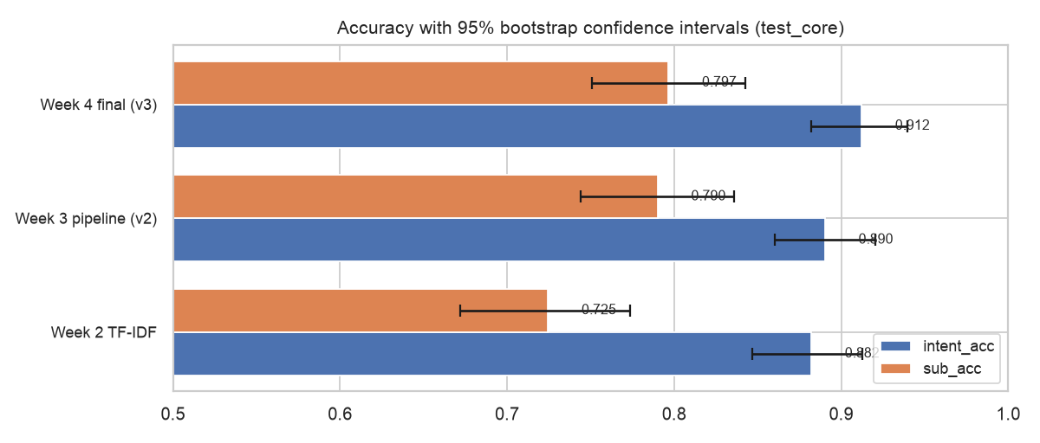
Figure 1. Accuracy with 95% confidence intervals
Significance (exact McNemar test on paired predictions): final vs Week 3 routing - 4 queries fixed, 2 broken, p = 0.6875; final vs Week 2 routing - 30 fixed, 8 broken, p = 0.00047; intent final vs Week 3 - p = 0.03857.
Table 4. Per-intent scores of the final system (test_core)
intent | precision | recall | f1 | support
CERTIFICATES | 0.9 | 0.931 | 0.9153 | 29
TRANSCRIPTS | 0.8846 | 0.92 | 0.902 | 25
EXAMINATIONS | 0.9508 | 0.8788 | 0.9134 | 66
FEES | 0.9167 | 0.9565 | 0.9362 | 23
SCHOLARSHIPS | 1.0 | 1.0 | 1.0 | 7
ATTENDANCE | 0.8125 | 0.7647 | 0.7879 | 17
ACADEMIC_REGISTRATION | 0.8621 | 0.9259 | 0.8929 | 27
ID_CARDS | 0.7273 | 1.0 | 0.8421 | 8
HOSTEL | 0.9375 | 0.9677 | 0.9524 | 31
LIBRARY | 0.9444 | 0.85 | 0.8947 | 20
STUDENT_SERVICES | 1.0 | 0.72 | 0.8372 | 25
STUDENT_WELFARE | 0.8667 | 0.963 | 0.9123 | 27
out_of_scope | 0.9365 | 0.9833 | 0.9593 | 60

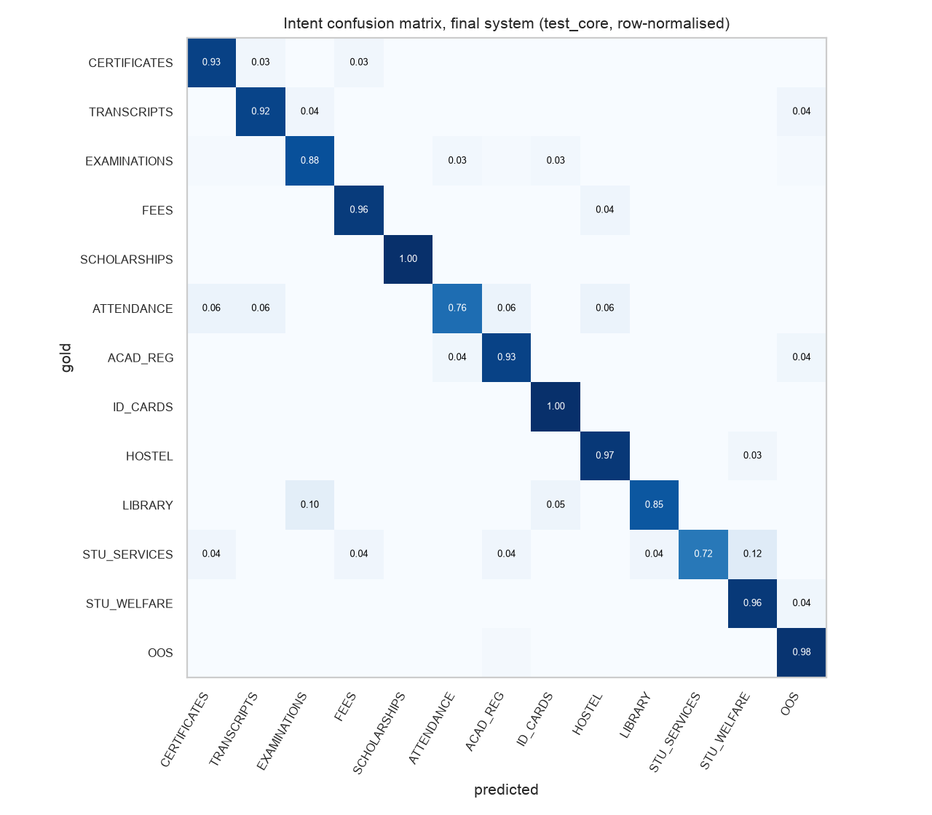
Figure 2. Intent confusion matrix (rows = gold, row-normalised)
Table 5. The 10 hardest sub-intents (of 95); 30 sub-intents are routed perfectly, 16 have F1 below 0.5
sub_intent | precision | recall | f1 | support
BOOK_BORROWING | 0.0 | 0.0 | 0.0 | 3
COUNSELLING | 0.0 | 0.0 | 0.0 | 2
HOSTEL_DOCUMENTS | 0.0 | 0.0 | 0.0 | 2
ACADEMIC_DOCUMENTS | 0.0 | 0.0 | 0.0 | 1
COURSE_ADD_DROP | 0.0 | 0.0 | 0.0 | 1
EXAM_GRIEVANCE | 0.0 | 0.0 | 0.0 | 1
ID_CARD_APPLICATION | 0.0 | 0.0 | 0.0 | 1
ID_CARD_CORRECTION | 0.0 | 0.0 | 0.0 | 1
SCHOLARSHIP_ELIGIBILITY | 0.0 | 0.0 | 0.0 | 1
SCHOLARSHIP_RENEWAL | 0.0 | 0.0 | 0.0 | 1

3.2 Calibration and selective prediction
A copilot that sends uncertain requests to staff needs confidence scores that mean something. Expected calibration error (ECE) measures the gap between confidence and accuracy; the risk-coverage curve shows the accuracy obtained if only the most confident queries are answered automatically.
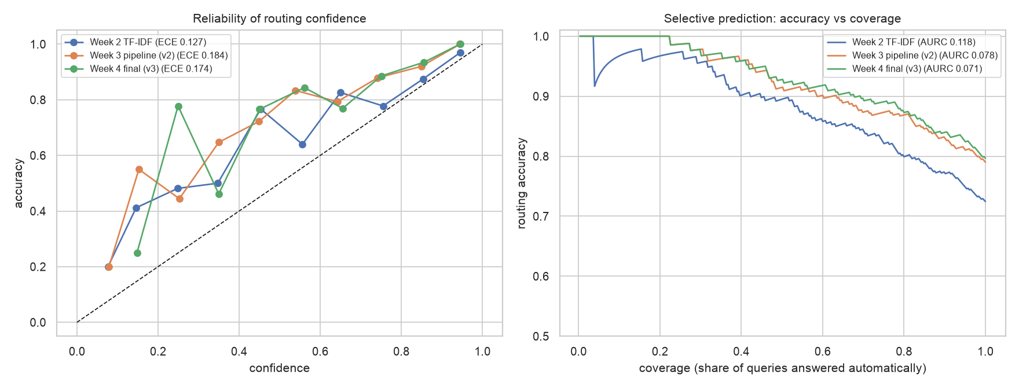
Figure 3. Reliability diagram (left) and accuracy vs coverage (right), routing
Table 6. Selective prediction for routing
System | Acc @50% cov. | Acc @70% | Acc @90% | Acc @100% | AURC (lower better)
Week 2 TF-IDF | 0.8947 | 0.8451 | 0.7737 | 0.7246 | 0.1179
Week 3 pipeline (v2) | 0.9145 | 0.8732 | 0.8321 | 0.7902 | 0.0782
Week 4 final (v3) | 0.9276 | 0.8967 | 0.8394 | 0.7967 | 0.0715

3.3 Named entity recognition
Table 7a. NER per entity type on the gold set - Week 3 pipeline (v2)
Entity type | Gold | Pred | Strict F1 | Relaxed P | Relaxed R | Relaxed F1
ACTION | 56 | 25 | 0.4444 | 0.88 | 0.3929 | 0.5432
CAMPUS | 1 | 0 | 0.0 | 0.0 | 0.0 | 0.0
CERTIFICATE | 10 | 10 | 0.9 | 1.0 | 1.0 | 1.0
CGPA | 1 | 1 | 1.0 | 1.0 | 1.0 | 1.0
DATE | 15 | 10 | 0.72 | 1.0 | 0.6667 | 0.8
DEADLINE | 3 | 2 | 0.8 | 1.0 | 0.6667 | 0.8
DEPARTMENT | 17 | 7 | 0.4167 | 0.7143 | 0.2941 | 0.4167
DOCUMENT | 42 | 16 | 0.4483 | 1.0 | 0.381 | 0.5517
EXAMINATION | 14 | 16 | 0.6667 | 0.6875 | 0.7857 | 0.7333
FEE | 10 | 9 | 0.5263 | 0.8889 | 0.8 | 0.8421
GRADE | 6 | 0 | 0.0 | 0.0 | 0.0 | 0.0
HOSTEL | 1 | 0 | 0.0 | 0.0 | 0.0 | 0.0
ISSUE | 35 | 19 | 0.5556 | 0.8947 | 0.4857 | 0.6296
ORGANIZATION | 11 | 2 | 0.1538 | 1.0 | 0.1818 | 0.3077
PERCENTAGE | 2 | 1 | 0.6667 | 1.0 | 0.5 | 0.6667
PROGRAM | 4 | 1 | 0.4 | 1.0 | 0.25 | 0.4
PURPOSE | 2 | 1 | 0.6667 | 1.0 | 0.5 | 0.6667
SCHOLARSHIP | 1 | 1 | 1.0 | 1.0 | 1.0 | 1.0
SCHOOL | 4 | 3 | 0.8571 | 1.0 | 0.75 | 0.8571
SEMESTER | 1 | 0 | 0.0 | 0.0 | 0.0 | 0.0
STUDENT_NUMBER | 1 | 0 | 0.0 | 0.0 | 0.0 | 0.0
UNIVERSITY | 8 | 6 | 0.8571 | 1.0 | 0.75 | 0.8571
ALL | 245 | 132 | 0.5358 | 0.8864 | 0.4776 | 0.6207

Table 7b. NER per entity type on the gold set - Week 4 final (v3)
Entity type | Gold | Pred | Strict F1 | Relaxed P | Relaxed R | Relaxed F1
ACTION | 56 | 26 | 0.439 | 0.8846 | 0.4107 | 0.561
CAMPUS | 1 | 0 | 0.0 | 0.0 | 0.0 | 0.0
CERTIFICATE | 10 | 11 | 0.8571 | 0.9091 | 1.0 | 0.9524
CGPA | 1 | 1 | 1.0 | 1.0 | 1.0 | 1.0
DATE | 15 | 11 | 0.6923 | 1.0 | 0.7333 | 0.8462
DEADLINE | 3 | 2 | 0.8 | 1.0 | 0.6667 | 0.8
DEPARTMENT | 17 | 11 | 0.5 | 0.6364 | 0.4118 | 0.5
DOCUMENT | 42 | 18 | 0.4667 | 0.9444 | 0.4048 | 0.5667
EXAMINATION | 14 | 17 | 0.7097 | 0.7647 | 0.9286 | 0.8387
FEE | 10 | 9 | 0.6316 | 1.0 | 0.9 | 0.9474
GRADE | 6 | 1 | 0.0 | 1.0 | 0.1667 | 0.2857
HOSTEL | 1 | 1 | 0.0 | 1.0 | 1.0 | 1.0
ISSUE | 35 | 23 | 0.5172 | 0.8696 | 0.5714 | 0.6897
ORGANIZATION | 11 | 4 | 0.1333 | 0.5 | 0.1818 | 0.2667
PERCENTAGE | 2 | 1 | 0.6667 | 1.0 | 0.5 | 0.6667
PROGRAM | 4 | 3 | 0.5714 | 1.0 | 0.75 | 0.8571
PURPOSE | 2 | 2 | 0.0 | 1.0 | 1.0 | 1.0
SCHOLARSHIP | 1 | 1 | 1.0 | 1.0 | 1.0 | 1.0
SCHOOL | 4 | 3 | 0.8571 | 1.0 | 0.75 | 0.8571
SEMESTER | 1 | 1 | 1.0 | 1.0 | 1.0 | 1.0
STUDENT_NUMBER | 1 | 0 | 0.0 | 0.0 | 0.0 | 0.0
UNIVERSITY | 8 | 6 | 0.8571 | 1.0 | 0.75 | 0.8571
ALL | 245 | 154 | 0.5363 | 0.8701 | 0.5469 | 0.6717

Table 8. NER error breakdown (gold spans; spurious = predicted spans with no gold overlap)
Outcome | Week 3 pipeline (v2) | Week 4 final (v3)
exact | 101 | 107
boundary error | 16 | 26
wrong type | 12 | 15
missed | 116 | 97
spurious (no gold overlap) | 3 | 2

3.4 Retrieval and end-to-end
Table 9. Retrieval on 870 verified test questions (727 passages)
System | R@1 | R@3 [95% CI] | R@5 | R@10 | MRR [95% CI]
Week 3 pipeline (v2) | 0.3885 | 0.616 [0.582, 0.648] | 0.6736 | 0.7678 | 0.523 [0.496, 0.550]
Week 4 final (v3) | 0.492 | 0.783 [0.756, 0.809] | 0.846 | 0.9034 | 0.647 [0.624, 0.671]

Table 10. End to end on 291 held-out questions (Apple M5 laptop)
System | Latency p50 (ms) | Latency p95 (ms) | Service-request status
Week 3 pipeline (v2) | 99.0 | 200.7 | ready 170, needs_confirmation 30, out_of_scope 8, needs_information 83
Week 4 final (v3) | 131.0 | 214.3 | ready 178, needs_confirmation 23, out_of_scope 4, needs_information 86

4. Robustness
Robustness is tested in three ways: (a) ten controlled perturbations applied to every in-scope test_core question (seeded, so the test is reproducible), measuring accuracy and consistency (same prediction as for the clean question); (b) the challenge set; (c) retrieval under typos.
Table 11. Routing accuracy under perturbations, and consistency of the final system
Perturbation | Acc Week 2 TF-IDF | Acc Week 3 pipeline | Acc Week 4 final | Consistency Week 4 final
clean | 0.7246 | 0.7902 | 0.7967 | 1.0
Hinglish suffix | 0.6984 | 0.7574 | 0.7803 | 0.9443
all abbreviations | 0.7311 | 0.7934 | 0.8 | 0.9902
drop 25% of words | 0.6459 | 0.7082 | 0.7213 | 0.8361
first half only | 0.5148 | 0.5344 | 0.541 | 0.6098
greeting prefix | 0.7279 | 0.7803 | 0.7869 | 0.9705
lowercase, no punctuation | 0.7246 | 0.7902 | 0.7967 | 1.0
shuffle word order | 0.7377 | 0.7738 | 0.7836 | 0.9344
typo x1 | 0.7246 | 0.7574 | 0.7607 | 0.9246
typo x2 | 0.6918 | 0.7344 | 0.7443 | 0.8787
typo x3 | 0.6492 | 0.6951 | 0.6787 | 0.8033

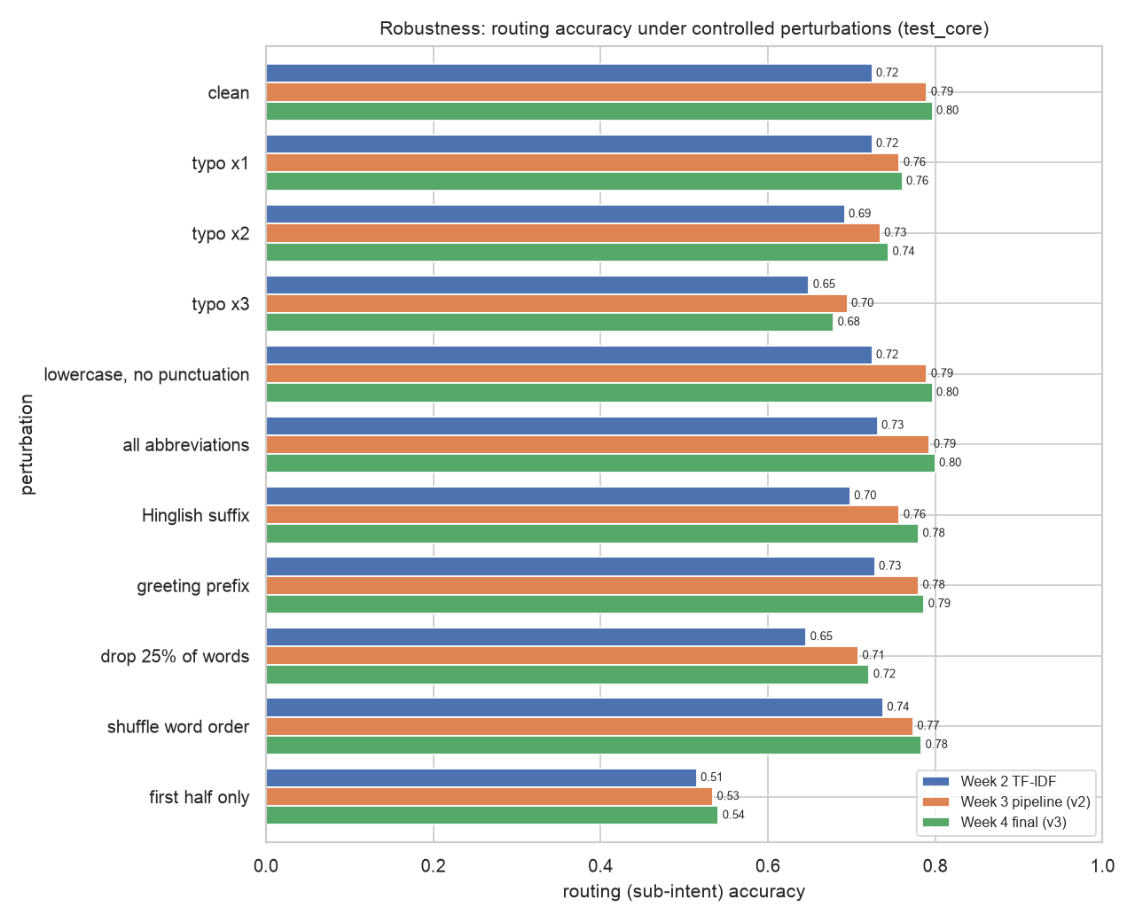
Figure 4. Robustness to perturbations
Table 12. Challenge set by category
Category | n | Intent acc Week 2 TF-IDF | Intent acc Week 3 pipeline | Intent acc Week 4 final | Final: intent+routing
ALL | 96 | 0.8125 | 0.8125 | 0.8333 | 0.6979
ambiguous | 8 | 0.75 | 0.75 | 0.75 | 0.75
entity rich | 6 | 1.0 | 1.0 | 1.0 | 1.0
general oos | 6 | 0.8333 | 1.0 | 1.0 | 1.0
heavy typos | 10 | 0.9 | 0.9 | 0.9 | 0.6
hinglish | 10 | 0.9 | 0.9 | 0.9 | 0.7
long rambling | 6 | 1.0 | 1.0 | 1.0 | 0.6667
multi intent | 8 | 1.0 | 1.0 | 1.0 | 1.0
near domain oos | 12 | 0.5 | 0.25 | 0.25 | 0.25
negation | 8 | 1.0 | 1.0 | 1.0 | 0.5
unseen phrasing | 10 | 0.4 | 0.6 | 0.8 | 0.6
very short | 12 | 0.9167 | 0.9167 | 0.9167 | 0.9167

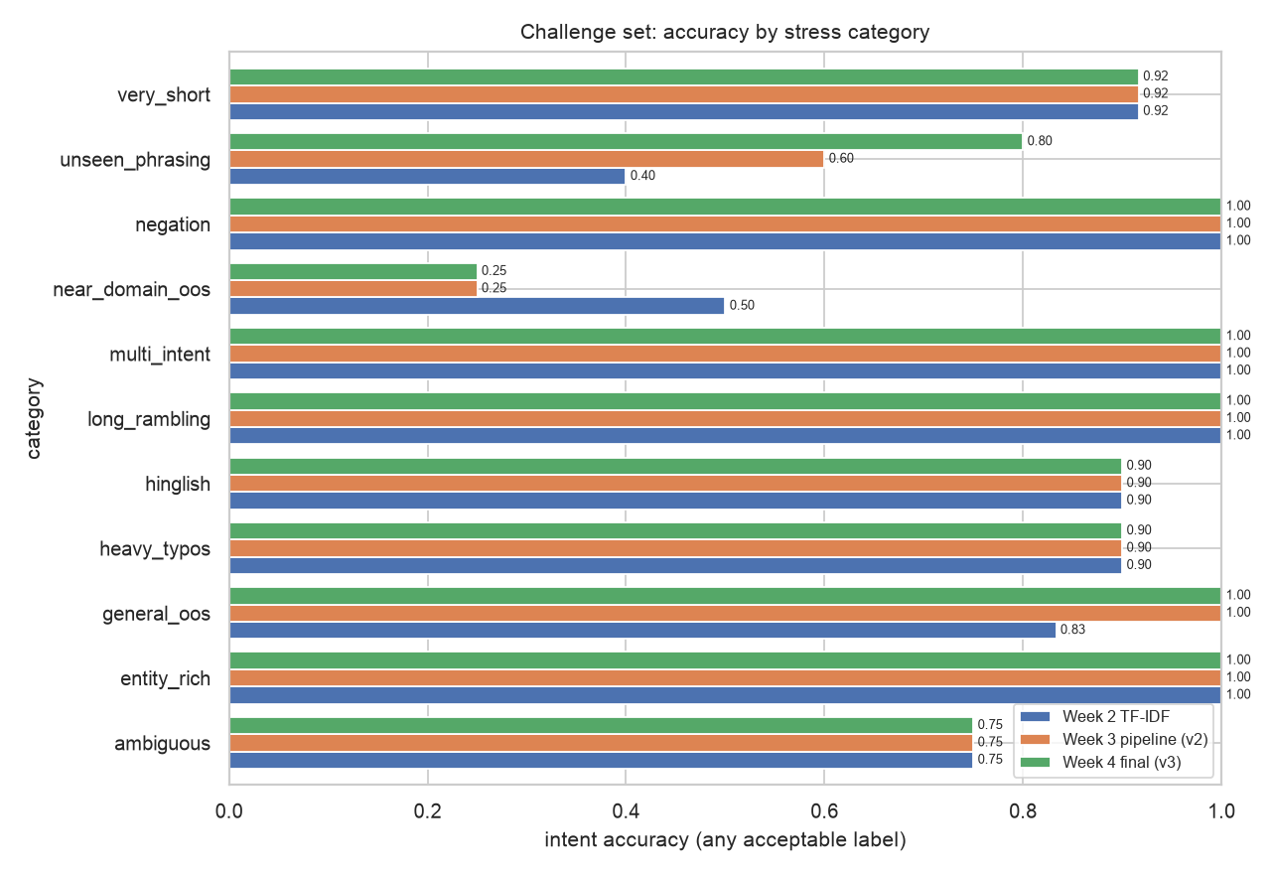
Figure 5. Challenge set
Table 13. Retrieval recall@3 under perturbation (compare with Table 9)
System | Perturbation | Recall@3
Week 3 pipeline (v2) | typo x2 | 0.5195
Week 4 final (v3) | typo x2 | 0.6575
Week 3 pipeline (v2) | lowercase, no punctuation | 0.6149
Week 4 final (v3) | lowercase, no punctuation | 0.7851

- Formatting does not matter: lowercasing, removing punctuation, NMIMS abbreviations and greetings change routing accuracy by at most 1 point for every system - the training rewordings did their job.
- Typos and missing words matter: three typos cost the final system 11.8 points and dropping a quarter of the words costs 7.5 points; keeping only the first half of a question costs 26 points because the key word (e.g. 'revaluation') is often at the end.
- Keyword reliance: shuffling word order costs only 1.3 points, so the models mostly ignore word order. This explains the negation failures (Case 3) and is the main limitation of sentence-embedding classifiers trained on short questions.
- Challenge set: the final system is best overall (intent 0.833, intent + routing 0.698) and perfect on general out-of-scope, multi-intent (first request), entity-rich and long questions, but rejects only 25% of near-domain out-of-scope questions and gets 50% routing on negation.

5. Error analysis
Every error of the final system on the full test set (972 queries: core + rewordings + out-of-scope) is assigned automatically to a category; all errors are listed in reports/week5/errors_v3.csv.
Table 14. Error taxonomy (223 errors)
Error type | Count | Share
wrong sub-intent, same intent | 94 | 42%
wrong intent | 79 | 35%
sub-intent outside predicted intent | 32 | 14%
false out-of-scope | 17 | 8%
missed out-of-scope | 1 | 0%

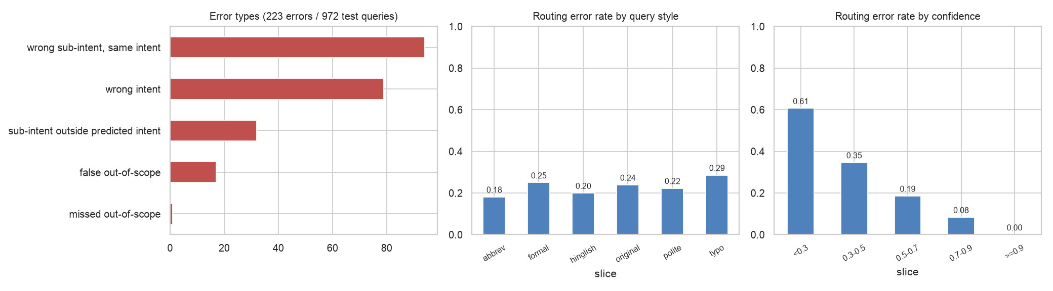
Figure 6. Error types and routing error rate by query style and by confidence
Table 15. Most frequent routing confusions
Gold sub-intent | Predicted | Count
BOOK_BORROWING | BOOK_RENEWAL | 7
ID_CARD_ACCESS | DUPLICATE_ID_CARD | 4
REVALUATION | RE_EXAMINATION | 4
MENTAL_HEALTH_SUPPORT | COUNSELLING | 4
ID_CARD_APPLICATION | DUPLICATE_ID_CARD | 3
ID_CARD_NOT_WORKING | ID_CARD_ACCESS | 3
BACKLOG_EXAM | RE_EXAMINATION | 3
EXAM_GRIEVANCE | REVALUATION | 3
FACILITIES | STUDENT_PORTAL | 3
ACADEMIC_GUIDELINES | BACKLOG_EXAM | 3

Routing error rate by query length
Slice | Queries | Routing error rate
1-5 words | 252 | 0.254
6-10 | 456 | 0.2346
11-15 | 156 | 0.2885
16-25 | 26 | 0.1154
26+ | 22 | 0.1364

Routing error rate by query style
Slice | Queries | Routing error rate
abbrev | 66 | 0.1818
formal | 76 | 0.25
hinglish | 5 | 0.2
original | 305 | 0.2393
polite | 233 | 0.2232
typo | 227 | 0.2863

- Most errors are near-misses: 42% of errors pick the right intent but a sibling sub-intent (e.g. BOOK_BORROWING vs BOOK_RENEWAL, REVALUATION vs RE_EXAMINATION), and 22 errors pick a sub-intent the dataset itself lists as a plausible alternative - the department is often still correct, so the student would still reach the right office.
- Rare sub-intents fail: the worst sub-intents (BOOK_BORROWING, COUNSELLING, HOSTEL_DOCUMENTS) have 1-3 test questions and few training questions; more labelled questions for these is the cheapest fix.
- Retrieval errors are mostly not routing errors: of 189 test questions without a relevant passage in the top 3, 114 were routed correctly - the remaining gap is vocabulary mismatch between how students ask and how NMIMS documents are written (Case 10).
- NER misses open-class phrases: 97 of 245 gold spans are missed, mostly ACTION / ISSUE / DOCUMENT phrases ("dental surgery", "hostel vacating"); closed-class entities (certificates, fees, dates, exams) score 0.84-0.95 relaxed F1.

6. Failure cases
13 failure cases, chosen to cover every component. For each: what happened, the root cause we identified, and how to fix it.

Case 1. Near-domain out-of-scope question accepted
Component: Classification - out-of-scope detection
Field | Value
query | what is the cutoff for IIT Bombay computer science
category | near_domain_oos
gold | ['out_of_scope'] / []
predicted | ACADEMIC_REGISTRATION / DIGITAL_RESOURCES

Root cause: The out-of-scope training data (CLINC150) is general-domain - banking, travel, small talk - so any question containing academic words (cutoff, computer science, admission) looks in-scope. 9 of 12 near-domain questions (other universities, coursework, entrance exams) were accepted.
Fix: Add near-domain negatives (other institutions, coursework help, entrance exams) to the out-of-scope class, and a separate in-domain/out-of-domain detector before routing.

Case 2. Confident wrong intent caused by a keyword
Component: Classification - intent
Field | Value
query | pyq for re exam available?
gold | LIBRARY / DIGITAL_RESOURCES
predicted | EXAMINATIONS / RE_EXAMINATION
confidence | 0.9551
sub confidence | 0.4995
style | original
plausible alternative | False

Root cause: "pyq" (previous-year question papers, a library resource) is rare in training, while "re exam" is a strong EXAMINATIONS keyword, so the model is 96% confident and wrong.
Fix: Add student slang to the normalisation lexicon (pyq -> previous year question papers) and more DIGITAL_RESOURCES questions that mention exams.

Case 3. Negation ignored
Component: Classification - routing (challenge set)
Field | Value
query | I am not asking about revaluation, I want a photocopy of my answer sheet
gold | EXAMINATIONS / ANSWER_BOOK_COPY
predicted | EXAMINATIONS / REVALUATION
confidence | 0.987

Root cause: The classifier relies on keywords (word order barely matters, Section 4); "revaluation" is the strongest cue in the sentence even though the student says it is NOT what they want.
Fix: Training questions with explicit contrast ("not X, I want Y"), or splitting on contrast markers (not / but / instead) and classifying the clause after them.

Case 4. Domain word with two meanings
Component: Classification - sibling sub-intents
Field | Value
query | how to issue books in mpstme library
gold | LIBRARY / BOOK_BORROWING
predicted | LIBRARY / DIGITAL_RESOURCES
confidence | 0.9941
sub confidence | 0.3398
style | original
plausible alternative | False

Root cause: At NMIMS "issue a book" means borrow it, but "issue" mostly means a problem in the training data. BOOK_BORROWING is the worst sub-intent (F1 0.0; confused with BOOK_RENEWAL 7 times).
Fix: Add NMIMS usage to the training data ("issue books", "get books issued") and merge BOOK_BORROWING and BOOK_RENEWAL for routing, since they go to the same library desk.

Case 5. Follow-up question without context
Component: Classification - false out-of-scope
Field | Value
query | can my parents do this for me
gold | TRANSCRIPTS / DUPLICATE_GRADE_SHEET
predicted | out_of_scope / HOSTEL_RULES
confidence | 0.6906
sub confidence | 0.1719
style | original
plausible alternative | False

Root cause: The question only makes sense after an earlier message ("this" = getting a duplicate grade sheet). A single-turn classifier has no content to classify, so it falls below the out-of-scope threshold.
Fix: Keep conversation state and carry the previous intent forward when a follow-up has no content words; otherwise ask a clarification question instead of declining.

Case 6. Sub-intent from a different intent
Component: Routing - consistency
Field | Value
query | is wifi available in the hostel rooms
gold | HOSTEL / HOSTEL_RULES
predicted | HOSTEL / FACILITIES
confidence | 0.7997
sub confidence | 0.3267
style | original
plausible alternative | False

Root cause: Routing is flat (chosen on validation), so it can pick STUDENT_SERVICES / FACILITIES while the intent is HOSTEL; the service request then names the wrong department. 32 errors are of this type.
Fix: Restrict routing to the predicted intent's sub-intents when intent confidence is high (hierarchical routing).

Case 7. Code-mixed Hinglish question
Component: Robustness - language
Field | Value
query | result kab aayega sem 5 ka
category | hinglish
gold | ['EXAMINATIONS'] / ['EXAM_RESULT']
predicted | ACADEMIC_REGISTRATION / ACADEMIC_CALENDAR

Root cause: Only the words "result" and "sem" are English; "kab aayega" (when will it come) is unknown to the model, and "when"-style questions about semesters are usually about the academic calendar.
Fix: A small Hinglish-to-English lexicon in the normaliser (kab -> when, aayega -> will come, chahiye -> need) and more code-mixed training questions (only 0.6% of the test set is Hinglish).

Case 8. Student ID read as a percentage
Component: NER
Field | Value
query | my SAP ID is 70022300145 and I need a bonafide certificate by 15 October
gold | 70022300145 [STUDENT_NUMBER], bonafide certificate [CERTIFICATE], 15 October [DATE]
predicted | SAP [ORGANIZATION], ID [HOSTEL], 70022300145 [PERCENTAGE], bonafide certificate [CERTIFICATE], 15 October [DATE]

Root cause: The transformer NER learned from rule-generated labels in which 11-digit SAP IDs are rare, so it guesses from the digit shape; the copilot then reports the request as ready without the student number.
Fix: A high-priority rule for NMIMS SAP IDs (11 digits starting 7002...) and roll numbers, which overrides the model, plus these patterns in the training data.

Case 9. Open-class phrases missed
Component: NER
Field | Value
query | dental surgery leave attendance proof
gold | dental surgery [ISSUE]; attendance [ACTION]; proof [DOCUMENT]
missed | dental surgery [ISSUE]; attendance [ACTION]; proof [DOCUMENT]
spurious
wrong type

Root cause: ISSUE / ACTION / DOCUMENT phrases are open-ended (any illness, any proof); the training labels only contain dictionary terms, so the model has never seen "dental surgery" as an ISSUE.
Fix: Hand-label a few hundred training questions (as done for the gold test set) so the model learns the phrase patterns rather than the dictionary.

Case 10. Right route, passage still missed
Component: Retrieval
Field | Value
query | problem with a faculty, how do i complain
gold sub | STUDENT_GRIEVANCE
pred sub | STUDENT_GRIEVANCE
rank of first relevant | 9
routing correct | True

Root cause: Vocabulary mismatch: the student says "problem with a faculty" and "complain", the official passage says "grievance redressal"; several grievance passages compete and the right one is ranked 9th.
Fix: Query expansion with an NMIMS synonym list (complain -> grievance), and passage titles/section names added to the indexed text.

Case 11. Routing error pushes retrieval the wrong way
Component: Retrieval - error propagation
Field | Value
query | how will college inform us about lecture cancellations
gold sub | STUDENT_PORTAL
pred sub | ADMISSION_CANCELLATION
rank of first relevant | >20
routing correct | False

Root cause: "lecture cancellations" is routed to ADMISSION_CANCELLATION because of the word "cancellation"; the sub-intent boost then promotes admission-cancellation passages and the relevant passage falls out of the top 20.
Fix: Scale the sub-intent boost by routing confidence (no boost below 0.5), so low-confidence routes do not override the retriever.

Case 12. LLM answer contradicts the rule
Component: Summarization (LLM-assisted)
Field | Value
query | attendance published on monday, can i report a mistake on friday?
reference | Attendance is displayed monthly; any discrepancy must be reported to the office in writing within 3 days of publication, after which no claim is entertained.
llm | Yes, you can report a mistake on Friday if it was published on Monday.
mmr | If a student has any issue or finds any discrepancy in his/her attendance, he/she should inform the office in writing regarding the same within 3 days of the publication of the attendance record. Attendance is displayed monthly; any discrepancy must be reported to the office in writing within 3 days of publication, after which no claim is entertained.
sim llm | 0.392
sim mmr | 0.8764

Root cause: The evidence says discrepancies must be reported within 3 days; Monday to Friday is 4 days, so the answer is no. The 1.5B model does not do the date arithmetic and answers "yes". The extractive answer quotes the rule correctly.
Fix: Keep extractive MMR as the default (as decided in Week 4); for LLM answers, require the rule sentence to be quoted and use a larger model.

Case 13. LLM invents a penalty
Component: Summarization (LLM-assisted)
Field | Value
query | what happens if a detained student writes the TEE anyway
reference | If the term is not granted for attendance shortfall, any appearance in the term-end exam is treated as null and void.
llm | If a detained student writes the TEE anyway, they will be excluded from the concerned university examination for five additional examinations according to the rules provided.
mmr | Any such material found in the possession of the student will be confiscated. 9.1.23 Students suspected to be guilty of any of the aforesaid acts will be allowed to write their examination only after giving an undertaking in writing that the decision of the University in respect of the reported act of unfair means will be binding on them.
sim llm | 0.4052
sim mmr | 0.3268

Root cause: Retrieval returned an unfair-means passage instead of the attendance rule, and the LLM combined pieces of it into a penalty that appears in no NMIMS source ("excluded for five additional examinations"). 5 of 60 LLM answers contained a number not in the evidence.
Fix: An automatic faithfulness check (every number and claim must appear in the evidence, otherwise fall back to the extractive answer), and decline when retrieval confidence is low.

7. Error-driven fixes
Fix 1 - typo normalisation. Section 4 showed typos as a main weakness. Before classification, each out-of-vocabulary word is replaced by the most frequent similar word from the training vocabulary (1770 words seen at least 3 times; similarity >= 0.8).
Table 16. Typo normalisation: routing accuracy before and after (final system)
Evaluation set | n | Before | After | Delta
validation (clean) | 944 | 0.7807 | 0.7712 | -0.0095
test_core (clean) | 305 | 0.7967 | 0.7934 | -0.0033
test_variants | 607 | 0.7891 | 0.7924 | 0.0033
test_core, typo x1 | 305 | 0.7607 | 0.7738 | 0.0131
test_core, typo x2 | 305 | 0.7443 | 0.7607 | 0.0164
test_core, typo x3 | 305 | 0.6787 | 0.7443 | 0.0656
challenge heavy_typos (intent) | 10 | 0.9 | 0.9 | 0.0

Examples (challenge set)
Before normalisation | After
how to aply for bonafied certficate | how to aply for bonafide certificate
revalutaion form last dat for tee | revaluation form last dat for tee
i lsot my idcard wat to do | i lot my card wat to do
atendence is belw 75 percnt | attendance is below 75 percent
hostle alotment kab hoga | hostel allotment kab hoga

Fix 2 - confidence-based hand-off. Using the calibration analysis, we set a routing-confidence threshold of 0.50 on validation data (target 90% accuracy). On test_core the copilot then answers 64% of in-scope questions automatically with 90.7% accuracy (vs 79.7% if it answered everything) and hands 36% to staff, catching 71% of its routing errors before they reach the student.
- Recommendation: enable the typo normaliser only when a query has two or more out-of-vocabulary words, which keeps the gain on noisy text without the small cost on clean text; use the 0.5 confidence threshold to ask the student to confirm instead of answering.

8. Limitations of this evaluation
- The challenge set (96 queries) and gold NER set (120) are small; per-category results have wide confidence intervals.
- Test questions are built from official NMIMS sources, with rule-generated rewordings; real student questions may be noisier.
- Perturbations are controlled, rule-based edits of the test questions; they test robustness to each kind of noise separately, not combined.
- Summarization faithfulness is measured automatically (number check, embedding similarity) on 60 answers; a human rating would be stronger.

9. Code
Table 17. Week 5 code
File | Purpose | Lines
src/nlp/pipeline/evaluate_week5.py | Whole Week 5 evaluation: test sets, metrics + CIs, significance, calibration, robustness, error taxonomy, failure cases, fixes | 701
data/annotations/challenge.yaml | New challenge test set (hard queries from official NMIMS sources, labelled) | 113
reports/week5/failure_notes.yaml | Our analysis of each failure case (root cause, fix) | 183
src/nlp/reports.py | Builds this report from the saved results | 909
tests/test_week5.py | Tests for the challenge set, perturbations, statistics and the typo normaliser | 38

uv sync
python -m nlp.pipeline.evaluate_week5 # full evaluation (~10 min on a laptop GPU)
python -m nlp.reports week5 code # this report + code zip
pytest tests/test_week5.py

10. Next steps
- Near-domain out-of-scope training data and a separate in/out-of-domain detector (Case 1).
- Normaliser with typo correction, student slang and Hinglish lexicon, gated on out-of-vocabulary rate (Cases 2, 7).
- Multi-turn clarification for follow-ups and low-confidence questions (Case 5, Section 7).
- SAP ID / roll-number rules and hand-labelled NER training data (Cases 8, 9).
- Confidence-scaled retrieval boosting and an automatic faithfulness check for LLM answers (Cases 11-13).

