University Administrative Copilot
Week 7: User Interface, Integration and Responsible AI
Demo: identifying the right elective from several syllabi (including a new course) and the student's academic identity
Group 10 | Roll No. J054, J055, J056, J057, J059
Repository: github.com/jashan7305/university_administrative_copilot
Code: submitted as Group10_Week7_code.zip (and in the repository)

Summary
Our demo in the University AI Application sequence takes several syllabi on a topic, including the syllabus of a new course, and a student's academic identity (for example "third year student, computer science program"). It returns the elective the student can enrol in. This week we built the elective advisor that does this. We also built a web interface for it and for the Week 6 NLP component, an HTTP API, an integration layer for other groups' components, documentation, and a measured responsible-AI analysis.
- Demo answer. For the demo input, the advisor recommends Generative AI and Large Language Model Applications (Semester 6, Program Elective-III, confidence 0.93). The new course is parsed from a free-text proposal. Each of the other courses is excluded with a sourced reason.
- Accuracy. On 13 held-out cases (65 course decisions), 98.5% of the eligibility decisions are correct and 100.0% of the recommendations match the expected course. On 10 development cases, the figures are 100.0% and 100.0%.
- Responsible AI. Adding a name, gender, religion, caste, region or disability to the student's text changed the advice in 0 of 230 cases. Every one of 488 checks cites its source, and every result asks the course coordinator to confirm.
- Integration. The advisor can take syllabi from a partner syllabus service and the academic identity from a partner student-record service, through a documented contract (one setting per partner). A mock with the same contract runs until the partner group's service is connected.

1. The demo
Input: five syllabi on artificial intelligence (four course outlines and one new-course proposal written as free text) and the identity "third year student, computer science program". The advisor reads the identity as B Tech Computer Science, year 3. Because no semester is given, it considers both semesters of that year.
Table 1. Demo output: every course checked (Group 10 demo input)
Course | Result | When | Main reason
Generative AI and Large Language Model Applications (new) | eligible | Sem 6 | Offered to B Tech Computer Science.
Deep Learning | eligible | Sem 5 | Offered to B Tech Computer Science.
Introduction to Machine Learning | not recommended | Sem 5 | Very similar to 'Artificial Intelligence and Machine Learning', a compulsory course in your Semester IV (similarity 1.00); it would add little.
Natural Language Processing | not eligible | Sem 6 | Offered to B Tech Information Technology, B Tech Computer Engineering; not to B Tech Computer Science.
Reinforcement Learning | not eligible | - | Taught in Semester VII; you are in Semester V/VI.

Why the recommendation: Offered to B Tech Computer Science. B Tech Computer Science, Semester VI has Program Elective-III, Program Elective-IV. Data Structures and Algorithms: Data Structures and Algorithms (Sem III); Machine Learning: Artificial Intelligence and Machine Learning (Sem IV) This is a new course: its syllabus was parsed from the proposal provided. Semester not given: this is the best fit overall; the best course for each semester is listed separately.
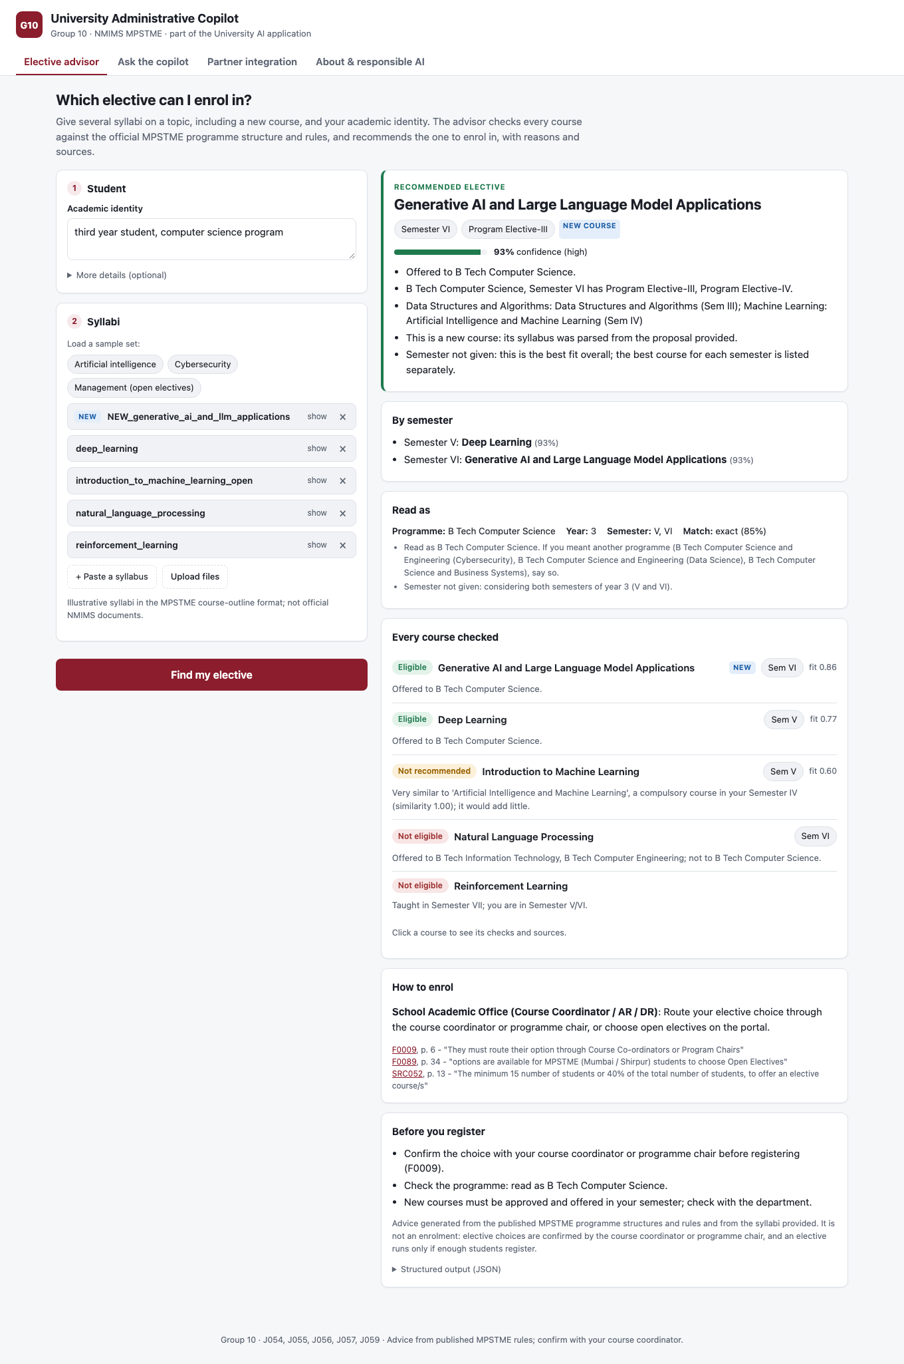
Figure 1. The elective advisor in the web interface (demo input)

2. User interface
A single web page served by the same FastAPI application at /ui/ (no separate build or install). It has four tabs:
- Elective advisor: enter the identity (free text, or programme, year and semester), optional interests and courses taken. Paste or upload syllabi (PDF, Word, text) or load a sample set. The result shows the recommendation with its confidence and reasons, a per-semester pick, how the identity was read, and every course with its checks and sources. It also shows overlapping courses, how to enrol, what the course coordinator should confirm, and the structured JSON.
- Ask the copilot: the Week 6 NLP component (intent, department, entities, grounded answer, decision with confidence).
- Partner integration: fetches syllabi and a student record from the partner services, shows each call (service, URL, latency, live or mock), then the advice.
- About and responsible AI: the architecture and the responsible-AI commitments.
All text from users and syllabi is escaped before it is shown, the layout works on a phone, and the page follows the system's light or dark setting.

3. API integration
Table 2. API used by the interface and by other components
Endpoint | Purpose
POST /v1/electives/advise | identity + syllabi -> eligibility per course, recommendation, citations
POST /v1/electives/parse | one syllabus (text or base64 PDF/DOCX/TXT) -> structured fields
POST /v1/electives/advise-from-partners | syllabi and student record from partner services -> advice
GET /v1/electives/programs, /samples | recognised programmes; demo syllabus sets
POST /v1/analyze, /v1/intent, /v1/entities, /v1/retrieve | Week 6 NLP component
GET /v1/manifest | component card for the application's service registry
GET /partner-mock/syllabi, /partner-mock/students/{id} | stand-in for the partner groups' services

The interface uses only these endpoints, so anything the demo does, another group's application can do too. The advisor reuses the copilot's knowledge base: the 'how to enrol' step comes from the ELECTIVE_SELECTION service (department, next action, verified facts F0009 and F0089). Inputs and outputs are typed pydantic models with JSON Schemas, carry schema_version 1.0, and return errors as {error, detail}.

4. How the advisor decides
The identity is matched to one of the 24 programmes in the official MPSTME programme structures, which we parsed from the Student Resource Book 2026 into 1,474 rows with 191 elective slots. The student is assumed to have completed the compulsory courses of earlier semesters, plus any courses they list. Each syllabus is parsed into its type, the programmes it is offered to, its semester, its prerequisites and its topics. Formal outlines are read by their labels; free-text proposals by prose patterns, with programme and course names recognised against the catalogue. Then seven checks run, each recording which kind of rule it is:
Table 3. Eligibility checks
Check | Condition | Rule type and source
Level | UG courses for UG students, PG for PG | NMIMS rule (SRB p. 14)
Programme | Offered to the student's programme | Syllabus
Semester | Taught in the student's semester | Syllabus
Slot | The programme structure has an elective slot of that type in that semester | NMIMS rule (programme structures)
First year | First-year UG students cannot opt CBCS (open) courses | NMIMS rule (SRB p. 14)
Prerequisites | Each prerequisite matches a completed course (embeddings + word overlap) | Syllabus
Duplicate | Not nearly the same as a compulsory course of the programme | Advisor policy (ours)

Any failed check makes the course not eligible. Missing information makes it needs_review, for the course coordinator to decide. A duplicate makes it not recommended. Eligible courses are ranked by prerequisite fit, novelty and, when given, similarity to the student's interests, and the best course per semester is recommended. Its confidence combines how well the syllabus and the identity were read with the margin over the runner-up.

5. Evaluation
Test data: 15 syllabi in three topics (artificial intelligence, cybersecurity, management), each topic with one new-course proposal in free prose. There are 23 labelled cases, each a student identity with one expected status per syllabus and an expected recommendation. Ten cases (dev) were looked at while the advisor was built. Thirteen (held out) were labelled from the published rules before the advisor was run on them. Syllabi and cases were written by the team; the programme structures and rules are official.
Table 4. Syllabus parsing accuracy (15 syllabi; the variants change the format, not the content)
Syllabi | Type | Programmes | Semester | Prerequisites | All fields
original | 100.0% | 100.0% | 100.0% | 100.0% | 100.0%
lowercased | 100.0% | 100.0% | 100.0% | 100.0% | 100.0%
labels removed reordered | 100.0% | 100.0% | 100.0% | 100.0% | 100.0%

Table 5. Eligibility and recommendation accuracy
Cases | n | Decisions | Status acc. | Can-enrol precision | Can-enrol recall | Recommendation acc. | Identity acc.
Dev, before fixes | 10 | 48 | 100.0% | 100.0% | 100.0% | 100.0% | 100.0%
Dev, final | 10 | 48 | 100.0% | 100.0% | 100.0% | 100.0% | 100.0%
Held out, before fixes | 13 | 65 | 95.4% | 100.0% | 88.9% | 91.7% | 92.3%
Held out, final | 13 | 65 | 98.5% | 100.0% | 100.0% | 100.0% | 100.0%

The first evaluation run found four faults: ordinal semesters ("sixth semester"), an upper-case branch code ("IT student"), "Prerequisites: None" written in prose, and prerequisites marked as failed (instead of unknown) when the programme or semester was missing. All four were fixed, and both runs are reported. The held-out numbers after the fixes are therefore no longer fully unseen.
Table 6. Remaining errors
Case | Remaining errors
H12 | entrepreneurship_open: expected not_recommended, got eligible

The remaining error is a known limitation. Duplicates are detected from course titles only, so "Entrepreneurship and New Venture Creation" is not recognised as overlapping the compulsory "Managing Innovation and Entrepreneurship" (B Tech CSBS, Semester VI).

6. Responsible-AI analysis
Table 7. Responsible-AI analysis
Principle | Risk | Mitigation | Evidence (measured)
Fairness | Advice depends on who the student is rather than what they studied | Only programme, year, semester, courses and optional interests are used | 230 counterfactual variants (name, gender, religion, caste, region, disability): 0 changed (100.0% invariant)
Transparency | A student cannot see why a course was excluded | Every check has a detail, a rule type (NMIMS / syllabus / advisor policy) and a source | 100.0% of 488 checks cite a source; 100.0% of exclusions give a reason
Human oversight | Advice taken as an enrolment | Output is advice; it lists what the course coordinator must confirm and states the 15 / 40% rule | 100.0% of outputs include a human-review step
Reliability | Different wording gives a different answer | Catalogue-aware parsing; abbreviations; prose fallback | Identity rewordings read correctly: 100.0% of 20; reformatted syllabi give the same advice: 100.0% of 46
Knowing its limits | Confident advice on input it does not understand | Unknown programme or missing year: no recommendation, needs_review | 100.0% of unknown-input probes abstain
Privacy | Student data stored or shared | Stateless API; nothing logged or stored; partner contract asks for no names, contacts or grades | By design (no storage code); partner contract in docs/integration.md
Data coverage | Students outside the covered programmes get wrong advice | Catalogue limited to MPSTME 2026; unknown programmes are not guessed | 24 programmes; 7 of 166 programme-semesters have rows missing from PDF extraction
Honesty about data | Sample syllabi taken as official | Sample syllabi are labelled illustrative everywhere they appear | UI, docs, data README

Other risks we considered:
- Steering: ranking by interests could narrow choices. The advisor therefore shows every eligible course, not only the top one, and ranking never overrides eligibility.
- Automation bias: a confident recommendation may not be questioned. The confidence is lowered when the runner-up is close, and the 'did you mean' programme alternatives are shown.
- Out-of-date rules: rules change every year. The catalogue is rebuilt from the current Student Resource Book with one command, and every rule shows its page.
- Advisor policy versus university rule: our duplicate-content policy is labelled as ours, so it is never presented as an NMIMS rule.

7. Integration with the University AI application
front ends (this UI, student portal, other groups' apps)
| HTTP /v1 (typed JSON, schema_version 1.0)
Group 10 Administrative Copilot: elective advisor + NLP component + official knowledge
| consumes (contracts, one setting each) ^ offers
partner syllabus service, partner student records registration, helpdesk, other agents
The component is stateless and runs as one service behind the application's gateway. GET /v1/manifest returns its card for a service registry: what it offers (elective recommendation, syllabus parsing, query understanding, intent, entities, retrieval) and what it consumes (a syllabus feed and a student academic record), with the contract and setting for each.

Interaction with another project's component
POST /v1/electives/advise-from-partners takes the topic's syllabi from a partner syllabus service and the student's programme, year, semester and completed courses from a partner student-record service. It then adds any new course syllabus the user pastes, and runs the advisor. The response lists every partner call. Both contracts are documented (docs/integration.md). A group whose component produces syllabi, for example a curriculum or syllabus-generation component, connects by setting PARTNER_SYLLABUS_URL, or its output for a new course can be pasted into the demo directly. Until the partner's service is available, a mock that implements the same contract answers (in-process, and over HTTP at /partner-mock), and the interface labels these calls 'mock'.

8. Documentation
- docs/elective_advisor.md: how the advisor decides, input/output, rules and sources, confidence, limitations
- docs/integration.md: architecture, what we offer and consume, how to connect a partner
- docs/responsible_ai.md: the responsible-AI analysis with measurements
- docs/nlp_component.md: the Week 6 NLP component
- /docs (OpenAPI): every endpoint and field, generated from the schemas
- data/electives/README.md: what is official and what is illustrative

9. Limitations and next steps
- Only MPSTME (Mumbai) programme structures for 2026 are covered; other schools need their structures added.
- Prerequisites and duplicates are compared by course names, not full syllabus content (Table 6).
- Students with backlogs: the advisor assumes earlier compulsory courses were passed unless the student lists what they completed.
- Seat limits, timetable clashes and whether an elective runs (at least 15 students or 40%) are not known to the advisor; the course coordinator decides them.
- Next: connect the partner group's syllabus service live, and add real NMIMS elective syllabi as they are published.

10. Code
Table 8. Week 7 code
File | Purpose | Lines
src/nlp/electives/catalog.py | Official programme structures -> catalogue of courses and elective slots | 144
src/nlp/electives/syllabus.py | Syllabus parsing (labelled fields and free text) | 314
src/nlp/electives/advisor.py | Identity parsing, eligibility checks, ranking, recommendation | 438
src/nlp/electives/schemas.py | Structured input/output of the advisor | 154
src/nlp/integrations/partners.py | Partner contracts and client | 90
src/nlp/integrations/mock.py | Mock partner services (same contract) | 35
src/backend/api/electives.py | Advisor, partner-flow and manifest endpoints | 106
src/backend/static/ | Web interface (index.html, app.js, styles.css) | 528
src/nlp/pipeline/evaluate_week7.py | Evaluation and responsible-AI measurements | 273
data/electives/ | Demo syllabi (illustrative) and labelled evaluation cases | 515
tests/test_week7.py | Tests | 156

uv sync
uvicorn backend.main:app # UI http://127.0.0.1:8000/ui/ API /docs
python -m nlp.pipeline.evaluate_week7 # evaluation in this report
python -m nlp.reports week7 code # this report + code zip
pytest tests/test_week7.py

