17. Find all the states with a total population less than 10 million.

* db.zipcodes.aggregate( [{ $group: { _id: "$state", totalPop: { $sum: "$pop" } } }, { $match: { totalPop: { $lt: 10*1000*1000 } } }] )

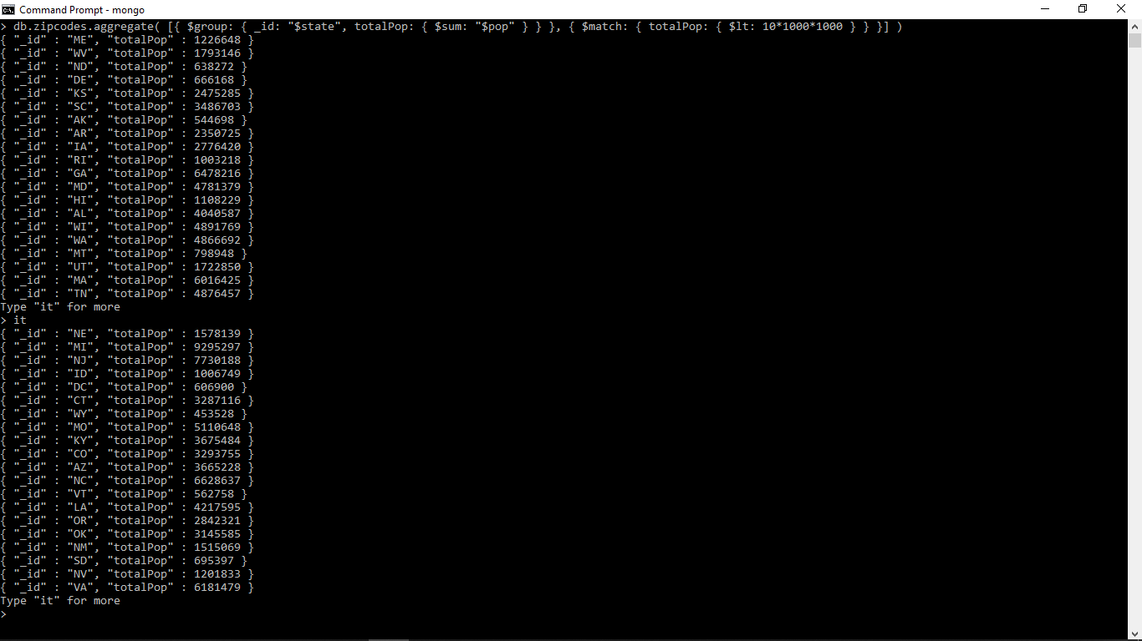

9. List the average population size for each state.

* db.zipcodes.aggregate( [ { $group: { _id: { state: "$state", city: "$city" }, pop: { $sum: "$pop" } } }, { $group: { _id: "$_id.state", avgCityPop: { $avg: "$pop" } } }] )

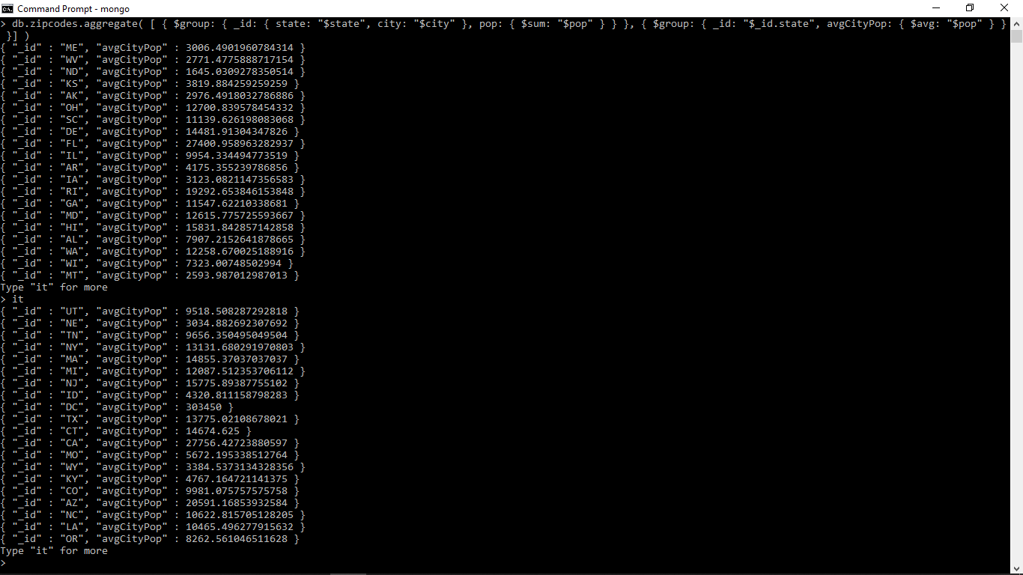

5. List all the distinct states.

* db.zipcodes.distinct(“state”)



7.What is the size of the smallest city(by population) in each state?

* db.zipcodes.aggregate( [ { $group: { _id: { state: "$state", city: "$city" }, pop: { $sum: "$pop" } }}, { $sort: { pop: 1 } }, { $group:{ _id : "$_id.state", smallestCityPop: { $first: "$pop" } } }])

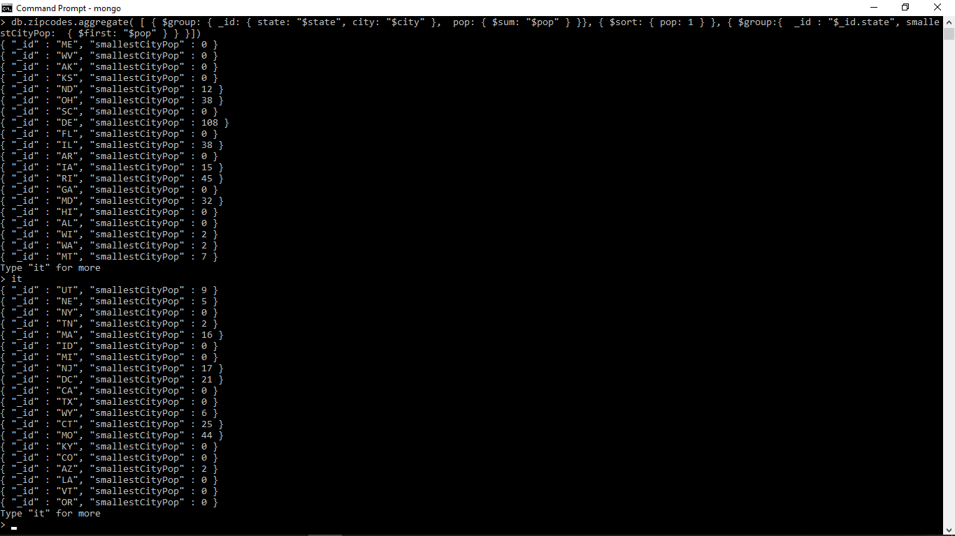

8. What is the name of the smallest city(by population) in each state? Use the reduce function of a group command to find the smallest population.

* db.zipcodes.aggregate( [ { $group: { _id: { state: "$state", city: "$city" }, pop: { $sum: "$pop" } }}, { $sort: { pop: 1 } }, { $group:{ _id : "$_id.state", smallestCity: { $first: "$_id.city" }, smallestPop: { $first: "$pop" } } }])

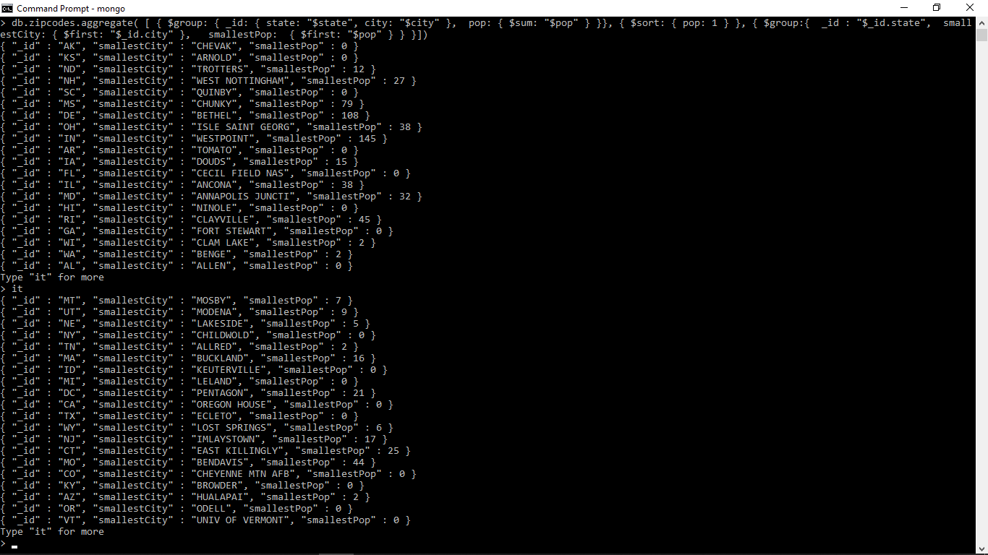

10. How many cities does state WA have?

* db.zipcodes.distinct(“city”,{“state”:”WA”}).length



1. What is the population of FISHERS ISLAND?

* db.zipcodes.distinct(“pop”,{“city”:”FISHERS ISLAND”})



2. List all the cities in the state “MA”.

* db.zipcodes.distinct(“city”, {“state”:”MA”})



16. How many different postcodes are there in the NY state?

* db.zipcodes.distinct(“_id”,{“state”:”NY”}).length



For this I figured if we counted all the distinct postcodes(zipcodes being the id) in NY(May have duplicates because people living in the same house), we would get the total amount of different postcodes for NY.

4. List all the cities in the state “MA” with a population less than 100.

* db.zipcodes.distinct(“city”, {“state”:”MA”},{“pop”:{$lt:10*10}})

