**Question 1**

<https://app.creately.com/diagram/yBL7tHeZU0V/view>

**Question 2**

1. All Create Table Queries

3. All Insert Queries

**Question 3**

1. select code, bname

from bank

where code in (select bcode from branch group by bcode having count(bcode) > 3);

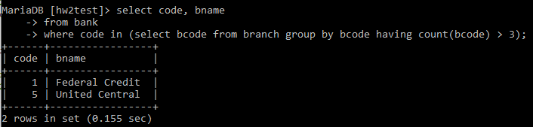

2. select name

from person

where name like '%s';

3. select count(*) as total_customer

from customer;

4. select name, pcust_id

from person

where pcust_id in (select lcust_id from loan group by lcust_id having lcust_id > 19)

and not pcust_id in (select cust_id from owns );

5. select address, branchNo

from branch

where branchNo in (1,2)

order by branchNo desc;

6. (select name

from person

where pcust_id in(select cust_id from owns where acct_no in(select acct_no from saving where rate > 2)))

union

(select cname

from company

where ccust_id in (select cust_id from owns where acct_no in(select acct_no from saving where rate > 2)));

7. select name

from person

where pcust_id in (select cust_id from owns where acct_no in (select acct_no from saving where balance > 10000));

8. select cname, ccust_id

from company

where ccust_id in (select cust_id from owns where cust_id = 10);

9. select name, pcust_id

from person

where pcust_id in(select lcust_id from loan);

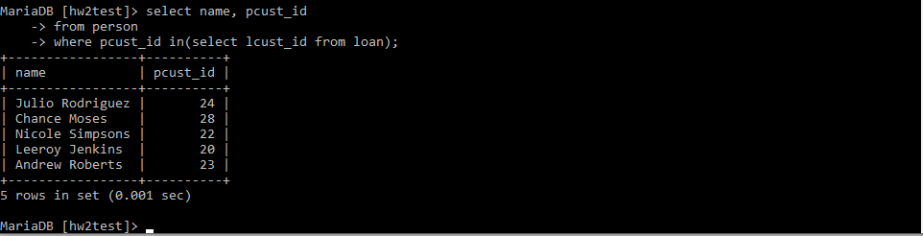

10. select avg(balance)

from saving

where acct_no in (select acct_no from owns where cust_id in (select pcust_id from person));

11. (select cname as maxMFeeCustomer

from company

where ccust_id in(select cust_id from owns where acct_no in(select acct_no from checking where mfee = (select max(mfee) from checking) group by acct_no)))

UNION

(select acct_no

from checking

where mfee = (select max(mfee) from checking) group by acct_no);

* **EXPLANATIONS FOR CODE WILL BE INCLUDED IN THE COMMENT SECTION OF THE QUERY SQL FILE -**