Project Report

Reporter:

Jubyer Ahmed Shezan (Full Stack Developer)

Email: jashezan@gmail.com

# Requested Features:

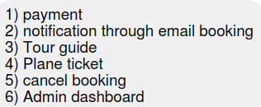

## Features added:

### 1. Payment:

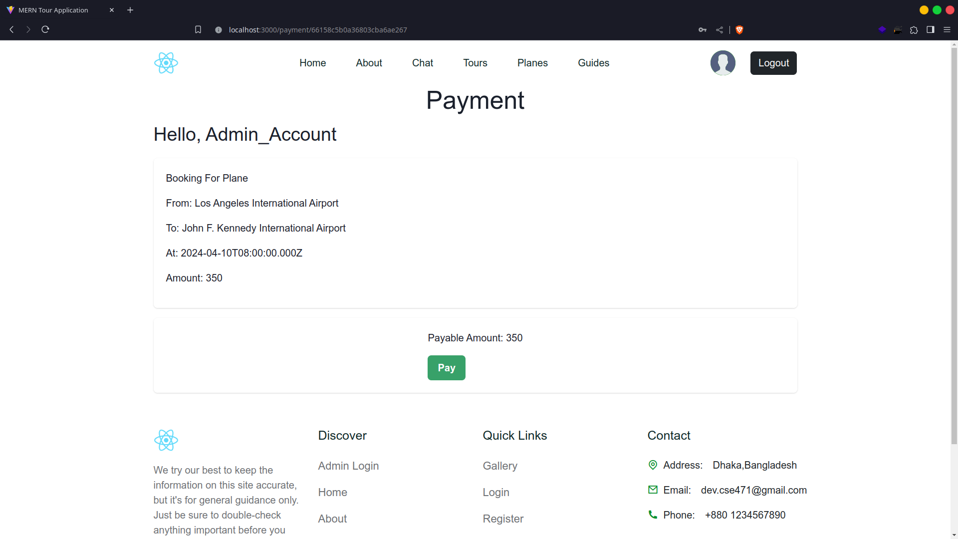

### 2. Notification Through Email:

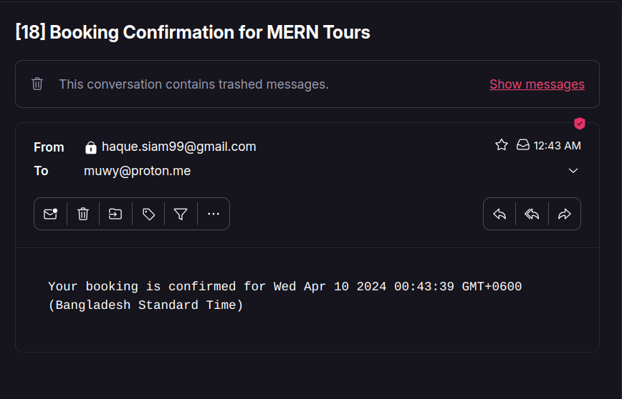

### 3. Tour Guide:

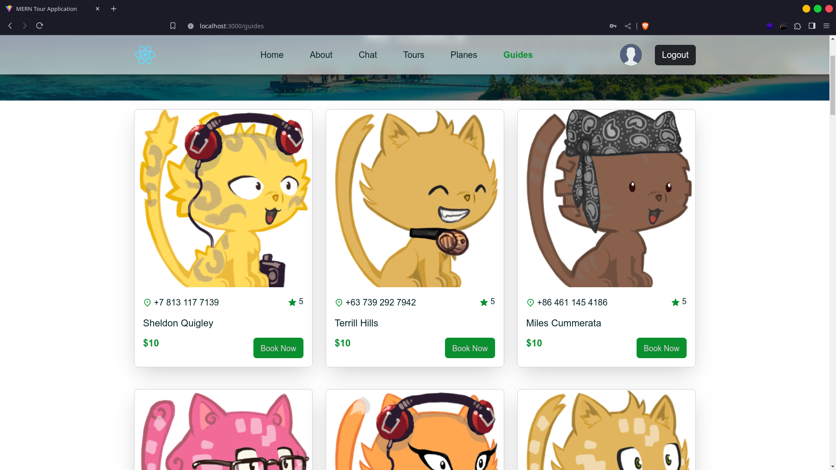

### 4. Plane Ticket

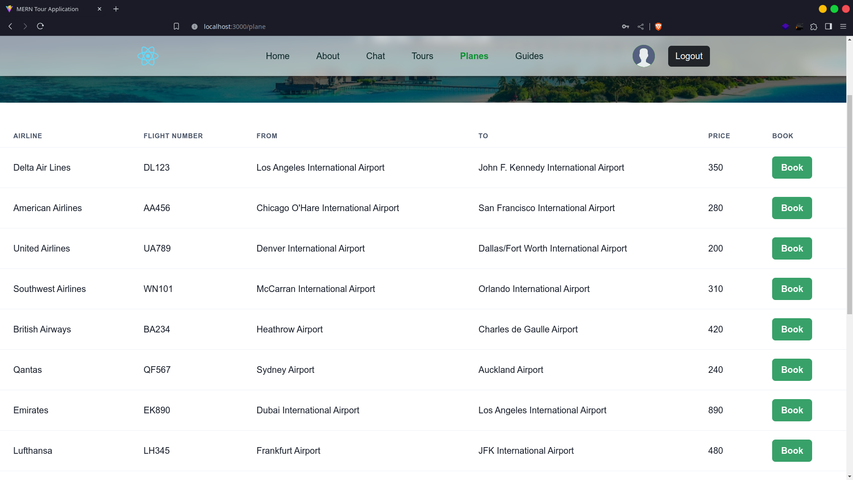

### 5. Cancel Booking

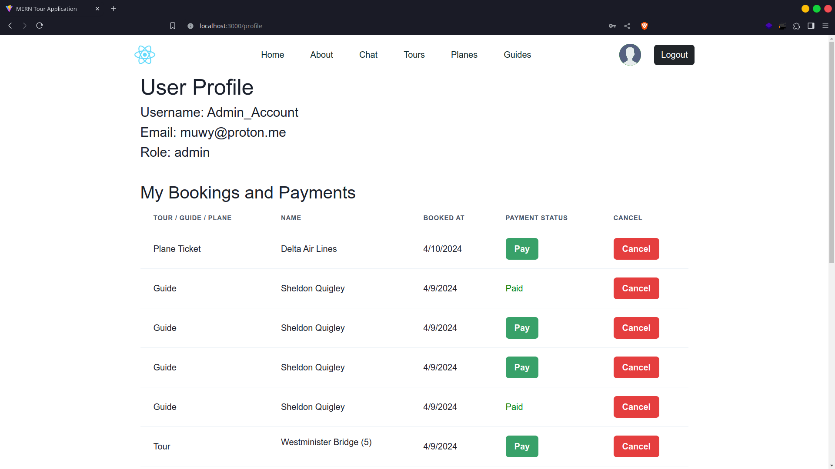

### 6. Admin DashBoard:

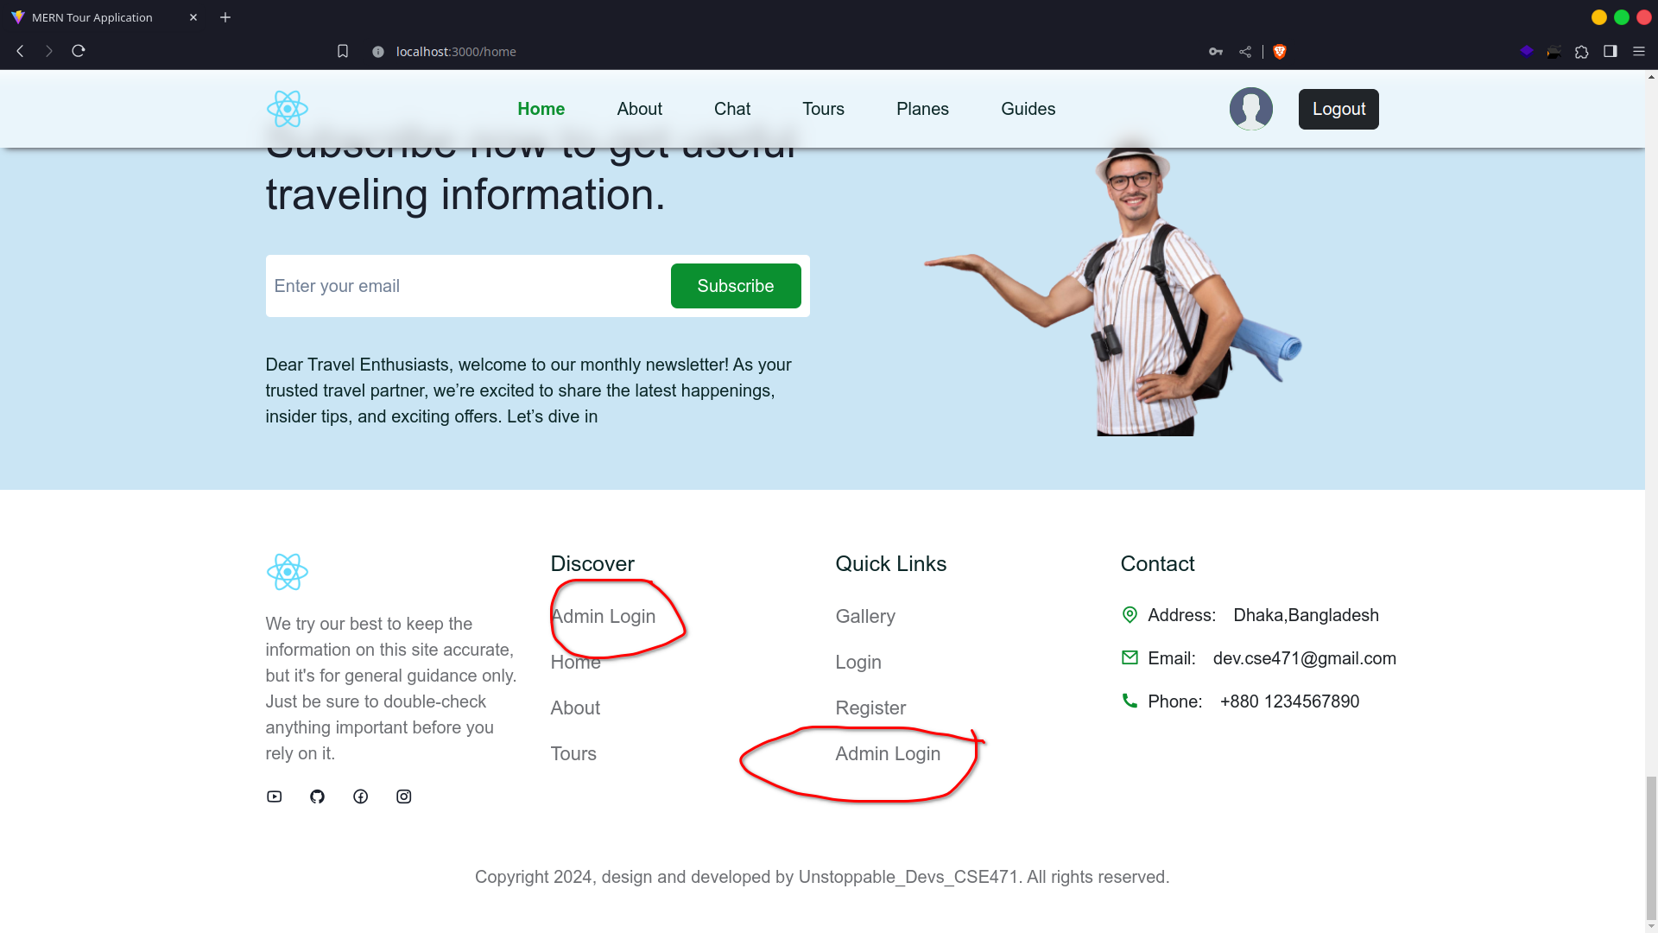

#### Login Page:

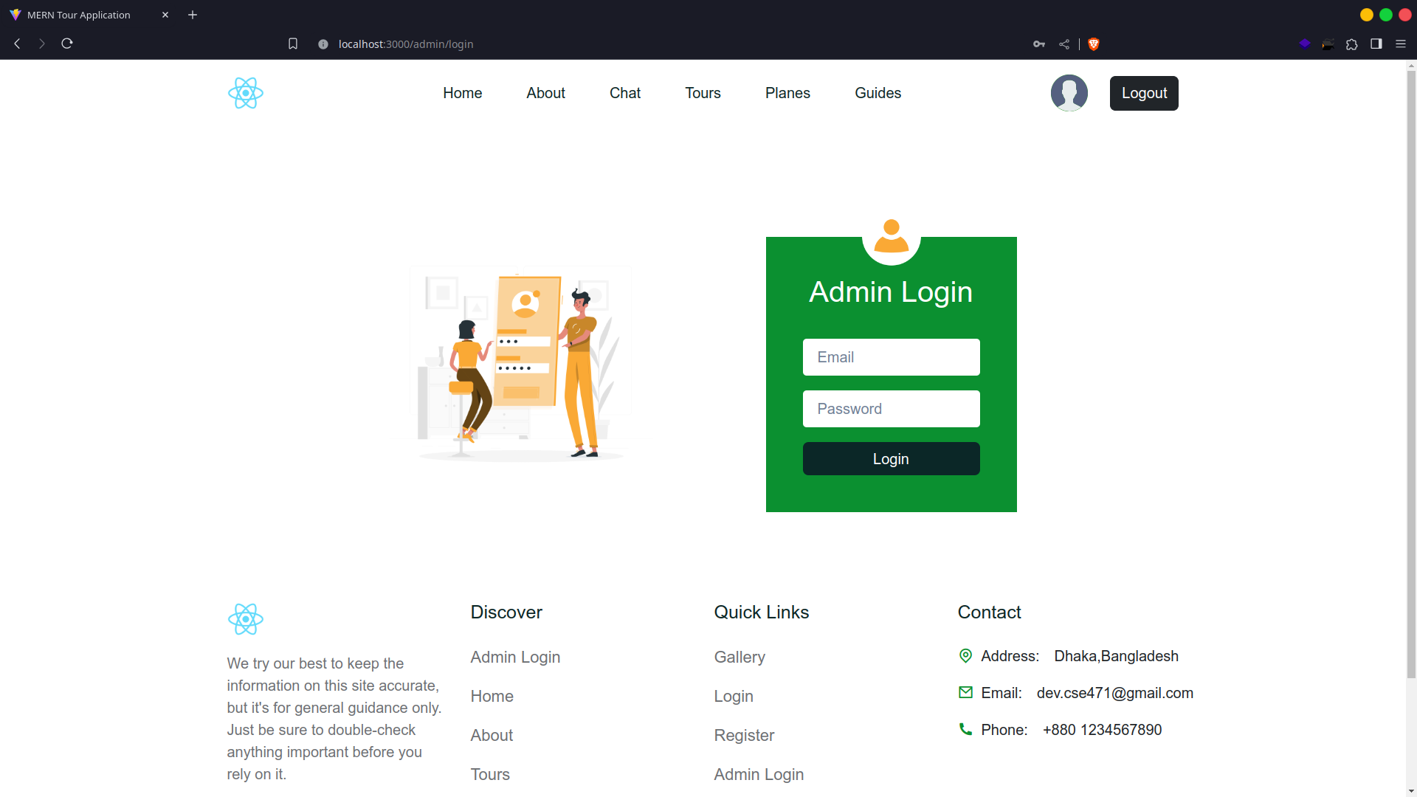

#### Booking Page

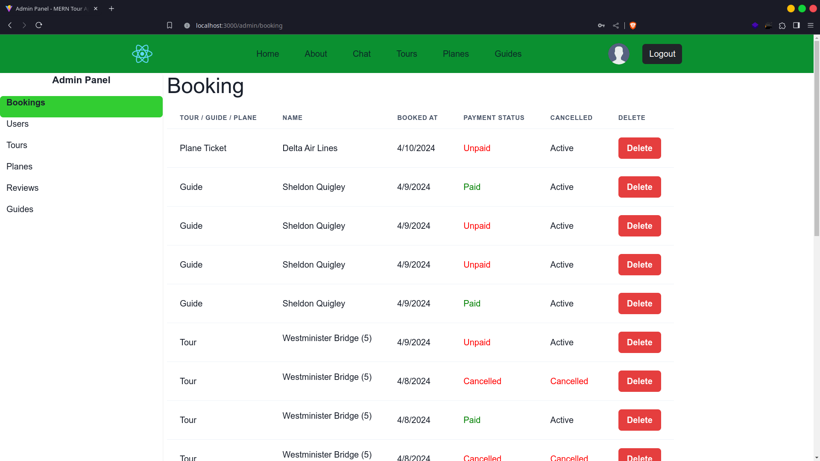

#### User Page

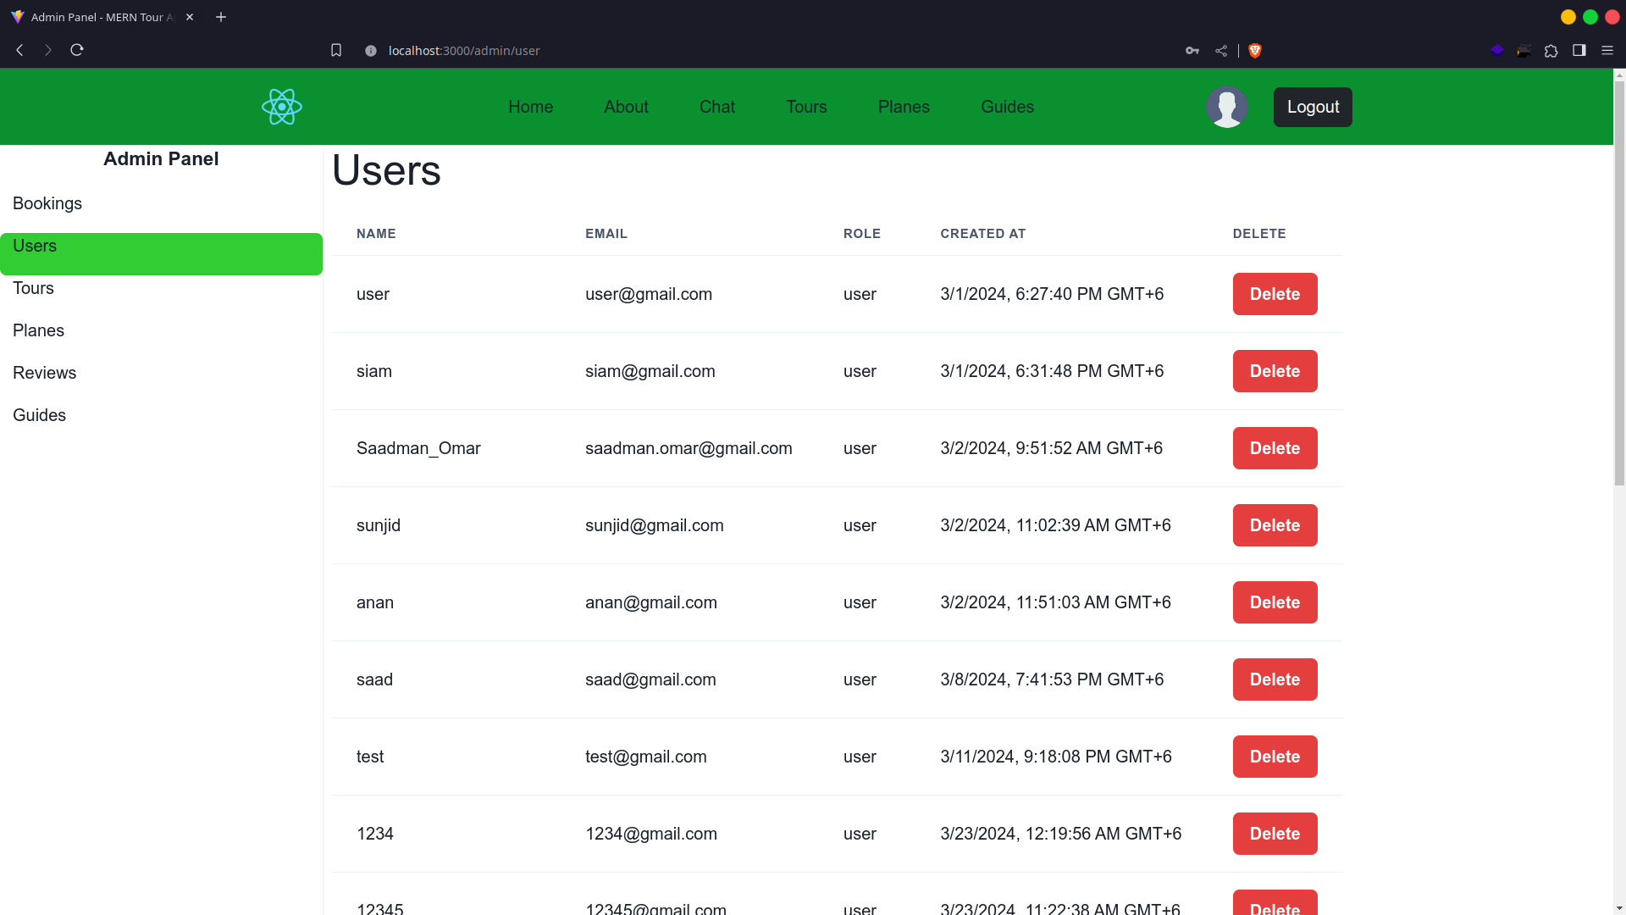

#### Tour (Places) Page

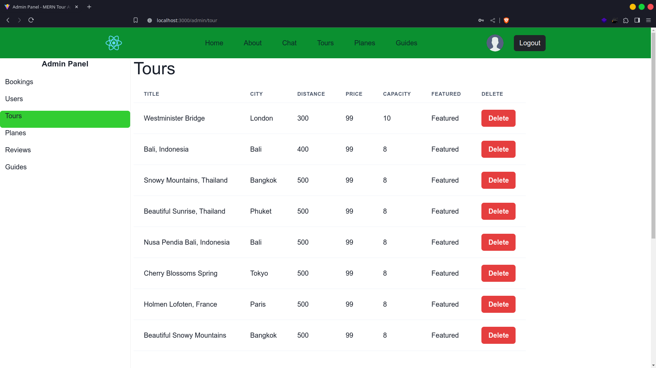

#### Plane Ticket Page

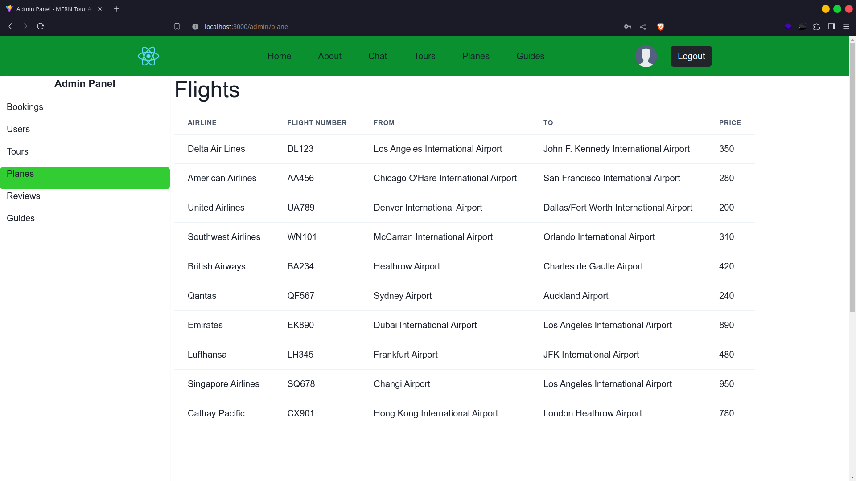

#### Review Page

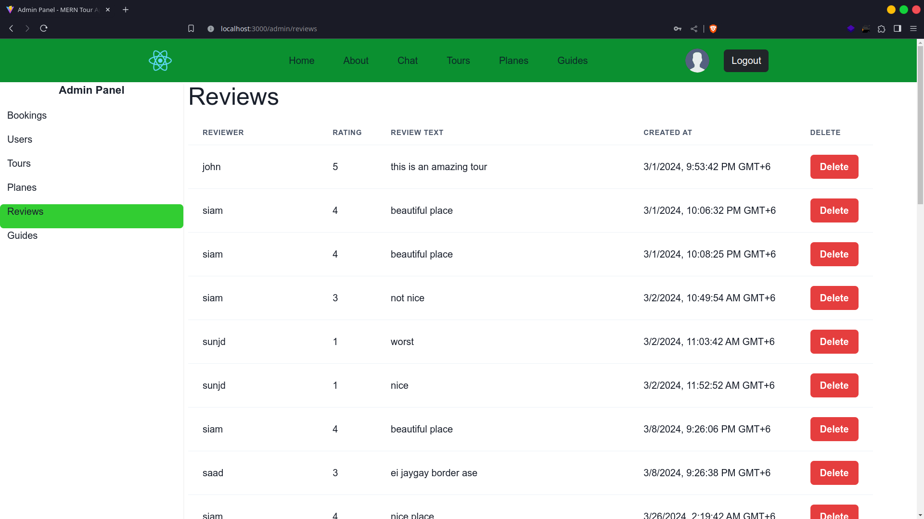

#### Tour Guide Page

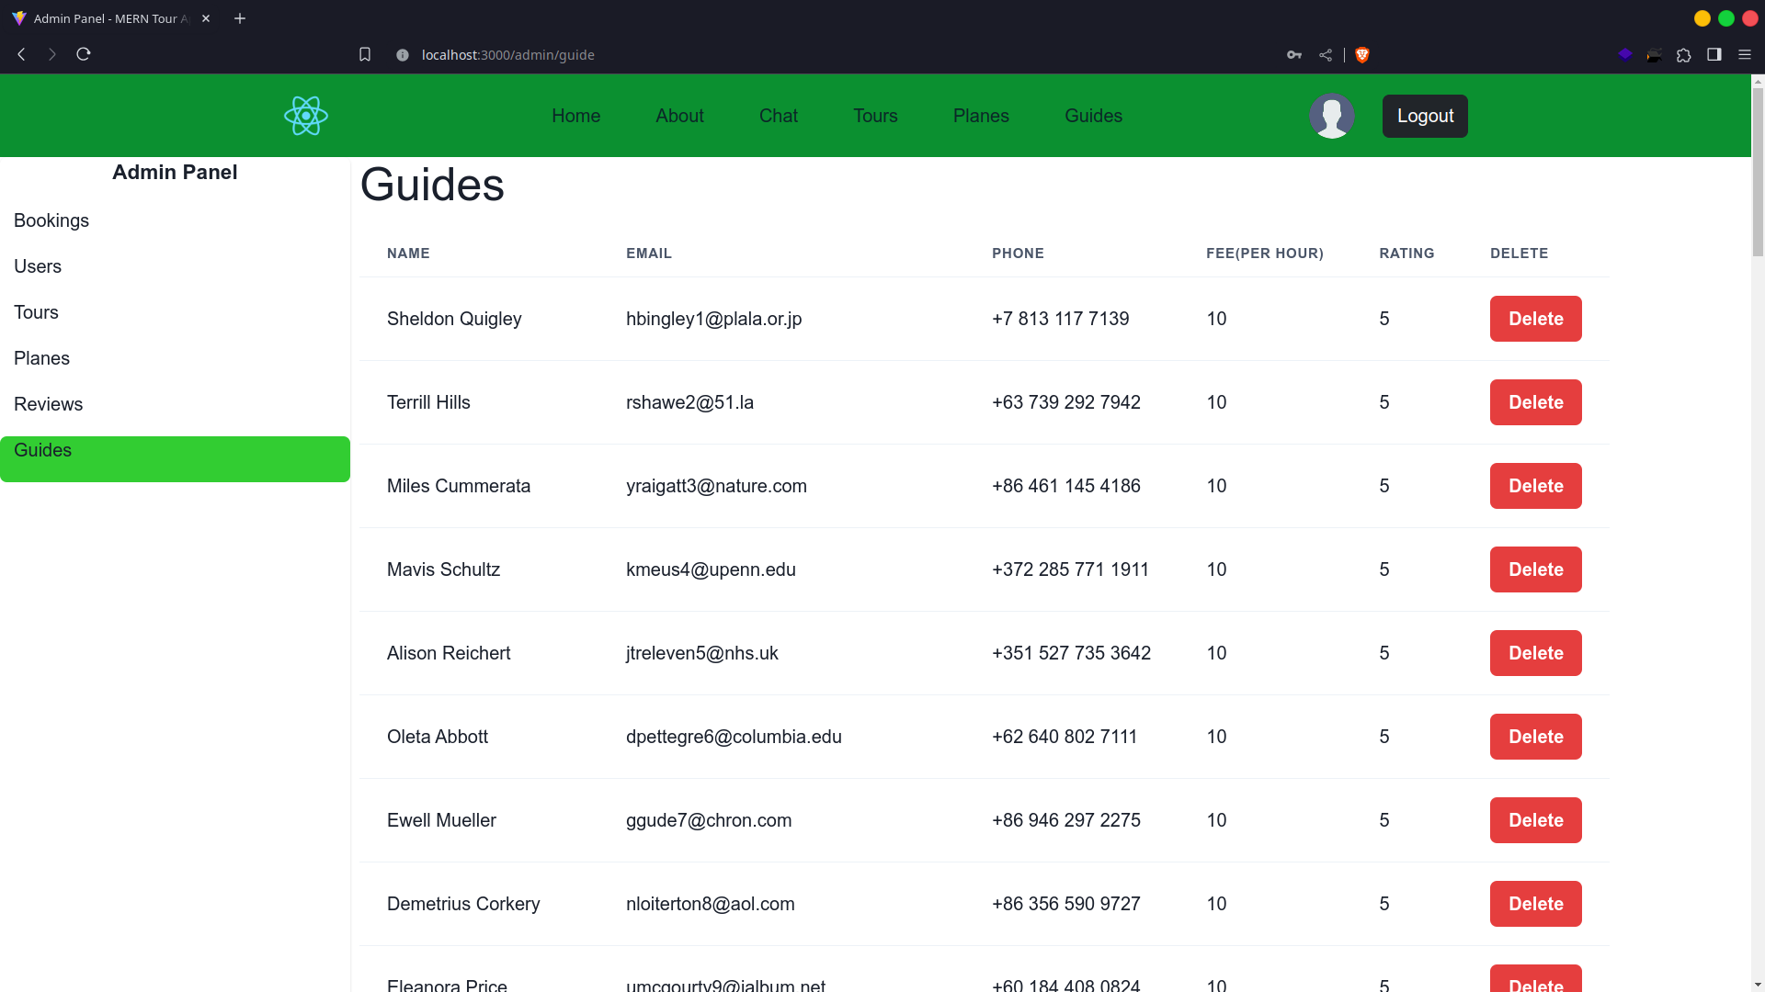

## Extra Features Added

### Instant on site notifier

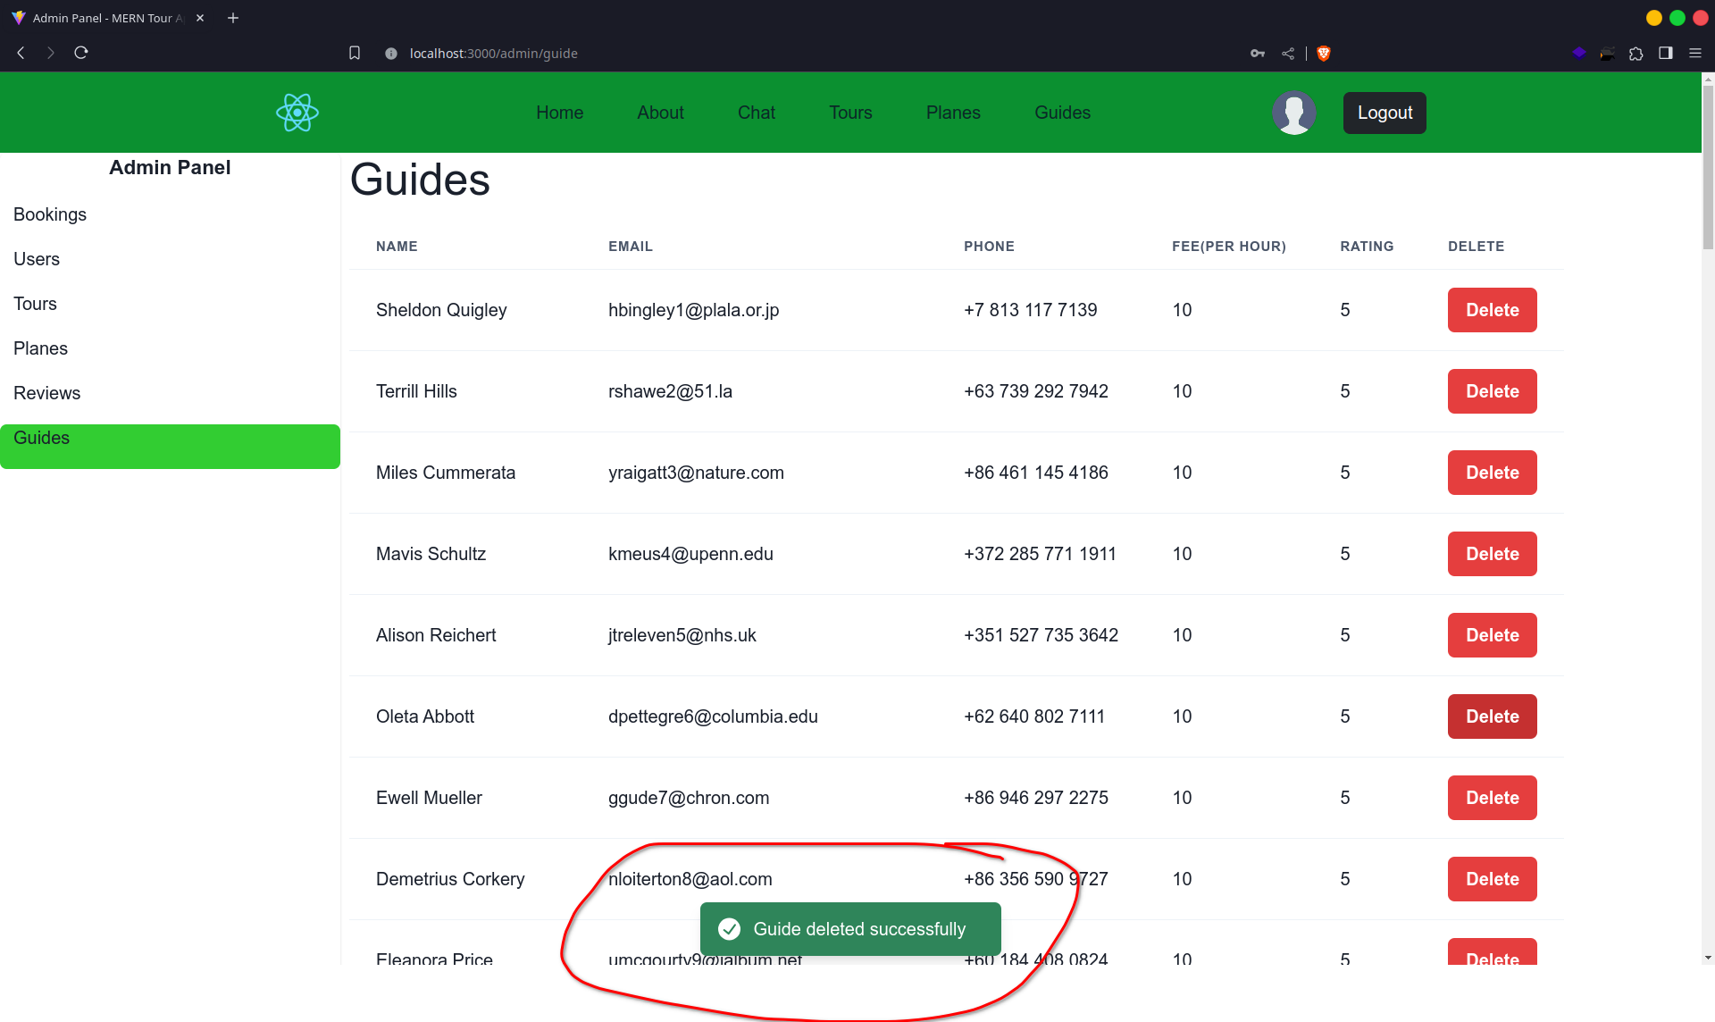

- Visible Bug Fixed (including styles)

- Internal Bug Fixed

- Backend Functionalities

- Added Accessibility

- Moved Frontend Tool for better performance (Create React App → Vite)