Frogger Game using WebGL

By Jash Gopani

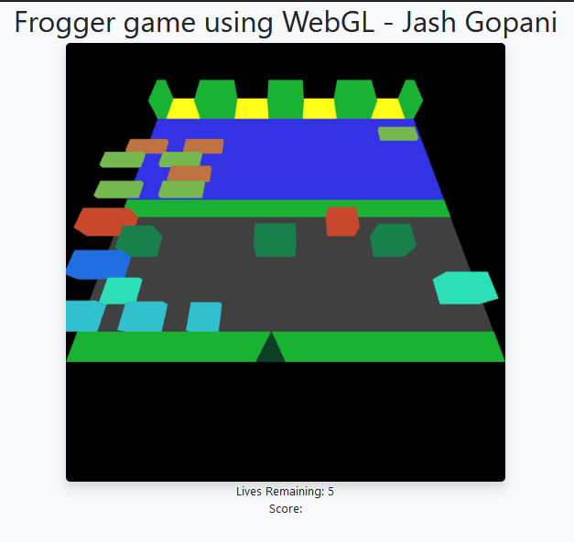

Description:

This is how the game looks to a player. The triangle is our tiny little frog and the very first stage of obstacles is on the grey road. The cuboids are vehicles and the frog has to safetly cross the road to first reach the grass layer from which it could jump over the brown wooden logs or green turtles to swim through the river and reach the safe zones.

For the make it your own part, I choose to go with a volcano theme where the roads and rivers are just lava and magma flowing with the woods and turtles having the ability to swim through the lava!!!

I have implemented all the parts mentioned in the assignment 1-6 .

In the below picture you can see how my volcano theme looks like 😊

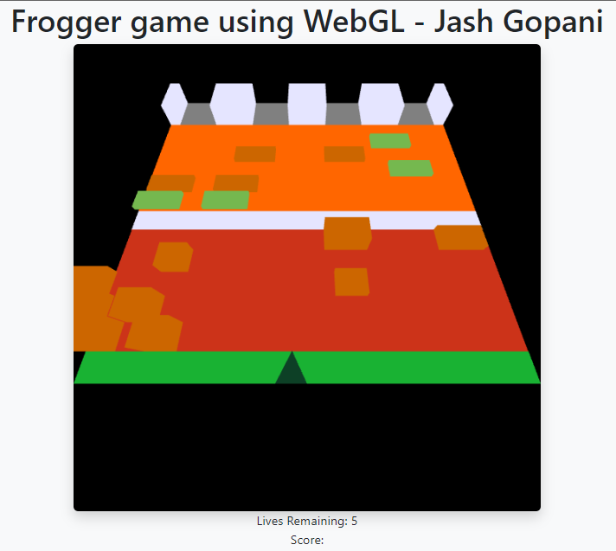

To run the program,

You’d probably need some kind of live server as the game uses local audio files. I use the live server extension in VS code during my development. Just turn that on and open the server url.