MySQL Task - 1

Jash Patel

**Q. Create MySQL Database of your choice which include 4-5 tables**

Schema:

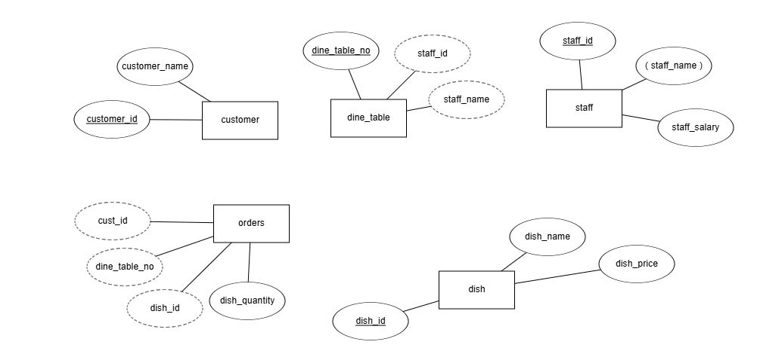

CREATE DATABASE Restaurant;

USE Restaurant;

CREATE TABLE customer (

cust_id int,

cust_name varchar(20)

);

CREATE TABLE dine_table(

dine_table_no int,

staff_id int

);

CREATE TABLE staff (

staff_id int,

staff_name varchar(20)

);

CREATE TABLE dish (

dish_id int,

dish_name varchar(20),

dish_price int

);

CREATE TABLE orders (

cust_id int,

dine_table_no int,

dish_id int,

dish_quantity int

);

**Q. Add primary key and foreign key constrains.**

ALTER TABLE customer

ADD PRIMARY KEY (cust_id);

ALTER TABLE dine_table

ADD PRIMARY KEY (dine_table_no);

ALTER TABLE dish

ADD PRIMARY KEY (dish_id);

ALTER TABLE orders

ADD FOREIGN KEY (customer_id) REFERENCES customer (customer_id);

ALTER TABLE orders

ADD FOREIGN KEY (dine_table_no) REFERENCES dine_table (dine_table_no);

ALTER TABLE orders

ADD FOREIGN KEY (dish_id) REFERENCES dish (dish_id);

**Q. Add composite primary key to any one of your table**

ALTER TABLE staff

ADD PRIMARY KEY (staff_id, staff_name);

**Foreign key referencing composite primary key:**

ALTER TABLE dine_table

ADD COLUMN

staff_name varchar(20);

ALTER TABLE dine_table

ADD FOREIGN KEY (staff_id, staff_name) REFERENCES staff (staff_id, staff_name);

**Q. Write a query to change the column name, data types.**

ALTER TABLE customer

CHANGE

cust_id customer_id int;

ALTER TABLE customer

CHANGE

cust_name customer_name varchar(20);

ALTER TABLE orders

CHANGE cust_id customer_id int;

**Q. Write a query to add a default value to specific column**

ALTER TABLE orders

ALTER dish_quantity SET DEFAULT 1;

**Q. Add indexes. Also add index on a column having datatype as varchar**

CREATE INDEX customer_index

ON customer (customer_id, customer_name);

**Q. Insert some data to the tables created via query**

INSERT INTO dish

VALUES

(1, "Dish Category One", "Dish One", 150),

(2, "Dish Category Two", "Dish two", 200),

(3, "Dish Category Three", "Dish three", 250),

(4, "Dish Category Four", "Dish Four", 250);

INSERT INTO customer

VALUES

(1, "Jash"),

(2, "Raj"),

(3, "Rahul");

**Q. Add unique constrains on single as well as multiple columns**

ALTER TABLE dish

ADD UNIQUE (dish_category, dish_name);

**Q. Try to insert multiple records at a time along with the duplicate values for the columns having unique constrains without any error prompt**

INSERT IGNORE INTO dish

VALUES

(3, "Dish Three", 210),

(4, "Dish Four", 210),

(5, "Dish Four", 240); // ignored this record

This command ignored the record which had a duplicate value.

INSERT INTO dish

VALUES

(5, "Dish Category Four", "Dish Four", 250),

(6, "Dish Category Six", "Dish Five", 350)

ON DUPLICATE KEY UPDATE dish_category = "Dish Category Five", dish_name = "Dish Five";