Task-1

Jash Patel

Repository link: https://github.com/jashhpatel/training

Q. BE: **Create a local maven project in java to calculate the Area of a Triangle. [Explore what maven project is]**

Creating a maven project adds a project object model pom.xml file in our project directory which allows us to add dependencies instantly.

We can easily add dependency by using <dependency> tag inside pom.xml

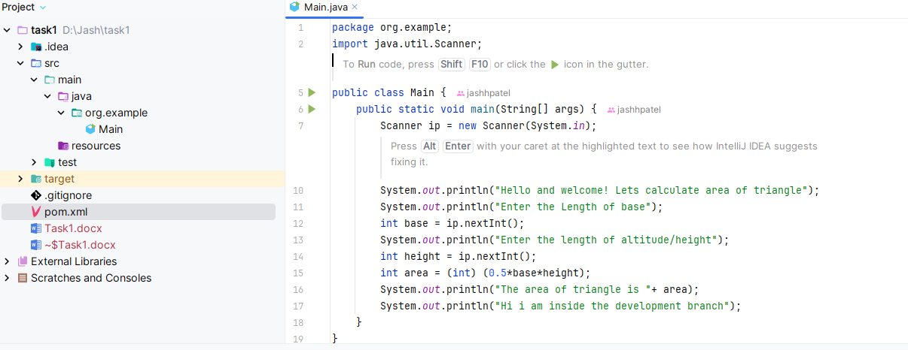

**Q. Create a repository on GitHub with two branches named *master* and *development* branch.**

Ans. created a repository on GitHub called training.

Created branches master and development using the following query:

**git branch master  
git branch development**

**Q. Deploy your code in both the branches**

Ans. Before deploying the code, I commit the changes using:

**git add .**

**git commit –m “added area program”**

next I add the remote using:

**git remote add origin https://github.com/jashhpatel/training.git**

then i push the code to branches using:

**git push origin master**

**git push origin development**

**Q. Make Some changes in development branch and push the code**

Ans. To make changes in development branch, first I switch into development branch using:

**Git checkout development**

Next, I make some changes to the code and push it using:

**Git push origin development**

**Q. Make Some changes in master branch and push the code**

Ans. To make changes in master branch, I switch into master branch using:

**Git checkout master**

Next, I make some changes to the code and push it using:

**Git push origin master**

**Q. Merge development branch with master branch**

Ans. To merge development into master,

First I switch into master branch using:

**Git checkout master**

Then I merge development into master using:

**Git merge development**

**Q. Try clonning your team mates repo and push some code.**

Ans. I cloned a github repo using:

**git clone https://github.com/astonizer/pos.git**

this command downloaded a copy of that github repo into my local folder

**Q. Explore other github commands shared in the docs and practice on the same**

Ans.

I used other github commands like:

**Git reset –hard [commit hash]:** This command reverts back the commit history to the specified commit hash as well as all the changes made to the code.

**Git pull origin master**: This command fetches any changes or updates in the code to the specified branch

**Git push –f** : this command is used when we have to push changes which has less files/lines than the origin branch.

**Git stash**: this command temporarily stores the changes which are not commited to a temp storage in a stack data structure.

**Git stash pop**: this command brings back the stashed changes in a Last in First out (LIFO) sequence.

Q. there are three commits done on branch development

Development:

Commit 1

Commit 2

Commit 3

Using git command, only fetch the changes of commit 2, without fetching commit 1 and commit 3.

Ans.

First I created three separate files and made a separate commit after creating each file

Next I switched to master branch. Using git checkout master

Then I fetch the changes of only the commit-2 using the command:

**git cherry-pick [hash of commit-2]**

this only fetched file-2 of the second commit into the master branch