Owner

Introduction
The Online Airline Booking System, or OABS for short, is designed to be an all in one solution for an airline wishing to speed up and save money compared to a traditional booking system. It consists simply of a server-side web application combined powerful backend database to provide the user with a highly accessible system.

This user manual is the first of two, this manual, the owner manual, describes how to install the system on a computer and how to use it from the airliner’s point of view. The second manual describes how to use the customer/travel consultant’s point of view

Minimum Requirements
The major advantage of OABS is that it is operating system independent and can work well on almost any computer. However it does require at a bare minimum: -
- 486 or above processor (1Ghz Pentium 3 recommended)
- 8Mb RAM (512Mb RAM recommended)
- 5Mb free hard disk space (more for decent caching)
- A web server with CGI support
- PHP version 3(?) - 4+
- MySQL 3+

Installation
Note: This installation guide assumes that all the components above are working and are fully configured.
- Unpack the zip file and place all the files into a directory that the web server can access.
- Open up the file database.php in the connections folder with a text editor and fill in the username, database name, password and table names etc.
- Point any browser to the install.php script and follow it through.
- Delete install.php and upgrade.php.

Upgrade from v1.5
Note: This installation guide assumes that all the components above are working and are fully configured.
- Delete the existing files for version 1.5 but leave the database alone.
- Unpack the zip file and place all the files into a directory that the web server can access.
- Open up the file database.php in the connections folder with a text editor and fill in the username, database name, password and table names etc.
- Run the upgrade.php script from a web browser
- Delete install.php and upgrade.php.

Configuration
All of the configuration is carried out on the admin pages that can be accessed by clicking on admin on the navigation bar to the left of any OABS page. To prevent any unauthorised changes to the configuration it is password protected. Once entering the password on a computer you will not need to re-enter it for another hour. You must have cookies enabled to use the admin area.

Configuration – Offers
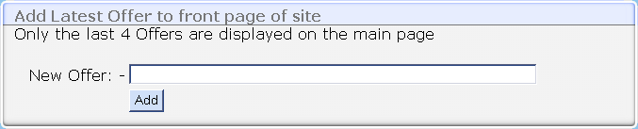
The offers are displayed on the main page of the site and can be used to display anything you require including the use of html coding to insert pictures, marquees etc. By default the main page only displays the last 4 offers added. To add an offer simply type the offer into the text box and click add. You can change the number of offers displayed on the main page by altering the option for this in the database.php file

Configuration – Add/Delete/View Flights
The naming convention for the various fields is as follows: -
Passb – the number of business class seats
Passf - the number of first class seats
Passe - the number of economy seats
Cost – cost of the entire flight (the system will work out if the flight will make a profit from this field)
Priceb - price of a business seat
Pricef – price of a first class seat
Pricee – price of an economy seat
Senior – the discount a senior will get off of a seat
Child – the price a child will get off of a seat

Add: - To add a new flight simply click on the add button in this section, a new page will then load containing a new form. Fill this with information of the flight. It is recommended that you leave the number field empty and let the system generate a number for it. For the datetime entry it should follow the following convention YYYYMMDDHHMMSS. Failure to do so will result in it resetting the value of this field to the current time. When finished, clicking save will return to the main page and save the flight, clicking more will add the flight and open a new form.

Delete: - You can delete a flight by clicking the scissors next to the entry.

View: - If there are too many flights the system will split the list into many pages. You can navigate these pages by clicking back and next.

Sort: - You can sort the list of flights by clicking the appropriate header.

Configuration – Customer Maintenance
The customer maintenance is similar to the flight system as explained above; the only difference is that you cannot add new customers because this is meant to happen through the booking section otherwise a plane could be overbooked unintentionally.

Configuration – Advertisement
You can add/view details for advertisements to be randomly displayed on OABS by clicking to enter advert administration. Here it displays the current adverts in the database, what they look like, where they link to, who bought it and how many impressions (views) it has before being deleted and when this happens the owner will be notified by email.

Alternate Configuration
Almost anything else can be changed about OABS, from the layout to the footer (which is located in footer.php). However it is only recommended for those with previous experience in PHP and HTML. Help is available from the developer but bigger tasks will require payment.

User

Introduction
OABS is designed so that the booking process is made a lot more efficient and as error free as possible. This guide demonstrates how to use the system and its functions.

Requirements
To use the system you will need a computer capable of running a graphical web browser. This can be a computer with any specification of above: -
- 386SX
- 4mb of RAM
- 20mb of disk space
- Mouse, keyboard, etc.
- A network connection to the network where OABS is

OABS Layout
Firstly, on reaching the main page of OABS you will notice that on the left there is the navigation bar, this bar appears on every page of the OABS. On the right is the main content of the page, this varies depending on what page you visit.

Booking a flight
To book a flight simply click on ‘booking’ in the navigation bar. On the resulting page is a list of flights that are available for booking at this time.
- Choose the flight you desire from the list and click on it to open the next page.
- 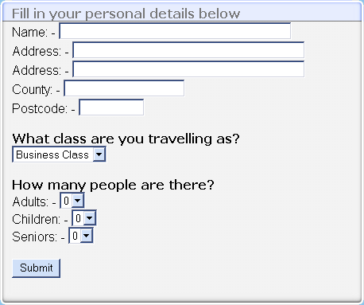On this page a form should appear like the one situated on the left. Fill it in using your personal details and select the type and number of seats you require. Once you have done this click on submit to continue.
- If the flight hasn’t got enough seats or you fail to correctly enter the form then it will return to the form and state why. Otherwise you will be sent to the confirmation page. Please check the information very carefully because after this there is way of editing your personal information.
- If you are sure it is correct then click confirm to book the seats. If all is well then the confirmation page will appear.

Flight Details
The flight details section can be used to find out information about when a flight will depart and the prices of seats etc. Clicking ‘flight details’ on the navigation bar to the left will bring it up and then clicking the flight you want more information on. This brings up a page with details of the flight. Similar to the picture below: -
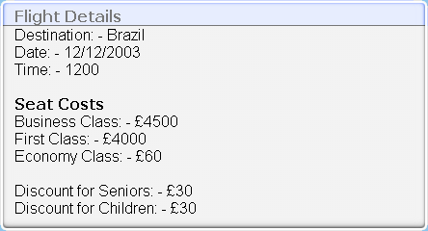

Help
Clicking help on the navigation bar leads to this page.

Additional Help
If you would like any additional help about the system, have noticed a mistake in a flight or any other error please contact the airline as they may have customised the system.

