12/2/2016

**Group 5**

**CHETAN POKALE**

**jASH mEHTA**

**aBHINAV DEWAN**

**rICHA malhotra**

IST 722: Project Design

Contents

Overview 2

Project Scope/Mission 2

Team Members & Roles 2

Key Stakeholders 2

**Analysis** 3

Business Processes 3

Bus Matrix: 4

Bubble Chart 4

Attribute List 5

**Design** 7

High Level Dimension Model 7

Detailed Level Dimension Model 7

Dimensional Hierarchies 7

Snowflake Schema 8

ETL Specifications 9

# 

# Overview

## Project Scope/Mission

The scope of this project is to create a data warehouse for an ecommerce website (nopCommerce), perform business intelligence to do data analysis, visualizations and provide insights/recommendations using user-friendly dashboards.

## Team Members & Roles

|  |  |  |  |
| --- | --- | --- | --- |
| Role | Description | Assigned to | Phase |
| Business Lead | In Charge of Initiative | Chetan Pokale | 1 |
| Project Manager | Manages Project | Jash Mehta | 1 |
| Business Analyst | Collects Requirements | Abhinav Dewan | 1 |
| Data Architect | Dimensional Modeling / Implementation | Richa Malhotra | 2 |
| ETL Architect | ETL Design/ Implementation | Chetan Pokale, Jash Mehta, Abhinav Dewan, Richa Malhotra | 2 |
| BI Architect | BI Design / Implementation | Chetan Pokale, Jash Mehta, Abhinav Dewan, Richa Malhotra | 2 |

## Key Stakeholders

**Internal**

* Business Lead
* Project Manager
* Business Analyst
* Data Architect
* ETL Architect
* BI Architect

**External**

* Customers
* Manufacturers/Suppliers
* Competitors

# **Analysis**

## Business Processes

The nopCommerce (Group 5) offers a selection of various product categories; they include desktops, notebooks, software, cameras, cell phones, other electronics, shoes, clothing, other apparel, digital downloads for music, books, jewelry and gift cards. For each category, the store provides around 15 products. The store experiences global sales; customers shop from countries such as Austria, India, United States, France and Germany. Customers also have the ability to leave ratings and reviews for products they purchase. Finally, the store offers various discounts/promotions. For example, there was a “Cyber Monday” discount code during spring break. The following are the business processes:

**Order Placement**

1. Facts: OrderTotal, OrderDiscount, QuantityOrdered
2. Dimensions: Customer, Product, Order Date, Order ID, Store
3. Data source for fact table: Customer, Product, Store
4. Business questions answered:

* Most frequent customers
* Top most ordered product per customer
* Impact of product discount on order placement
* Busiest time period for order placement

**Product Review Analysis**

1. Facts: Rating, ReviewApprovedCount, HelpfulYesCount, HelpfulNoCount, CustomerRatingCount
2. Dimensions: Customer, Product, Review
3. Data source for fact table: Customer table, Product table, ProductReview table
4. Business questions:

* Products which have most number of reviews
* Top rated products of nopCommerce using weighted rating formula as below:

Weighted rating (WR): (v÷(v+m))×R+(m÷(v+m))×C where:

* R = average for the product (mean) = (Rating)
* v = number of votes for the products = (votes)
* m = minimum reviews required to be listed in the Top 5
* C = the mean vote of all the products across the warehouse

## Bus Matrix

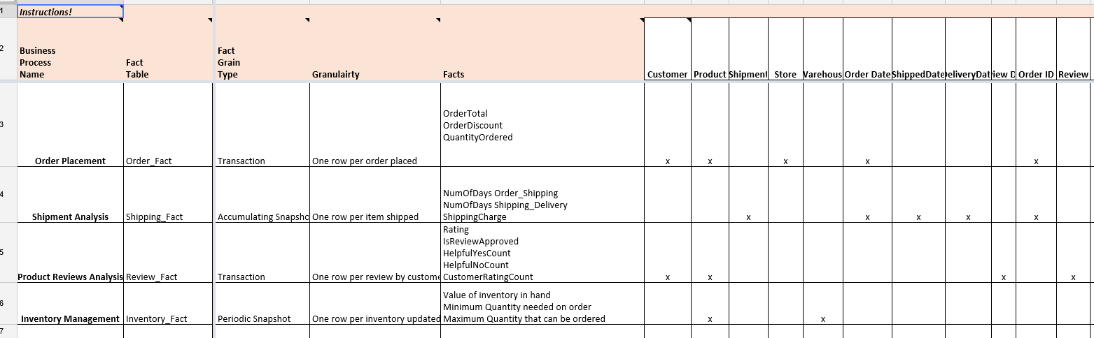

## Bubble Chart

**Order**

Order

Product Rating

Product Category

**Review**

Review

Product Rating

Product Category

## Attribute List

**Dim Product**

|  |  |  |
| --- | --- | --- |
|  |  |  |

**Dim Store**

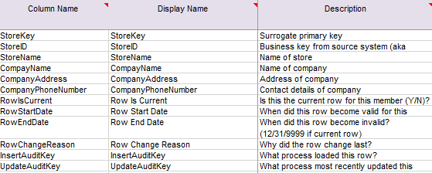

**Dim Customers**

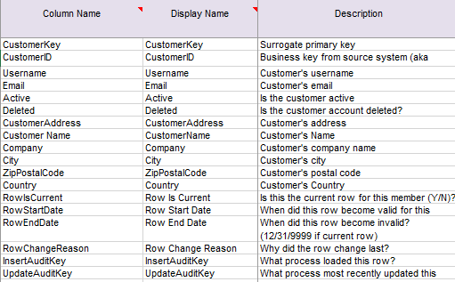

**Fact Orders**

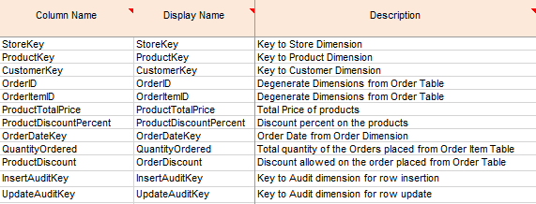

**Fact Reviews**

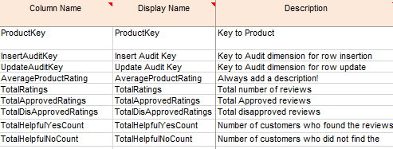

# **Design**

## High Level Dimension Model



## Detailed Level Dimension Model



## Dimensional Hierarchies

**Date Dimension:**

Example of Year-Quarter-Month hierarchy: 2016 -> 1st Quarter -> February -> 2/12/2016.

Example of Weekday-Day (right): Y -> Monday -> 2/12/2016.

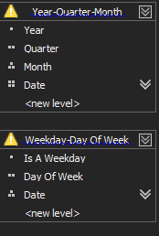

**Customer Dimension**

Example of Customer Location hierarchy: United States-> Syracuse->400 Greenwood Pl->13210

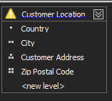

**Products Dimension**

Example of Category-Product hierarchy: Electronics-> Lumia 10

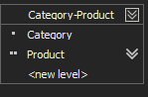

## Snowflake Schema

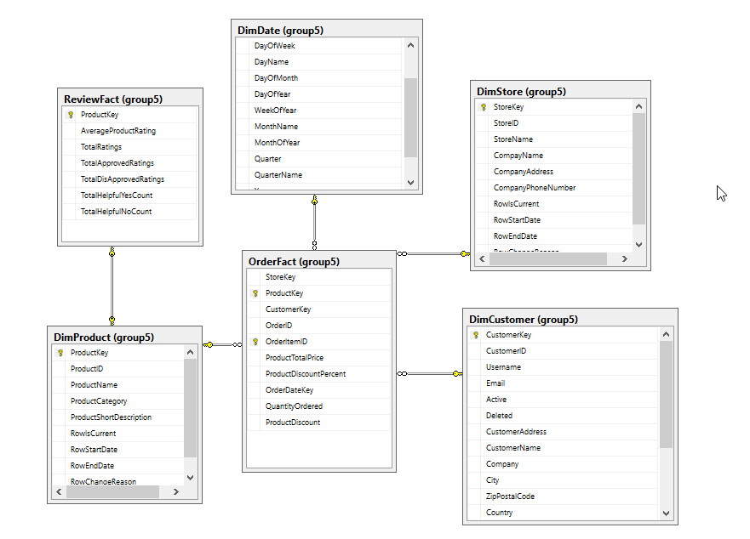

## ETL Specifications

