**PROJECT PART II**

**Course:** Principles of Database Systems

**Section:** CS-GY 6083 – INET SUMMER 2022

**Submission Date:** 26th August 2022

**Team members:**

1. **Niko Ganev (ng2451)**
2. **Bhargav Makwana (bm3125)**
3. **Jash Merchant (jjm9801)**

**Table of Contents**

1. Summary
2. Technology Stack
3. Logical and Relational ERD
4. Data tables
5. Demo
6. Features
7. Lessons learnt
8. SQL queries and results

**1.Summary**

In this project we implemented a new information system for the insurance company We Do Secure (WDS). This system is based on a relational database with 12 tables which securely stores the data for users and admins and allows users to apply for insurance policies as well as pay their invoices.

The goal of our application is to increase the number of users reached by WDS through an online portal that can be found online by anyone looking for insurance and convert these potential users into actual paying customers thanks to the easy process and appealing user interface.

Besides the increase in the number of applications and general awareness of the WDS brand, our solution aims at differentiating WDS from their competition by guaranteeing data security as well as improving worker productivity through simple workflows for both customers and insurance agents.

The admin panel allows the insurance agents to monitor their own performance and manage their clients effortlessly empowering an optimal experience for all parties.

**2.Technology Stack**

**Front end:** html with bootstrap

**Backend:** python with flask and sqlAlchemy libraries

**Database:** SQL database with python sqlAlchemy database

**Deployment:** on Heroku

**3.Logical and Relational ERD**

**Logical ERD**

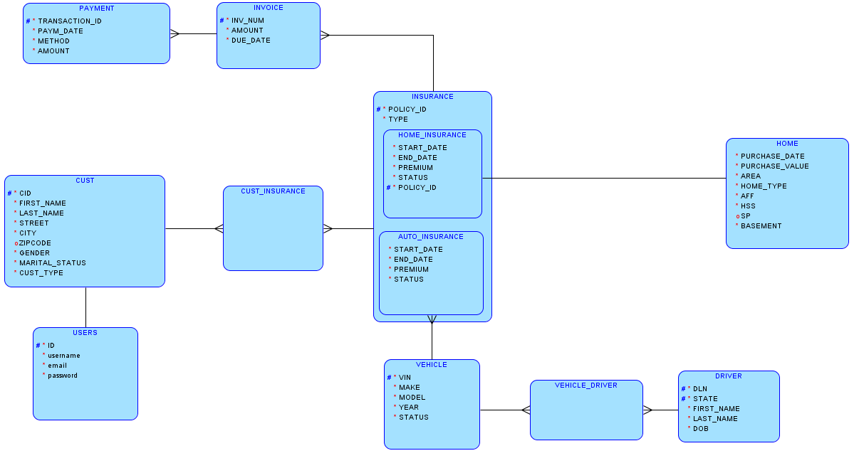

**Relational ERD**

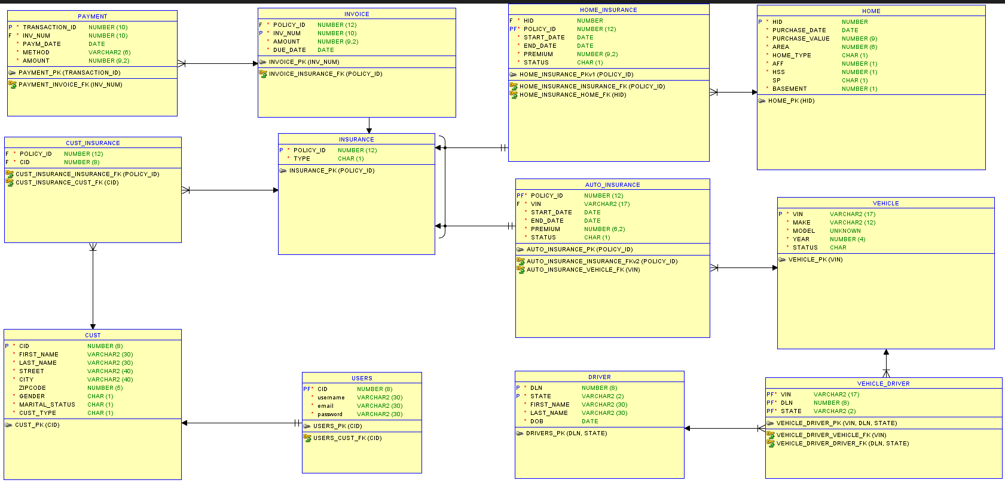

**4.Data Tables**

**Assumptions:**

1. A customer can enroll in more than one insurance and an insurance contract can have more than one person on contract such as husband and wife and hence customer to insurance becomes a many to many relationship requiring an intersect table which we have named cust_insurance.
2. Similarly, we have considered vehicle and driver to be a many to many relationship needing vehicle_driver as an intersect table.
3. Insurance supertype possess two subtypes - Home insurance and Auto insurance.
4. A single insurance can have multiple invoices generated and each invoice could be paid in several installments.
5. Address is a composite attribute resolved into street, zip code and city.
6. Name is a composite attribute resolved into first and last name

**Tables:**

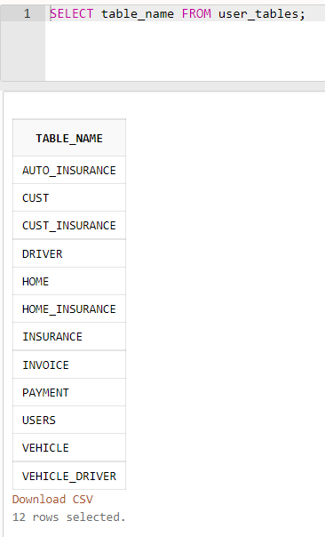

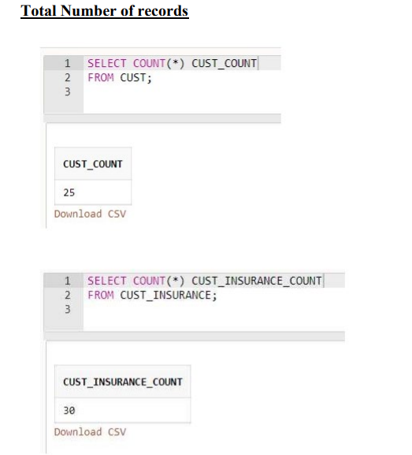

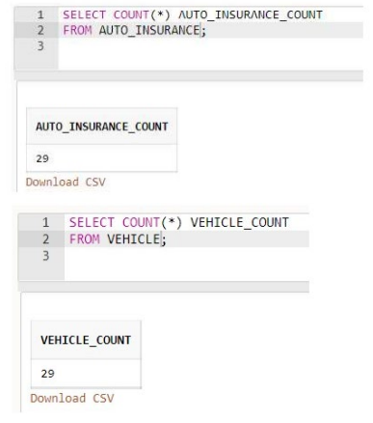

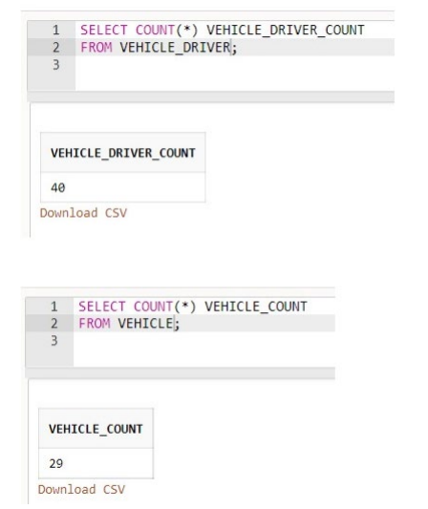

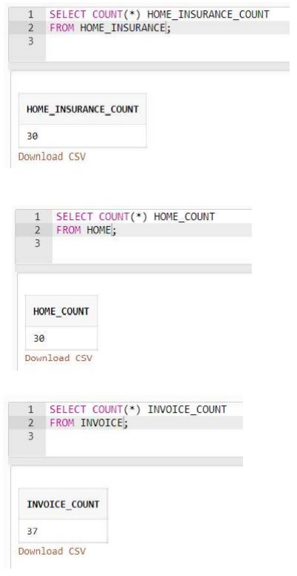

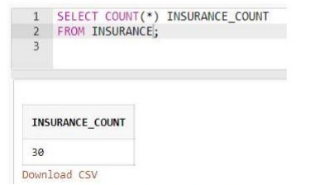

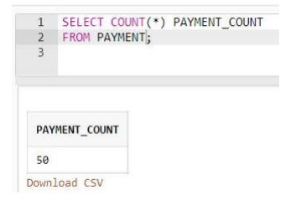

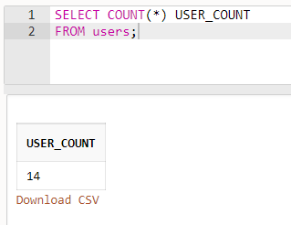

**5.Demo**

**6.Features**

* Create account feature (writing to database)
* Password encryption (writing to database)
* Login feature with password verification (retrieving from database)
* Reset password feature by getting an email (updating database)
* Customer panel (retrieving from database)
* Admin Panel (retrieving from database)
* Customer application for home insurance (writing to database)
* Customer application for auto insurance (writing to database)
* Customer my policies view of all their insurance policies and payment button (retrieving from database)
* Admin view of all customers (retrieving from database)
* Admin view of all users (retrieving from database)
* Admin ability to delete users (delete from database)
* Deployment to heroku

**7. Lessons learnt**

**8.SQL Queries and results**

**Q1)**

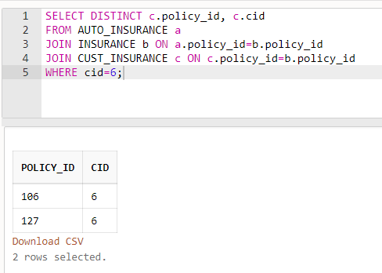

This query returns all insurance policies for customer with id 6.

**Q2)**

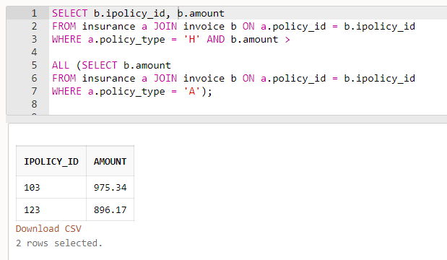

This query returns all home insurance policies that are more expensive than all of the auto insurance policies.

**Q3**

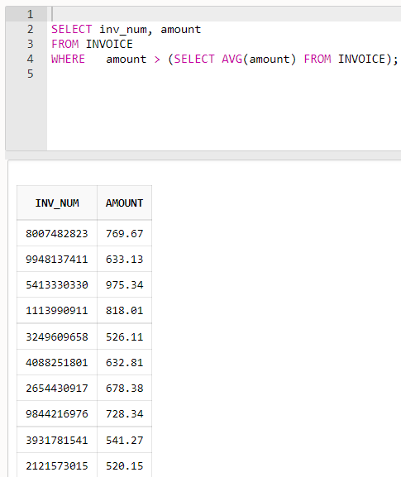

This query returns all invoices that are above the average invoice amount.

**Q4)**

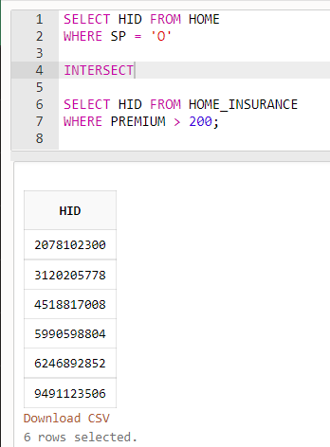

This query returns the ids of all homes with an outdoor pool paying more than 200 dollars in home insurance premium.

**Q5)**

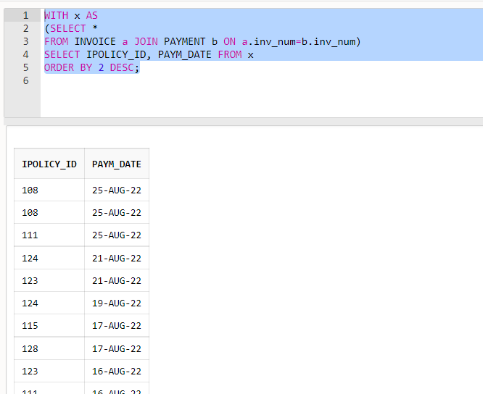

This query returns the IDs and payment date of policies which received a payment the most recently.

**Q6)**

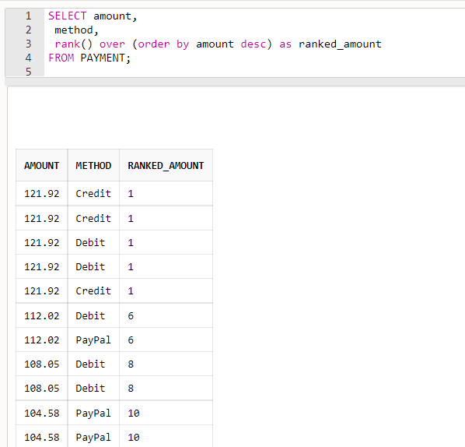

This insurance returns the top payment amounts along with the method of payment allowing to look for corelation between payment amount and method.