|  |
| --- |
| The Zombie Hunter |
| **3D Game Assignment.** |
| Version #0.0  All work Copyright © by XX Games.  All rights reserved. |
| **JASVANT NISHAD.** |
|  |



|  |
| --- |
| March 11,2016 |

**Table of Contents**

# Contents

Contents 2

I. Game Overview 4

II. Game Play Mechanics 4

III. Camera 4

IV. Controls 4

V. Interface Sketch 4

VI. Menu and Screen Descriptions 4

VII. Game World 4

VIII. Levels 5

IX. Game Progression 5

X. Characters 5

XI. Non-player Characters 5

XII. Enemies 5

XIII. Weapons 5

XIV. Items 6

XV. Script 6

XVI. Scoring 6

# Game Overview

This will be a tactical First Person game, with opposite team as Zombies. The Player (Hero) and the Zombies will fight to death. The player will have health bar, which shows the actual health of the player. The Player dies once the health bar is empty.

# Game Play Mechanics

The Player can win the level once it reaches to the complete its mission. The Zombies wins if they kill the player (Hero). This game will have some levels. In order to clear a level, the player has to achieve certain objectives.

# Camera

First Person View.

# Controls

Key W- Up movement

Key A- Left Movement

Key D- Right Movement

Key S- Back Movement

Space Bar key- Jump

Shooting- Mouse

# Interface Sketch

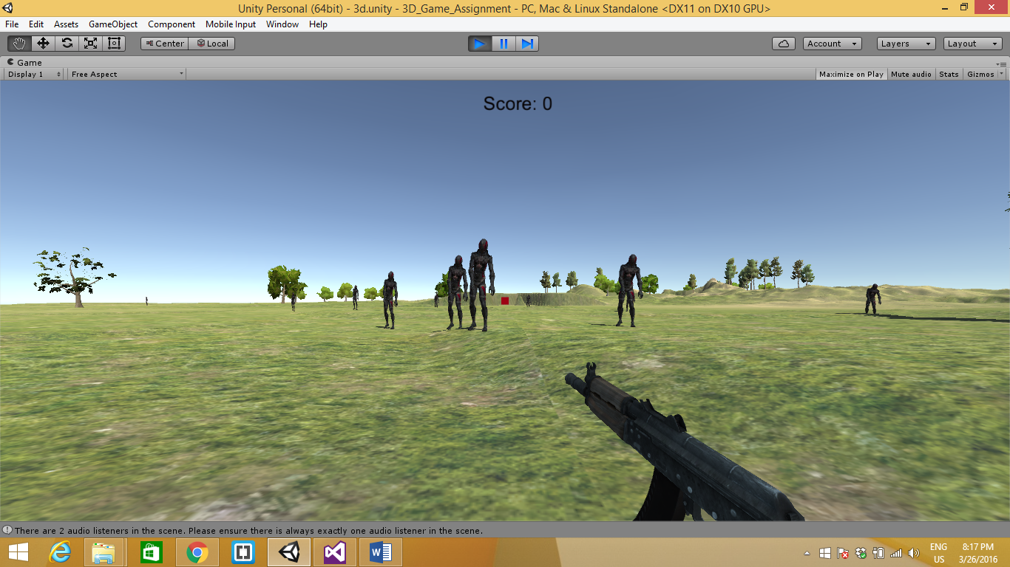

Score Updated.

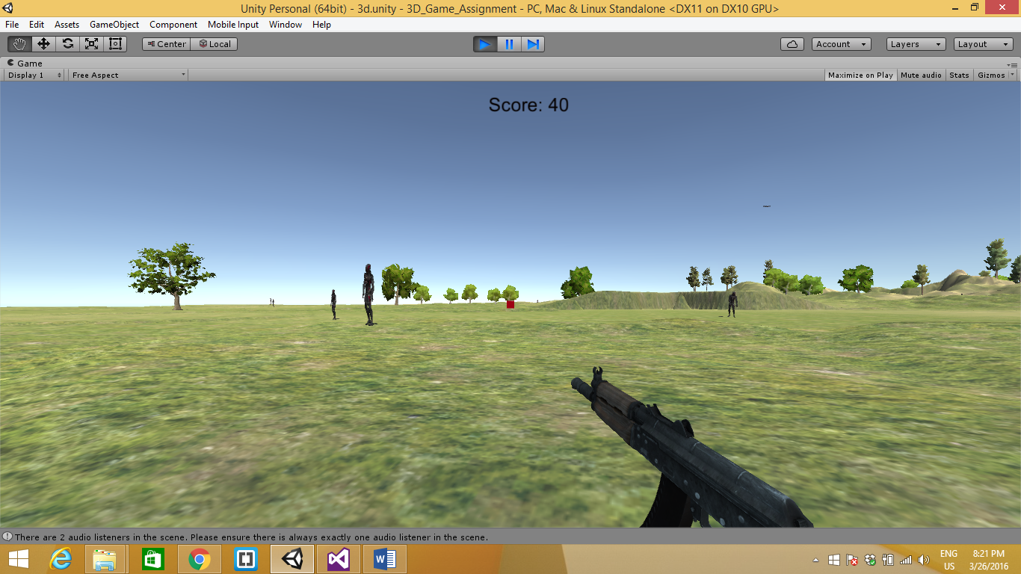

# Game World

This will be particularly a shooting game.

# Levels

As the Player passes each level, the Number of enemies (Zombies) increases. The obstacles in each level increases. The player will find it difficult to achieve its objectives.

# Game Progression

The game starts with the basic introduction of the game, the task to accomplish and the control information. The level starts with few zombies and the difficulty will be moderate. The level will have some average timing of completion. The difficulty of the game increases with the progression of each levels. The level completes once the player reaches to its objective.

# Characters

This game will be the First person perspective game, so the character is player with a Rifle in its hand.

# Non-player Characters

The Other things excluding Player and Zombies will be the non-Player characters.

# Enemies

The Zombies will be the enemies.

# Weapons

The player will have a Rifle.

# Items

Trees, sky, stones, rifle.

# Script

1. Player Control
2. Enemy Control
3. Game Controller
4. Weapon Control

# Scoring

There will be scoring in this game, point’s increases if the player kills as many zombies and reward points as well. The player will also have health bar, which will indicate the relative health of the player at a certain point in the game.