Jashwanth Reddy Gangula

SUID: 646254141

Email: [jgangula@syr.edu](mailto:jgangula@syr.edu)

**Lab 0**

1. Installed the Ubuntu on virtual Machine using option 2

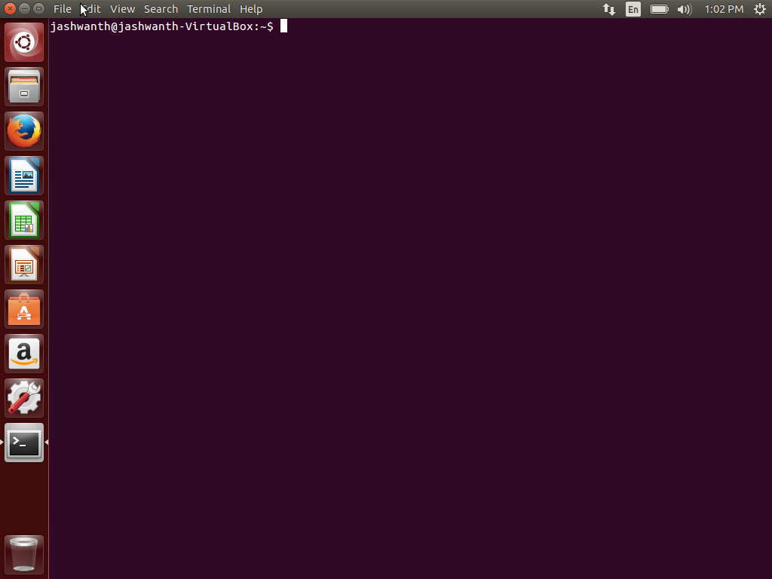

2.Pulled the source code from the git created and created sgx-emulator folder

