ACA Lab4

JASHWANTH REDDY GANGULA

SUID: 646254141

1. Task is to traverse the matrix

Original Code:

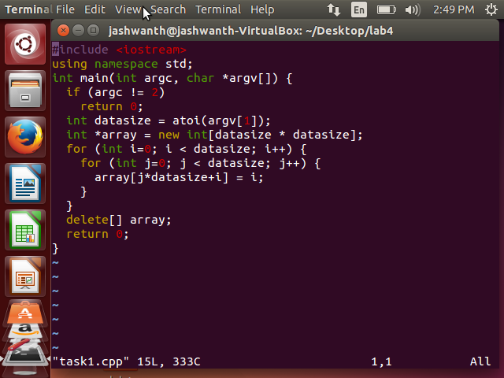

Compile the original Code and run the valgrind tool to get the D1 miss rate

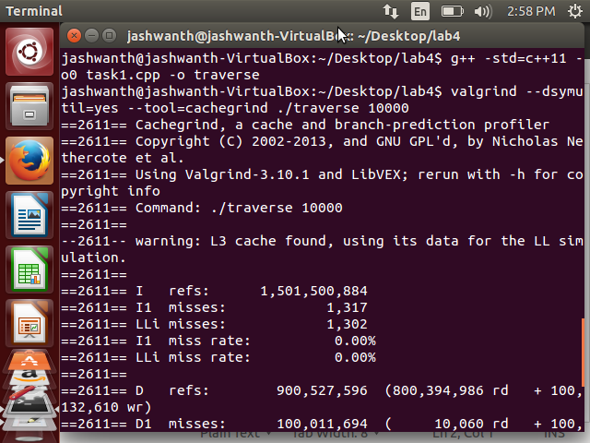

**Display the D1 miss rate:**

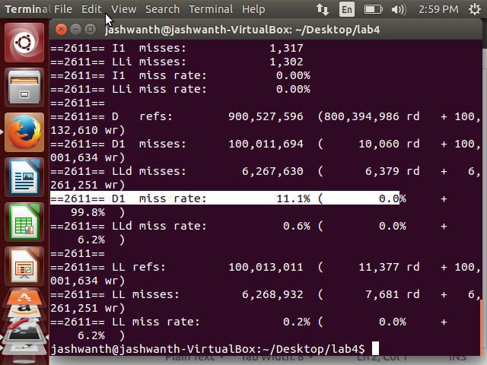

Optimize the Task1:

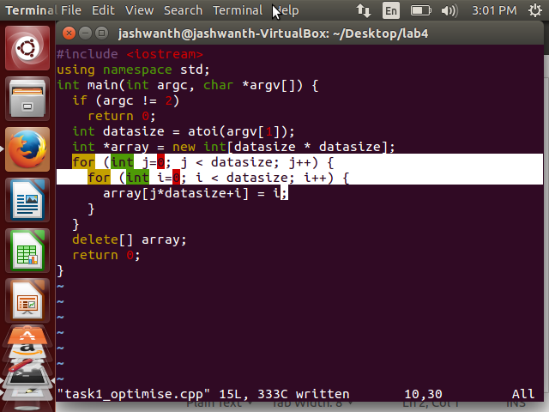

Compile the optimized Code and run the valgrind tool to get the D1 miss rate:

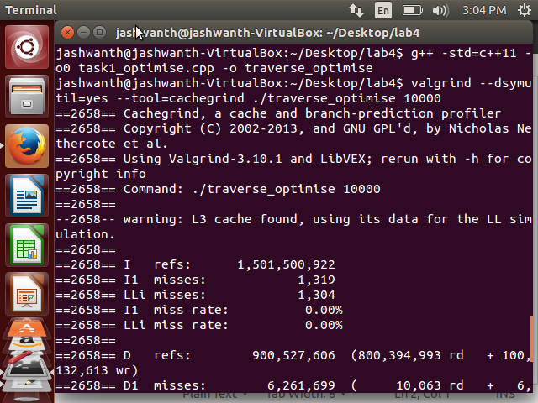

**Display the D1 miss rate after Optimization:**

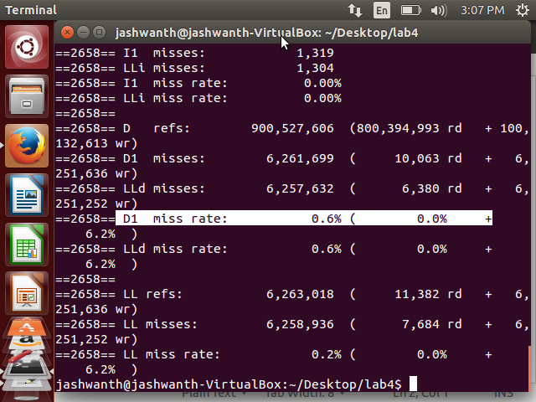

Explanation:

In the optimized code we have interchanged the indexes in the for loop. In the 2-D array after

Interchanging spatial locality is improved. In the original code the elements accessed are not sequential. Because the elements accessed are 10000 far away from each other. After the optimization the 2-d array elements are accessed sequentially. This technique is called **Loop Interchange** technique**.** Hence the improvement in D1 miss rate.

Task 2:

Matrix Transpose

Original Code:

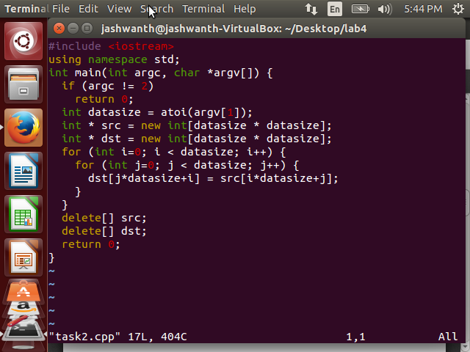

Compile the original Code and run the valgrind tool to get the D1 miss rate

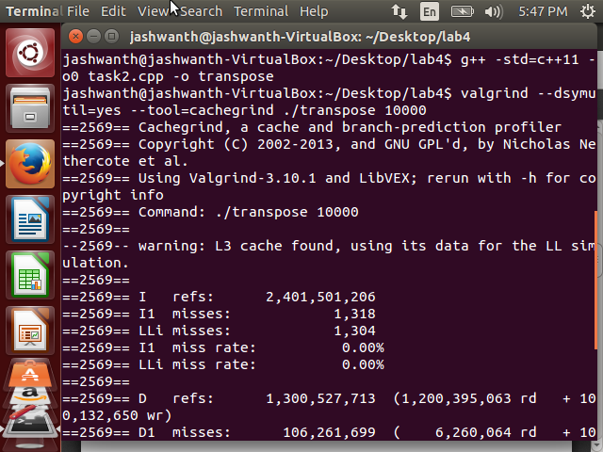

Display the D1 miss rate:

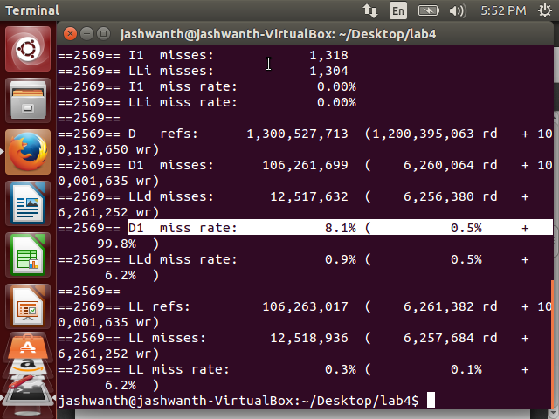

Optimise Task2:

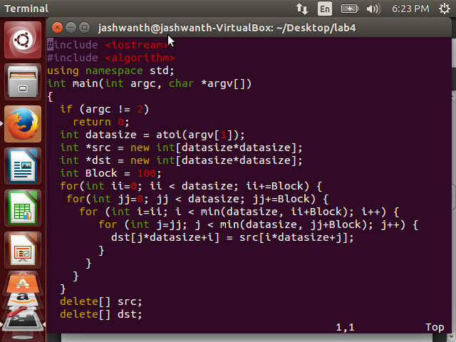

Compile the Optimised Code and run the valgrind tool to get the D1 miss rate

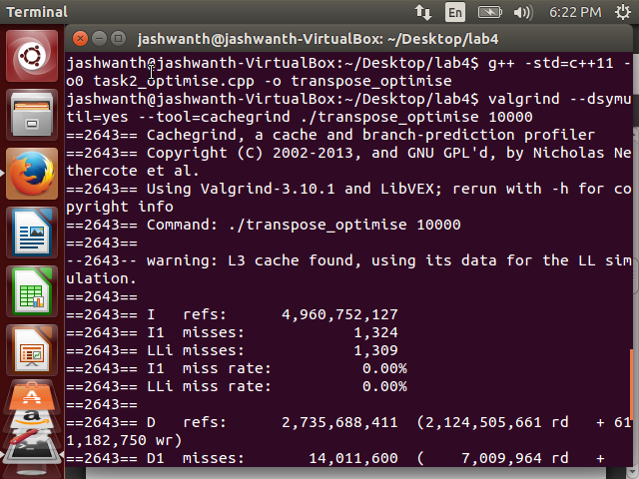

**Display the D1 miss rate:**

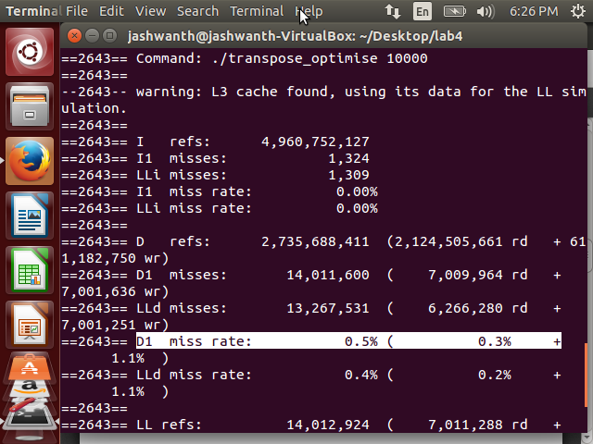

Explanation:

The concept of Blocked algorithm is used to reduce the miss rate.

Instead of accessing entire rows or columns, it subdivides matrices into blocks

Maximize computations on block data already in cache. For the destination matrix,

We fetched the block of column and source matrix we fetched block in its row according

to the optimized code. The destination matrix benefits from spatial locality and source matrix benefits from spatial locality. We are also reducing the memory access by factor of Block size.