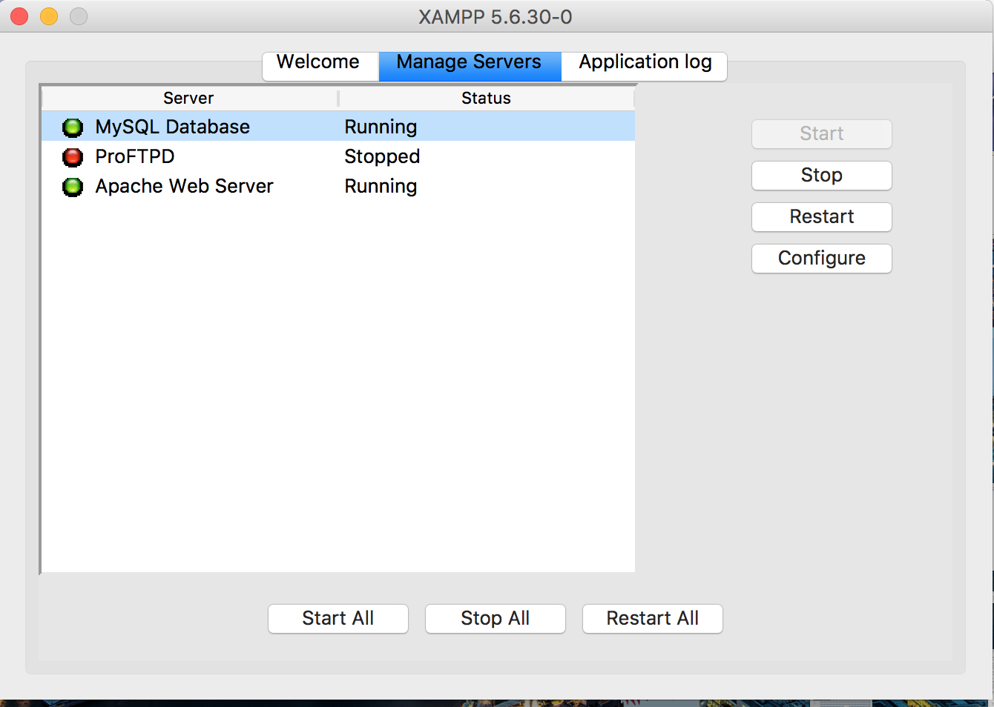

**Part 1.** Installed the XAMPP and got the MYSQL and Apache Server running

**Part2**

Wrote the helloworld.php script and placed it inside the htdocs folder. The script was running successfully by displaying the hello world in the browser.

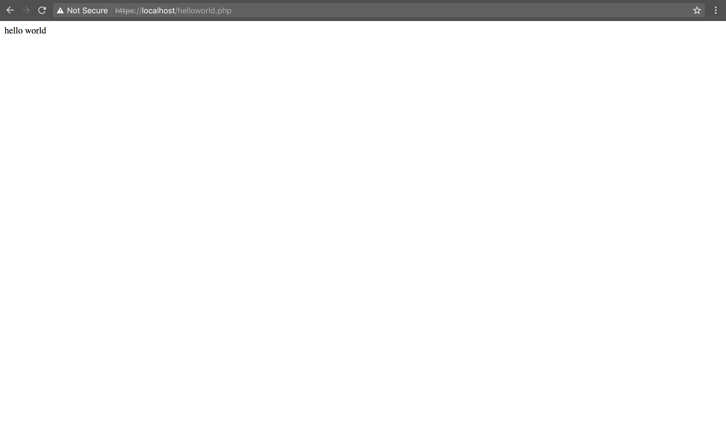

The phpmyadmin was also running successfully.

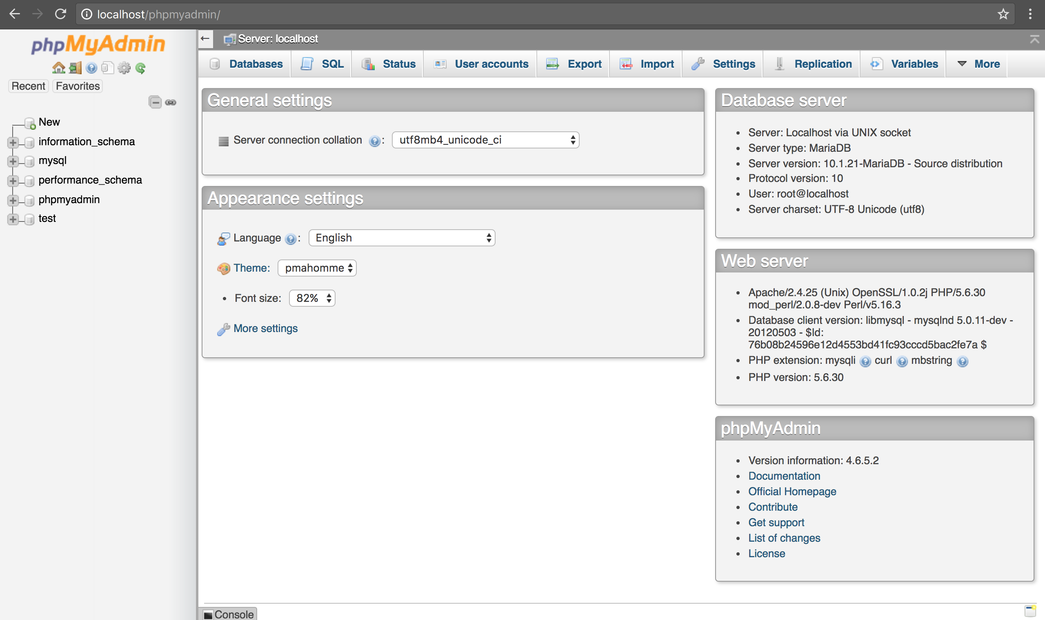

**Part 3:**

<VirtualHost *:80>

ServerName jashwanth-reddy.com

ServerAdmin jashwanth@jashwanth-reddy.com

DocumentRoot "/Applications/XAMPP/xamppfiles/htdocs/jashwanth-reddy"

<Directory "/Applications/XAMPP/xamppfiles/htdocs/jashwanth-reddy">

Options Indexes FollowSymLinks Includes execCGI

AllowOverride None

Order Allow,Deny

Allow From All

Require all granted

</Directory>

</VirtualHost>

<VirtualHost *:80>

ServerName www.example.com

ServerAdmin jashwanth@www.example.com

DocumentRoot "/Applications/XAMPP/xamppfiles/htdocs/example.com"

<Directory "/Applications/XAMPP/xamppfiles/htdocs/example.com">

Options Indexes FollowSymLinks Includes execCGI

AllowOverride None

Order Allow,Deny

Allow From All

Require all granted

</Directory>

</VirtualHost>

**Part4:**

Changed the php script for redirection based on url

Created two folders jashwanth-reddy and example.com which contains simple html welcome page.

<?php

if (!empty($_SERVER['HTTPS']) && ('on' == $_SERVER['HTTPS'])) {

$uri = 'https://';

} else {

$uri = 'http://';

}

$uri .= $_SERVER['HTTP_HOST'];

if (strpos($uri, 'jashwanth-reddy') != false) {

header('Location: '.$uri.'/jashwanth-reddy/');

exit;

} else if(strpos($uri, 'www.example.com') != false) {

header('Location: '.$uri.'/example.com/');

} else {

header('Location: '.$uri.'/dashboard/');

exit;

}

?>

Restart the Apache Server and check that Virtual Host name is resolved.

Observe the URL here given as Hostname and is resolved.

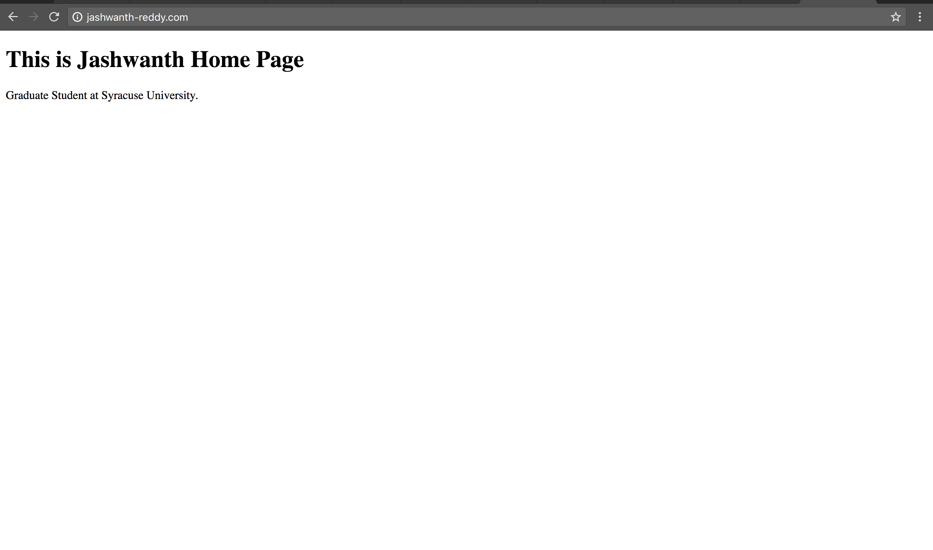

Another page for [www.example.com](http://www.example.com)

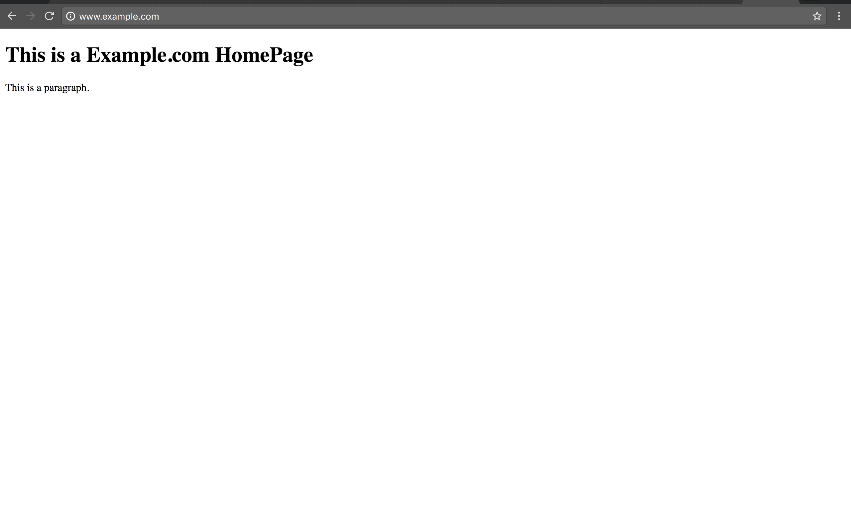

**Part 5:**

echo $PATH

/Users/jashwanthreddy/Library/Android/sdk/platform-tools:/Users/jashwanthreddy/Library/Android/sdk/tools:/usr/local/bin:/usr/bin:/bin:/usr/sbin:/sbin

Below are the steps to copy the hosts to the /system folder of android file system which is made writable.

emulator -writable-system -avd Nexus_5X_API_25

adb devices

adb root

adb start-server

adb shell

mount -o rw,remount /system

exit

adb push /etc/hosts /system/etc/hosts

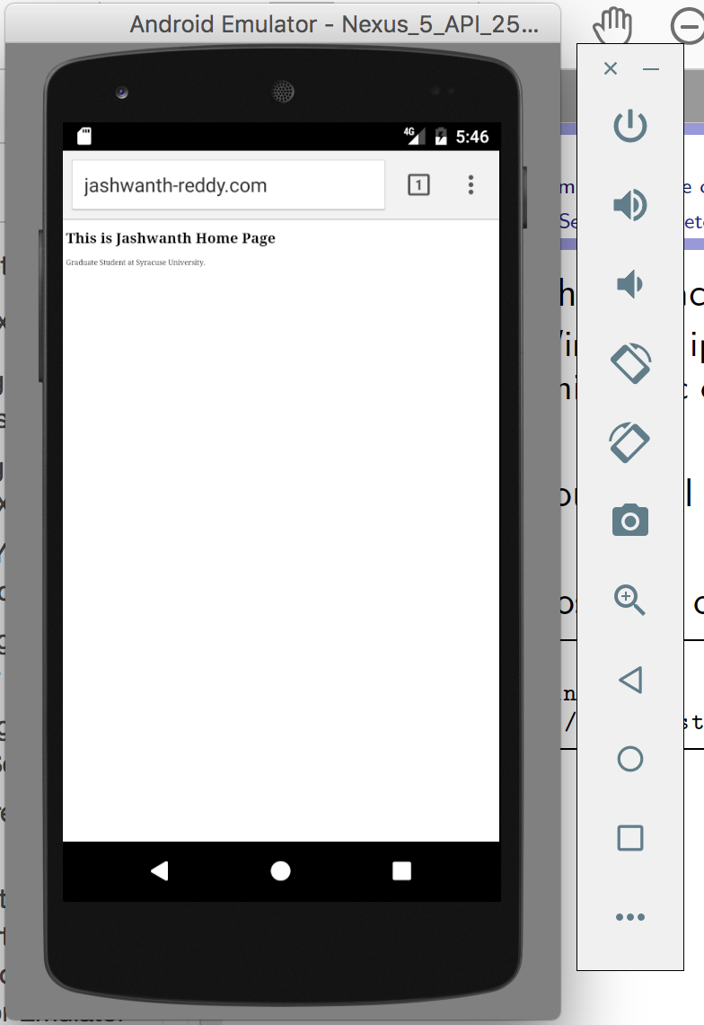

Demon starting the second virtual Host

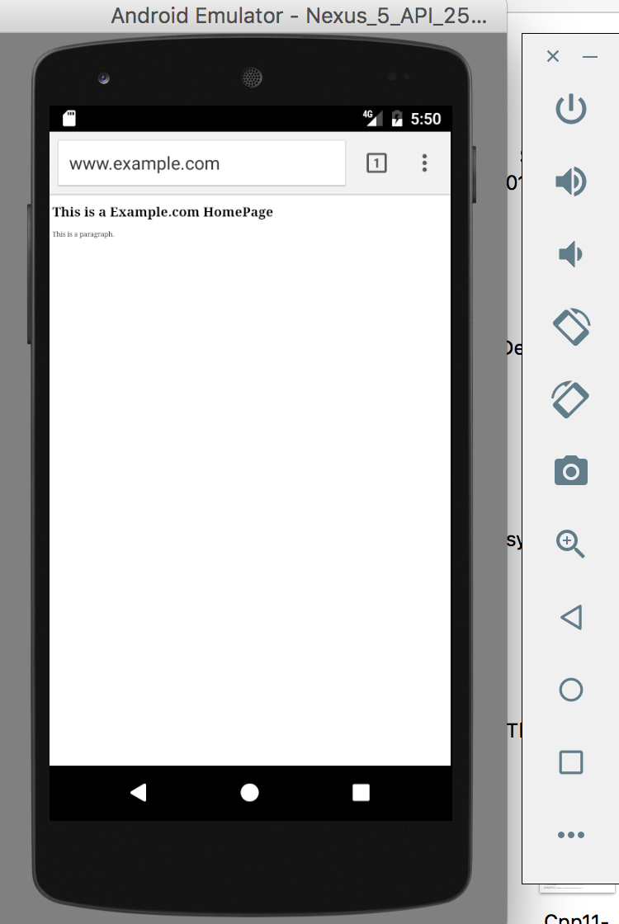

**No Late Submission for This Assignment!**

The submission should essentially be a report document. The document should contains the sequence of steps followed and the screen shots of the app along with the source code (php files).

Finish the server-side setup, and write some server-side programs (php code).  You need to cover the followings:

* (20) Install xampp and get the HTTP server and MySQL server running.
* (20) Write your "hello world" php code, and demonstrates that it works.
* (20) Modify the hosts file on your Windows/Mac/Linux machine, so you can use *www.example.com* and another name of your choice in your URLs.
* (20) Configure your Apache virtual hosts, so *www.example.com* and the name that you select can point to different folders (i.e., different server-side programs).
* (20) Modify /system/etc/hosts inside your Genymotion VM, so you can use *www.example.com* and another name of your choice. These names should all point to your xampp server (i.e. your laptop in most cases).