CSE 581  
Jashwanth Reddy Gangula  
Fall 2016  
SUID: 646254141

Lab 1: Database Account Setup

a.

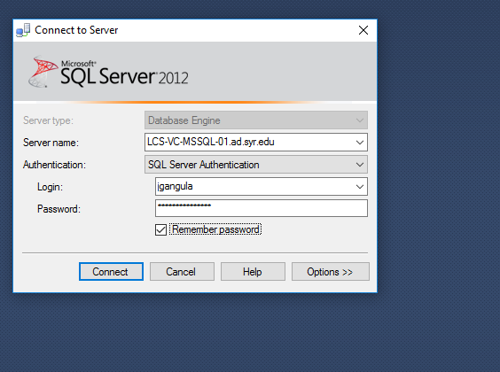

b.

