CSE 581

**Lab 2: Basic Selects**

**Jashwanth Reddy Gangula   
Fall 2016**

**SUID : 646254141**

1. SELECT *   
    FROM [Order Details];

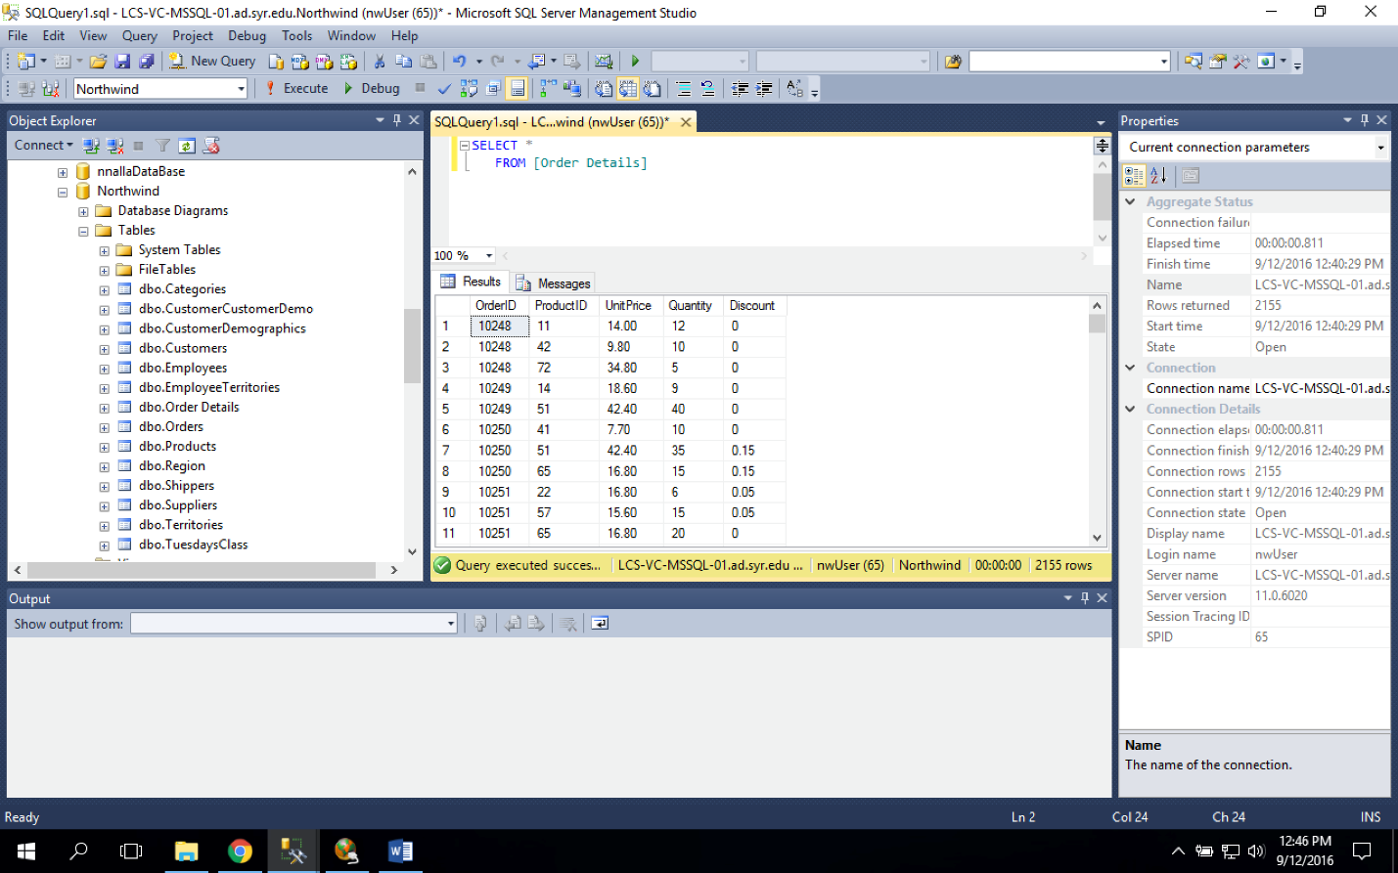

1. SELECT *  
    FROM Customers

ORDER BY ContactName;

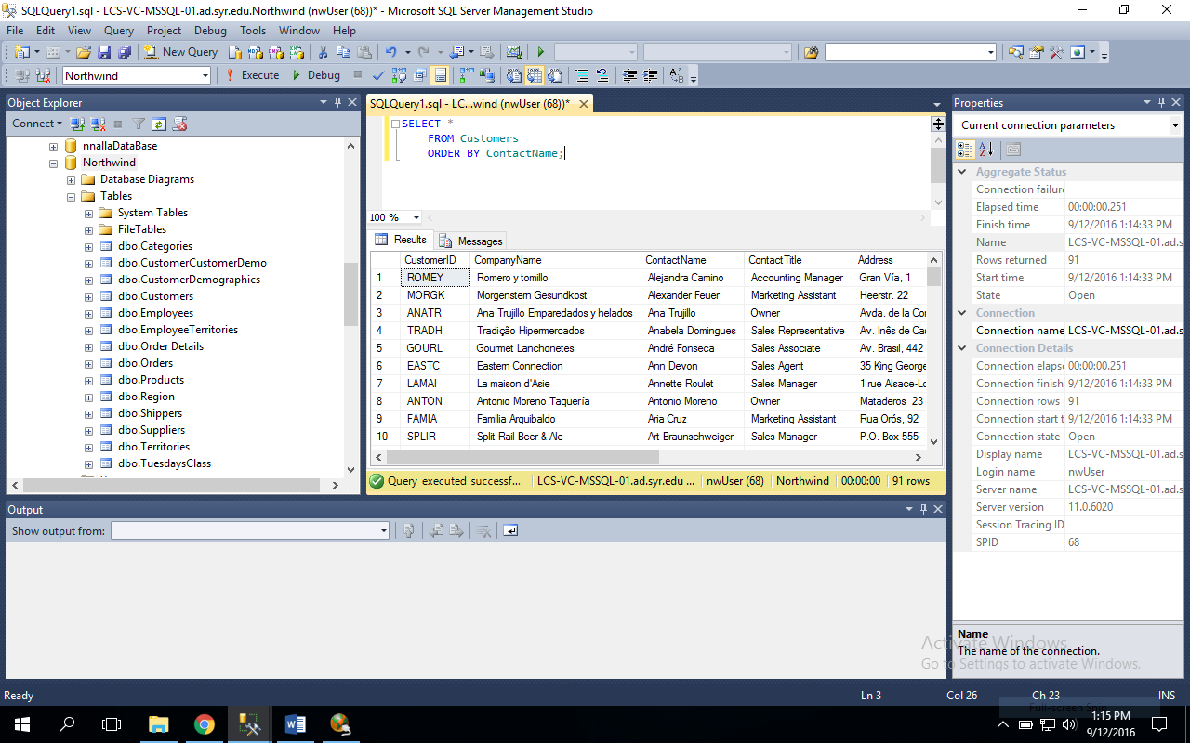

1. SELECT *

FROM Orders

ORDER BY OrderDate;  
 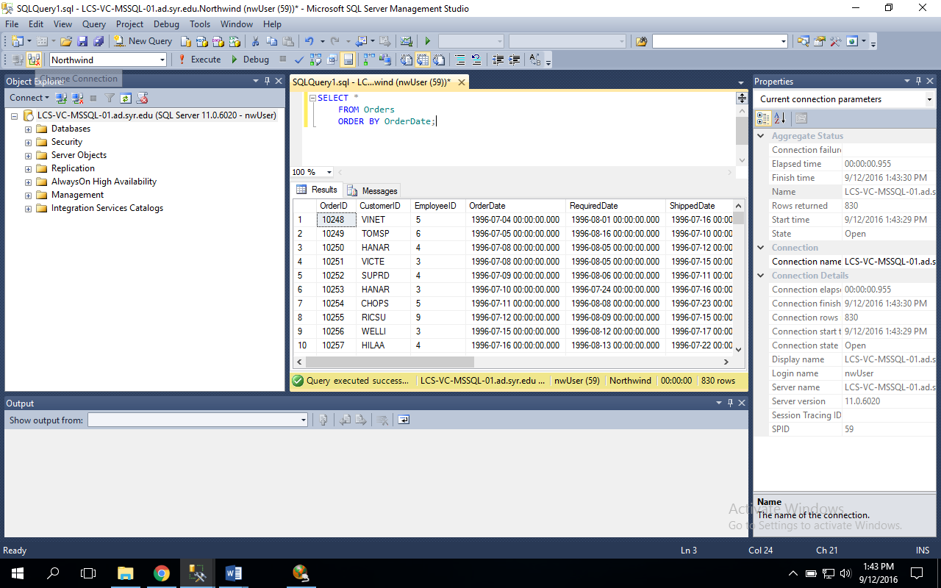

1. SELECT *

FROM Orders

ORDER BY ShippedDate DESC;

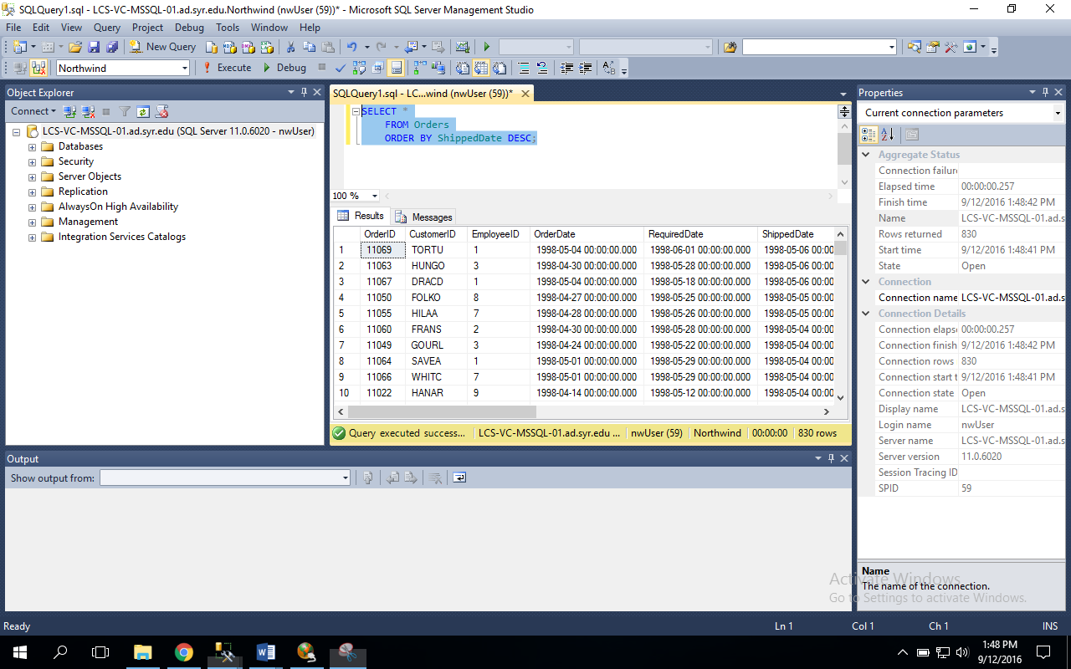

1. SELECT *

FROM Orders

WHERE ShippedDate IS NULL;

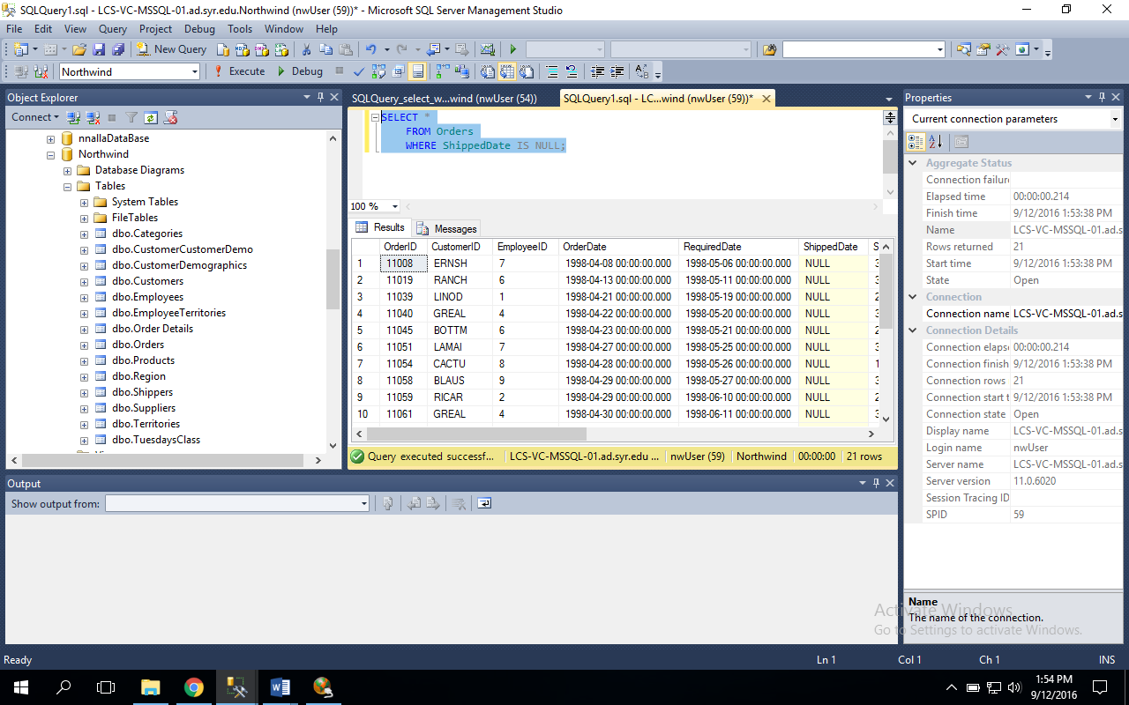

1. SELECT CompanyName, ContactName, ContactTitle

FROM Customers

WHERE CompanyName LIKE 'D%';  
 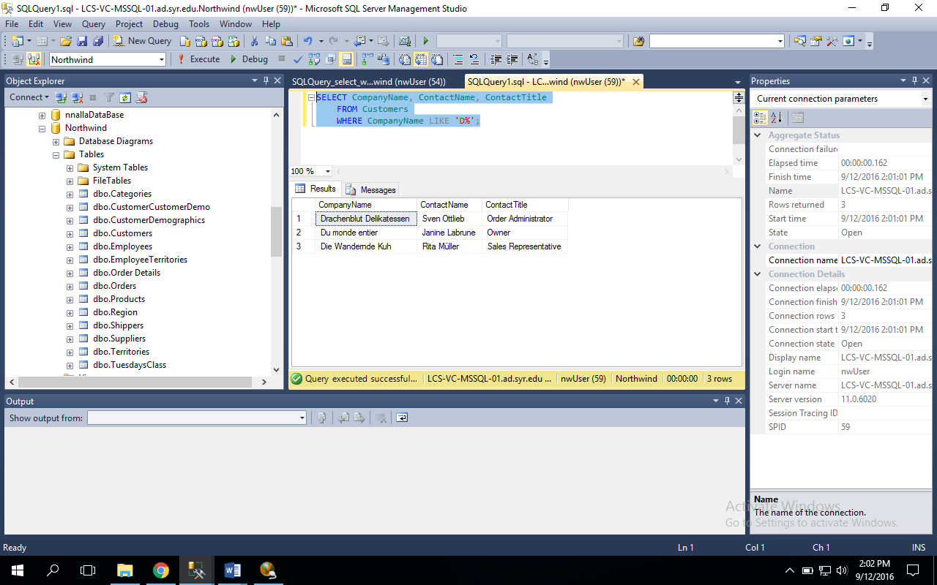

1. SELECT EmployeeID, FirstName, LastName, Title

FROM Employees

WHERE LastName LIKE '[DEF]%';

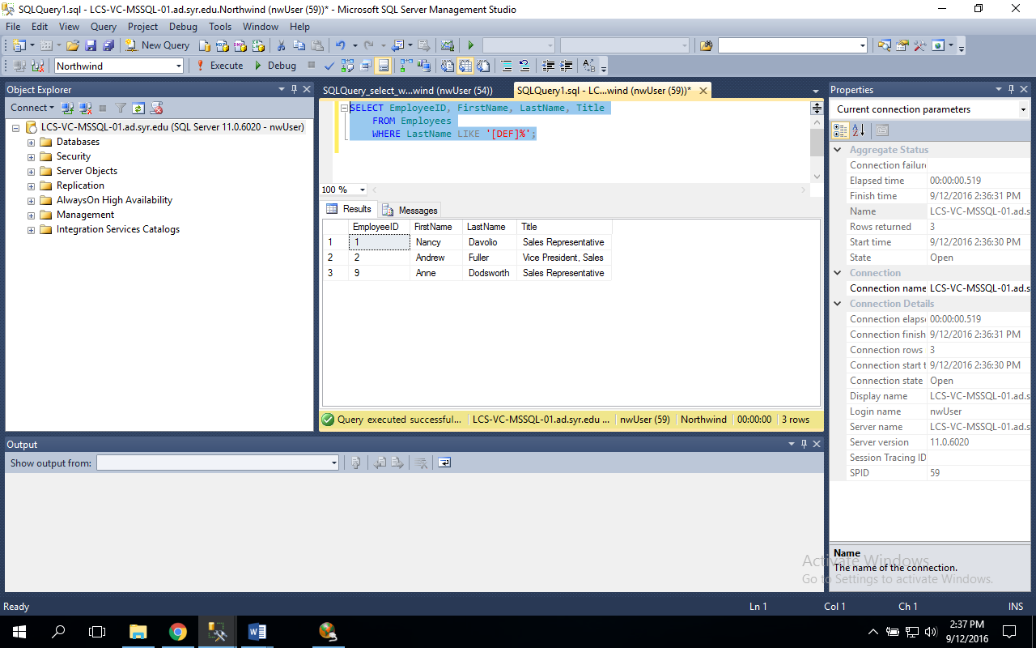

1. SELECT COUNT(SupplierID)

FROM Suppliers;

