**Lab 3: Selects with Joins**

*JASHWANTH REDDY GANGULA  
FALL 2016*

*CSE 581*

*SUID: 646254141*

1. List all orders and their corresponding order details.

SELECT *

FROM Orders LEFT OUTER JOIN [Order Details]

ON Orders.OrderID = [Order Details].OrderID;

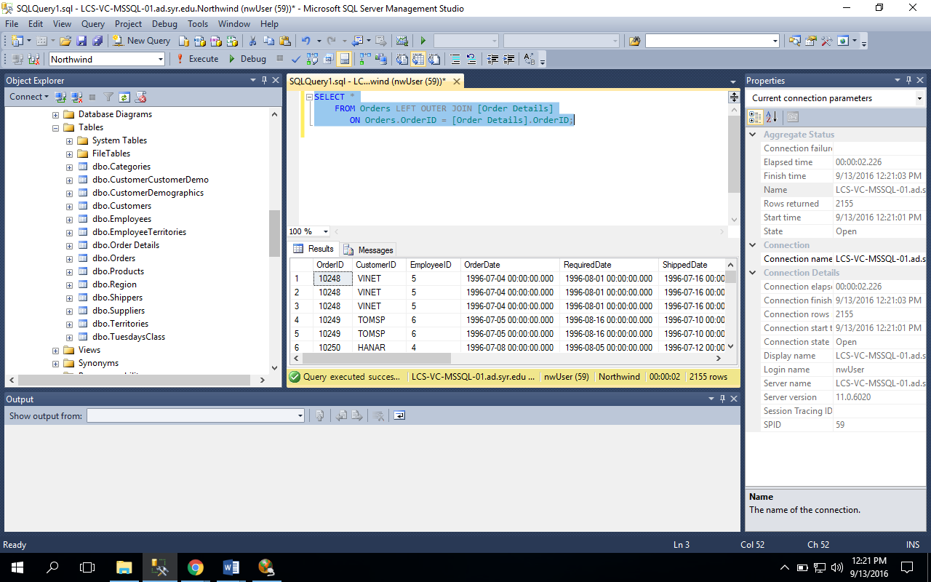

1. List all orders (OrderID) and matching customers (Company Name).

SELECT Orders.OrderID, Customers.CompanyName

FROM Orders LEFT OUTER JOIN Customers

ON Customers.CustomerID = Orders.CustomerID;

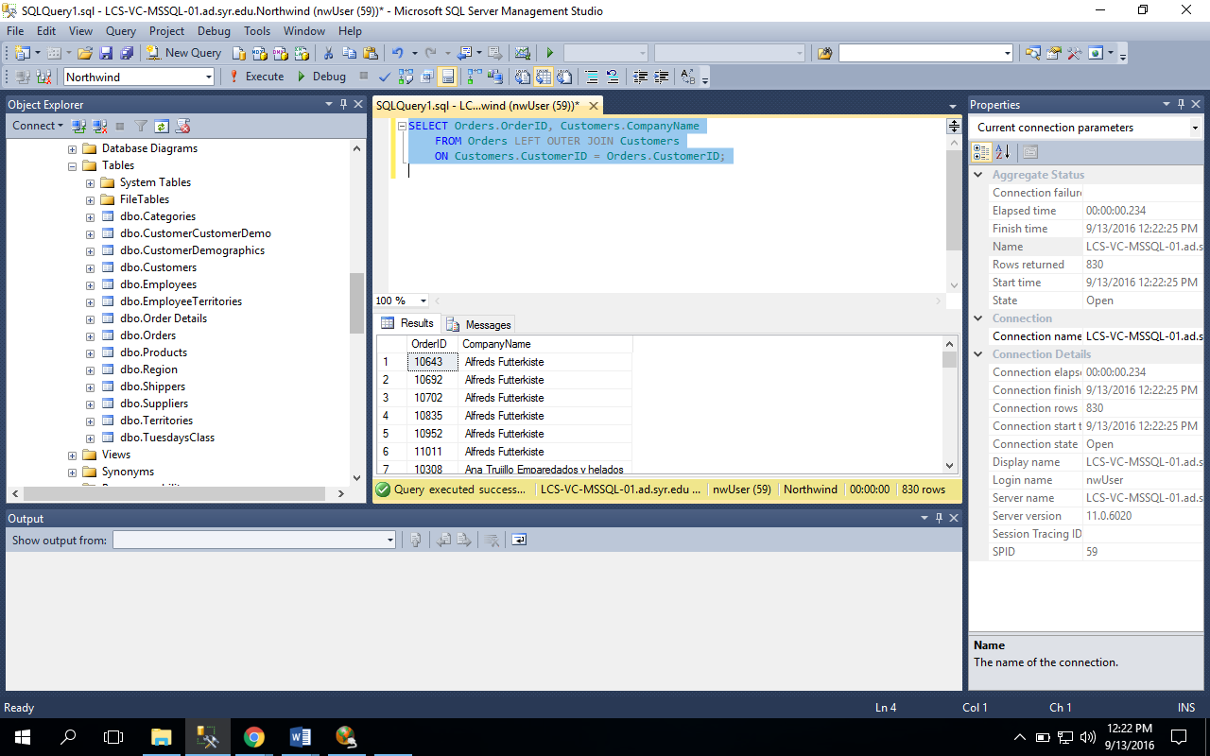

1. List orders (OrderID) and corresponding customers (Company Name), only where the records match up.

SELECT Orders.OrderID, Customers.CompanyName

FROM Orders INNER JOIN Customers

ON Customers.CustomerID = Orders.CustomerID;

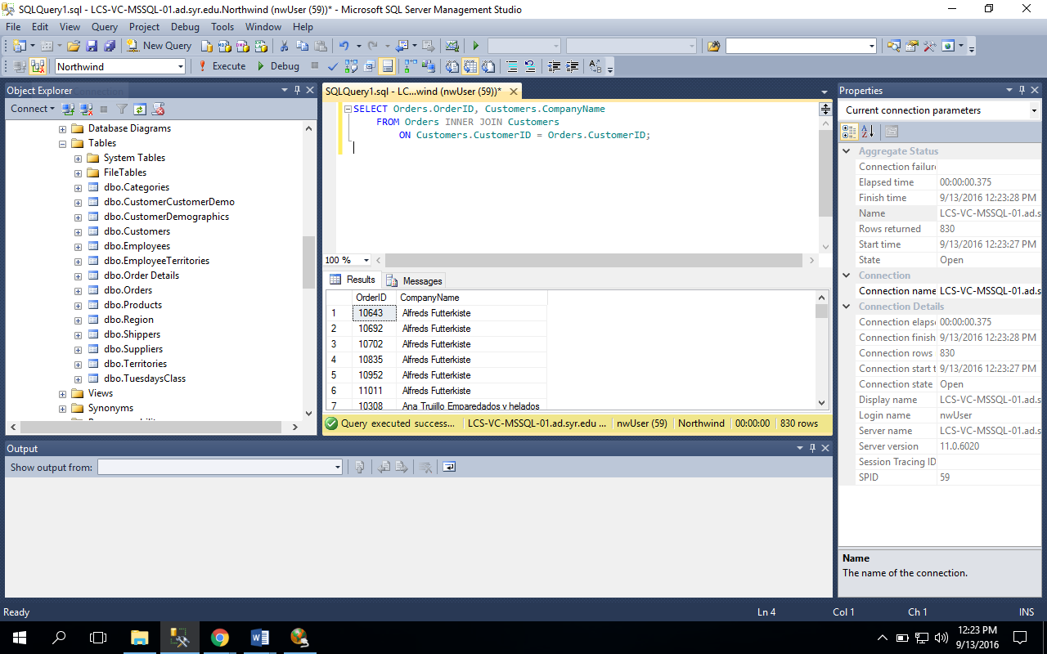

1. List all orders (OrderID) and all customers (Company Name), matching records appropriately.

SELECT Orders.OrderID, Customers.CompanyName  
 FROM Orders FULL OUTER JOIN Customers

ON Customers.CustomerID = Orders.CustomerID;

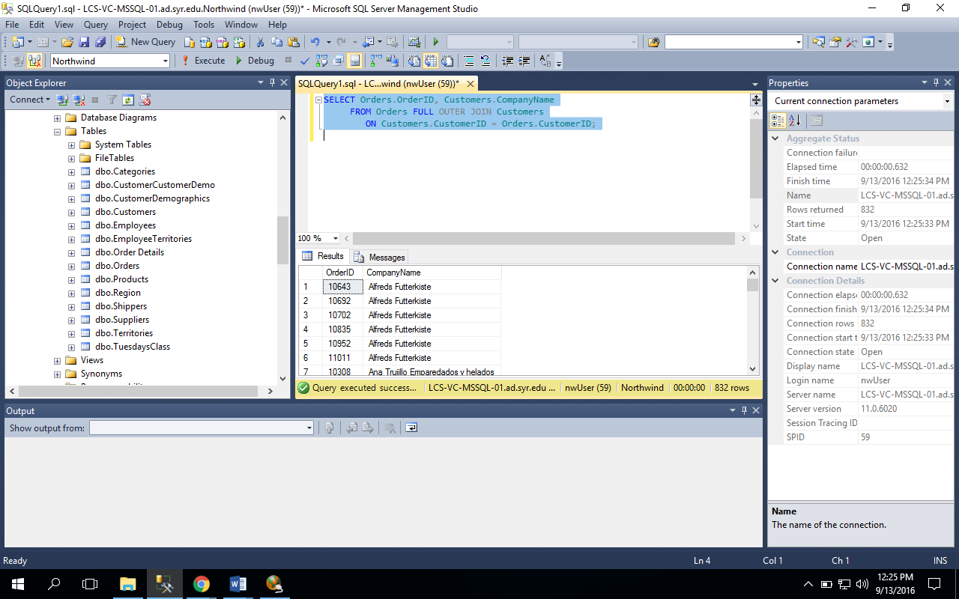

1. List matching orders (OrderID) and all customers (Company Name).

SELECT Orders.OrderID, Customers.CompanyName

FROM Orders RIGHT OUTER JOIN Customers

ON Customers.CustomerID = Orders.CustomerID;

