CSE 581

Jashwanth Reddy Gangula

Fall 2016

SUID: 646254141

**Lab 4: More Advanced Selects**

1. SELECT c.CompanyName, COUNT(*)

FROM Customers c INNER JOIN Orders o

ON o.CustomerID = c.CustomerID

GROUP BY c.CompanyName

HAVING COUNT(*) >= 5 ;

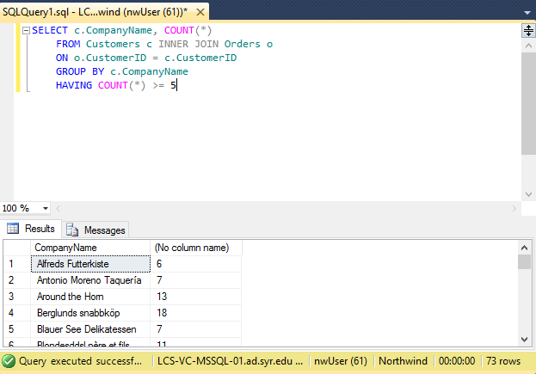

1. SELECT e.EmployeeID, e.Firstname, f.FirstName

FROM Employees e LEFT OUTER JOIN Employees f

ON e.ReportsTo = f.EmployeeID ;

