CSE 581

Jashwanth Reddy  
Fall 2016  
SUID: 646254141

**Lab 5: System Functions Exercise**

1. SELECT UPPER(e.LastName) + ',' + ' ' + LOWER(e.FirstName)  
    FROM Employees e;  
     
   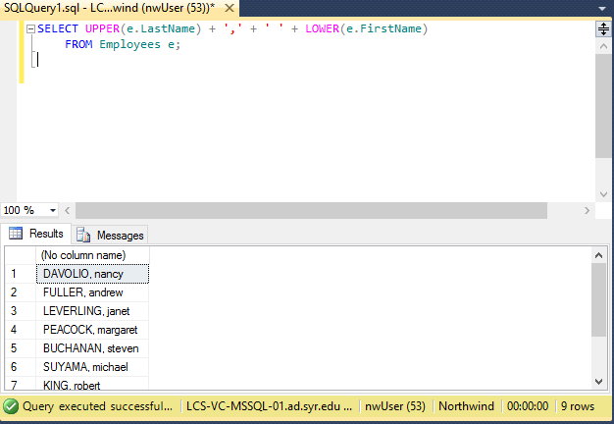
2. SELECT c.CompanyName, LEN(c.CompanyName) AS TextLength

FROM Customers c;

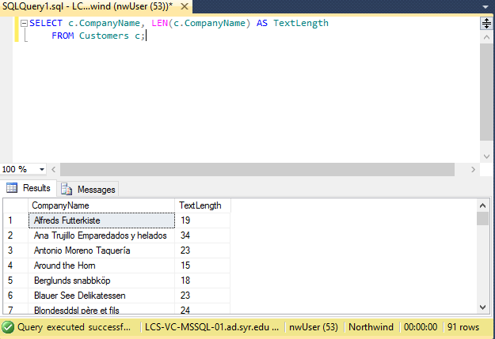

1. SELECT o.ShippedDate, DATEADD(DAY, 5, o.ShippedDate) AS ExpectedDate

FROM Orders o

WHERE o.ShippedDate IS NOT NULL;

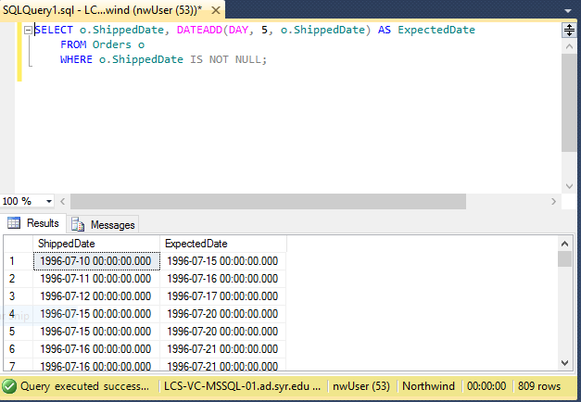

1. SELECT *

FROM Orders

WHERE YEAR(ShippedDate) = 1998 ;  
  
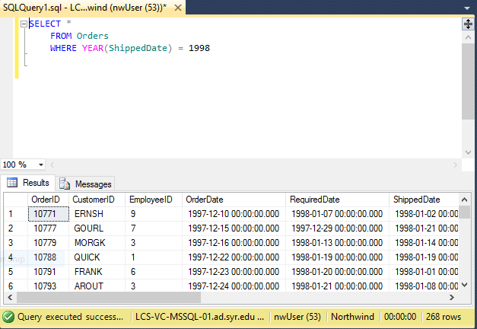

1. SELECT *

FROM Orders

WHERE YEAR(OrderDate) = 1997

AND MONTH(OrderDate) = 1

AND DAY(OrderDate) = 1;

