CSE 581

Jashwanth Reddy  
Fall 2016  
SUID : 646254141

**Lab 8: Selects with Data Types**

1. Select all data from the Orders table, ordered by OrderDate, newest date on top, for orders shipped between January 1997 and August 1997.

SELECT *

FROM Orders

WHERE YEAR(ShippedDate) = 1997

AND MONTH(ShippedDate) >= 1

AND MONTH(ShippedDate) <= 8

ORDER BY OrderDate DESC;

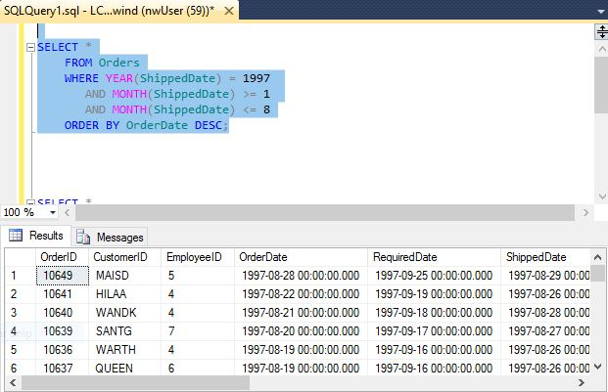

1. Select all data from the Orders table, ordered by OrderDate, newest date on top, for orders placed between July 1996 and January 1997.  
    SELECT *

FROM Orders

WHERE ((MONTH(OrderDate) BETWEEN 7 AND 12) AND YEAR(OrderDate)=1996)OR

(MONTH(OrderDate) <= 1 AND YEAR(OrderDate)=1997)

ORDER BY OrderDate DESC;

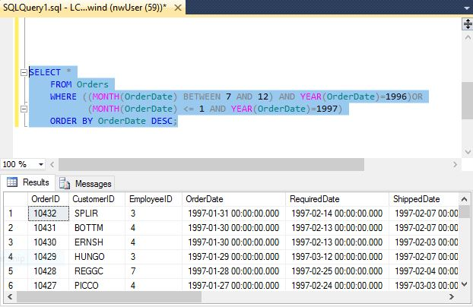

1. Select all data from the Orders table, for orders placed in January 1998.

SELECT *

FROM Orders

WHERE MONTH(OrderDate) = 1

AND YEAR(OrderDate) = 1998;

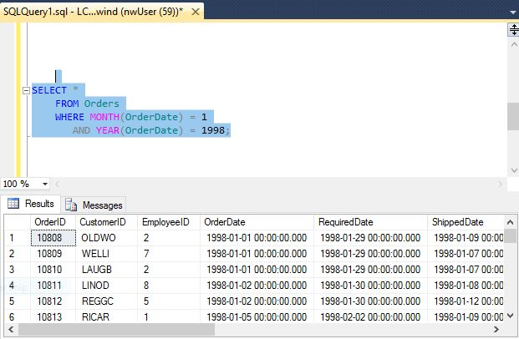

1. Select count of Orders shipped in 1996, 1997 and 1998. (one query containing all values) -> 2 columns (count and year), 3 rows (1 row per year)

SELECT YEAR(ShippedDate) , COUNT(*) AS 'Number Of Orders Shipped'

FROM Orders

WHERE YEAR(ShippedDate) BETWEEN 1996 and 1998

GROUP BY YEAR(ShippedDate)

ORDER BY YEAR(ShippedDate);

