Digital Logic & Processor
Mid-Sem1
Monsoon -2013
September 6th, 2013

Roll number:

Name:

Seat:

Q₁ | Q₂ | Q₃ | Q₄ | Q₅ | Q₆ | Total

Answer all questions. Marks are indicated against each question. The answers should be given in the space provided. You may use the last page for rough work, if necessary. State your assumptions clearly if there is ambiguity with question. All the best!

- Simplify where refers to logical OR and

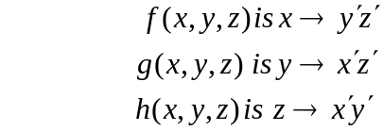

[5]

- Design a keyboard encoder that encodes 8 keys alphabets A,B,C,D,E,F,G,H and only one key is pressed at a time. Show clearly the number of input and output lines of the encoder and the truth table for the same. Under what conditions is the Boolean function that realizes the truth table valid.

[5]

- Now assume that the following keys are pressed B,C,D,D,A,F,F,H. Design a ROM that stores these keys. What are the specifications of the ROM. Clearly show the decoder and the OR gates of the ROM along with the truth table.
[5]

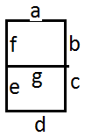
- Now design a decoder that on the selection of the particular input address of the ROM decodes the encoded key there into a 7-segment display. Clearly specify the truth-table of the decoder explaining what each of the input and output variables exemplify. [5]

- Assume that the EXOR gates have a propagation delay of 10ns and that the AND , OR
gates have a propagation delay of 5ns. What is the total propagation delay time for a four-bit parallel adder circuit. [5+5]

- With look-ahead carry

- Without look-ahead carry

- Design a 4-comparator circuit that checks if a given 4 bit number is greater than or equal to or less that the binary number 4. Write down the expressions for the three conditions. Now encapsulate the circuit as a block diagram showing the inputs and outputs of the black box. The black box should command a Red and a Green LED as follows: IF the number is greater than or equal to 4 the Green LED should glow else the Red LED should glow. Show the appropriate design for lighting the LEDs. [5]

5) Using 4x1 MUXs and gates implement the following function

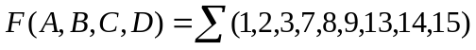 [5]

6)
Perform the following arithmetic operations. All numbers are stored using 8-bit registers with
2’s complements to represent negative numbers. Indicate clearly the carry on the row above.
[5x 2=10]
a) -67 – 37

b) 25 – 97

c) -97 – 37

d) -126 − 2

e) Indicate in which of the above cases an overflow error has occurred.

