Amdahl's Law Calculator and Parallel Speedup Analyzer
A Mini Project Report on Parallel Computing

1. Introduction
Parallel computing divides a computational task among multiple processors so that it completes faster than on a single processor. As the number of available processors continues to grow in modern computing systems, it becomes important to estimate, in advance, how much speedup a program can realistically achieve when it is parallelized. Not every part of a program can be executed in parallel; some portion must always run serially due to dependencies, shared resources, or sequential logic. Amdahl's Law provides a simple mathematical model to predict the theoretical speedup of a program based on the fraction of the program that can be parallelized and the number of processors used. This report presents a simple calculator that applies Amdahl's Law to compute and analyze theoretical speedup for varying numbers of processors.

2. Objectives
- To define the serial fraction and parallel fraction of a program.
- To implement Amdahl's Law formula for computing theoretical speedup.
- To test the calculator for 1, 2, 4, 8, and 16 processors.
- To generate a speedup table and a corresponding graph.
- To explain the concept of diminishing returns and determine the maximum theoretical speedup.

3. Amdahl's Law
Serial Fraction (S): The serial fraction is the portion of a program's execution time that must be carried out sequentially and cannot be divided among multiple processors. This includes tasks such as initialization, sequential dependencies, and I/O operations that must occur in a fixed order.
Parallel Fraction (P): The parallel fraction is the portion of the program's execution time that can be divided and executed simultaneously across multiple processors.
Since the serial and parallel portions together make up the entire program, the two fractions are related by:
S + P = 1
Amdahl's Law expresses the theoretical speedup obtained when a program with serial fraction S and parallel fraction P is executed on N processors:
Speedup(N) = 1 / (S + P / N)
Here, N represents the number of processors used to execute the parallel portion of the program. As N increases, the term P/N decreases, so the total execution time decreases and the speedup increases. However, the serial fraction S remains fixed regardless of the number of processors, which limits how much speedup can ultimately be achieved.

Applications of Amdahl's Law
Amdahl's Law is widely used in parallel and high-performance computing to reason about the benefits and limits of parallelization. Some of its common applications include:
- Predicting the theoretical performance gain before parallelizing a program, so developers can judge whether the effort is worthwhile.
- Guiding the design of multicore and multiprocessor systems by showing how many processors are actually useful for a given workload.
- Evaluating the performance scalability of software in high-performance computing (HPC) and cloud/distributed computing environments.
- Identifying serial bottlenecks in an application so that optimization efforts can be focused on the code that limits overall speedup.
- Supporting hardware procurement and resource-allocation decisions by estimating the return on adding more processing units.

4. System / Program Implementation
A simple Python program was developed to implement Amdahl's Law as a calculator. The program does not perform any actual parallel execution; it only computes the theoretical speedup predicted by the formula. The implementation consists of the following steps:
- Input: The serial fraction S is provided (the parallel fraction P is derived as P = 1 - S).
- Input: A list of processor counts N is provided (1, 2, 4, 8, 16).
- Calculation: For each value of N, the program applies the formula Speedup = 1 / (S + P/N).
- Output: The program prints a speedup table and plots a graph of Number of Processors versus Theoretical Speedup.
The core calculation is implemented as a single function that takes the serial fraction and the number of processors as input and returns the computed speedup, as shown below (simplified):
def amdahl_speedup(S, N):
P = 1 - S
return 1 / (S + P / N)

5. Speedup Table
The following table shows the theoretical speedup computed by the program for a serial fraction S = 0.10 (parallel fraction P = 0.90), for processor counts of 1, 2, 4, 8, and 16, which is used consistently across the table, the graph, and the worked examples of this report.
Number of Processors (N) | Theoretical Speedup
1 | 1.000
2 | 1.818
4 | 3.077
8 | 4.706
16 | 6.400

6. Graph
The graph below plots the number of processors (N) on the horizontal axis against the theoretical speedup on the vertical axis, for S = 0.10. The dashed red line marks the maximum theoretical speedup (1/S = 10).
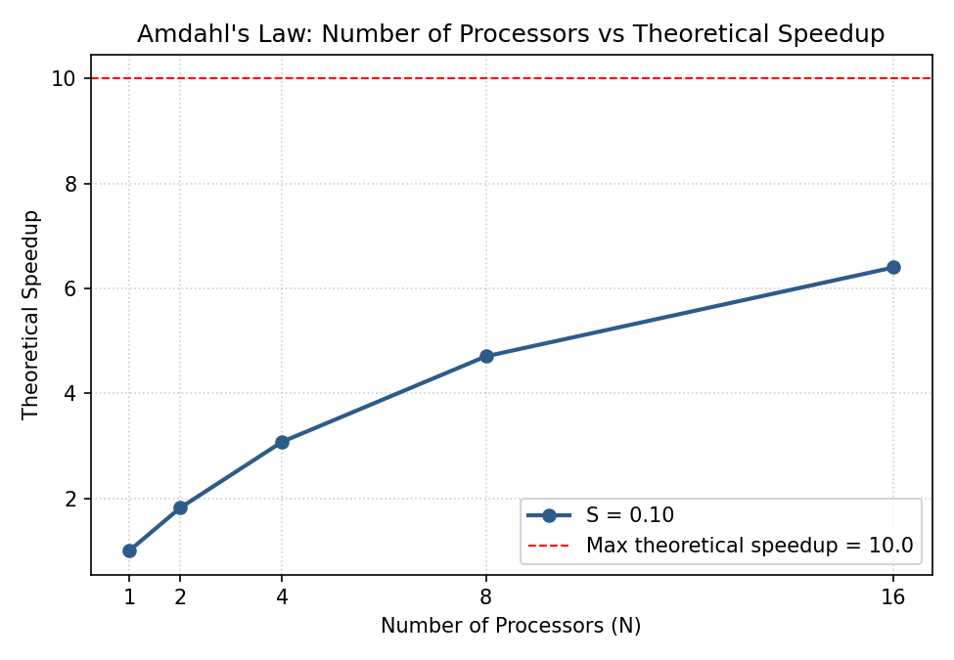
The graph shows that speedup increases rapidly at first as processors are added, but the curve gradually flattens as N grows larger. Beyond a certain point, adding more processors yields only small improvements in speedup, and the curve approaches, but never reaches, the maximum theoretical speedup line.

Annexure: Java Source Code (Core Calculation Logic)
The following code excerpts show the core Amdahl's Law calculation logic implemented in Java, used to compute the speedup values presented in this report. GUI (Swing) code is excluded; only the calculation and worked-example generation logic is listed.
// Required processor counts
private final int[] processors = {1, 2, 4, 8, 16};
// Core Amdahl's Law formula
private double calculateSpeedup(double serial, double parallel, int numberOfProcessors) {
return 1.0 / (serial + (parallel / numberOfProcessors));
}
// Input validation: S + P must equal 1
if (serial < 0 || parallel < 0) {
throw new IllegalArgumentException(
"Serial and parallel fractions cannot be negative.");
}

if (Math.abs((serial + parallel) - 1.0) > 0.000001) {
throw new IllegalArgumentException(
"Serial fraction + Parallel fraction must equal 1.");
}
// Computing speedup for each processor count (N = 1, 2, 4, 8, 16)
double[] speedups = new double[processors.length];

for (int i = 0; i < processors.length; i++) {
int n = processors[i];
speedups[i] = calculateSpeedup(serial, parallel, n);
}
// Maximum theoretical speedup: Speedup(max) = 1 / S
double maxSpeedup;

if (serial == 0) {
maxSpeedup = Double.POSITIVE_INFINITY;
} else {
maxSpeedup = 1.0 / serial;
}
// Generating worked numerical examples for each processor count
for (int i = 0; i < processors.length; i++) {
int n = processors[i];
double speedup = calculateSpeedup(serial, parallel, n);

// Example N: Speedup = 1 / (S + P / N) = speedup
}
A screenshot of the working calculator, showing the input parameters, the speedup table, and the generated graph, is presented below:
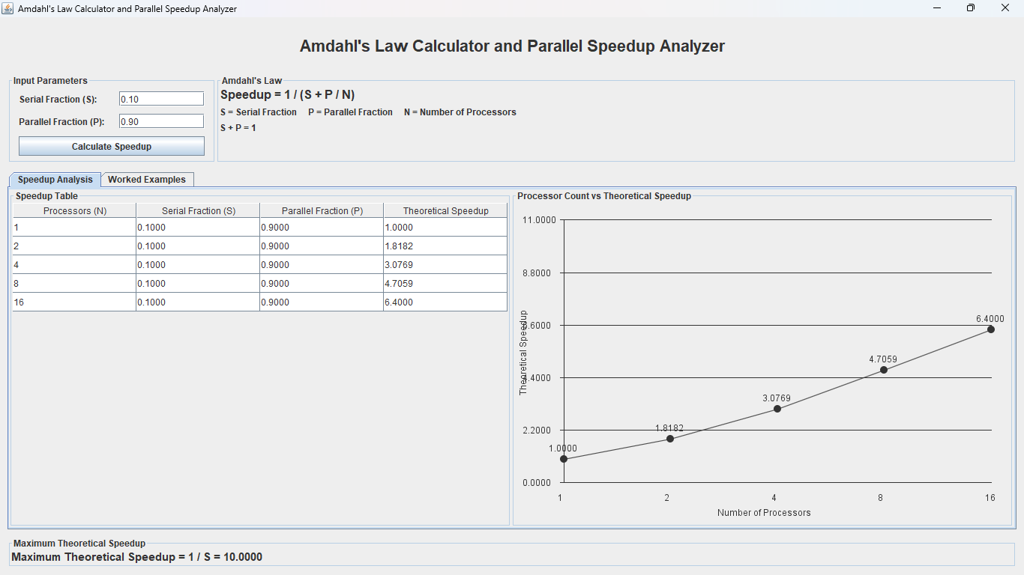
Figure: Output screenshot of the Amdahl's Law calculator, showing the entered serial/parallel fractions, the resulting speedup table for N = 1, 2, 4, 8, 16, and the corresponding speedup graph.

7. Worked Numerical Examples

Example 1: S = 0.10, N = 4
Given: Serial fraction S = 0.10, Parallel fraction P = 0.90, Number of processors N = 4.
Speedup = 1 / (S + P / N)
Substitution: Speedup = 1 / (0.10 + 0.90 / 4)
Calculation: Speedup = 1 / (0.10 + 0.22500) = 1 / 0.32500
Final Speedup = 3.077

Example 2: S = 0.25, N = 8
Given: Serial fraction S = 0.25, Parallel fraction P = 0.75, Number of processors N = 8.
Speedup = 1 / (S + P / N)
Substitution: Speedup = 1 / (0.25 + 0.75 / 8)
Calculation: Speedup = 1 / (0.25 + 0.09375) = 1 / 0.34375
Final Speedup = 2.909

Example 3: S = 0.05, N = 16
Given: Serial fraction S = 0.05, Parallel fraction P = 0.95, Number of processors N = 16.
Speedup = 1 / (S + P / N)
Substitution: Speedup = 1 / (0.05 + 0.95 / 16)
Calculation: Speedup = 1 / (0.05 + 0.05937) = 1 / 0.10938
Final Speedup = 9.143

Example 4: S = 0.50, N = 2
Given: Serial fraction S = 0.50, Parallel fraction P = 0.50, Number of processors N = 2.
Speedup = 1 / (S + P / N)
Substitution: Speedup = 1 / (0.50 + 0.50 / 2)
Calculation: Speedup = 1 / (0.50 + 0.25000) = 1 / 0.75000
Final Speedup = 1.333

Example 5: S = 0.10, N = 16
Given: Serial fraction S = 0.10, Parallel fraction P = 0.90, Number of processors N = 16.
Speedup = 1 / (S + P / N)
Substitution: Speedup = 1 / (0.10 + 0.90 / 16)
Calculation: Speedup = 1 / (0.10 + 0.05625) = 1 / 0.15625
Final Speedup = 6.400

8. Diminishing Returns
Amdahl's Law shows that increasing the number of processors does not produce unlimited speedup. As N increases, the parallel term P/N becomes progressively smaller, but the serial term S remains constant. Once P/N becomes very small compared to S, adding further processors has almost no effect on the total execution time, because the serial portion dominates the overall runtime. This behavior is clearly visible in the speedup table and graph above: the speedup gain from N = 1 to N = 2 is much larger than the gain from N = 8 to N = 16, even though the number of processors doubles in both cases. This is known as diminishing returns.

9. Maximum Theoretical Speedup
As the number of processors N approaches infinity, the parallel term P/N approaches zero, and the speedup formula reduces to:
Speedup(max) = 1 / S
For the primary example used in this analysis, S = 0.10, so the maximum theoretical speedup is 1 / 0.10 = 10. This means that no matter how many processors are used, this program can never run more than 10 times faster than its single-processor execution, because 10% of it must always execute serially.

10. Results and Discussion
The speedup table and graph confirm the behavior predicted by Amdahl's Law. For S = 0.10, speedup rises from 1.000 at N = 1 to 6.400 at N = 16, while the maximum achievable speedup for this program is capped at 10. The worked examples further demonstrate that a larger serial fraction (as in Example 4, where S = 0.50) severely limits achievable speedup even for small N, while a smaller serial fraction (as in Example 3, where S = 0.05) allows much higher speedup for the same number of processors. This confirms that the serial fraction, rather than the number of processors alone, is the dominant factor governing the limits of parallel performance.

11. Conclusion
This mini project successfully implements Amdahl's Law as a simple calculator to analyze theoretical speedup for a parallel program. The program computes speedup for 1, 2, 4, 8, and 16 processors, generates a speedup table and graph, and demonstrates through worked examples how the serial fraction limits achievable performance. The results confirm that speedup increases with the number of processors but is ultimately bounded by the serial fraction of the program, as expressed by the maximum theoretical speedup, 1/S.

12. References
1. G. M. Amdahl, "Validity of the single processor approach to achieving large scale computing capabilities," AFIPS Conference Proceedings, vol. 30, pp. 483-485, 1967.
2. B. Wilkinson and M. Allen, Parallel Programming: Techniques and Applications Using Networked Workstations and Parallel Computers, 2nd ed., Pearson, 2005.
3. A. Grama, A. Gupta, G. Karypis, and V. Kumar, Introduction to Parallel Computing, 2nd ed., Addison-Wesley, 2003.

