Project Proposal

TIH - IoT CHANAKYA Fellowship
Program 2026

Image-based Disease Detection leveraging Machine Learning Approaches for the crops (Mention names of the crops)
Submitted by
Faculty Name
Affiliation
Date of Submission


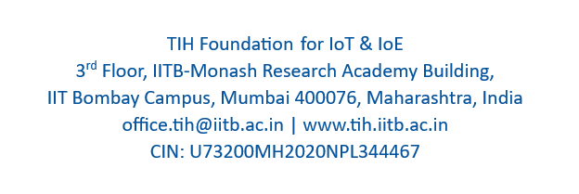


Executive Summary
This section will summarize the entire document by describing the background for the project, problem statement, objective, deliverables and timeframe. (Length: Max 250 words).

1 Background
Provide a brief historical view of the problem being addressed, so that it sets the context upon which the project will be initiated. (Length: Max 200 words)
Select any two crops. Provide a brief study of the diseases in the targeted crops.

2 Statement of the problem
Mention the original problem statement along with the names of the focused crops. Provide briefly the work done previously (Length: Max 100 words)

3 Objectives
Define the scope of work and clearly state the project objectives, including the following:
Try to make the objective of the project “SMART” which means Specific, Measurable, Action orientated, Realistic and Time based (Length: Max 100 words)

4 Deliverables
- In this section, provide a detailed description of what you are providing, the solution that solves the problem.
- List all of the key deliverables that are to be produced in as much depth as possible.
- Deliverables shall be quantitative i.e. some performance parameters, accuracy etc. (Length: Max 100 words)

5 Project Plan with Major Milestones
- All projects must be delivered within a specific timeframe as specified in the call..
- The major milestones to be achieved should be specified clearly in the project plan.
- Monthly milestones can be specified in the project plan.
Sr. No. | Milestone | Target Date | Remarks
1
2
3
4

6 Resources and budget
- In order to approve the Project Proposal, it is necessary to understand the amount of resources/ students required to undertake it.
- Resource requirements should include the details regarding equipment and materials needed to undertake the project. (Length: Max 100 words)
- This is only to get an idea about the project budget for the reviewers. TIH-IoT will not be providing any budget for the project development.

7 Appendix

Brief about the background work accomplished by the faculty/ team of students in image analysis/ computer vision.

List of relevant publications of faculty, students

