Permutated 10000 anchored alignments

HOX

Alignment score of original sequence is 64

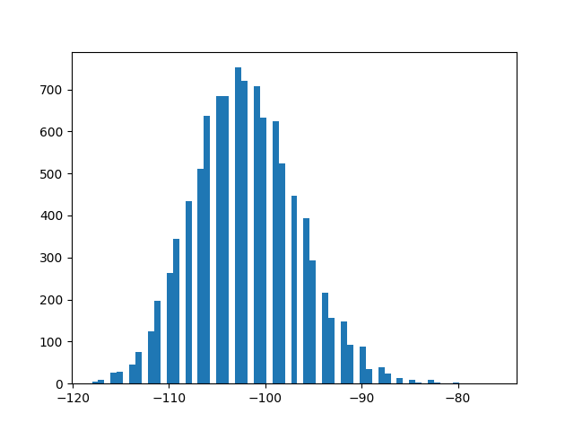

PAX

Alignment score of original sequence is 182

