RIPHAH INTERNATIONAL UNIVERSITY



Faculty of Computing
FINAL YEAR PROJECT PROPOSAL & PLAN

Wheat Rust Guard

Project Team
Full Name of Student | SAP Id | Program | Contact Number | Email Address
Naqi Turab | 36520 | BSCS | 03485241190 | 36520@students.riphah.edu.pk
Haider Ali Sammar | 38192 | BSCS | 03325784041 | 38192@students.riphah.edu.pk
Jasim Sagheer | 32676 | BSCS | 03315807601 | 32676@students.riphah.edu.pk

Mr. Zeeshan Ali
(Junior Lecturer)
Wheat Rust Guard

Change Record

Author(s) | Version | Date | Notes | Supervisor’s Signature
Jasim Sagheer, Naqi Turab, Haider Ali Sammar | 1.0 | 10-Sep-2024 | Original Draft
Jasim Sagheer, Naqi Turab, Haider Ali Sammar | 2.0 | 26-Sep-2024 | Changes Based on Feedback From Supervisor

Project Proposal
Project Title: Wheat Rust Guard

Opportunity & Stakeholders:
Wheat is one of the major crops in Pakistan, being an important contributor to its economy; however, farmers here go through some challenges in the identification and management of wheat rust disease caused by fungus that has prevailed in decreasing the yields in wheat production and also caused economic loss. We can bring value through exploiting AI-based solution to detect the diagnosis at the early stage so as to help farmers with early action plans and reduce the damage. Key stakeholders of this solution are wheat farmers, agriculture experts and researchers of crop health management. This shall enable the farmers to safeguard their crops with reduced losses by incorporation of machine learning and image technologies toward better yield for sustainability in the agricultural economy.
Existing System/ Description of the Current Situation:
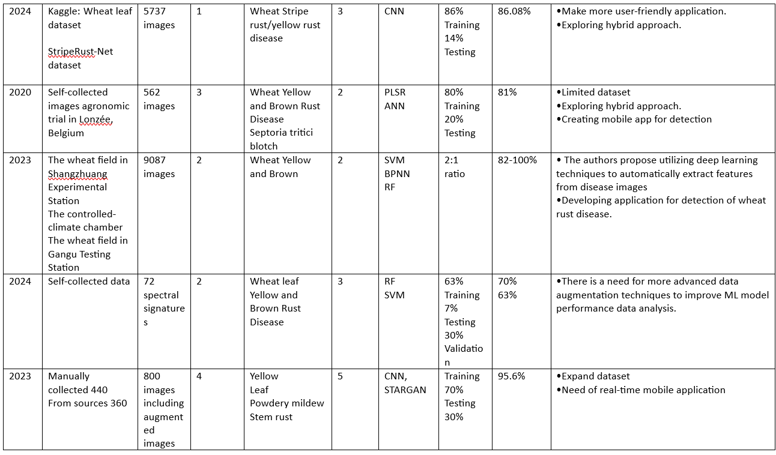
Wheat is Pakistan’s primary crop and wheat rust (Yellow and Brown types) poses a major threat to quality and reducing crop yield. In Pakistan 36% of wheat fields are affected by brown rust and on the other hand 19% suffer from yellow rust. The current methods of wheat rust detection are slow and not optimized for real-time detection.

Problem Statement:

The research on wheat rust diseases is currently limited by a lack of diverse datasets and insufficient exploration of hybrid machine learning methods, leading to less-than-optimal performance of disease classification models. Furthermore, there is a requirement for a user-friendly, real-time system to accurately detect wheat diseases.

Proposed Solution:
The proposed solution focuses on addressing wheat rust detection challenges by using diverse datasets for training to improve model robustness. It also involves developing a hybrid model that combines machine learning and deep learning techniques to enhance detection accuracy. Additionally, the project aims to create a user-friendly, real-time mobile application that allows farmers and agricultural experts to efficiently detect wheat yellow and brown.

Scope:
Development of Machine Learning Model:
- Data Collection: Acquire publicly available datasets of images of wheat depicting variable yellow and brown rust intensities.
- Data Preprocessing:
- Data Augmentation: Enhance the dataset by using techniques like image rotation, flipping, cropping, zooming, and brightness adjustment to expand its size and diversity.
- Model Training: Building and training a machine learning model on the detection of yellow and brown rust diseases.
Application Development:
- Platform: Development of an android application for disease diagnosis that will be very user-friendly.
- Integration: Integrate machine learning model into the mobile application for identifying yellow and brown rust diseases through images in real time.
Testing: Perform the validation of an application with real users.
List of Faculty Proposed Changes
Project Title

Supervisor’s Signature: ______________

Proposed Change | Proposed By | Supervisor’s Decision
Updated literature review for refinement of problem statement | Mr. Mubariz Rehman,  Mr. Muhammad Usman Sharif,  Mr. Hassan Ashraf,  Mr. Imran Khan | After refinement discuss with teachers
Project scope fine, dataset choice should be clear | Mr. Abdul Mateen | Approve.
Ensure app effectiveness and focus on collecting high quality images which vary with environment such as dust or varying weather | Mr. Abdullah,  Mr. Ihtisham Ullah | Approve.  Check latest methods to address the different environment conditions.
Ensure relevance and accuracy | Mr. Tajamul Shahzad
Incomplete datasets information collection | Mr. Muhammad Usman | Find publically available datasets.
Correctly map problem statement and do extensive literature review | Mr. Muhammad Usman Sharif | Do extensive literature review.
Rewrite problem statement and should be clear | Mr. Sherjeel Gillani,  Mr. Tabassum Javed | After rewriting problem statement discuss with Teachers
Do consider irrelevant classes for model development | Mr. Hassan Ashraf | Approved
Research more about brown rust | Mr. Zeeshan Ali

Project Plan

Roles & Responsibility Matrix:
The purpose of roles & responsibility matrix is to identify who will do what.
WBS # | WBS Deliverable | Activity # | Activity to Complete the Deliverable | Duration  (# of Days) | Responsible Team Member(s) & Role(s)
1 | Feasibility Study | 1.0 | Research Work  Performance Study | 15 days | Jasim Sagheer, Haider Ali Sammar, Naqi Turab
2 | Reports/ Documentation | 2.0 | Proposed Final Report/ Final Documentation | 35-40 days | Jasim Sagheer, Naqi Turab Haider Ali Sammar
 | Frontend Development | 2.1 | Android App Development | 25-30 days | Naqi Turab, Jasim Sagheer
3 | Hybrid Approach Model | 3.0 | Collecting Dataset | 25 days | Jasim Sagheer, Haider Ali Sammar
 |  | 3.1 | Performing EDA/ Data Augmentation/ Pre-Processing | 20-25 days | Jasim Sagheer
 |  | 3.2 | Performing Different Algorithms to Achieve Best Results | 25 days | Haider Ali Sammar, Jasim Sagheer, Naqi Turab
4 | Backend Development | 4.0 | Backend Work (App Development) | 30 days | Naqi Turab, Haider Ali Sammar
 |  | 4.1 | Integrating Model and App | 5-8 days | Haider Sammar
 |  | 4.2 | Performing Testing and Validation | 10 days | Jasim Sagheer, Naqi Turab, Haider Ali Sammar

Approval
Project Supervisor
Comments_______________________________________________________________
________________________________________________________________________
________________________________________________________________________
________________________________________________________________________
Name:______________________________
Date:_______________________________ | Signature:__________________________

Project Coordinator
Comments_______________________________________________________________
________________________________________________________________________
________________________________________________________________________
________________________________________________________________________
________________________________________________________________________
Name:______________________________
Date:_______________________________ | Signature:__________________________

