YUVA INTERN
WEEK 4 FINAL PROJECT REPORT
Comprehensive Data Analysis, Statistical Modeling
and Predictive Reporting
Telecom Customer Churn Analysis

Project Item | Details
Dataset | Telecom Customer Churn Dataset
Original data | 7,043 observations × 38 variables
Modeling data | 6,589 Stayed/Churned observations
Predictive model | Binary Logistic Regression
Training / test | 5,271 / 1,318 observations
Software | R 4.6.1 and RStudio
Analysis period | Weeks 1–4 integrated project

Prepared for the Virtual R Data Analyst Internship

1. Executive Summary
This final Week 4 report integrates the data-cleaning, visualization, statistical-analysis, and predictive-modeling work completed across the previous internship tasks into one coherent telecom customer churn study. The project uses a telecom dataset containing 7,043 customer records and 38 original variables. The overall objective is to identify important churn patterns, test whether selected customer characteristics differ between churned and stayed customers, and develop an interpretable model that can support retention decisions.
The first stage established data quality. Missing values were reviewed and treated using business meaning where possible, duplicates were checked, potential outliers were identified using the IQR rule, and 120 invalid negative Monthly Charge values were corrected. Selected numerical variables were normalized and selected categorical variables were encoded. The exploratory stage then showed 1,869 churned customers, 4,720 stayed customers, and 454 joined customers.
Visualization and statistical analysis provided stronger evidence. Competitor-related reasons represented 44.99% of recorded churn reasons. Month-to-Month customers had an observed churn share of 45.84%, compared with 10.71% for One Year and 2.55% for Two Year contracts. Welch t-tests showed significant differences in Monthly Charge and Tenure between churned and stayed customers. Churned customers had a higher mean Monthly Charge (74.55) and much shorter mean tenure (17.98 months) than stayed customers (63.09 and 41.04 months respectively).
The final predictive stage used binary logistic regression. On the held-out test set, the model achieved 84.05% accuracy, 74.57% precision, 68.32% recall, and a 71.31% F1 score. The confusion matrix contained 121 false negatives, meaning that some actual churners were not detected. Therefore, the model is a useful baseline decision-support tool, but it should not be treated as a perfect churn detector. Threshold tuning, repeated cross-validation, alternative algorithms, additional behavioral features, and probability calibration are recommended for future improvement.

2. Project Objectives
- Integrate the analytical work completed across Weeks 1, 2, and 3 into one coherent report.
- Document the data-cleaning and preprocessing workflow in a reproducible way.
- Communicate important customer and churn patterns through appropriate visualizations.
- Apply descriptive and inferential statistical techniques to compare churned and stayed customers.
- Build and evaluate a binary logistic regression model for churn prediction.
- Interpret statistical and predictive results in business terms rather than reporting metrics alone.
- Identify model limitations, false-negative risk, and practical opportunities for improvement.
- Provide actionable recommendations for customer-retention strategy and future analytics.

3. Integrated Methodology
Stage | Main Work | Key Output
Week 1 — Preparation | Inspection, missing values, duplicates, outliers, invalid charges, normalization, encoding | Clean analytical dataset
Week 2 — Visualization | Status, age, revenue, contract, tenure, churn-category visualizations | Visual evidence and descriptive insights
Week 3 — Statistics | t-tests, correlation, normality, logistic regression, diagnostics | Statistical evidence and predictive model
Week 4 — Integration | Business interpretation, limitations, recommendations, final presentation | Comprehensive final report

4. Dataset and Business Context
The dataset contains customer-level information covering demographics, service subscriptions, contract type, payment method, billing, revenue, customer status, and churn information. This combination is useful because it connects customer characteristics with commercially meaningful retention outcomes. The data also contains categorical and numerical variables, making it suitable for both visualization and statistical modeling.
Measure | Value
Original records | 7,043
Original variables | 38
Stayed customers | 4,720 (67.02%)
Churned customers | 1,869 (26.54%)
Joined customers | 454 (6.45%)
Modeling observations | 6,589
Training observations | 5,271
Testing observations | 1,318

5. Data Preparation and Quality Management

5.1 Initial Inspection
The initial workflow used dim(), str(), summary(), and direct frequency checks to understand dataset size, data types, distributions, and categorical structure. The source contained 7,043 records and 38 variables, with a mixture of integer, numeric, and character fields.
dim(data)
str(data)
summary(data)

5.2 Missing-Value Treatment
Missingness was not handled with a single blanket rule. Service-related blanks were interpreted using business context. For example, customers without internet service were assigned explicit No Internet Service categories for applicable fields, and customers without phone service were assigned No Phone Service for Multiple Lines. Churn fields for customers who had not churned were treated as Not Applicable. Remaining numerical missing values were treated using median-based imputation where appropriate. Final verification showed zero missing values in the analyzed dataset.
- Churn Category and Churn Reason contained large amounts of missingness because they were not applicable to non-churned customers.
- Several internet-service variables had 1,526 missing/blank observations associated with customers without internet service.
- Multiple Lines and Average Monthly Long Distance Charges each had 682 missing/blank observations.
- Final missing-value checks were performed before inferential analysis and modeling.

5.3 Duplicate and Outlier Checks
The duplicate check returned zero exact duplicate rows. Potential numerical outliers were detected using the IQR rule. These observations were not automatically deleted because extreme customer behavior can be legitimate. Examples included potential outliers in Number of Dependents, Number of Referrals, Average Monthly GB Download, Total Refunds, Total Extra Data Charges, Total Long Distance Charges, and Total Revenue.
sum(duplicated(data))
# IQR-based outlier detection
Q1 <- quantile(x, 0.25, na.rm = TRUE)
Q3 <- quantile(x, 0.75, na.rm = TRUE)
IQR_value <- Q3 - Q1
lower <- Q1 - 1.5 * IQR_value
upper <- Q3 + 1.5 * IQR_value

5.4 Invalid Billing Values
A notable quality problem was 120 negative Monthly Charge values. Negative monthly billing is not meaningful in this business context, so the values were converted to missing and replaced with the median valid Monthly Charge. A final validation returned zero negative Monthly Charge values.
sum(data$Monthly.Charge < 0)
data$Monthly.Charge[data$Monthly.Charge < 0] <- NA
data$Monthly.Charge[is.na(data$Monthly.Charge)] <-
median(data$Monthly.Charge, na.rm = TRUE)
sum(data$Monthly.Charge < 0) # 0

5.5 Normalization and Encoding
Min-max normalization was applied to selected numerical variables, including Age, Monthly Charge, and Total Revenue, producing values between 0 and 1. Selected binary categorical variables were also encoded as 0/1 indicators while retaining the original fields for interpretability.

6. Exploratory Analysis and Visualization
The visualization stage translated the cleaned dataset into a visual narrative. The charts were selected to answer different analytical questions: overall customer status, age distribution, relationships between financial measures, contract-level differences, tenure-related revenue patterns, and the reasons recorded for churn.

6.1 Customer Status
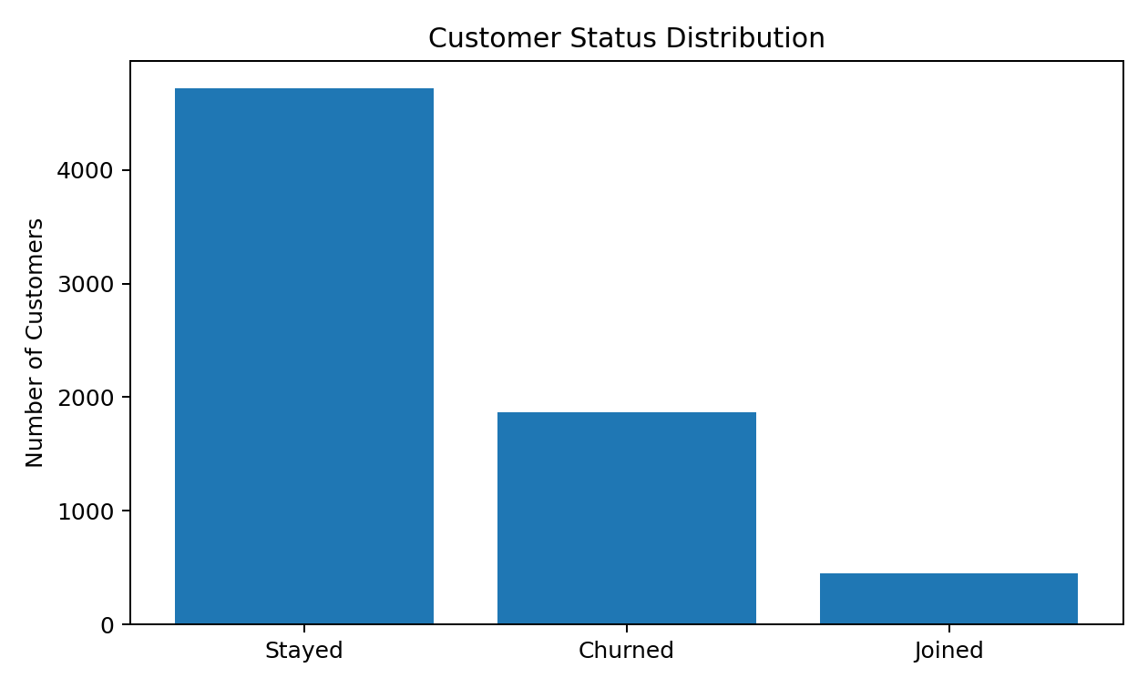
Figure 1. Customer status distribution.
The dataset contains 4,720 stayed customers, 1,869 churned customers, and 454 joined customers. The churned group therefore represents 26.54% of the full dataset. This is large enough to justify dedicated retention analysis rather than treating churn as a rare edge case.

6.2 Churn Category
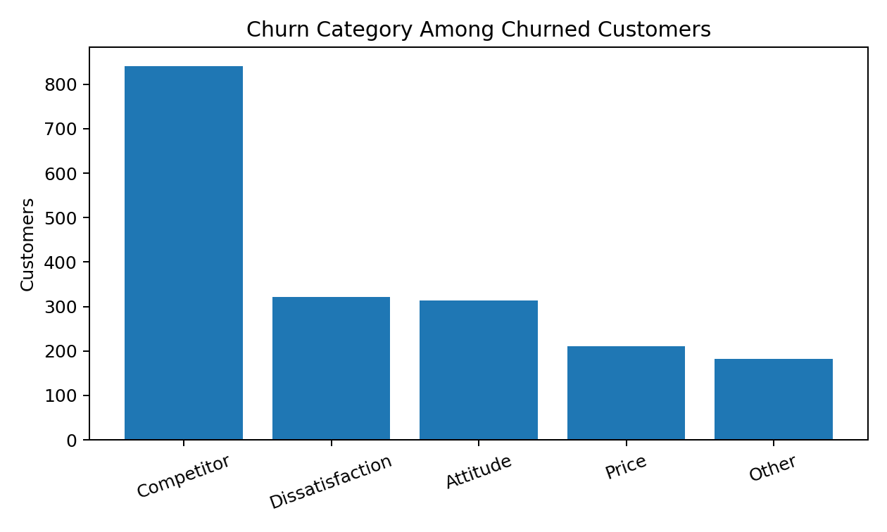
Figure 2. Recorded churn categories among churned customers.
Competitor-related churn is the largest recorded category, with 841 customers or 44.99% of the 1,869 churned customers. Dissatisfaction accounts for 17.17%, Attitude for 16.80%, Price for 11.29%, and Other for 9.74%. This suggests that competitive pressure is an important area for retention investigation, while service experience and pricing remain additional areas for action.

6.3 Contract Type
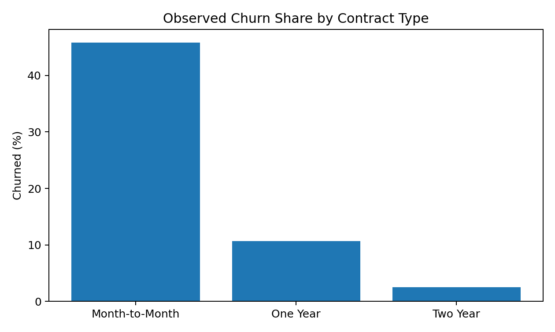
Figure 3. Observed churn share within each contract type.
The observed churn share is much higher for Month-to-Month customers than for customers on longer contracts. Within the Month-to-Month group, 45.84% are churned; the corresponding values are 10.71% for One Year and 2.55% for Two Year. These are associations in the observed data and do not prove that contract length alone causes churn.

6.4 Supporting Visual Evidence from Week 2
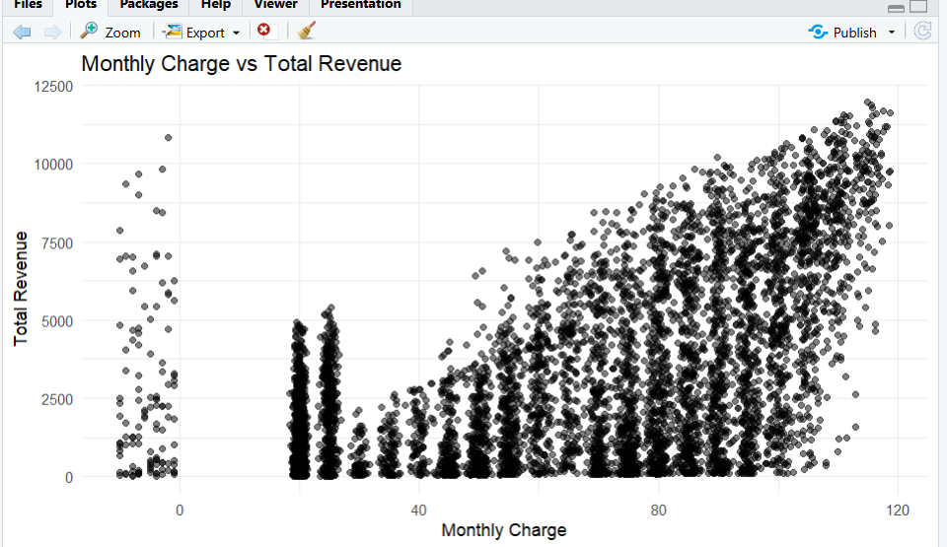
Figure 4. Monthly Charge versus Total Revenue visualization from the Week 2 analysis.
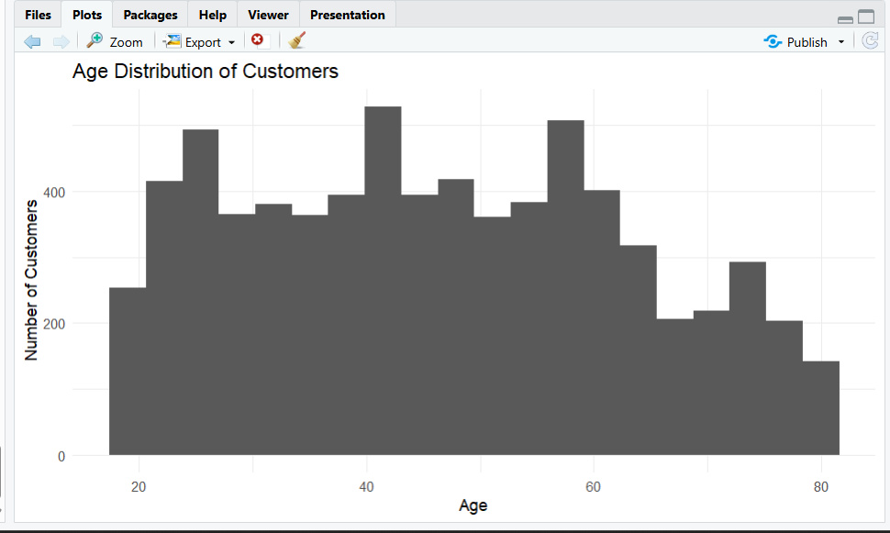
Figure 5. Age distribution visualization from the Week 2 analysis.
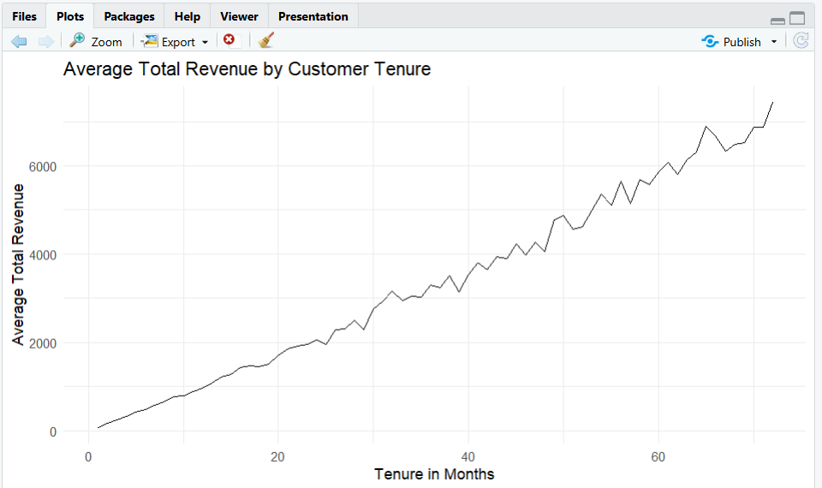
Figure 6. Average Total Revenue by customer tenure.
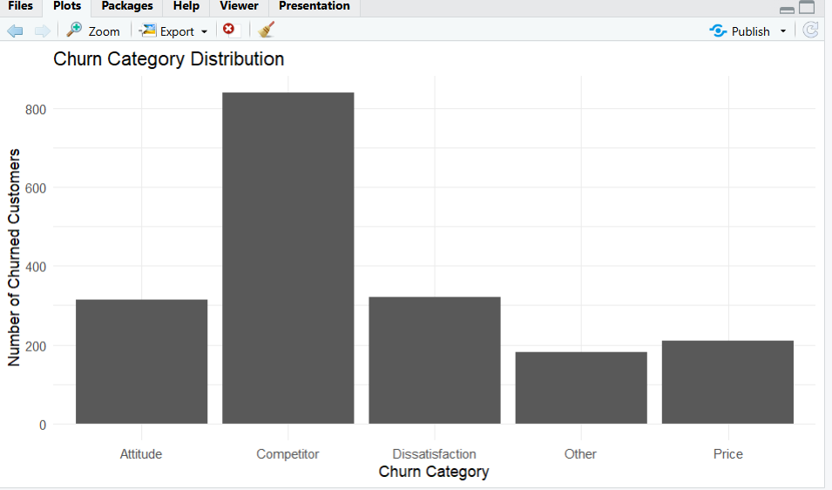
Figure 7. Churn category distribution visualization.

7. Statistical Analysis

7.1 Hypothesis Test: Monthly Charge
Null hypothesis (H0): the mean Monthly Charge is equal for Churned and Stayed customers. Alternative hypothesis (H1): the means are different. A Welch two-sample t-test was used because it does not require the two groups to have equal population variances.
Statistic | Result
Churned mean | 74.595
Stayed mean | 63.136
Welch t | 15.872
Degrees of freedom | 4307.6
p-value | < 2.2e-16
95% CI | 10.044 to 12.875

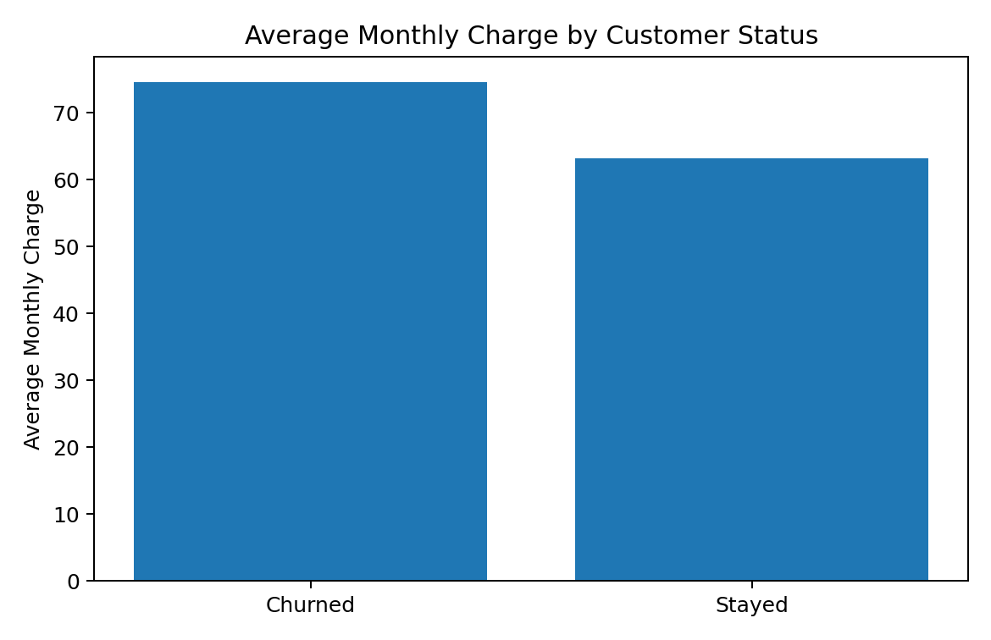
Figure 8. Mean Monthly Charge by customer status.
The p-value is far below 0.05, so the null hypothesis is rejected. Churned customers have a higher average Monthly Charge by approximately 11.46 units. This is strong evidence of a group difference, but it should not be interpreted as proof that higher charges cause churn.

7.2 Hypothesis Test: Tenure
Statistic | Result
Churned mean tenure | 17.979 months
Stayed mean tenure | 41.042 months
Welch t | -41.417
Degrees of freedom | 3895.4
p-value | < 2.2e-16
95% CI | -24.154 to -21.971

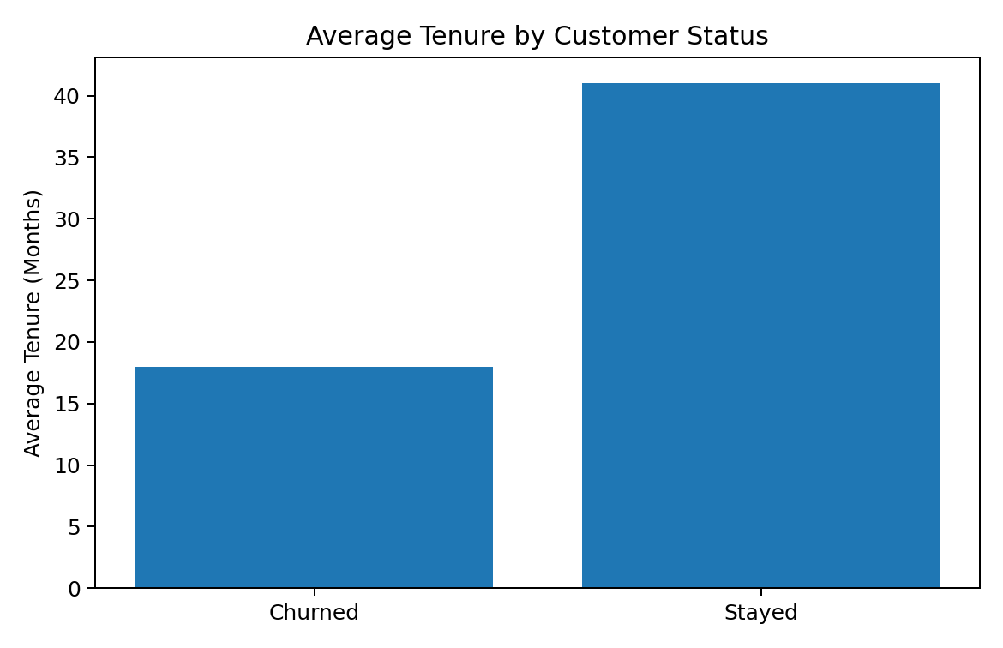
Figure 9. Mean tenure by customer status.
The null hypothesis is rejected. Stayed customers have approximately 23 months more average tenure than churned customers. The difference is both statistically significant and practically important for retention analysis.

7.3 Correlation Analysis
Variable Pair | Correlation | Interpretation
Total Charges vs Total Revenue | 0.97 | Very strong positive
Tenure vs Total Revenue | 0.84 | Strong positive
Tenure vs Total Charges | 0.83 | Strong positive
Monthly Charge vs Total Charges | 0.64 | Moderate/strong positive
Monthly Charge vs Total Revenue | 0.58 | Moderate positive
GB Download vs Monthly Charge | 0.38 | Moderate positive
Age vs Monthly Charge | 0.13 | Weak positive

The 0.97 correlation between Total Charges and Total Revenue indicates substantial overlap between the two measures. This supports avoiding both highly redundant revenue measures in the final logistic regression model. Correlation describes linear association and does not establish causation.

7.4 Normality Assessment
A Shapiro-Wilk test on a sample of Monthly Charge values produced W = 0.92434 with p < 2.2e-16, indicating departure from a normal distribution. This result is useful for understanding the data, but logistic regression does not require predictors themselves to be normally distributed.

8. Predictive Modeling

8.1 Target Definition
For predictive modeling, Customer Status was converted into a binary outcome: Churned = 1 and Stayed = 0. The 454 Joined customers were excluded because they did not represent an observed retention or churn outcome. This produced 6,589 modeling observations: 4,720 stayed and 1,869 churned.
model_data <- data %>%
filter(Customer.Status %in% c("Churned", "Stayed"))
model_data$Churn <- ifelse(
model_data$Customer.Status == "Churned", 1, 0
)

8.2 Train/Test Split
Dataset | Rows | Purpose
Modeling data | 6,589 | Stayed vs Churned outcomes
Training set | 5,271 | Fit the logistic regression
Testing set | 1,318 | Evaluate unseen observations

An 80/20 train-test split was used. The test set was held out from model fitting and used to estimate performance on unseen observations.

8.3 Logistic Regression Model
The binary logistic regression model used Age, Number of Dependents, Number of Referrals, Tenure in Months, Monthly Charge, Contract, Internet Service, Paperless Billing, and Payment Method. These predictors were selected to represent demographics, customer engagement, billing intensity, contract commitment, service behavior, and payment behavior while keeping the model interpretable.
logistic_model <- glm(
Churn ~ Age + Number.of.Dependents +
Number.of.Referrals + Tenure.in.Months +
Monthly.Charge + Contract +
Internet.Service + Paperless.Billing +
Payment.Method,
family = binomial,
data = train_data
)
summary(logistic_model)

8.4 Key Model Signals
Predictor | Odds Ratio | Interpretation
Age | 1.015 | Small increase in modeled odds per unit, holding other variables constant
Dependents | 0.614 | Lower modeled odds per additional dependent
Referrals | 0.758 | Lower modeled odds per additional referral
Tenure | 0.966 | Longer tenure associated with lower modeled churn odds
Monthly Charge | 1.021 | Higher charge associated with higher modeled churn odds
One Year Contract | 0.288 | Much lower odds vs reference contract
Two Year Contract | 0.092 | Much lower odds vs reference contract
Paperless Billing | 1.373 | Higher modeled odds vs reference
Mailed Check | 1.451 | Higher modeled odds vs reference payment method

Odds ratios are conditional associations from the fitted model. They should not be interpreted as causal effects. Reference categories also matter when interpreting categorical predictors.

9. Model Evaluation and Diagnostics

9.1 Confusion Matrix
Actual \ Predicted | 0 — Stayed | 1 — Churned
0 — Stayed | 846 (TN) | 89 (FP)
1 — Churned | 121 (FN) | 261 (TP)

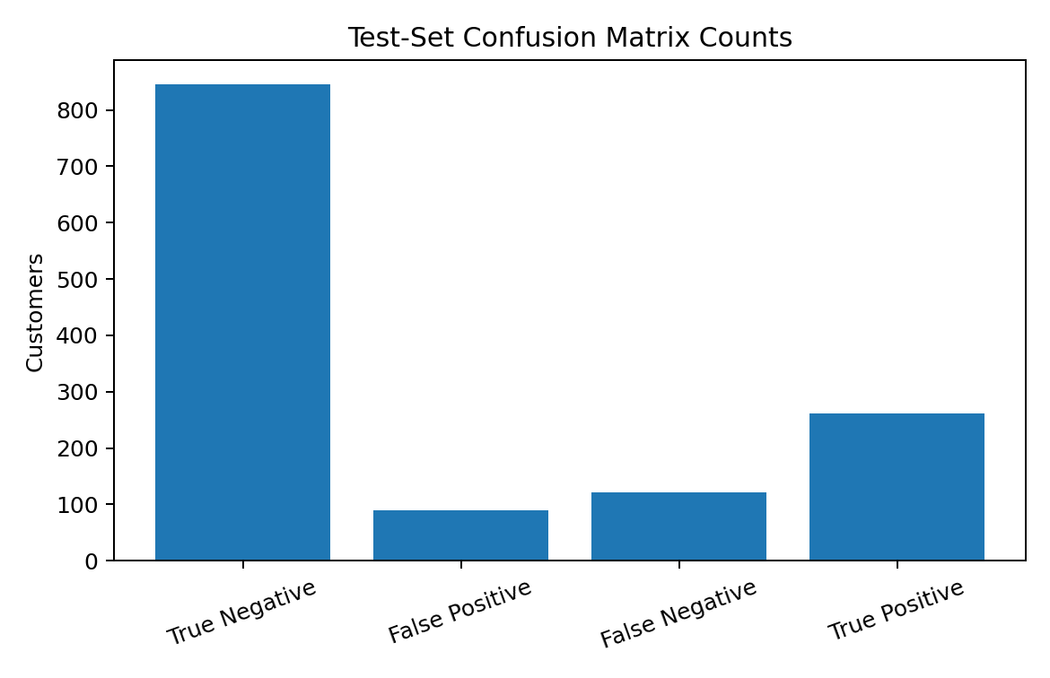
Figure 10. Confusion matrix counts on the test set.
The model correctly identified 846 stayed customers and 261 churned customers. It incorrectly flagged 89 stayed customers as churners and missed 121 actual churners. In a retention setting, the 121 false negatives are particularly important because these customers may leave without being identified for intervention.

9.2 Performance Metrics
Metric | Result | Business meaning
Accuracy | 84.05% | Overall share of correct classifications
Precision | 74.57% | Share of predicted churners who actually churned
Recall | 68.32% | Share of actual churners detected
F1 Score | 71.31% | Balance between precision and recall

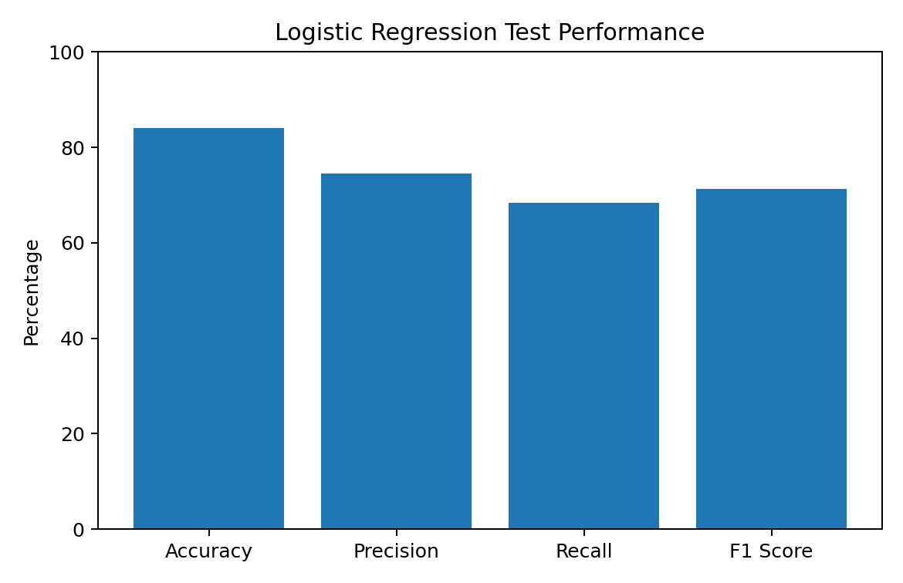
Figure 11. Logistic regression performance metrics.
Accuracy is strong for a baseline model, but recall is lower than accuracy. This means the model is better at overall classification than at detecting every actual churner. If the business cost of missing a likely churner is high, recall should receive greater attention than accuracy alone.

9.3 Residual Diagnostics and Multicollinearity
A residuals-versus-fitted diagnostic was examined for unusual observations and systematic patterns. The analysis also calculated VIF values. The VIF values ranged from approximately 1.04 to 2.08, which provides no strong evidence of problematic multicollinearity among the selected predictors.
Diagnostic | Finding
Residual diagnostic | Used to inspect unusual observations and systematic patterns
VIF range | Approximately 1.04–2.08
Multicollinearity conclusion | No strong evidence of problematic multicollinearity

10. Integrated Findings and Business Discussion

10.1 Finding 1 — Contract Commitment Is Strongly Associated with Churn
The descriptive contract analysis shows a major difference in customer status across contract types. Month-to-Month customers have a 45.84% observed churn share, while One Year and Two Year customers have much lower observed churn shares. The logistic model also produces odds ratios below 1 for the One Year and Two Year contract indicators relative to the reference category. This consistency across descriptive and predictive analysis makes contract structure an important retention signal.

10.2 Finding 2 — Tenure Is a Major Retention Signal
Stayed customers average 41.04 months of tenure compared with only 17.98 months among churned customers. The Welch test is highly significant, and the logistic regression tenure odds ratio is below 1. Together, these results indicate that customer relationship duration is strongly associated with retention. Early-life customer engagement should therefore be a priority for intervention.

10.3 Finding 3 — Higher Monthly Charges Are Associated with Churn
Churned customers have an average Monthly Charge of 74.55 compared with 63.09 for stayed customers. The difference is highly significant, and the logistic regression odds ratio for Monthly Charge is above 1. This does not prove that pricing causes churn; it indicates that higher billing levels are associated with greater modeled churn risk after accounting for the other selected variables.

10.4 Finding 4 — Competition Is the Largest Recorded Churn Category
Competitor is the largest churn category at 841 customers, representing 44.99% of churned customers. This finding suggests that retention strategy should not focus only on internal service problems. Competitive offers, perceived value, contract flexibility, and customer switching incentives should also be investigated.

10.5 Finding 5 — The Model Is Useful but Misses Some Churners
The model's 84.05% accuracy demonstrates useful predictive ability, but 121 actual churners were classified as non-churners. For a retention program, these false negatives represent a material business risk. A model should therefore be evaluated according to the cost of missed churn, not accuracy alone.

11. Model Limitations and Lessons from Evaluation
- The analysis is based on one telecom dataset and may not generalize to other companies or time periods.
- The logistic regression captures an interpretable baseline relationship but may miss nonlinear patterns and interactions.
- The 68.32% recall shows that a meaningful number of churners remain undetected.
- A single train/test split can produce a performance estimate that varies with the random split.
- Statistical association does not establish causation.
- The model uses available customer attributes but may lack richer behavioral information such as service-contact history, complaint frequency, recent usage changes, or offer-response history.
- The classification threshold was not optimized specifically for the business cost of false negatives.

12. Recommended Improvements
Priority | Recommendation | Expected Benefit
High | Use repeated k-fold cross-validation | More stable estimates of generalization performance
High | Tune the classification threshold | Increase recall when missed churn is costly
High | Compare Random Forest and Gradient Boosting | Capture nonlinear and interaction effects
Medium | Add ROC-AUC and Precision-Recall AUC | Evaluate ranking and class-detection quality more fully
Medium | Engineer behavioral features | Capture recent customer engagement and service changes
Medium | Check probability calibration | Improve reliability of risk scores for targeted campaigns
Long term | Build time-based validation | Test how well the model works on future customers

13. Business Recommendations
- Prioritize Month-to-Month customers for proactive retention because their observed churn share is substantially higher.
- Create early-tenure intervention programs, especially during the first months of the customer relationship.
- Review pricing and perceived value for high-charge customers rather than assuming price alone is the cause.
- Investigate competitor-related churn through competitor-offer tracking, retention incentives, and value communication.
- Use the model as a risk-ranking tool for human-led retention actions rather than as an automatic decision maker.
- For retention campaigns, consider a lower prediction threshold if the business cost of missing churn is greater than the cost of contacting some false positives.
- Track model performance continuously and retrain when customer behavior, products, or market conditions change.

14. Challenges Encountered and Solutions
Challenge | Solution
Missing and blank values | Used business-context treatment plus median imputation for remaining numeric gaps
Invalid negative Monthly Charge values | Converted invalid values to NA and replaced them using the median of valid charges
Potential outliers | Used IQR detection and treated them as candidates for investigation rather than automatically deleting them
Joined customer status | Excluded Joined customers from binary churn modeling because they lack an observed stay/churn outcome
Mixed numerical and categorical predictors | Used appropriate encoding and factor handling for logistic regression
Model performance imbalance | Reviewed precision, recall, F1, and false negatives instead of relying only on accuracy
Interpretability | Used logistic regression, odds ratios, and business-oriented explanations

15. Reproducibility and R Workflow
The project was completed in R 4.6.1 using RStudio. The workflow is reproducible because the major analysis stages were documented through R code, output screenshots, and final reports. The key functions used across the project included dim(), str(), summary(), colSums(), duplicated(), quantile(), median(), cor(), t.test(), shapiro.test(), sample(), glm(), predict(), table(), plot(), vif(), and exp().
# Statistical testing
t.test(Monthly.Charge ~ Customer.Status,
data = model_data)
t.test(Tenure.in.Months ~ Customer.Status,
data = model_data)
# Correlation
cor(correlation_data, use = "complete.obs")
# Logistic regression
logistic_model <- glm(
Churn ~ Age + Number.of.Dependents +
Number.of.Referrals + Tenure.in.Months +
Monthly.Charge + Contract +
Internet.Service + Paperless.Billing +
Payment.Method,
family = binomial,
data = train_data
)
# Prediction
predicted_probability <- predict(
logistic_model,
newdata = test_data,
type = "response"
)

16. Final Conclusion
This Week 4 project brings together the complete telecom customer churn analysis developed during the internship. The work progressed from data-quality assessment and preprocessing to visual exploration, statistical hypothesis testing, predictive modeling, diagnostics, and business recommendations. The integrated analysis shows that churn is associated with several meaningful customer characteristics, particularly contract structure, tenure, monthly charge, referrals, and payment behavior.
The evidence is strongest when multiple analytical approaches point in the same direction. The descriptive contract analysis and logistic regression both identify longer contracts as associated with lower churn risk. The t-test and regression both highlight tenure as an important signal. Monthly Charge also differs significantly between churned and stayed customers and has a positive modeled association with churn. Competitor-related reasons form the largest recorded category among churned customers.
The logistic regression provides a useful baseline with 84.05% accuracy, 74.57% precision, 68.32% recall, and 71.31% F1 score. However, the 121 false negatives demonstrate why predictive analytics should be evaluated in the context of business consequences. The next stage should focus on threshold optimization, repeated cross-validation, alternative machine-learning models, richer behavioral features, and probability calibration.
Overall, the project demonstrates how R can transform raw telecom customer records into an evidence-based analytical story. The final outcome is not simply a prediction model; it is a structured decision-support framework that connects data quality, statistical evidence, visual communication, predictive performance, and practical retention strategy.

17. Appendix — Selected Evidence and Deliverables
- Week 1: data inspection, missing-value treatment, duplicate check, IQR outlier detection, invalid charge correction, normalization, encoding, EDA, and correlation analysis.
- Week 2: six visualization types and their interpretations, including customer status, age distribution, Monthly Charge versus Total Revenue, contract comparison, tenure/revenue trend, and churn category.
- Week 3: hypothesis testing, correlation, normality assessment, binary logistic regression, prediction, confusion matrix, performance metrics, residual diagnostics, VIF, and odds ratios.
- Week 4: integrated final report, business discussion, model limitations, improvement plan, and recommendations.
Final Evidence Item | Included in Final Project
Comprehensive Word report | Yes
R analysis scripts | Yes
Telecom churn dataset | Yes
Visualization screenshots | Yes
Statistical output screenshots | Yes
Predictive model evaluation | Yes
Business insights and recommendations | Yes
Model limitations and improvement plan | Yes

