WEEK 1 TASK
Data Cleaning and Preliminary Analysis with R
Virtual R Data Analyst Internship
Dataset: Telecom Customer Churn
Prepared by: Jasim Abdul Latheef
Tools: R 4.6.1 • RStudio • ggplot2
Submission focus: Data cleaning, preprocessing, exploratory analysis, and initial insights

1. Executive Summary
This Week 1 project applies an end-to-end data cleaning and preliminary exploratory analysis workflow in R to a telecom customer churn dataset. The dataset contains 7,043 customer records and 38 original variables covering demographics, services, contracts, charges, revenue, customer status, and churn information. The work focused on understanding the structure of the data, identifying missing and invalid values, checking duplicates, detecting potential outliers, normalizing selected numerical variables, encoding selected categorical variables, and producing initial descriptive insights and visualizations.
The analysis found 1,869 customers classified as Churned, 4,720 as Stayed, and 454 as Joined. Among churned customers, Competitor-related reasons represented 44.99%, followed by Dissatisfaction (17.17%), Attitude (16.80%), Price (11.29%), and Other (9.74%). Contract type also showed a clear descriptive association with customer status: the observed churn share was 45.84% within the Month-to-Month group, compared with 10.71% for One Year and 2.55% for Two Year contracts. Correlation analysis showed strong positive relationships between Tenure in Months and Total Charges (0.83), Tenure in Months and Total Revenue (0.85), and Total Charges and Total Revenue (0.97). These are descriptive associations and should not be interpreted as causal effects.

2. Dataset Overview
The selected telecom customer churn dataset was appropriate for the internship because it contains both numerical and categorical variables and includes missing/blank observations that require preprocessing. The original dataset contains 7,043 observations and 38 variables.
Item | Result
Rows | 7,043
Original columns | 38
Data types | Numerical and categorical
Main analysis theme | Telecom customer churn
R version | 4.6.1

3. Initial Data Inspection
Initial inspection used dim(), str(), summary(), and direct table-based checks. The structure output confirmed that the dataset includes customer identifiers, demographic variables, service variables, contract information, financial measures, and churn-related fields.
Key checks performed:
- dim(data) to confirm dataset size.
- str(data) to inspect variable types and structure.
- summary(data) to obtain descriptive statistics.
- head(data) to inspect sample records.

4. Data Cleaning and Preprocessing

4.1 Missing Values
Missingness was checked using is.na() and an additional blank-string check. The initial analysis identified missing values in service-related fields, numerical usage fields, and churn-related fields. Missing values were then treated using the business meaning of each field. For example, service fields were assigned explicit 'No Service' categories where the corresponding service was not subscribed, while churn fields for non-churned customers were treated as 'Not Applicable'. Remaining numerical missing values were handled with appropriate median-based treatment. A final colSums(is.na(data)) check returned zero missing values across the cleaned dataset.

4.2 Duplicate Check
Duplicate rows were checked with sum(duplicated(data)). The result was 0, indicating that no exact duplicate rows were present in the analyzed dataset.

4.3 Outlier Detection
The Interquartile Range (IQR) rule was used to identify potential numerical outliers. The method flags observations outside Q1 − 1.5×IQR and Q3 + 1.5×IQR. These observations were treated as potential outliers rather than automatically deleted, because legitimate customer behavior can produce extreme values.
Potential outlier counts included 1,627 for Number of Dependents, 676 for Number of Referrals, 362 for Avg. Monthly GB Download, 525 for Total Refunds, 728 for Total Extra Data Charges, 196 for Total Long Distance Charges, and 21 for Total Revenue.

4.4 Invalid Monthly Charge Values
A separate data-quality check found 120 negative Monthly Charge values. The minimum observed value was −10.00, which is not meaningful for a customer billing amount. These 120 invalid values were converted to missing values and replaced with the median valid Monthly Charge (70.05). A final check confirmed zero negative Monthly Charge values.

5. Normalization and Categorical Encoding

5.1 Min-Max Normalization
Min-max normalization was applied to selected numerical variables using the transformation (x − min(x)) / (max(x) − min(x)). The normalized variables were Age, Monthly Charge, and Total Revenue. The resulting variables had minimum values of 0 and maximum values of 1.

5.2 Categorical Encoding
Selected binary categorical variables were encoded into 0/1 indicators while retaining the original columns. Examples include Gender (Female=0, Male=1), Married (No=0, Yes=1), Phone Service, Internet Service, and Paperless Billing.

6. Exploratory Data Analysis

6.1 Customer Status
The dataset contains 1,869 Churned customers (26.54%), 454 Joined customers (6.45%), and 4,720 Stayed customers (67.02%). This provides an initial view of the distribution of customer status.
Customer Status | Count | Percentage
Churned | 1,869 | 26.54%
Joined | 454 | 6.45%
Stayed | 4,720 | 67.02%

6.2 Churn Category
Among the 1,869 churned customers, Competitor was the largest recorded category at 841 (44.99%). Dissatisfaction accounted for 321 (17.17%), Attitude for 314 (16.80%), Price for 211 (11.29%), and Other for 182 (9.74%).
Category | Customers | Share of Churned
Competitor | 841 | 44.99%
Dissatisfaction | 321 | 17.17%
Attitude | 314 | 16.80%
Price | 211 | 11.29%
Other | 182 | 9.74%

6.3 Contract Type and Customer Status
The 100% stacked analysis shows a descriptive association between contract type and customer status. Within Month-to-Month contracts, 45.84% were Churned, 11.30% Joined, and 42.85% Stayed. Within One Year contracts, 10.71% were Churned, 1.55% Joined, and 87.74% Stayed. Within Two Year contracts, 2.55% were Churned, 1.17% Joined, and 96.28% Stayed.
These figures describe the observed composition of each contract group. They do not establish that contract type causes customer churn.

7. Correlation Analysis
A Pearson correlation matrix was calculated for selected numerical variables using complete observations. The strongest relationships observed were Tenure in Months with Total Charges (0.83), Tenure in Months with Total Revenue (0.85), and Total Charges with Total Revenue (0.97). Monthly Charge also showed positive relationships with Total Charges (0.65) and Total Revenue (0.58). Avg. Monthly GB Download and Monthly Charge had a correlation of 0.39.
Correlation measures linear association and does not by itself demonstrate causation.

8. Visualizations and Output Evidence
The following selected screenshots document the R workflow and outputs. They provide evidence of the required cleaning, preprocessing, descriptive analysis, correlation analysis, and visualization steps.
Customer Status Distribution
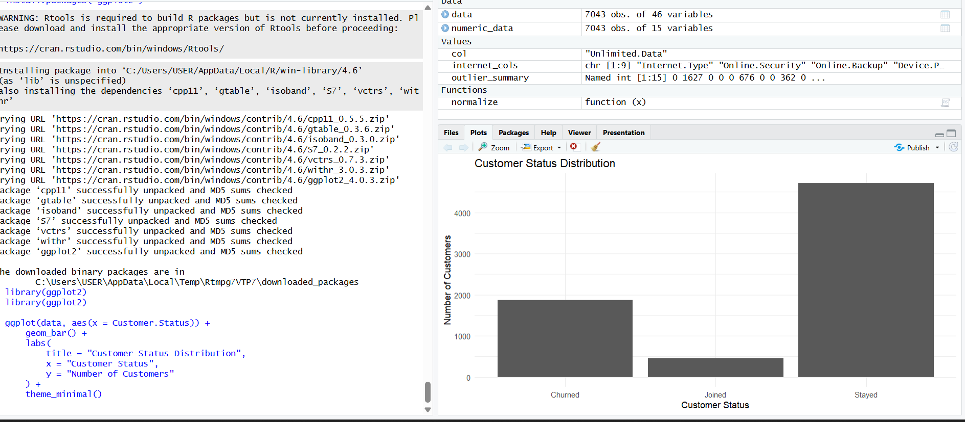
Churn Category Distribution
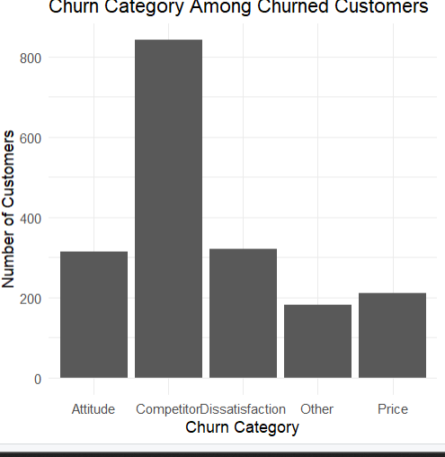
Customer Status by Contract Type
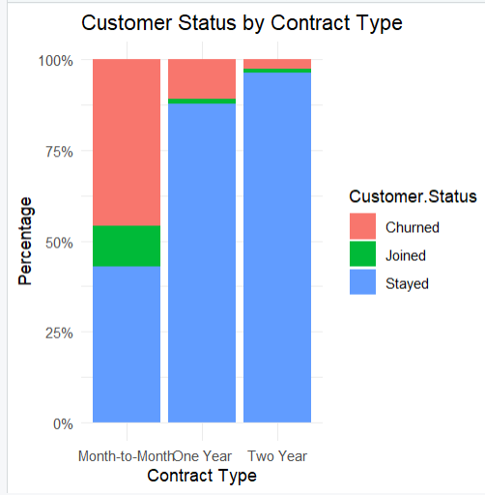
Correlation Analysis Output
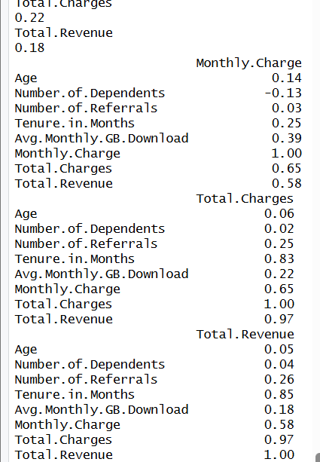
Normalization Results
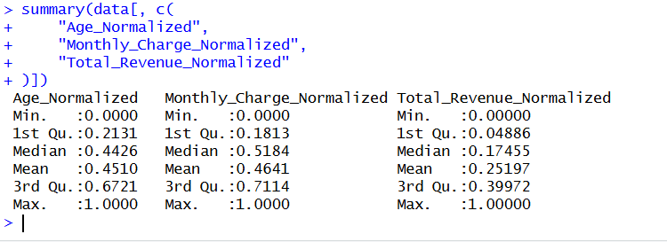
Categorical Encoding Results
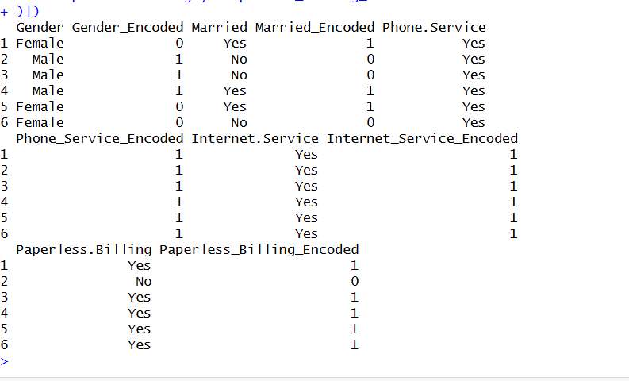

9. Key Initial Insights
- The dataset contains 7,043 customers, with 67.02% classified as Stayed, 26.54% as Churned, and 6.45% as Joined.
- Competitor-related reasons account for 44.99% of the churned-customer categories in this dataset.
- The observed churn share is substantially higher within the Month-to-Month contract group than within the One Year and Two Year groups.
- Longer tenure is strongly positively associated with cumulative financial measures: correlations are 0.83 with Total Charges and 0.85 with Total Revenue.
- Total Charges and Total Revenue have a very strong positive correlation of 0.97.
- The data contained 120 negative Monthly Charge values, which were treated as invalid billing values and replaced using the median valid charge.

10. Selected R Code Evidence
# Dataset inspection
dim(data)
str(data)
summary(data)
# Missing-value check
colSums(is.na(data))
# Duplicate check
sum(duplicated(data))
# IQR outlier detection
numeric_data <- data[sapply(data, is.numeric)]
# Min-max normalization
normalize <- function(x) {
(x - min(x, na.rm = TRUE)) /
(max(x, na.rm = TRUE) - min(x, na.rm = TRUE))
}
# Binary categorical encoding
data$Gender_Encoded <- ifelse(data$Gender == "Male", 1, 0)
data$Married_Encoded <- ifelse(data$Married == "Yes", 1, 0)
# Customer status
table(data$Customer.Status)
# Churn category
churned_data <- data[data$Customer.Status == "Churned", ]
table(churned_data$Churn.Category)
# Correlation
correlation_matrix <- cor(
data[sapply(data, is.numeric)],
use = "complete.obs"
)

11. Conclusion
Week 1 established a reproducible R-based workflow for cleaning and preliminarily analyzing the telecom customer churn dataset. The workflow covered structural inspection, missing-value assessment and treatment, duplicate checking, IQR-based outlier detection, invalid billing value treatment, min-max normalization, categorical encoding, descriptive analysis, visualization, and correlation analysis. The resulting cleaned dataset and analytical outputs provide a suitable foundation for the next internship task on data visualization and insight communication.

