WEEK 2 INTERNSHIP PROJECT
Telecom Customer Churn
Data Visualization and Insight Communication using R
YuvaIntern – Week 2
Tools: R, RStudio, ggplot2, dplyr

1. Project Overview
This Week 2 project focuses on data visualization and insight communication using R. The Telecom Customer Churn dataset used in Week 1 was continued for this task, as permitted by the internship instructions. The objective was to create multiple visualization types and use them to communicate patterns, relationships, distributions, and customer churn insights in a clear format suitable for technical and non-technical audiences.

2. Dataset Overview
The dataset contains 7,043 customer records and 38 variables. It includes customer demographics, service details, contract information, monthly charges, total charges, total revenue, customer status, and churn-related fields. Key variables used include Customer.Status, Age, Monthly.Charge, Total.Revenue, Contract, Tenure.in.Months, and Churn.Category.

3. Visualization Approach
Six visualizations were developed using ggplot2: bar charts, a histogram, a scatter plot, a grouped bar chart, and a line chart. Each chart was selected according to the type of question it helps answer, including categorical comparison, numerical distribution, relationships between numerical variables, comparison across categories, and ordered trends.

4. Customer Status Distribution
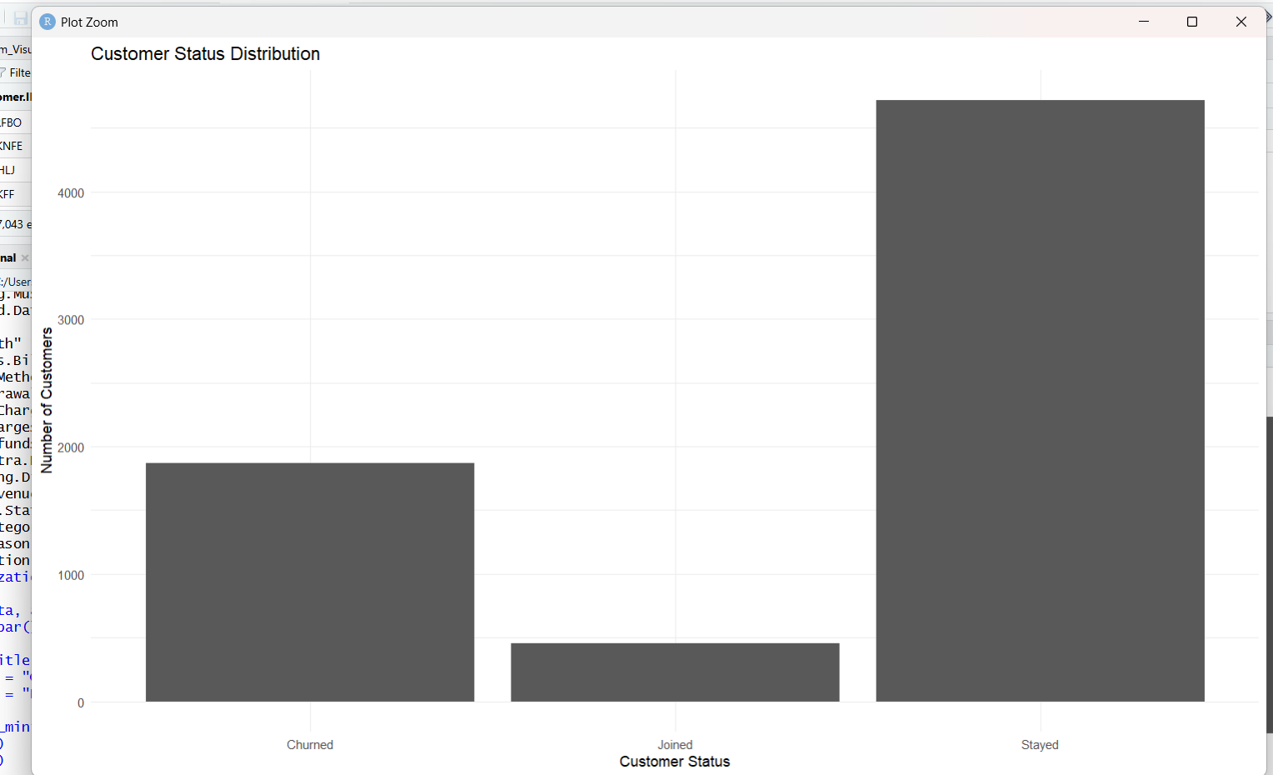
This bar chart compares the number of customers in each customer-status category. The dataset contains 1,869 churned customers, 454 joined customers, and 4,720 stayed customers. A bar chart was selected because it makes categorical counts easy to compare.

R Code
ggplot(data, aes(x = Customer.Status)) +
geom_bar() +
labs(title = "Customer Status Distribution",
x = "Customer Status",
y = "Number of Customers") +
theme_minimal()

5. Age Distribution of Customers
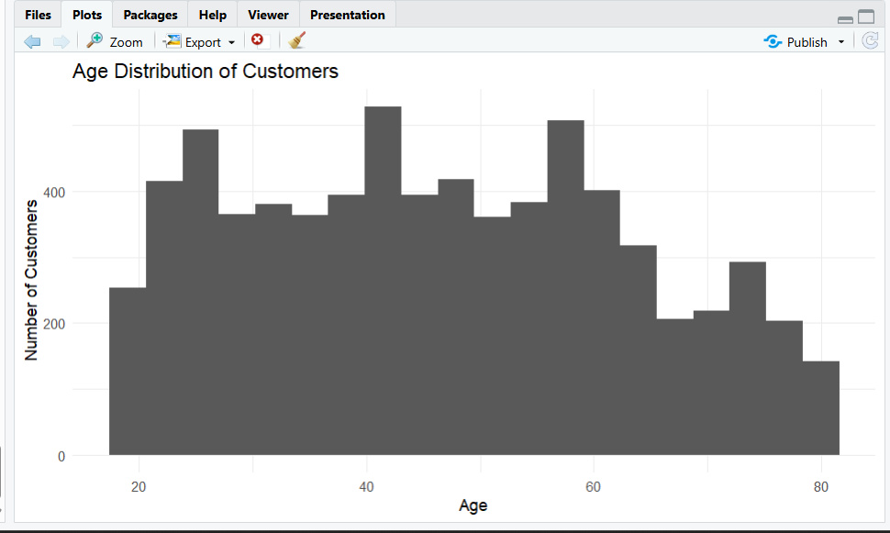
The histogram shows how customer ages are distributed across the dataset. Ages cover a broad range, with several intervals having relatively high frequencies. A histogram was selected because it is suitable for showing the distribution of a continuous numerical variable.

R Code
ggplot(data, aes(x = Age)) +
geom_histogram(bins = 20) +
labs(title = "Age Distribution of Customers",
x = "Age",
y = "Number of Customers") +
theme_minimal()

6. Monthly Charge vs Total Revenue
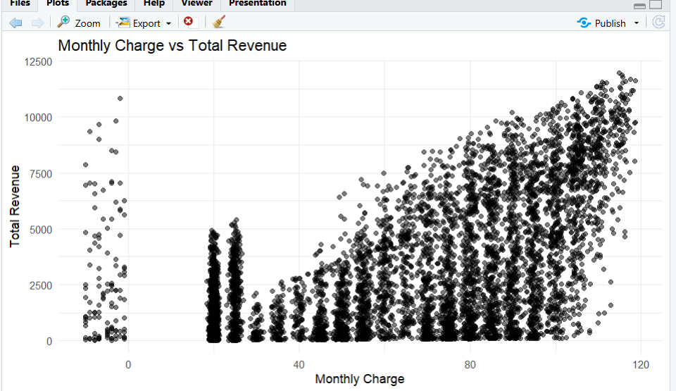
The scatter plot shows a generally positive relationship between Monthly Charge and Total Revenue. Customers with higher monthly charges tend to have higher total revenue, although the points show substantial variation. A scatter plot was selected to examine the relationship between two numerical variables.

R Code
ggplot(data, aes(x = Monthly.Charge, y = Total.Revenue)) +
geom_point(alpha = 0.5) +
labs(title = "Monthly Charge vs Total Revenue",
x = "Monthly Charge",
y = "Total Revenue") +
theme_minimal()

7. Customer Status by Contract Type
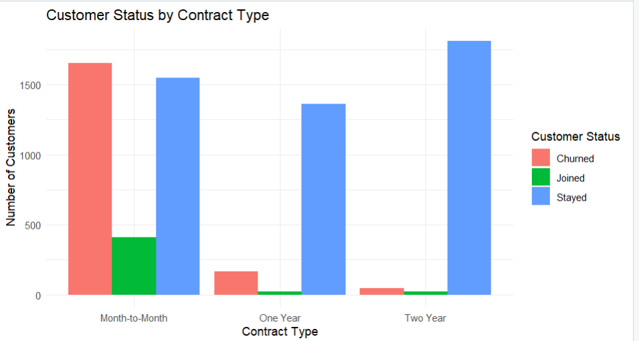
The grouped bar chart compares customer status across contract types. Month-to-Month contracts contain substantially more churned customers, while One Year and Two Year contracts contain much larger stayed groups. A grouped bar chart was selected to compare two categorical variables together.

R Code
ggplot(data, aes(x = Contract, fill = Customer.Status)) +
geom_bar(position = "dodge") +
labs(title = "Customer Status by Contract Type",
x = "Contract Type",
y = "Number of Customers",
fill = "Customer Status") +
theme_minimal()

8. Average Total Revenue by Customer Tenure
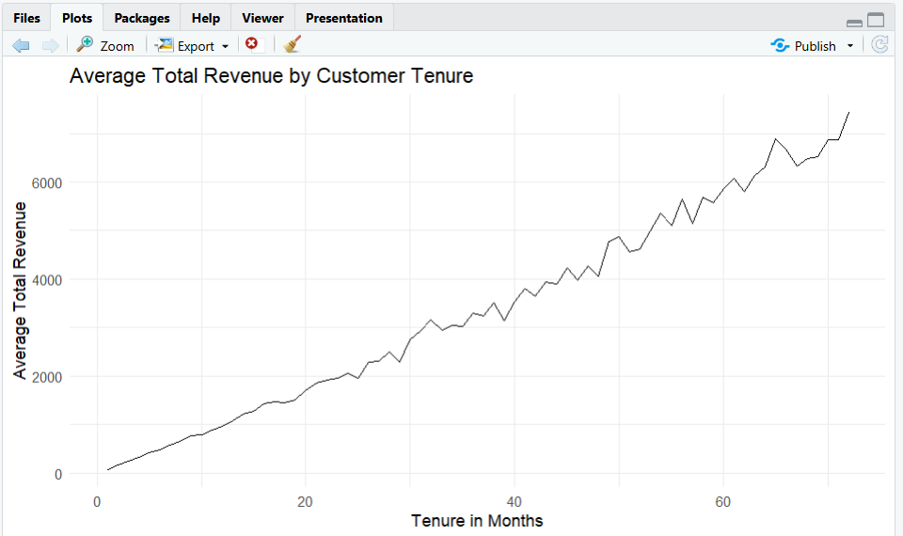
The line chart shows average total revenue by customer tenure in months. The overall pattern rises as tenure increases, with some fluctuations. A line chart was selected because tenure is an ordered numerical variable and the chart communicates progression across months.

R Code
tenure_summary <- data %>%
group_by(Tenure.in.Months) %>%
summarise(Average_Revenue = mean(Total.Revenue, na.rm = TRUE))
ggplot(tenure_summary, aes(x = Tenure.in.Months, y = Average_Revenue)) +
geom_line() +
labs(title = "Average Total Revenue by Customer Tenure",
x = "Tenure in Months",
y = "Average Total Revenue") +
theme_minimal()

9. Churn Category Distribution
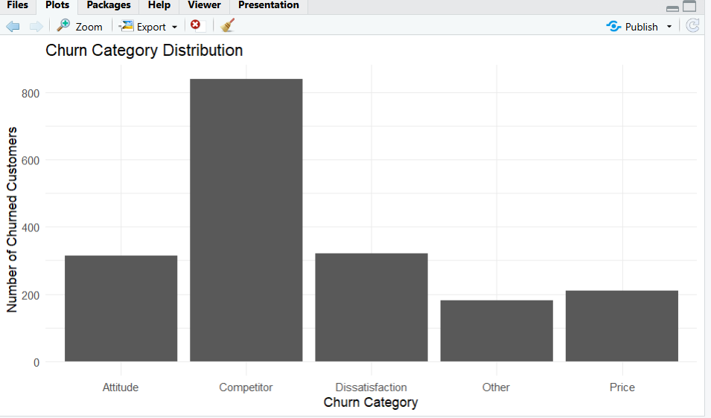
Among customers whose Customer Status is Churned, Competitor is the largest churn category, followed by Dissatisfaction and Attitude. Price and Other are smaller categories. A bar chart was selected because it allows straightforward comparison of churn-category counts.

R Code
churned_data <- data[data$Customer.Status == "Churned", ]
ggplot(churned_data, aes(x = Churn.Category)) +
geom_bar() +
labs(title = "Churn Category Distribution",
x = "Churn Category",
y = "Number of Churned Customers") +
theme_minimal()

10. Key Insights
- The customer-status distribution contains 4,720 stayed customers, 1,869 churned customers, and 454 joined customers.
- Customer ages are distributed across a broad range, allowing the dataset to represent multiple age groups.
- Monthly Charge and Total Revenue show a generally positive relationship, although individual customer values vary.
- Month-to-Month contracts contain substantially more churned customers than One Year and Two Year contracts in the dataset.
- Average Total Revenue generally increases with customer tenure, with smaller fluctuations at different tenure levels.
- Among churned customers, Competitor is the largest recorded churn category, followed by Dissatisfaction and Attitude.

11. Communication and Business Relevance
The visualizations convert raw customer records into patterns that can be understood quickly. The customer-status and churn-category charts show the scale and composition of churn. The contract comparison highlights differences in customer status across contract types. The scatter plot connects monthly charges with accumulated revenue, while the tenure line chart shows how average revenue changes as customer relationships become longer. Together, the charts provide a compact visual story that can support further investigation into retention, contract structure, customer value, and churn.

12. Conclusion
This Week 2 project demonstrated the use of R and ggplot2 for communicating data-driven insights through multiple visualization types. The analysis used the Telecom Customer Churn dataset to create categorical comparisons, a numerical distribution, a numerical relationship, and an ordered trend. Each visualization was accompanied by an explanation of its purpose and the insight it provides. The resulting charts and interpretations provide a clear foundation for further customer churn analysis and reporting.

13. Project Files
- Telecom customer churn dataset (CSV)
- Week 2 R analysis script
- Six visualization screenshots
- This final Word report

