# DATA STRUCTURES AND ALGORITHMS

## E-Commerce Platform Search function

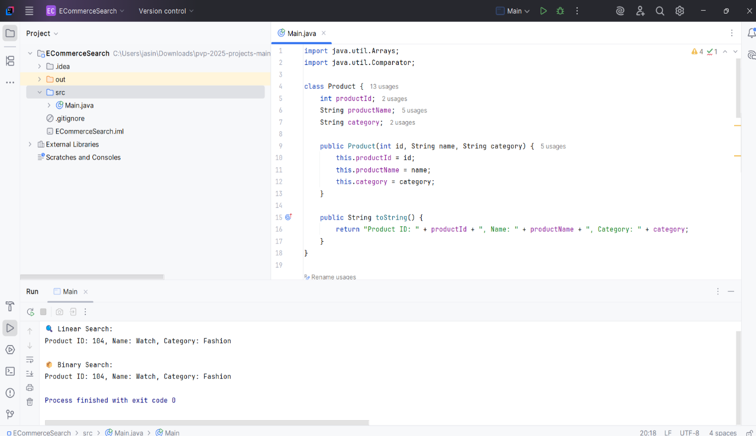

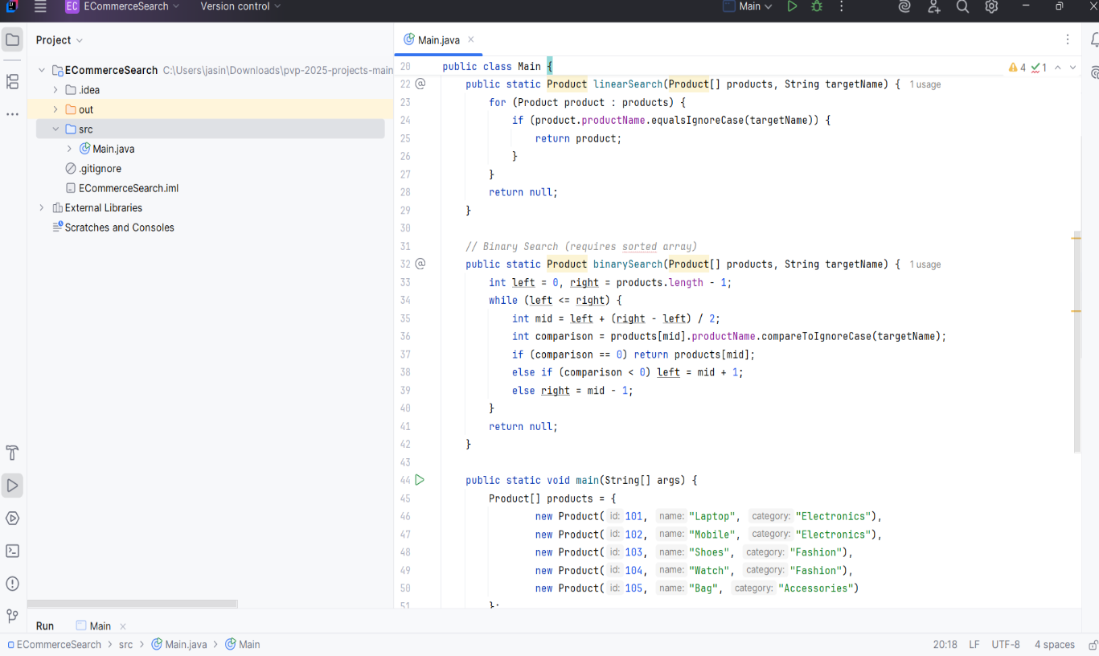

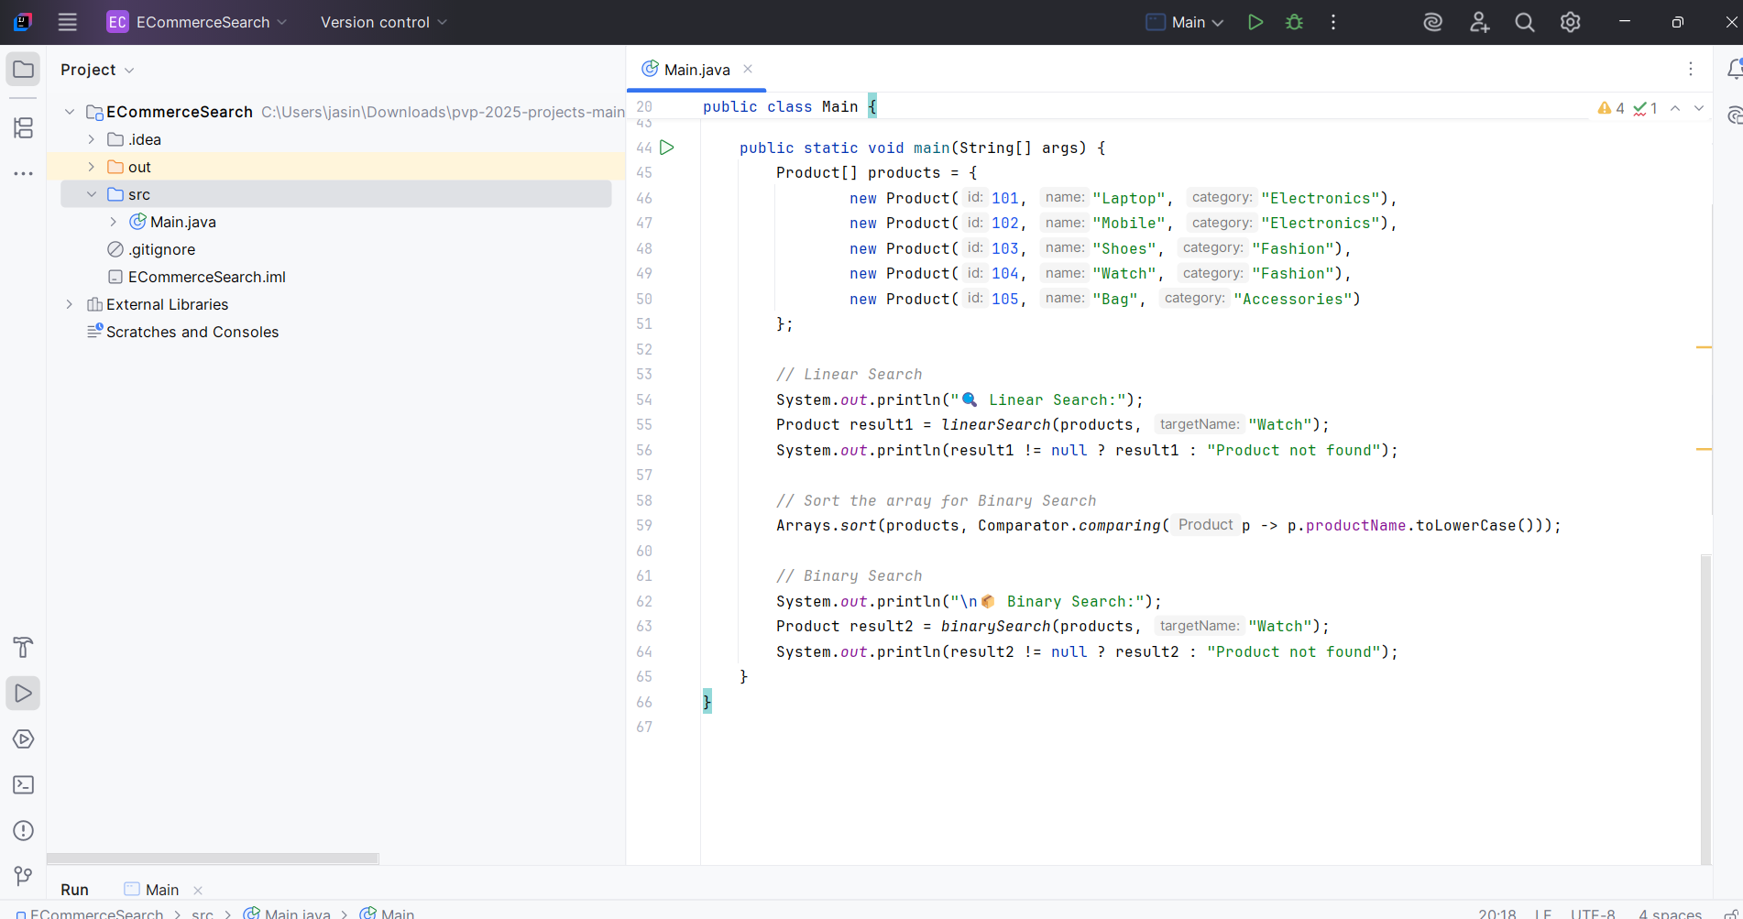

Financial Forecasting

