# WEEK-2

## **Module-3:PL/SQL Programming**

## **Exercise -1: Control structures**

**Code: Creating A Table and inserting values to it**

**CREATE TABLE customers (**

**customer_id NUMBER PRIMARY KEY,**

**name VARCHAR2(100),**

**age NUMBER,**

**balance NUMBER(10, 2),**

**is_vip VARCHAR2(5) DEFAULT 'FALSE'**

**);**

**CREATE TABLE loans (**

**loan_id NUMBER PRIMARY KEY,**

**customer_id NUMBER REFERENCES customers(customer_id),**

**interest_rate NUMBER(5,2),**

**due_date DATE**

**);**

**INSERT INTO customers VALUES (1, 'Alice', 65, 12000, 'FALSE');**

**INSERT INTO customers VALUES (2, 'Bob', 45, 8000, 'FALSE');**

**INSERT INTO customers VALUES (3, 'Carol', 70, 9500, 'FALSE');**

**INSERT INTO loans VALUES (101, 1, 7.5, SYSDATE + 10);**

**INSERT INTO loans VALUES (102, 2, 6.0, SYSDATE + 45);**

**INSERT INTO loans VALUES (103, 3, 8.0, SYSDATE + 5);**

**COMMIT;**

**Apply Discount on Above 60yr old:**

**BEGIN**

**FOR rec IN (**

**SELECT l.loan_id**

**FROM loans l**

**JOIN customers c ON l.customer_id = c.customer_id**

**WHERE c.age > 60**

**) LOOP**

**UPDATE loans**

**SET interest_rate = interest_rate - 1**

**WHERE loan_id = rec.loan_id;**

**END LOOP;**

**COMMIT;**

**END;**

**/**

**mark_vip_customers.sql**

**BEGIN**

**FOR rec IN (**

**SELECT customer_id**

**FROM customers**

**WHERE balance > 10000**

**) LOOP**

**UPDATE customers**

**SET is_vip = 'TRUE'**

**WHERE customer_id = rec.customer_id;**

**END LOOP;**

**COMMIT;**

**END;**

**/**

**OUTPUT:**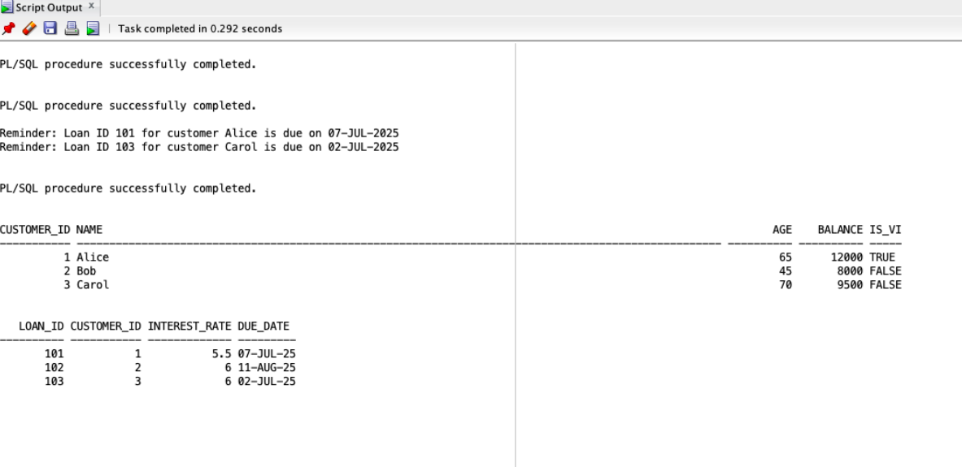

**Exercise 3 - Stored Procedures**

**CREATING TABLE AND INSERTING VALUES IN IT**

**CREATE TABLE customers (**

**customer_id NUMBER PRIMARY KEY,**

**name VARCHAR2(100),**

**age NUMBER,**

**balance NUMBER(15, 2),**

**is_vip VARCHAR2(5) DEFAULT 'FALSE'**

**);**

**CREATE TABLE accounts (**

**account_id NUMBER PRIMARY KEY,**

**customer_id NUMBER REFERENCES customers(customer_id),**

**balance NUMBER(15, 2),**

**account_type VARCHAR2(20)**

**);**

**CREATE TABLE employees (**

**employee_id NUMBER PRIMARY KEY,**

**department VARCHAR2(50),**

**salary NUMBER(15, 2)**

**);**

**INSERT ALL**

**INTO customers VALUES (1101, 'Alice', 65, 12000, 'FALSE')**

**INTO customers VALUES (1102, 'Bob', 45, 8000, 'FALSE')**

**INTO customers VALUES (1103, 'Carol', 70, 9500, 'FALSE')**

**SELECT * FROM dual;**

**INSERT ALL**

**INTO accounts VALUES (101, 1, 15000, 'SAVINGS')**

**INTO accounts VALUES (102, 2, 300000, 'CHECKING')**

**SELECT * FROM dual;**

**INSERT ALL**

**INTO employees (employee_id, department, salary)**

**VALUES (101, 'IT', 15000)**

**INTO employees (employee_id, department, salary)**

**VALUES (102, 'IT', 300000)**

**SELECT * FROM dual;**

**COMMIT;**

**SELECT * FROM customers;**

**SELECT * FROM accounts;**

**SELECT * FROM employees;**

**PROCESS MONTHLY INTEREST**

**CREATE OR REPLACE PROCEDURE Process Monthly Interest AS**

**BEGIN**

**UPDATE accounts**

**SET balance = balance * 1.01**

**WHERE account_type = 'SAVINGS';**

**COMMIT;**

**END;**

**/**

**Stored procedure test:**

BEGIN

ProcessMonthlyInterest;

END;

/

BEGIN

UpdateEmployeeBonus('IT', 5);

END;

/

BEGIN

TransferFunds(101, 102, 1000);

END;

/

SELECT * FROM accounts;

SELECT * FROM employees;

FUND TRANSFERS:

CREATE OR REPLACE PROCEDURE TransferFunds (

p_from_acct IN NUMBER,

p_to_acct IN NUMBER,

p_amount IN NUMBER

) AS

v_balance NUMBER;

BEGIN

SELECT balance INTO v_balance

FROM accounts

WHERE account_id = p_from_acct

FOR UPDATE;

IF v_balance < p_amount THEN

RAISE_APPLICATION_ERROR(-20001, 'Insufficient funds: ' || v_balance);

END IF;

UPDATE accounts

SET balance = balance - p_amount

WHERE account_id = p_from_acct;

UPDATE accounts

SET balance = balance + p_amount

WHERE account_id = p_to_acct;

COMMIT;

END;

/

**UpdateEmployeeBonus:**

CREATE OR REPLACE PROCEDURE UpdateEmployeeBonus (

p_dept IN VARCHAR2,

p_bonus_pct IN NUMBER

) AS

BEGIN

UPDATE employees

SET salary = salary * (1 + p_bonus_pct / 100)

WHERE department = p_dept;

COMMIT;

END;

/

OUTPUT:

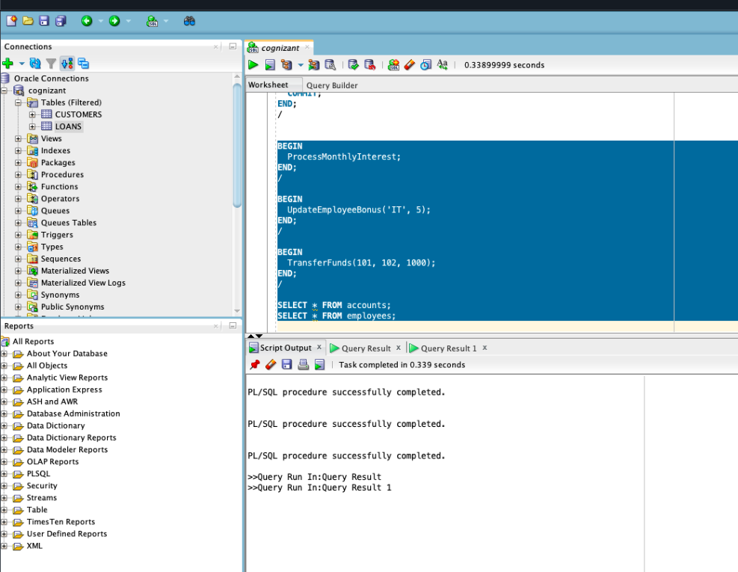

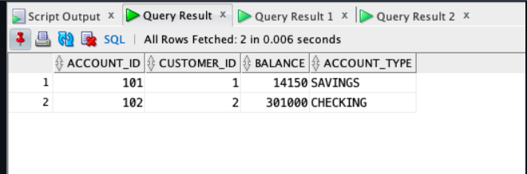

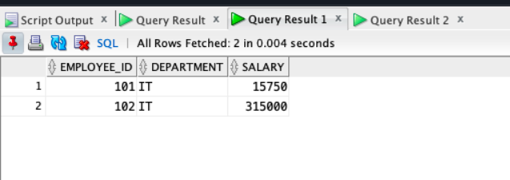

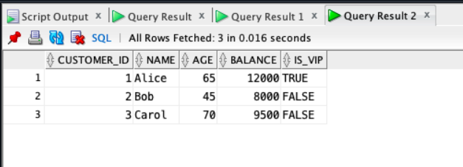

# **Module-4:Test driven development and Logging framework**

package com.example;

/**

* Hello world!

*

*/

public class App

{

public static void main( String[] args )

{

System.out.println( "Hello World!" );

}

}

***Calculator:***

package com.example;

public class Calculator {

public int add(int a, int b) {

return a + b;

}

public int subtract(int a, int b) {

return a - b;

}

}

**J UNIT:**

**Exercise-01:SettingUpJunit:**

package com.example.JUnit.Exercise_01_Setting_Up_JUnit;

import static org.junit.Assert.assertEquals;

import org.junit.Test;

public class TestClass {

@Test

public void testAddition() {

int result = 2 + 3;

assertEquals("Addition should be 5", 5, result);

}

}

OUTPUT:

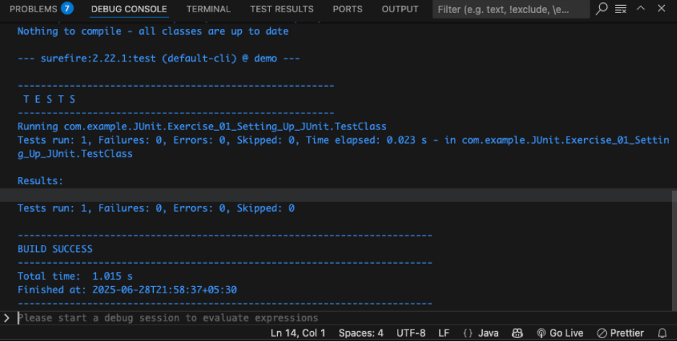

**Exercise-03:Assertions_in_Junit:**

package com.example.JUnit.Exercise_03_Assertions_in_JUnit;

import static org.junit.Assert.assertEquals;

import static org.junit.Assert.assertFalse;

import static org.junit.Assert.assertNotNull;

import static org.junit.Assert.assertNull;

import static org.junit.Assert.assertTrue;

import org.junit.Test;

public class AssertionsTest {

@Test

public void testAssertions() {

// Assert equals

assertEquals(5, 2 + 3);

// Assert true

assertTrue(5 > 3);

// Assert false

assertFalse(5 < 3);

// Assert null

assertNull(null);

// Assert not null

assertNotNull(new Object());

}

}

OUTPUT:

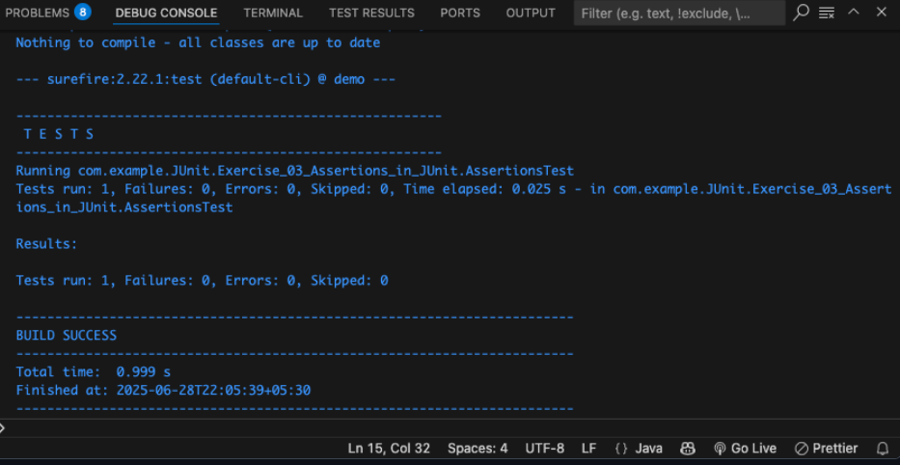

# **Exercise_04_AAA_and_Fixtures:**

package com.example.JUnit.Exercise_04_AAA_and_Fixtures;

import org.junit.After;

import static org.junit.Assert.assertEquals;

import org.junit.Before;

import org.junit.Test;

import com.example.Calculator;

public class CalculatorTest {

private Calculator calculator;

@Before

public void setUp() {

calculator = new Calculator();

System.out.println("Setup complete.");

}

@After

public void tearDown() {

calculator = null;

System.out.println("Teardown complete.");

}

@Test

public void testAddition() {

int result = calculator.add(5, 3);

assertEquals(8, result);

}

@Test

public void testSubtraction() {

int result = calculator.subtract(10, 4);

assertEquals(6, result);

}

}

OUTPUT:

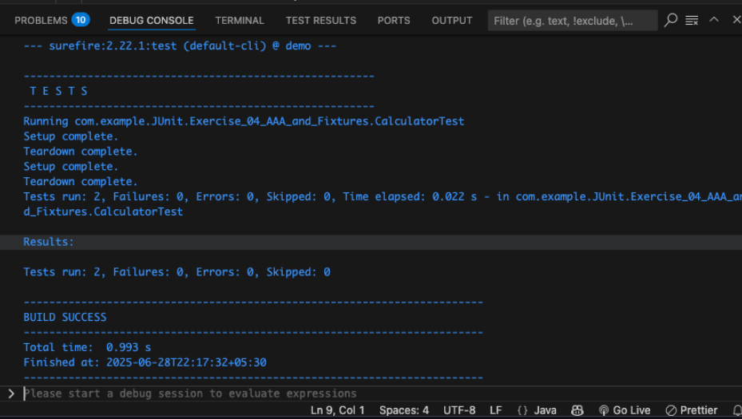

**Mockito:**

**Exercise_01_Mocking_and_Stubbing:**

package com.example.Mockito.Exercise_01_Mocking_and_Stubbing;

import static org.junit.jupiter.api.Assertions.assertEquals;

import org.junit.jupiter.api.Test;

import static org.mockito.Mockito.mock;

import static org.mockito.Mockito.when;

import com.example.Mockito.ExternalApi;

import com.example.Mockito.MyService;

public class MyServiceTest {

@Test

public void testExternalApi() {

// Arrange

ExternalApi mockApi = mock(ExternalApi.class);

when(mockApi.getData()).thenReturn("Mock Data");

// Act

MyService service = new MyService(mockApi);

String result = service.fetchData();

// Assert

assertEquals("Mock Data", result);

}

}

OUTPUT:

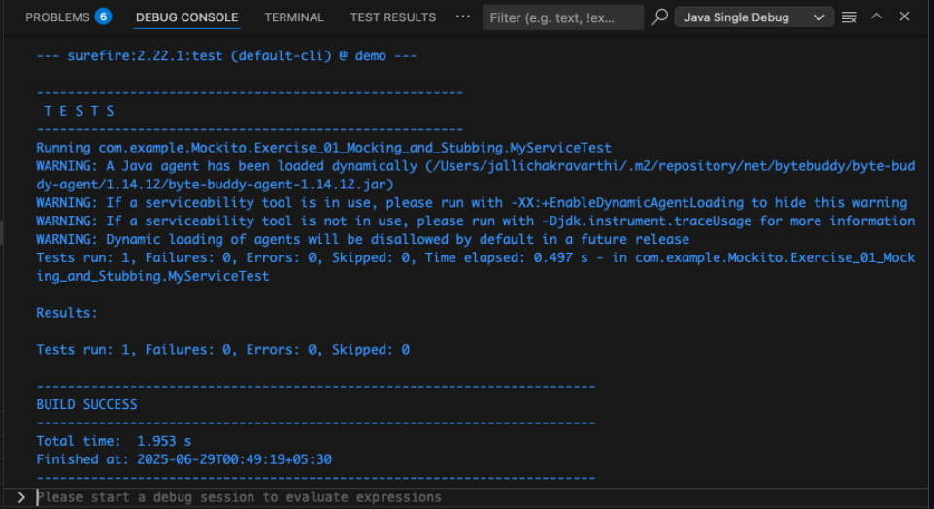

**Exercise_02_Verifying_Interactions:**

package com.example.Mockito.Exercise_02_Verifying_Interactions;

import org.junit.jupiter.api.Test;

import static org.mockito.Mockito.mock;

import static org.mockito.Mockito.verify;

import com.example.Mockito.ExternalApi;

import com.example.Mockito.MyService;

public class MyServiceTest {

@Test

public void testVerifyInteraction() {

// Arrange

ExternalApi mockApi = mock(ExternalApi.class);

MyService service = new MyService(mockApi);

// Act

service.fetchData();

// Assert

verify(mockApi).getData();

}

}

OUTPUT:

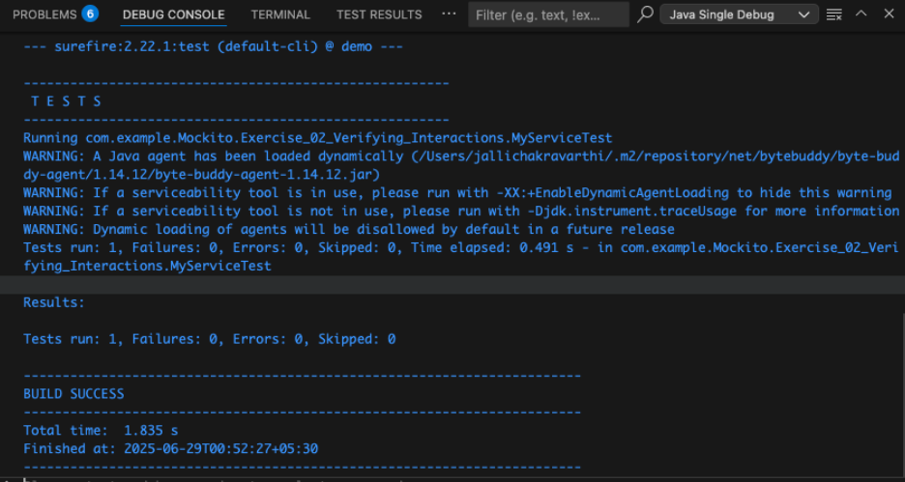

ExternalApi:

package com.example.Mockito;

public interface ExternalApi {

String getData();

}

MY SERVICE :

package com.example.Mockito;

public class MyService {

private ExternalApi

public MyService(ExternalApi api) {

this.api = api;

}

public String fetchData() {

return api.getData()

}

}

[SLF4J_Logging](https://github.com/jallichakravarthi/Digital-Nurture-4.0-6372771/tree/main/Week%2002-Programming%20Languages/Module%2004%20%E2%80%93%20Test%20driven%20development%20and%20Logging%20framework/src/test/java/com/example/SLF4J_Logging):

**Exercise_01_Logging_Error_Warning**

package com.example.SLF4J_Logging.Exercise_01_Logging_Error_Warning;

import org.slf4j.Logger;

import org.slf4j.LoggerFactory;

public class LoggingExample {

private static final Logger logger = LoggerFactory.getLogger(LoggingExample.class);

public static void main(String[] args) {

logger.error("This is an error message");

logger.warn("This is a warning message");

}

}

OUTPUT:

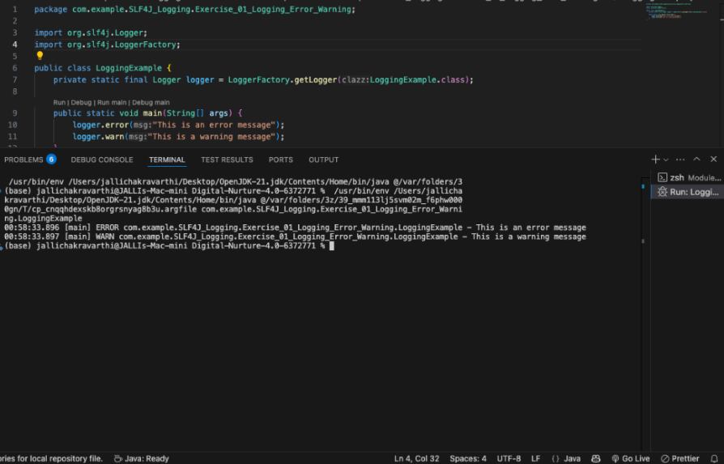

**AppTest:**

package com.example;

import static org.junit.Assert.*;

import org.junit.Test;

/**

* Unit test for simple App.

*/

public class AppTest

{

/**

* Rigorous Test :-)

*/

@Test

public void shouldAnswerWithTrue()

{

assertTrue( true );

}

}