**WEEK-3**

**Exercise 1: Configuring a Basic Spring Application**

**Code:**

**pom.xml**

<project xmlns="http://maven.apache.org/POM/4.0.0" xmlns:xsi="http://www.w3.org/2001/XMLSchema-instance" xsi:schemaLocation="http://maven.apache.org/POM/4.0.0 https://maven.apache.org/xsd/maven-4.0.0.xsd">

<modelVersion>4.0.0</modelVersion>

<groupId>com.library</groupId>

<artifactId>LibraryManagement</artifactId>

<version>0.0.1-SNAPSHOT</version>

<dependencies>

<!-- Spring Core -->

<dependency>

<groupId>org.springframework</groupId>

<artifactId>spring-context</artifactId>

<version>5.3.33</version>

</dependency>

</dependencies>

</project>

**applicationContext.xml**

<?xml version="1.0" encoding="UTF-8"?>

<beans xmlns="http://www.springframework.org/schema/beans"

xmlns:xsi="http://www.w3.org/2001/XMLSchema-instance"

xsi:schemaLocation="

http://www.springframework.org/schema/beans

http://www.springframework.org/schema/beans/spring-beans.xsd">

<!-- BookRepository bean -->

<bean id="bookRepository" class="com.library.repository.BookRepository" />

<!-- BookService bean -->

<bean id="bookService" class="com.library.service.BookService" />

</beans>

**BookService.java**

package com.library.service;

public class BookService {

public void addBook(String bookName) {

System.out.println("Adding book: " + bookName);

}}

**BookRepository.java**

package com.library.repository;

public class BookRepository {

public void save(String bookName) {

System.out.println("Book saved: " + bookName);

}

}

**Main.java**

package com.library;

import com.library.service.BookService;

import org.springframework.context.ApplicationContext;

import org.springframework.context.support.ClassPathXmlApplicationContext;

public class Main {

public static void main(String[] args) {

ApplicationContext context = new ClassPathXmlApplicationContext("applicationContext.xml");

BookService bookService = (BookService) context.getBean("bookService");

bookService.addBook("The Alchemist");

}

}

**Output:**

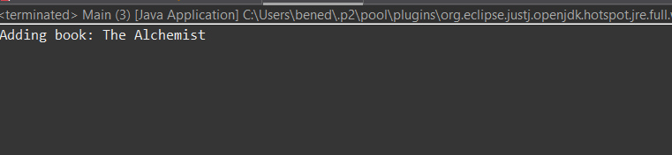

**Exercise 2: Implementing Dependency Injection**

**Code:**

**applicationContext.xml**

<?xml version="1.0" encoding="UTF-8"?>

<beans xmlns="http://www.springframework.org/schema/beans"

xmlns:xsi="http://www.w3.org/2001/XMLSchema-instance"

xsi:schemaLocation="

http://www.springframework.org/schema/beans

http://www.springframework.org/schema/beans/spring-beans.xsd">

<bean id="bookRepository" class="com.library.repository.BookRepository" />

<!-- Injecting BookRepository -->

<bean id="bookService" class="com.library.service.BookService">

<property name="bookRepository" ref="bookRepository" />

</bean>

</beans>

**BookService.java**

package com.library.service;

import com.library.repository.BookRepository;

public class BookService {

private BookRepository bookRepository;

// Dependency injection

public void setBookRepository(BookRepository bookRepository) {

this.bookRepository = bookRepository;

}

public void addBook(String bookName) {

System.out.println("Adding book: " + bookName);

bookRepository.save(bookName);

}

}

**BookRepository.java**

package com.library.repository;

public class BookRepository {

public void save(String bookName) {

System.out.println("Book saved: " + bookName);

}

}

**Main.java**

package com.library;

import com.library.service.BookService;

import org.springframework.context.ApplicationContext;

Import org.springframework.context.support.ClassPathXmlApplicationContext;

public class Main {

public static void main(String[] args) {

ApplicationContext context = new ClassPathXmlApplicationContext("applicationContext.xml");

BookService bookService = (BookService) context.getBean("bookService");

bookService.addBook("The Alchemist");

}

}

**Output:**

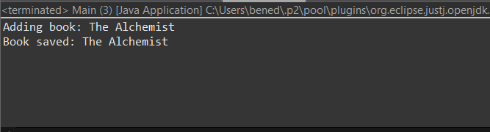

**Exercise 4: Creating and Configuring a Maven Project**

**Code:**

**pom.xml**

<project xmlns="http://maven.apache.org/POM/4.0.0" xmlns:xsi="http://www.w3.org/2001/XMLSchema-instance" xsi:schemaLocation="http://maven.apache.org/POM/4.0.0 https://maven.apache.org/xsd/maven-4.0.0.xsd">

<modelVersion>4.0.0</modelVersion>

<groupId>com.library</groupId>

<artifactId>LibraryManagement</artifactId>

<version>0.0.1-SNAPSHOT</version>

<properties>

<maven.compiler.source>1.8</maven.compiler.source>

<maven.compiler.target>1.8</maven.compiler.target>

</properties>

<dependencies>

<!-- Spring Context -->

<dependency>

<groupId>org.springframework</groupId>

<artifactId>spring-context</artifactId>

<version>5.3.32</version>

</dependency>

<!-- Spring AOP -->

<dependency>

<groupId>org.springframework</groupId>

<artifactId>spring-aop</artifactId>

<version>5.3.32</version>

</dependency>

<!-- Spring WebMVC -->

<dependency>

<groupId>org.springframework</groupId>

<artifactId>spring-webmvc</artifactId>

<version>5.3.32</version>

</dependency>

</dependencies>

<!-- Configure Maven Compiler Plugin -->

<build>

<plugins>

<plugin>

<groupId>org.apache.maven.plugins</groupId>

<artifactId>maven-compiler-plugin</artifactId>

<version>3.8.1</version>

<configuration>

<source>1.8</source>

<target>1.8</target>

</configuration>

</plugin>

</plugins>

</build>

</project>

**Output:**

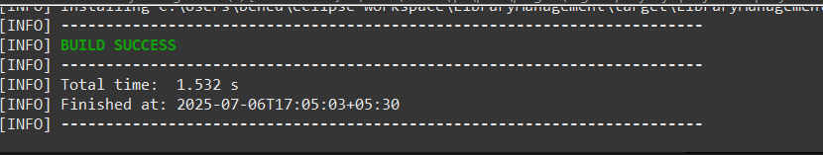

Exercise 1: Spring Data JPA - Quick Example

Code:

OrmLearnApplication.java:

package com.cognizant.ormlearn;

import java.util.List;

import com.cognizant.ormlearn.model.Country;

import com.cognizant.ormlearn.service.CountryService;

import org.slf4j.Logger;

import org.slf4j.LoggerFactory;

import org.springframework.boot.SpringApplication;

import org.springframework.boot.autoconfigure.SpringBootApplication;

import org.springframework.context.ApplicationContext;

@SpringBootApplication

public class OrmLearnApplication {

private static CountryService countryService;

private static final Logger LOGGER = LoggerFactory.getLogger(OrmLearnApplication.class);

private static void testGetAllCountries() {

LOGGER.info("Start");

List<Country> countries = countryService.getAllCountries();

LOGGER.debug("countries={}", countries);

LOGGER.info("End");

}

public static void main(String[] args) {

ApplicationContext context = SpringApplication.run(OrmLearnApplication.class, args);

LOGGER.info("Inside main");

countryService = context.getBean(CountryService.class);

testGetAllCountries();

}

}

Country.java:

package com.cognizant.ormlearn.model;

import jakarta.persistence.Column;

import jakarta.persistence.Entity;

import jakarta.persistence.Id;

import jakarta.persistence.Table;

@Entity

@Table(name = "country")

public class Country {

@Id

@Column(name = "co_code")

private String code;

@Column(name = "co_name")

private String name;

// Getters and Setters

public String getCode() { return code; }

public void setCode(String code) { this.code = code; }

public String getName() { return name; }

public void setName(String name) { this.name = name; }

@Override

public String toString() {

return "Country [code=" + code + ", name=" + name + "]";

}

}

CountryRepository.java:

package com.cognizant.ormlearn.repository;

import org.springframework.data.jpa.repository.JpaRepository;

import org.springframework.stereotype.Repository;

import com.cognizant.ormlearn.model.Country;

@Repository

public interface CountryRepository extends JpaRepository<Country, String> {

}

CountryService.java:

package com.cognizant.ormlearn.service;

import java.util.List;

import jakarta.transaction.Transactional;

import org.springframework.beans.factory.annotation.Autowired;

import org.springframework.stereotype.Service;

import com.cognizant.ormlearn.model.Country;

import com.cognizant.ormlearn.repository.CountryRepository;

@Service

public class CountryService {

@Autowired

private CountryRepository countryRepository;

@Transactional

public List<Country> getAllCountries() {

return countryRepository.findAll();

}

}

Output:

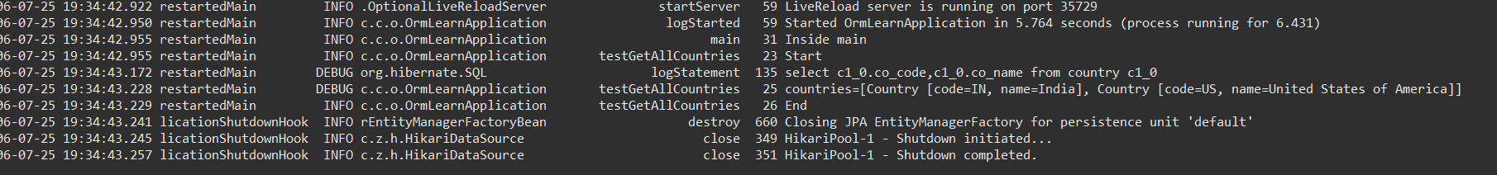

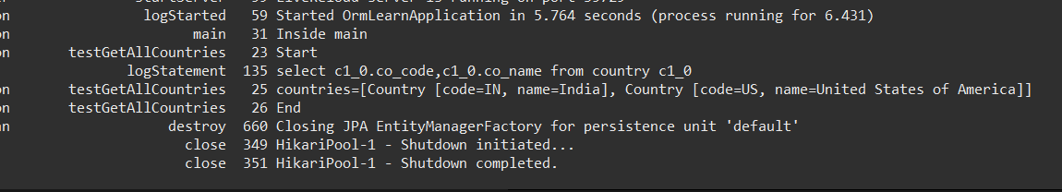

**"Inside main” and the list of countries retrieved from database can be seen in the logs above**

**MySQL queries**

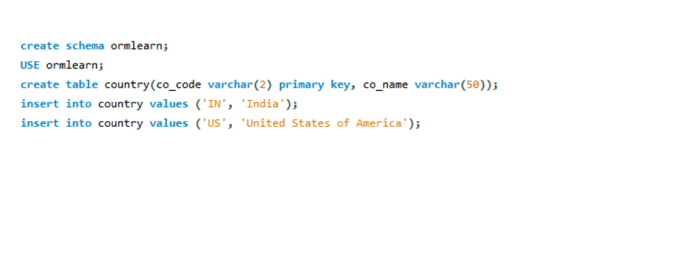



Exercise 4: Difference between JPA, Hibernate and Spring Data JPA

Java Persistence API (JPA)

* A specification (JSR 338) for persisting, reading, and managing data from Java objects to a relational database.
* Does not contain any implementation.
* Only defines interfaces like EntityManager,Query, etc.
* Hibernate is a popular implementation of JPA.

Hibernate

* A concrete implementation of JPA.
* It is an ORM (Object-Relational Mapping) tool that maps Java classes to database tables.
* Provides:  
  + Transaction management
  + Lazy/eager loading
  + Caching
* You write more boilerplate code with Hibernate (session handling, transaction, etc.).

Spring Data JPA

* Built on top of JPA (and often Hibernate).
* Provides abstraction and automation by generating repository code at runtime.
* Reduces boilerplate by allowing you to use interfaces for CRUD operations.
* Spring manages bean injection,transactions,exception handling

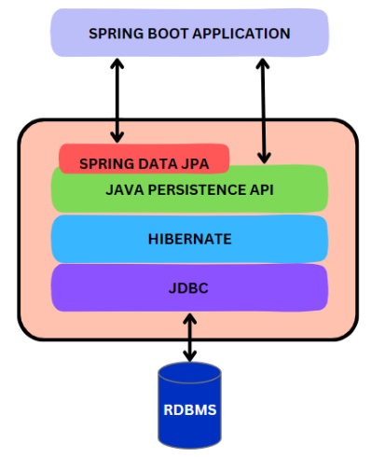

Code Comparison

Hibernate

/* Method to CREATE an employee in the database */

public Integer addEmployee(Employee employee){

Session session = factory.openSession();

Transaction tx = null;

Integer employeeID = null;

try {

tx = session.beginTransaction();

employeeID = (Integer) session.save(employee);

tx.commit();

} catch (HibernateException e) {

if (tx != null) tx.rollback();

e.printStackTrace();

} finally {

session.close();

}

return employeeID;

}

Spring Data JPA

EmployeeRespository.java

public interface EmployeeRepository extends JpaRepository<Employee, Integer> {

}

EmployeeService.java

@Autowire

private EmployeeRepository employeeRepository;

@Transactional

public void addEmployee(Employee employee) {

employeeRepository.save(employee);

}

* From the above codes we can observe that Spring Data JPA significantly reduces boilerplate code by abstracting away low-level database operations like opening sessions, managing transactions, and handling exceptions manually.
* Hibernate gives full control but requires more longer and complex code (managing sessions, transactions, error handling).
* Spring Data JPA allows you to focus on business logic, with automatic transaction handling and CRUD operations through simple repository interfaces.

In conclusion, Spring Data JPA simplifies persistence logic, making your application cleaner, faster to develop